NAME: AGBATO OLAOLUWA
MATRIC NO: 17/MHS01/031
DEPARTMENT: PHYSIOLOGY
COURSE CODE: BCH 204

Mitochondrial oxidation of fatty acids takes place in three stages (Fig. 16-7). In the first stage-β oxidation-the fatty acids undergo oxidative removal of successive two-carbon units in the form of acetyl-CoA, starting from the carboxyl end of the fatty acyl chain. For example, the 16-carbon fatty acid palmitic acid (palmitate at pH 7) undergoes seven passes through this oxidative sequence, in each pass losing two carbons as acetyl-CoA. At the end of seven cycles the last two carbons of palmitate (originally C-15 and C-16) are left as acetyl-CoA. The overall result is the conversion of the 16-carbon chain of palmitate to eight two-carbon acetyl-CoA molecules. Formation of each molecule of acetyl-CoA requires removal of four hydrogen atoms (two pairs of electrons and four H⁺) from the fatty acyl moiety by the action of dehydrogenases.
In the second stage of fatty acid oxidation the acetyl residues of acetyl-CoA are oxidized to CO₂ via the citric acid cycle, which also takes place in the mitochondrial matrix. Acetyl-CoA derived from fatty acid oxidation thus enters a final common pathway of oxidation along with acetyl-CoA derived from glucose via glycolysis and pyruvate oxidation (see Fig. 15-1).
The first two stages of fatty acid oxidation produce the reduced electron carriers NADH and FADH₂, which in the third stage donate electrons to the mitochondrial respiratory chain, through which the electrons are carried to oxygen (Fig. 16-7). Coupled to this flow of electrons is the phosphorylation of ADP to ATP, to be described in Chapter 18. Thus energy released by fatty acid oxidation is conserved as ATP.
We will now look in more detail at the first stage of fatty acid oxidation, for the simple case of a saturated chain with an even number of carbons, and for the slightly more complicated cases of unsaturated and odd-number chains. We then consider the regulation of fatty acid oxidation, and the β-oxidative processes occurring in organelles other than mitochondria.
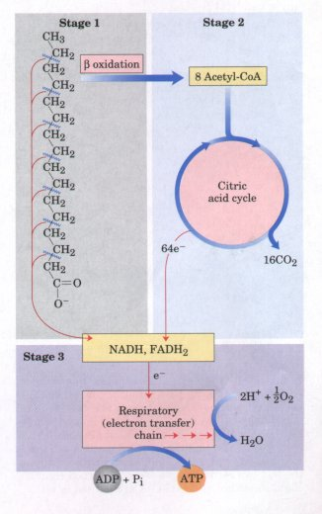
Figure 16-7 Stages of fatty acid oxidation. Stage 1: A long-chain fatty acid is oxidized to yield acetyl residues in the form of acetyl-CoA. Stage 2: The acetyl residues are oxidized to CO₂ via the citric acid cycle. Stage 3: Electrons derived from the oxidations of stages 1 and 2 are passed to O₂ via the mitochondrial respiratory chain, providing the energy for ATP synthesis by oxidative phosphorylation.

