NAME:OBI STEPHANIE CHIDIEBUBE
NURSING
19/MHS02/084
BIO 102 ASSIGNMENT

- CLASSIFICATION OF PLANTS ACCORDING TO EICHLER’S GROUPING IN 1883:
In 1883, Eichler divided the kingdom plantae into two sub-kingdoms, crytogamae and phanerogamae.

SUB-KINGDOM CRYPTOGAMAE:
Characteristics of sub-kingdom cryptogamae:
- They are lower plants and they do not bear flowers or seed. Hence they are called non-flowering and seedless plants.
- Their reproductive organs are inconspicuous (not clearly visible).
- The embryo if present is naked and is called spores.
- They include three divisions: thallophyta, bryophyte, and pteridophyta.
DIVISION THALLOPHYTA:
- Plants belonging to this group do not have well differentiated body design but has a simple body design.
- The plants in this group are commonly called algae.
- They are predominantly aquatic. Freshwater or marine.
- Examples are: spirogyra, ulothrix, cladophora, and chara.

SUB-DIVISION ALGAE:
- They are autotrophs.
- Their body is simple and not well differentiated.
- Their forms and sizes are variable.
- Algae are further classified as green algae, red algae and brown algae. The red color and brown are due to the presence of accessory photosynthetic pigments.

DIVISION BRYOPHYTA:
- The plant body is commonly differentiated to form a stem and leaf-like structures.
- Roots are not present but a small root-like structure is present called the rhizoids.
- They are called amphibians of the plant kingdom because they grow in moist areas.
- It has an embryo in its developmental process.
- Examples are: moss (funaria), and marchantia (liverwort).

DIVISON PTERIDOPHYTA:
- In pteridophytes, the plant body is sporophyte and can be differentiated into roots, stem, and leaves. It is the highest group among the cryptogams.
- They have a specialized tissue for the conduction of water and other substances from one part of the plant body to another. They are also called vascular cryptogams.
- Seeds are absent. They produce naked embryo called spores.
- They bear sporangia which produce spores.
- Examples are: ferns, marsilea, pteris, selaginella, etc.

SUB-KINGDOM PHANEROGAMAE:
- They bear flowers and seed. They are called the spermatophytes.
- The plant body is well differentiated into stems, leaves and roots.
- Seeds are the result of sexual reproductive process.
- They are further classified into GYMNOSPERM (NAKED SEED) AND ANGIOSPERM (ENCLOSED SEED).

SUB-DIVISION GYMNOSPERMAE:
- The plants of this group bear naked seeds and are usually perennial, evergreen and woody.
- It includes medium-sized trees and shrubs.
- Sporangia are formed over a modified leaf-like structure called sporophylis.
- Examples are: cycas, picea (Christmas tree), Thuja (morpankhi).

SUB-DIVISION ANGIOSPERMAE:
- These are flowering plants.
- Their seeds develop inside an organ which is modified to become a fruit.
- These are the highly evolved group of plants.
- Their reproductive organs are aggregated into flowers. The male sex organs are called stamens and female sex organs are called pistil.
- They have plant embryo in seed structures called cotyledons.
- They are divided into two groups: MONOCOTS (plants that have one cotyledon) example; (maize, rice, wheat). And DICOTS (plants that have two cotyledon) example; (garden pea).

- IMPORTANCE OF ALGAE TO MAN:
- FOOD FOR SEA ANIMALS AND FISHES: The algae are used as a direct source of food by several sea animals. The marine algae are rich in iodine and several other important materials. This makes the fundamental source of food for all marine animals and in this respect sea is the richest food producing area.
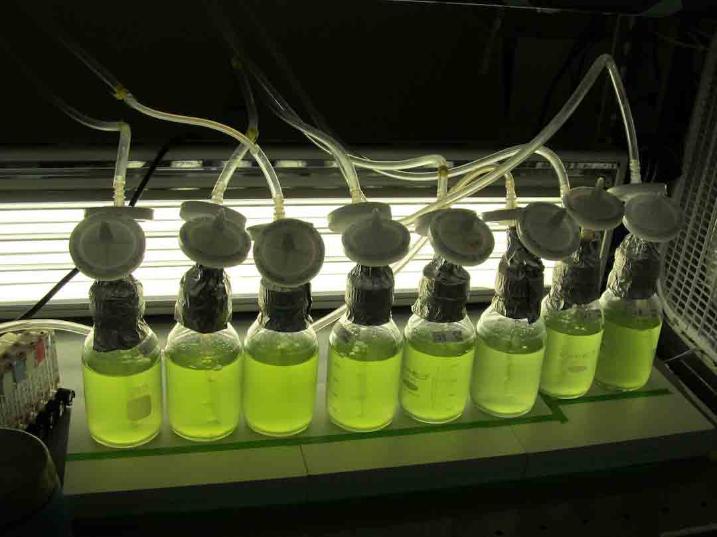
- MINERAL CONTENTS: High mineral content, up to five percent of the wet material, in which all the mineral elements important in human and animal physiology are found, makes sea weeds a unique supplement for a well balanced diet.
- AS A SOURCE OF VITAMINS: The marine algae are the richest source of vitamins. The vitamins A, B and E are found abundantly in sea weeds. The vitamin B essentially required for the development of human body is found in great abundance in almost all phaeophyceae.

- A UNICELLULAR FORM OF ALGAE: Unicellular algae are plant like autotrophs and contain chlorophyll. They include groups that have both multicellular and unicellular species. Diatoms, unicellular algae that have siliceous cell walls. They are the most abundant form of algae in the ocean, although they can be found in fresh water as well. We also have chlamydomonas which represents the unicellular and module form of green algae. It is found in stagnant water
- REPRODUCTION: Reproduction can either be vegetative (asexual) or sexual. The vegetative reproduction results in daughter cells because the genetic materials contained in the mother cells are maintained in the daughter cells. While the sexual reproduction involves the mating and this pairing is isogamous because the gametes are morphologically identical.
- DIFFERENCE BETWEEN THE TWO COLONIAL FORMS OF ALGAE:
- VOLVOX:
- Its sexual reproduction is oogamus.
- It has a multicellular motile thallus.
- Its complex form is pandorina.
- PANDORINA
- Its sexual reproduction is anisogamous.
- It has a unicellular motile thallus.
- It’s a genus of green algae.
- A COMPLEX FORM OF ALGAE:
- FUCUS: it’s a genus of the brown algae which are found in rocks of the sea shores. The body of the plant is flattened, dichotomously-branched thallus with a mid rib. The body has air bladders which aids the plant to float. It varies in size from a few centimeters to about 2 meters in length.

