NAME: OKOR PRECIOUS EIKHOMUN
MATRIC NO: 17/MHS01/248
DEPARTMENT: PHARMACOLOGY
COURSE CODE: BCH 204

- Describe the three stages of beta oxidation (show pathway where necessary)

ANSWER

Fatty acids provide highly efficient energy storage, delivering more energy per gram than carbohydrates like glucose. In tissues with high energy requirement, such as heart, up to 50–70% of energy, in the form of ATP production, comes from fatty acid (FA) beta-oxidation.
During fatty acid β-oxidation long chain acyl-CoA molecules – the main components of FAs – are broken to acetyl-CoA molecules.
- Fatty acid transport into mitochondria
Fatty acids are activated for degradation by conjugation with coenzyme A (CoA) in the cytosol. The long-chain fatty-acyl-CoA is then modified by carnitine palmitoyltransferase 1 (CPT1) to acylcarnitine and transported across the inner mitochondrial membrane by carnitine translocase (CAT). CPT2 then coverts the long chain acylcarnitine back to long-chain acyl-CoA before beta-oxidation.
- Beta-oxidation
Beta-oxidation consists of four steps:
1) Dehydrogenation catalyzed by acyl-CoA dehydrogenase, which removes two hydrogens between carbons 2 and 3.
2) Hydration catalyzed by enoyl-CoA hydratase, which adds water across the double bond.
3) Dehydrogenation catalyzed by 3-hydroxyacyl-CoA dehydrogenase, which generates NADH.
4) Thiolytic cleavage catalyzed beta-ketothiolase, which cleaves the terminal acetyl-CoA group and forms a new acyl-CoA which is two carbons shorter than the previous one.
The shortened acyl-CoA then reenters the beta-oxidation pathway.
- 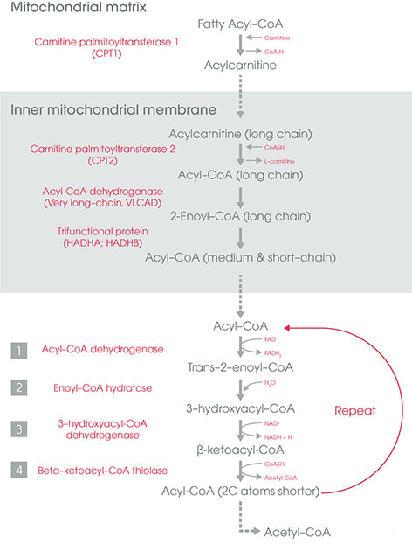Schematic diagram of fatty acid transport and beta-oxidation in the mitochondria. Click on image to enlarge.
- ATP synthesis
Acetyl-CoA generated by the beta-oxidation pathway enters the mitochondrial TCA cycle, where is further oxidized to generate NADH and FADH₂. The NADH and FADH₂ produced by both beta oxidation and the TCA cycle are used by the mitochondrial electron transport chain to produce ATP. Complete oxidation of one palmitate molecule (fatty acid containing 16 carbons) generates 129 ATP molecules.

