**MATRIC NUMBER: 17/MHS01/314**

**NAME: UMOH EDIDIONG ENOBONG**

**DEPARTMENT: MECHANICAL ENGINEERING**

**COURSE: ENGINEERING DRAWING ENG232**

ENG 232 QUESTIONS

1. How do you represent a sectioned surface on a drawing?

ANS: thin lines are made pattern similar to hatching at 45 degrees to the horizontal on the surface that is sectioned.

1. List out the various principles to be followed while dimensioning a drawing.

ANS:

* The dimension lines are continuous thin lines.
* Arrow Head should be appropriately triangular in shape and darkened.
* Dimension lines should be at least 2mm from the drawing.
* Dimensions are to be in the left hand side of the dimension lines.

1. Explain the terms, (*a*) half section, (*b*) Full section

ANS:

(a)Half section – A view of an object showing one half of the view in section. A center line is used to separate the sectioned half from the u sectioned half of the object.

(b)Full section – An imaginary cutting plane passes through the entire object, splitting the drawn object in two with the purpose of revealing the interior of the object. It is the most widely-used sectional view.

1. How are leader lines terminated?

ANS: leader line are terminated on a short horizontal bar below the lettering of a note while the head end of leader line can be terminated with : a dot within the outline of the object, an arrow head on the outline of an object or without a dot or an arrow head on a dimension line.

1. What do you understand by, (a) scale = 5:1 and (b) scale = 1:10?

ANS: (a) A drawing 5 times more than it’s original size. (b) A drawing 10 times less than it’s original size.

1. Give the shape identification symbols for the following: (*a*) diameter, (*b*) radius, (*c*) square and (*d*) spherical radius.
2. Centre line, (*b*) cutting plane line and (*c*) long break

ANS: (a) ∅

(b)R

(c)

(d)SR

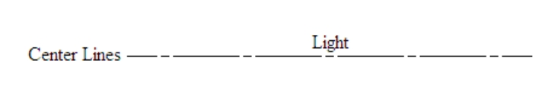(e)

(f)

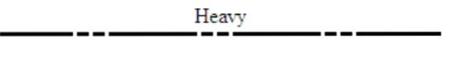

(g)

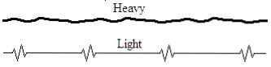

1. What are the elements to be considered while obtaining a projection and what is an orthographic projection?

ANS: an orthographic projection is a 2-Dimensional drawing that represents a 3-Dimensional object showing the plan, side and front views.

1. When is a projection of an object called an orthographic projection?

ANS: when all perspective is eliminated.

1. Explain the following, indicating the symbol to be used in each case: (*a*) First angle projection, (*b*) Third angle projection

ANS:

* 1. First angle projection

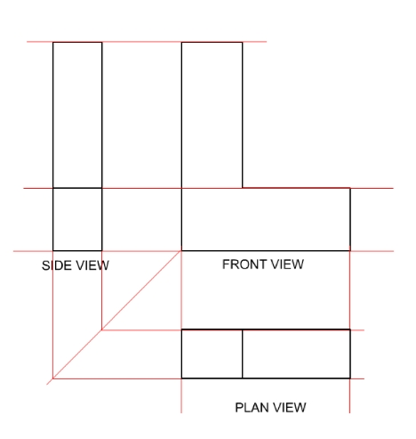This is a method of drawing an orthographic projection that is mostly used in Europe.

* 1. Third angle projection

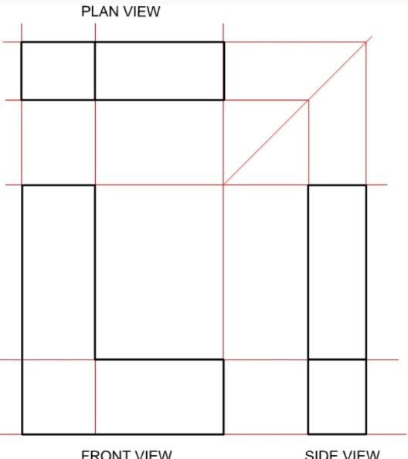This method of orthographic projection differs from the first due to the position of the different views.

Objectives

1. To project the auxiliary view, an imaginary plane known as ……………….
2. Reference Plane
3. Principle plane
4. Normal plane
5. Inclined plane
6. Reference plane is parallel to the direction of view
7. True
8. False
9. Dimension of one side of the inclined surface can be………………projected on the reference plane
10. Indirectly
11. Equally
12. Directly
13. Normally
14. In isometric projection the three edges of an object are inclined to each other at

(a) 60o (b) 120o (c) 100o (d) 90o

5. The angle between the flanks of a metric thread is

(a)60o (b) 90o (c) 75o (d) 55o

6. Which one among the following represents a permanent fastener

a) Nut b) Rivet c) Screw d) Bolt

7. The convexity provided on the rim of the solid web cast iron pulley is called

a) Bending b) Curving c) Crowning d) Riveting

8. Section lines are generally inclined with the base, at an angle of

a) 30o b)45o c)60o d)90o

9. The isometric view of a sphere is always

a) a circle b) an ellipse c) a Parabola d) a Semicircle

10. In isometric projection, the four center method is used to construct

a) an ellipse b) a square c) a triangle d) a rectangle

11



12



13. A footstep bearing is a

a) journal bearing b) thrust bearing c) pivot bearing d) pedestal bearing

14. The angle between the flanks of B.S.W. thread is

a) 60o b) 65o c) 55o d)75o

15. Top view is projected on the

a) Vertical Plane b) Corner Plane c) Side Plane d) Horizontal Plane