NAME: IRERUKE EMMANUELLA OGHENETEGA
MATRIC NO: 17/MHS01/163
LEVEL: 300
DEPARTMENT: MBBS
COURSE CODE: ANA 305
COURSE TITLE: HISTOLOGY OF SPECIAL SENSES AND NEUROHISTOLOGY
1. Write an essay on the histological importance of eye in relation to their cellular functions.
The eye is a complex and highly developed photosensitive organ that permits an accurate analysis of the form, light intensity, and color reflected from objects. Each eye is composed of three concentric layers: an external layer that consists of the sclera and the cornea; a middle layer also called the vascular layer consisting of the choroid, ciliary body, and iris; and an inner layer of nerve tissue, the retina, which consists of an outer pigment epithelium and an inner retina proper. The photosensitive retina proper is part of the central nervous system and communicates with the cerebrum through the optic nerve and extends forward to the ora serrata.
A histological understanding of the layers of the eye is essential for appreciating disease pathophysiology and also understanding certain therapeutic approaches. Broadly, from an anatomical perspective, the eye can be viewed as a series of overlapping layers of tissue.

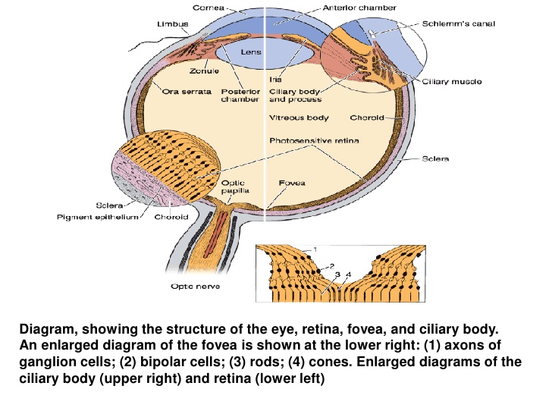
Now, we are going to discuss the histological layers of the eye with the aid of diagrams.
- The outermost layer: Sclera and Cornea
- THE SCLERA (White of the Eye): The sclera consists of tough, dense connective tissue made up mainly of flat collagen bundles intersecting in various directions while remaining parallel to the surface of the organ, a moderate amount of ground substance, and a few fibroblasts. The external surface of the sclera, the episclera is connected by a loose system of thin collagen fibers to a dense layer of connective tissue called Tenon's capsule. Tenon's capsule comes into contact with the loose conjunctival stroma at the junction of the cornea with the sclera. Between the sclera and the choroid is the suprachoroidal lamina, a thin layer of loose connective tissue rich in melanocytes, fibroblasts, and elastic fibers.
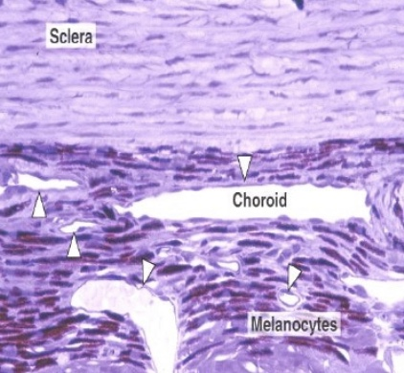
Section of choroid and sclera. The choroid is a highly vascular layer (arrowheads) of connective tissue containing melanocytes that prevent the reflection of incident light. The sclera is a dense layer of connective tissue rich in fibers of collagen type I, arranged in parallel bundles.
The outer layer, or sclera, consists of dense fibrous connective tissue. – The sclera is "white" of the eye. The sclera is continuous with the transparent substantia propria of the cornea. The exposed front surface of the eye, including the cornea, is also covered by a thin, non-keratinized stratified squamous epithelium.
- The Cornea: It is colorless and transparent. Consists of type I collagen fibers oriented in a uniform parallel direction to maintain transparency. It consists of five layers: epithelium, Bowman's membrane, stroma, Descemet's membrane, and endothelium. The corneal epithelium is stratified, squamous, and nonkeratinized and consists of five or six layers of cells. In the basal part of the epithelium are numerous mitotic figures that are responsible for the cornea's remarkable regenerative capacity. The surface corneal cells show microvilli protruding into the space filled by the precorneal tear film. This epithelial tissue is covered by a protective layer of lipid and glycoprotein, about 7m thick. The cornea has one of the richest sensory nerve supplies of any eye tissue.
Furthermore, we will discuss the various layers present in the cornea.
• The Bowman's membrane: consists of collagen fibers crossing at random,
a condensation of the intercellular substance, and no cells. Bowman's membrane
contributes greatly to the stability and strength of the cornea. It is composed of type 1 collagen, lamina, and several other heparin sulfate proteoglycans.
• The stroma: The largest layer of the cornea. It is formed of many layers of parallel collagen bundles that cross at approximately right angles to each other. The collagen fibrils within each lamella
are parallel to each other and run the full width of the cornea. Between the several
layers, the cytoplasmic extensions of fibroblasts are flattened like the wings of a
butterfly. The function of this layer is to maintain transparency, which occurs by the regular arrangement, and lattice structure of the fibrils.
• Descemet's membrane: is a thick homogeneous structure composed of fine
collagenous filaments organized in a three-dimensional network. It is made of type IV collagen that serves as a modified basement membrane of the corneal endothelium
•The endothelium: of the cornea is a simple squamous epithelium. These cells
possess organelles for secretion that are characteristic of cells engaged in active
transport and protein synthesis and that may be related to the synthesis and
maintenance of Descemet's membrane.
•The corneal endothelium and epithelium : are responsible for maintaining the transparency of the cornea. Both layers are capable of transporting sodium ions
toward their apical surfaces. Chloride ions and water follow passively, maintaining
the corneal stroma in a relatively dehydrated state. This state, along with the
regular orientation of the very thin collagen fibrils of the stroma, accounts for the
transparency of the cornea.
NB: The corneoscleral junction, or limbus, is an area of transition from
the transparent collagen bundles of the cornea to the white opaque
fibers of the sclera. It is highly vascularized, and its blood vessels
assume an important role in corneal inflammatory processes.
• The cornea, an avascular structure, receives its metabolites by
diffusion from adjacent vessels and from the fluid of the anterior
chamber of the eye.
• In the region of the limbus in the stromal layer, irregular endotheliumlined channels, the trabecular meshwork, merge to form Schlemm's
canal, which drains fluid from the anterior chamber of the eye.
Schlemm's canal communicates externally with the venous system.
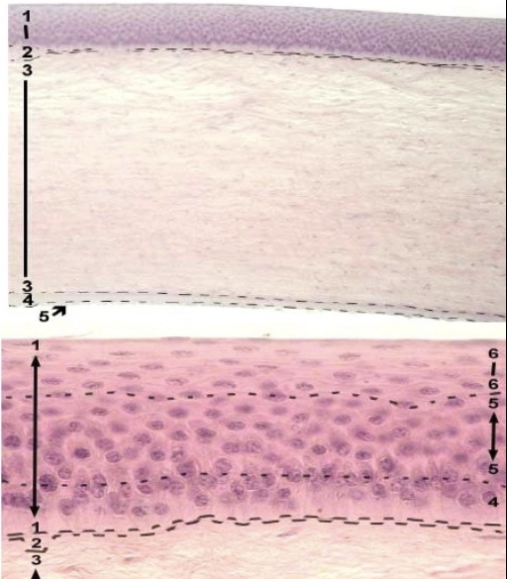

From the diagram above, you can appreciate: 1 - anterior epithelium (stratified squamous epithelium) 2 - anterior basement (Bowman's) membrane 3 - substantia propria 4 - posterior basement (Descemet's) membrane 5 - posterior epithelium (simple squamous or endothelium)

- Middle Layer: Uvea (Iris, Ciliary Body, Choroid):
• The middle (vascular) layer of the eye consists of three parts: choroid, ciliary body, and iris, known collectively as the uveal tract
- The Cilliary Body: The ciliary body contains ciliary muscle that is composed of smooth muscle. Contraction and relaxation of the ciliary muscles change the tension of the zonular fibers or suspensory ligaments of the lens. This allows the lens to change shape, a process known as accommodation. The ciliary processes are folds of connective tissue that are covered by two layers of epithelium. There is also a complex vasculature that cannot be seen easily. Fluid from these vessels is processed and transported by the epithelial cells to the posterior chamber as aqueous humor. The epithelial cells constitute the blood-aqueous barrier.
The aqueous humor enters the anterior chamber through the pupil as it flows between the lens and the iris. - Aqueous humor leaves the anterior chamber through the trabecular meshwork and into the canal of Schlemm. Obstruction of the trabecular meshwork and canals of Schlemm are thought to be the major cause of elevated intraocular pressure, which could then lead to glaucoma.
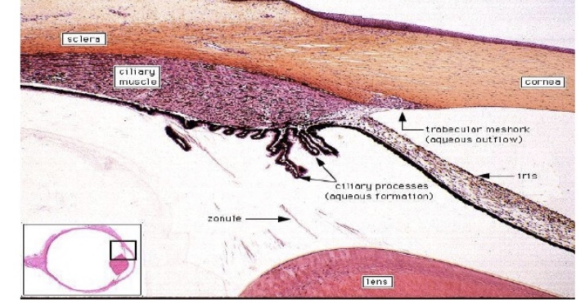
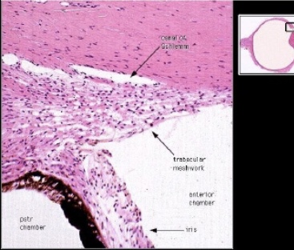
From the diagram above we can appreciate the cilliary body and its process
- The Iris: The anterior surface of the iris contains loose, variably pigmented stroma. It is open to the circulating aqueous humor within the anterior chamber. Two layers of heavily pigmented epithelium cover the posterior surface of the iris. Note that the sphincter pupillae muscle can be easily seen near the pupil margin. It is smooth muscle controlled by parasympathetics. The dilator pupillae muscle is more difficult to identify, but it dilates the pupil upon sympathetic innervation. The pigmented layer of cells blocks rays of light and ensures that light must move through the pupil to reach the retina.The angle formed by the iris and cornea contains connective tissue with endothelial channels called the trabecular meshwork, which drains aqueous humor in the anterior chamber into the venous canal of Schlemm[8]. From here, fluid drains into episcleral veins.

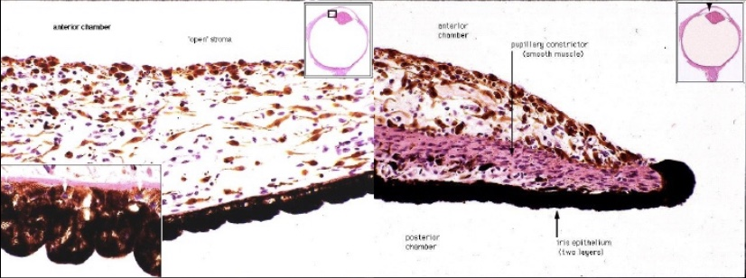
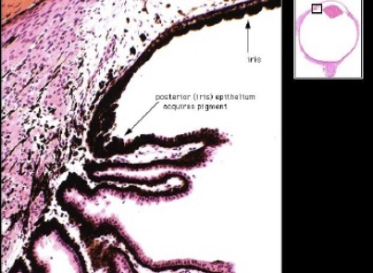
A Diagram of the Showing the Iris and Relatable structures
- Choroid:
Consists of a dense network of blood vessels supplying nourishment to structures of the eye, housed in loose connective tissue.The choriocapillary layer is located in the innermost part of the choroid and supplies the retinaThe Bruch membrane is an extracellular matrix layer situated between the retina and choroid and has significance in age-related macular degeneration, where an accumulation of lipid deposits prevent diffusion of nutrients to the retina.

(C) Innermost layer: Lens, Vitreous, Retina:
1) The Lens: The lens consists of a lens capsule, the subcapsular epithelium and lens fibres. It does not contain blood vessels or nerves. The lens separates the aqueous and vitreous chamber It consists of an outer capsule, a middle layer called cortex, and an inner layer called the nucleus.
- The capsule is the basement membrane of the lens epithelium which lies below
- New lens cells differentiate from the lens epithelium and are incorporated peripherally, pushing older lens cells towards the middle.
2. Vitreous: a jelly-like space made of type II collagen separating the retina and the lens
3. Retina: nervous tissue of the eye where photons of light convert to neurochemical energy via action potentials
Moreover, the retina itself is divided into various layers as follows:
Retinal pigment epithelium: made of cuboidal cells containing melanin which absorbs light. These cells also establish a blood-retina barrier through tight junctions.
Rod and cone cells: the layer of cells with photoreceptors and glial cells. Rods are located peripherally and are more sensitive to light and motion than cones. Cones have higher visual acuity and specificity for color vision.
- Outer limiting membrane: a layer of Muller cells and rod/cone junctions which serves to separate the photosensitive regions of the retina from the areas that transmit the electrical signals.
- Outer nuclear layer: This layer consists of nuclei of rod and cone cells.
- Outer plexiform layer: This layer contains synaptic processes of rod and cone cells.
- Inner nuclear layer: This layer contains the cell body of glial, amacrine, bipolar, and horizontal cells
- Inner plexiform layer: This layer relays information from cells of the inner nuclear layer. Thus, this layer has axons of amacrine, bipolar, and glial cells and dendrites of retinal ganglion cells.
- Ganglion cell layer: This layer contains nuclei of retinal ganglion cells.
- Nerve fiber layer: This layer contains axons of retinal ganglion cells and the astroglia which support them. Collectively, these axons constitute the optic nerve.
- Internal limiting membrane: A thin layer of Muller glial cells and basement membrane which demarcates the vitreous anteriorly from the retina posteriorly.[15]
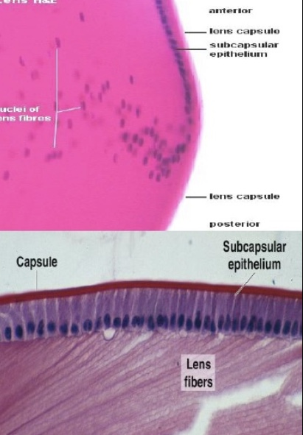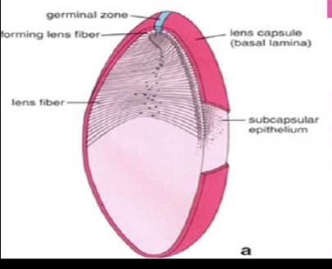

Functions of the cellular structures of the eye
The layers of the eye perform distinct functions which coalesce to create a unified, perceptual experience. The essential role of the external eye structures is to protect the delicate tissue of the internal eye. The eyelid prevents foreign bodies from entering the inner eye and helps refresh and distribute the tear film by blinking. Eyelashes are finely sensitive to touch and warn the eye of possible debris and particles that may cause injury.
Internal parts of the eye have primarily structural and visual functions. The cornea serves a protective role and is responsible for two-thirds of the refractive properties of the eye. The remaining one-third of refraction is performed by the lens, which is functionally adjustable through the action of the zonular fibers and ciliary muscles. At the end of the visual process, as rays of light bend through the cornea and lens, photon energy is converted to neurochemical action potentials by cells of the retina, which then send these impulses to the brain, via the optic nerve.
The uvea of the eye is a crucial mediator of nutrition and gas exchange, as blood vessels course through the ciliary body and iris, while the choriocapillaris in the posterior eye help support the retina. This abundant blood supply is implicated in uveitis, as inflammatory mediators enter the eye through this vascular network.

Clinical Significance
Several of the most common diseases of the eye are manifestations of pathology within specific histological layers. Below are examples of common eye conditions, and the layers of the eye implicated.
- Chalazion : A sterile lump often in the upper eyelid caused by obstruction of the meibomian oil glands.
- Conjunctivitis: Inflammation of the transparent conjunctiva that may be caused by bacterial or viral infections, allergies, or exposure to certain chemicals.
- Cataracts: A sclerotic nuclear cataract is the most common and is due to opacification in the central nucleus of the lens. Cortical cataracts are due to opacifications in the cortex and have a distinct wedge-shaped appearance. Posterior subcapsular cataracts arise from behind the sac-like structure of the lens.
- Glaucoma: Refers to optic nerve damage related to increased intraocular pressure. Drainage of aqueous humor through the trabecular meshwork is often implicated.
- Age-related macular degeneration: A progressive eye disease causing damage to the macula or central portion of the retina. Accumulation of drusen, or lipid-laden deposits in Bruch’s membrane of the retina, is associated with disease severity.
- Fuchs Dystrophy: A disease of the corneal endothelium, that causes accumulation of excess edema in the corneal stroma. Progression of the disease often causes blisters in the eye, also referred to as bullous keratopathy.
- Floaters: The sensation of floaters is due to changes that occur in the jelly-like vitreous layer of the eye.
- Retinal detachment: It occurs when the outer pigment epithelial layer separates from the inner neurosensory layer consisting of rods and cones; this is a vision-threatening condition as the neurosensory layer is unable to receive nutrients from the underlying choriocapillaris and retinal pigment epithelium.

2. Corona virus can penetrate the body through eye and implicate the immune system.
Expalin:
According to the American Optometric Association (AOA), the coronavirus might enter your body through the conjunctiva and then spread throughout your body through blood vessels within the conjunctiva. One of the primary functions of the conjunctiva is to protect the eye from dust, debris and infection-causing microorganisms. The passage through which germs and other organism can enter the body through the eye (conjunctiva) is through the blood-ocular barrier. The blood ocular barrier prevents the entry of lethal substances and maintains homeostasis to protect the eye. The blood-aqueous barrier (BAB) and the blood-retinal barrier (BRB) constitute the blood-ocular system. The blood-aqueous barrier (BAB) is the anterior barrier of the eye that is composed of endothelial cells of blood vessels in the iris and the non-pigmented cell layer of the ciliary epithelium. The blood-retinal barrier (BRB) is the posterior barrier comprised of retinal pigment epithelium and endothelium cells of retinal blood vessels (inner barrier) with non-leaky tight junctions. It limits the movement of substances after systemic and periocular application to the retina.
Therefore, when the virus passes through this barrier, it can make its way through the rest of the body.

  - Briefly discuss the layers of retina for information penetration
The retina is said to have 10 layers, which are:
- Inner limiting membrane – basement membrane elaborated by Müller cells.
- Nerve fibre layer – axons of the ganglion cell bodies (note that a thin layer of Müller cell footplates exists between this layer and the inner limiting membrane).
- Ganglion cell layer – contains nuclei of ganglion cells, the axons of which become the optic nerve fibres, and some displaced amacrine cells.^{[2]}
- Inner plexiform layer – contains the synapse between the bipolar cell axons and the dendrites of the ganglion and amacrine cells.^{[2]}
- Inner nuclear layer – contains the nuclei and surrounding cell bodies (perikarya) of the amacrine cells, bipolar cells, and horizontal cells.^{[2]}
- Outer plexiform layer – projections of rods and cones ending in the rod spherule and cone pedicle, respectively. These make synapses with dendrites of bipolar cells and horizontal cells.^{[2]} In the macular region, this is known as the Fiber layer of Henle.
- Outer nuclear layer – cell bodies of rods and cones.
- External limiting membrane – layer that separates the inner segment portions of the photoreceptors from their cell nuclei.
- Inner segment / outer segment layer – inner segments and outer segments of rods and cones. The outer segments contain a highly specialized light-sensing apparatus.^{[14][15]}
- Retinal pigment epithelium – single layer of cuboidal epithelial cells (with extrusions not shown in diagram). This layer is closest to the choroid, and provides nourishment and supportive functions to the neural retina, The black pigment melanin in the pigment layer prevents light reflection throughout the globe of the eyeball; this is extremely important for clear vision.^{[16][17][18]}

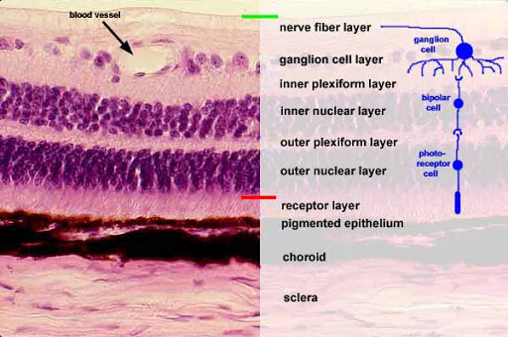
A DIAGRAM SHOWING THE LAYERS OF THE RETINA

