NAME: OLONIYO SIMILOLUWA GRACE
MATRIC NUMBER:19/mhs02/132
NURSING
200LEVEL
PHYSIOLOGY ASSIGNMENT
PHS 212

WRITE SHORTS NOTES ON THE FOLLOWING.
SPERMATOGENESIS.
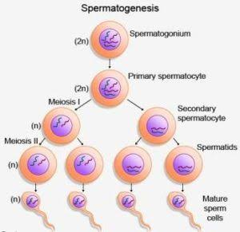
Spermatogenesis is the process by which haploid spermatozoa develop from germ cells in the seminiferous tubules of the testis. This process starts with the mitotic division of the stem cells located close to the basement membrane of the tubules.[1] These cells are called spermatogonial stem cells. The mitotic division of these produces two types of cells. Type A cells replenish the stem cells, and type B cells differentiate into primary spermatocytes. The primary spermatocyte divides meiotically (Meiosis I) into two secondary spermatocytes; each secondary spermatocyte divides into two equal haploid spermatids by Meiosis II. The spermatids are transformed into spermatozoa (sperm) by the process of spermiogenesis. These develop into mature spermatozoa, also known as sperm cells.[2] Thus, the primary spermatocyte gives rise to two cells, the secondary spermatocytes, and the two secondary spermatocytes by their subdivision produce four spermatozoa and four haploid cells.[3]
The image above represents the process of spermatogenesis.

TESTOSTERONE
This is the primary male sex hormone and anabolic steroid. In male humans, testosterone plays a key role in the development of male reproductive tissues such as testes and prostate, as well as promoting secondary sexual characteristics such as increased muscle and bone mass, and the growth of body hair. In addition, testosterone is involved in health and well-being and the prevention of osteoporosis. Insufficient levels of testosterone in men may lead to abnormalities including frailty and bone loss.
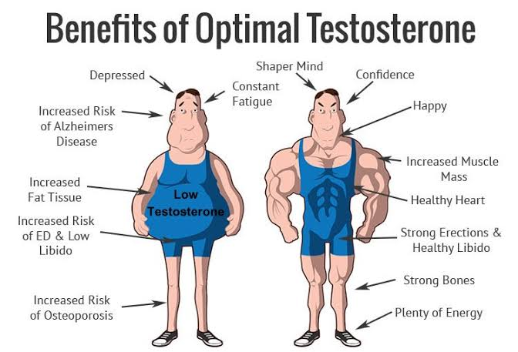
If a male has a low level of testosterone, the symptoms can include erectile dysfunction, and reduced bone mass and sex drive. The hormone has many important functions, including: the development of the bones and muscles. the deepening of the voice, hair growth, and other factors related to appearance

Testosterone is a sex hormone that plays important roles in the body. In men, it's thought to regulate sex drive (libido), bone mass, fat distribution, muscle mass and strength, and the production of red blood cells and sperm. A small amount of circulating testosterone is converted to estradiol, a form of estrogen.

SEMEN
Semen, also known as seminal fluid, is an organic fluid that contains spermatozoa. It is secreted by the gonads (sexual glands) and other sexual organs of male or hermaphroditic animals and can fertilize the female ovum.
Sperm is just one of the many components of semen, though, arguably the most vital. The other elements are there to help aid the sperm in getting to its end goal: an egg. These other parts help the sperm by assisting with its mobility, lubrication, and even reducing the resistance of the egg to the sperm (yes, eggs fight against the sperm
A typical male can produce anywhere from 2 – 6 mL of semen when ejaculating. For comparison, a US teaspoon is about 5 mL, so a guy’s jazz can be about half or a little more than the amount of vanilla extract you put into cookies. *Disclaimer: We don’t advise adding this secret

MALE ORGASM.
What is orgasm?
Orgasm: A series of muscle contractions in the genital region that is accompanied by sudden release of endorphins. Orgasm normally accompanies male ejaculation as a result of sexual stimulation, and it also occurs in females as a result of sexual stimulation.
. The steps that lead a man to successful orgasm include:

Arousal The man perceives something or someone that prompts sexual interest. That perception prompts the brain to send a signal down the spinal cord to the sex organs, causing an erection. The penis becomes erect when blood fills spongy tissue inside its shaft, brought by arteries that have expanded to allow blood to race in at up to 50 times its normal speed. The veins in the penis that normally drain blood out squeeze shut so that more blood remains inside, producing a firm erection. The scrotum pulls toward the body, and muscles throughout the body increase in tension.
Plateau The male body prepares for orgasm in this phase, which can last from 30 seconds to 2 minutes. Muscle tension increases even more and involuntary body movements, particularly in the pelvis, begin to take over. The man's heart rate increases to between 150 and 175 beats per minute, says Ingber. A clear fluid may begin to flow from the urethra. This pre-ejaculatory fluid is meant to change the pH balance of the urethra, to improve the chances of sperm survival.
Orgasm The orgasm itself occurs in two phases, emission and ejaculation. In emission, the man reaches ejaculatory inevitability, the "point of no return." Semen is deposited near the top of the urethra, ready for ejaculation. Ejaculation occurs in a series of rapid-fire contractions of the penile muscles and around the base of the anus. Involuntary pelvic thrusting may also occur. The nerves causing the muscle contractions send messages of pleasure to the man's brain.
Resolution and refraction After ejaculation, the penis begins to lose its erection. About half of the erection is lost immediately, and the rest fades soon after. Muscle tension fades, and the man may feel relaxed or drowsy, according to Ingber. Men usually must undergo a refractory period, or recovery phase, during which they cannot achieve another erection. This period is variable in men, says Ingber. In an 18-year-old, this is typically less than 15 minutes. In elderly men, it can be up to 10 to 20 hours. The average refractory period is about half an hour. Men differ from women in that men usually are satiated after one orgasm. Women can experience more than one orgasm with no loss of sexual arousal, and do not have to undergo a refractory period.

MALE INFERTILITY.
Male infertility refers to a male's inability to cause pregnancy in a fertile female. In humans it accounts for 40–50% of infertility.It affects approximately 7% of all men. Male infertility is commonly due to deficiencies in the semen, and semen quality is used as a surrogate measure of male fecundity. The main symptom of infertility is not getting pregnant. There may be no other obvious symptoms. Sometimes, a woman with infertility may have irregular or absent menstrual periods. In some cases, a man with infertility may have some signs of hormonal problems, such as changes in hair growth or sexual function.

Most couples will eventually conceive, with or without treatment.

When to see a doctor

Have been diagnosed with endometriosis or pelvic inflammatory disease
Have had multiple miscarriages
Have undergone treatment for cancer
Men should talk to a doctor if they have:

A low sperm count or other problems with sperm
A history of testicular, prostate or sexual problems
Undergone treatment for cancer
Small testicles or swelling in the scrotum
Others in your family with infertility problems

