ENG 232 QUESTIONS

1. How do you represent a sectioned surface on a drawing?

Ans:

You represent a sectioned surface by shading the surface with thin lines inclined to the base of the drawing at a 45° angle.

1. List out the various principles to be followed while dimensioning a drawing.

Ans:

* Thin continuous lines only are used for dimensioning.
* Dimensioning lines should not touch the drawing.
* Dimensioning lines should all be spaced equally from the drawing.

1. Explain the terms, (*a*) half section, (*b*) Full section

Ans:

Half section is used to expose the interior of one half of an object while retaining the exterior of the other half. Half sections are used mainly for symmetric objects or assembly drawings. A center line is used to separate the two halves. Hidden lines should not be shown on either half. An example is shown in the illustration below;

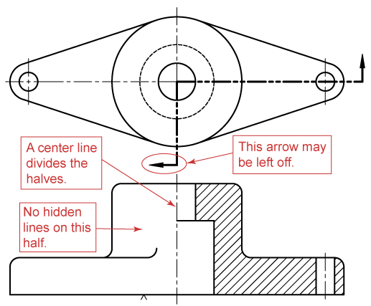

Full section is obtained when an imaginary cutting plane passes clean through an object, splitting it in two with the interior of the object revealed. It is the most common type of sectioning in engineering drawing. An illustration of full sectioning is shown below;

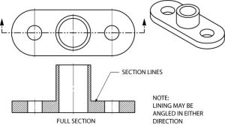

1. How are leader lines terminated?

Ans:

Leader lines are terminated with arrow heads.

1. What do you understand by, (a) scale = 5:1 and (b) scale = 1:10?

Ans:

A scale of 5:1 suggests that the object is 5 times as large in the drawing, as it is in real life. For example, a 5cm line in the drawing is only 1cm long in real life.

A scale of 1:10 suggests that the object is 10 times as large in real life, as it is in the drawing. As such, a 10cm line on paper would represent a 100cm line in real life.

1. Give the shape identification symbols for the following: (*a*) diameter, (*b*) radius, (*c*) square and (*d*) spherical radius.
2. Centre line, (*b*) cutting plane line and (*c*) long break

Ans:

Diameter: ∅

Radius: R

Square:

Spherical radius: SR

1. What are the elements to be considered while obtaining a projection and what is an orthographic projection?

Ans:

Elements that are considered when trying to obtain a projection include; the plan, the end(side) elevation and the front elevation.

An orthographic projection is a way of representing three dimensional objects in two dimensions. This is achieved by drawing the plan(top), front and side views of the object so a person can observe at one glance all the important sides for the drawing.

1. When is a projection of an object called an orthographic projection?

Ans:

A projection is said to be orthographic when; it is drawn in 2-D, and the front, plan and end elevations are drawn separately with parallel lines joining the three together.

1. Explain the following, indicating the symbol to be used in each case: (*a*) First angle projection, (*b*) Third angle projection

Ans:

The first angle projection is deployed mainly in Europe. In this projection, the object is placed in the first quadrant, that is, between the plan of projection and the observer. Basically, the front elevation is drawn in the first quadrant. The plan is drawn in the second and the end elevation is drawn beside the front elevation in the fourth vquadrant.

The third angle projection is used in The United States. Here, the object is placed in the third quadrant. The plane of projection is between the observer and the object(The plane of projection is transparent). Basically, the front elevation is drawn in the third quadrant, the plan is drawn in the fourth quadrant above the front elevation. The side elevation is drawn in the second quadrant.

|  |  |  |
| --- | --- | --- |
|  |  |  |
|  |  |  |
|  | | |

Objectives

1. To project the auxiliary view, an imaginary plane known as ……………….

Ans: a) Reference Plane

1. Reference plane is parallel to the direction of view

Ans: b) False

1. Dimension of one side of the inclined surface can be………………projected on the reference plane

Ans: c) Directly

1. In isometric projection the three edges of an object are inclined to each other at

Ans: a) 60°

1. The angle between the flanks of a metric thread is

Ans: a) 60°

1. Which one among the following represents a permanent fastener

Ans: b) Rivet

1. The convexity provided on the rim of the solid web cast iron pulley is called

Ans: c) Crowning

1. Section lines are generally inclined with the base, at an angle of

Ans: b) 45°

1. The isometric view of a sphere is always

Ans: b) An ellipse

1. In isometric projection, the four center method is used to construct

Ans: a) An ellipse



Ans: c) Cylinder



Ans: a) Cone

1. A footstep bearing is a

Ans: c) Pivot bearing

1. The angle between the flanks of B.S.W. thread is

Ans: c) 55°

1. Top view is projected on the

Ans: d) Horizontal plane.