NAME: OGUEJI HANNAH EBUBECHUCKWU
COLLEGE: LAW
DEPARTMENT: LAW
MATRICULATION NUMBER: 19/LAW01/176
ASSIGNMENT: 1 What is family
2 Discuss the functions of the Family
3 Discuss the African Traditional family
4 Discuss your Nuclear family
5 Draw your family tree
ANSWER
- 'Family' is a single word, with many different meanings. People have many ways of defining a family and what being a part of a family means to them. Families differ in terms of economic, cultural, social, and many other facets. But generally, a family can be said to be a group of people that are related to each other by blood, marriage or adoption. A family, by definition, is a group of people affiliated by a specific relationship. Basically, the family is the most fundamental unit of social organization that with which we most intimately identify. Your family influences your personal, emotional, intellectual, and social development.

- First, the family is the primary unit for socializing children. No society is possible without adequate socialization of its young. In most societies, the family is the major unit in which socialization happens. Parents, siblings, and, if the family is extended rather than nuclear, other relatives all help to socialize children from the time they are born.
Secondly, the family is ideally a major source of practical and emotional support for its members. It provides them food, clothing, shelter, and other essentials, and it also provides them love, comfort, help in times of emotional distress, and other types of intangible support that we all need.
Thirdly, the family provides its members with a social identity. Children are born into their parents’ social class, race and ethnicity, religion, and so forth. As we have seen in earlier chapters, social identity is important for our life chances. Some children have advantages throughout life because of the social identity they acquire from their parents, while others face many obstacles because the social class or race and ethnicity into which they are born is at the bottom of the social hierarchy.
Fourthly, the family helps regulate sexual activity and sexual reproduction. All societies have norms governing with whom and how often a person should have sex. The family is the major unit for teaching these norms and the major unit through which sexual reproduction occurs. One reason for this is to ensure that infants have adequate emotional and practical care when they are born.
Other functions include, protection and care of the young, provision of a home, stable satisfaction of sexual needs (between husband and wife), procreation, religious functions, health functions, etc.

- Despite the changes taking place in sub Saharan African societies due to the modernization process, the family still remains a prominent central point in the social life of Africans. In Africa, there is considerable importance attached to the respect for elders and ancestor. African communities are characterized by the prevalence of collectivism as opposed to individuality. This means that the families live in large groups, sometimes including extended family members. The major characteristic features of African household is said to be that they are mostly rural, patriarchal and hierarchical, polygamous and open to kinship networks, and finally they attached substantial importance to lineage continuation. These features in all play a pivotal role in influencing the number of children women give birth to. The families are normally large, as this is the preference. The children are needed for work, especially in the farms. Male children are also generally preferred. The social organization of most African families is embedded in a patriarchal and hierarchical system that precludes the possibility of women, who generally have lower status than men in the society to make deliberate choice on the number of children they want to have. At marriage, women tend to have lower status than all the members of their husband’s family. In traditional rural societies in most sub Saharan societies, women were voiceless and powerless. Male supremacy has also being altered a bit even though it still has a prominent strong hold in the society. There is the existence of substantial cultural importance attributed to fertility and lineage continuation, tight patriarchal traditions, wide rate of polygamy prevalence. The women get married at very young ages. The men are also allowed to have many wives; as many as they can cater for. These are the prominent features that characterized most traditional African societies.
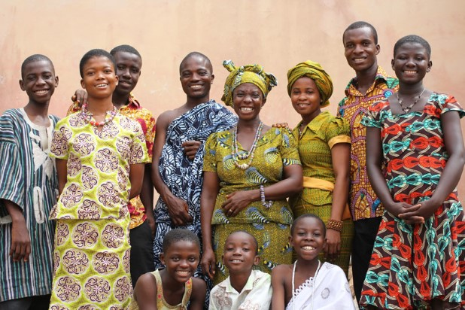
- In simple terms, a nuclear family system is a family structure that consists of two parents living with their children, also known as an immediate family. It simply consists of the father, mother and children. It is the opposite of extended family which consists of other members of the family such as the uncles, aunts, grandparents, cousins, etc. My nuclear family consists of my father, mother and three other siblings. Making us six in number. All the children are girls-we have no boy. We live together as of now as none of us children are old enough to live on our own. I’m the second born. The last two children are twins. We are a very simple family. We are a proper family as all the functions of family have been carried out.

Theresa Ogueji
Femby Ogueji
(Grandparents)

Chimezirim Ogueji
Chigozirim Ogueji
ME
Faith Ogueji

