NAME: OGBEBOR EHIZOGIE SUSSY
MATRIC NUM: 19/LAW01/173
COUSRE: INTRODUCTION TO SOCIOLOGY
COUSE CODE: SOC 102

FAMILY
A family is a group consisting of two parents and their children living as a unit, this unit is the smallest in the society. A family is a group of people related by blood or marriage. The term ‘family’ has several definitions, some structures are excluded from the first definition given due to childlessness or other variations on the family unit. Another definition is two or more people who share similar goals and values, have long term commitments to one another and reside in the same dwelling. According to sociologists, the family is an intimate domestic group of people related to one another by bonds of blood, sexual mating, or legal ties. It has been a very resilient social unit that has survived and adapted through time.
THE AFRICAN TRADITIONAL FAMILY
Some of the issues raised about the African traditional family is polygamy, clan and kinship, maternal and paternal family etc. It has challenging variations across the continent and they are caused by differences in tribal customs, history, geography, religion etc. polygamy is an act of an individual being married to more than one spouse. It is seen as wealth for a man to marry more than one wife and have many children. And in some cases a woman can marry more than one husband. In the African family, the first male child inherits all the wealth of the family, each member of the family his/her duties towards the family. It comprises of the father, mother, grand-parents, in most cases great grand-parents, uncles and aunties, children, cousins, niece, nephew and grand-children dwelling together as one family.

FUNCTIONS OF THE FAMILY
Important functions of the family includes:
- Procreation and rearing of children.
- Agent of socialization
- Secondary functions of the family ie economic, educational, religious, cultural, health and social functions.
- Love and care.
- Provision of a home.

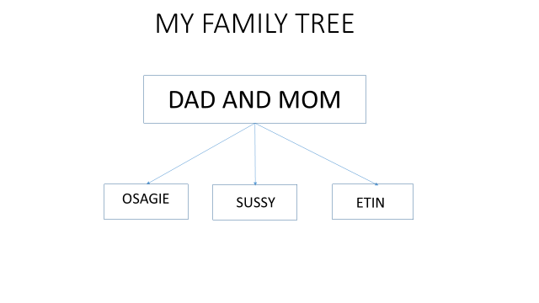My nuclear family
The name of my family is the Ogbebor Family. My family consists of my dad, Chief barrister Alex Ogbebor, my mom, Chief Mrs Phil Ogbebor, my elder brother, Osagie Ogbebor, myself, Sussy Ogbebor, and my younger brother, Etinosa Ogbebor. My father is 76 years old, he was born on the 24th of September, he is a retired lawyer and a stockbroker, he is from Benin city, Edo state. My mother is 46 years old, she is an educationist, she was born on the 20th of July, she hails from Delta state but was born and brought up in Lagos state. My brother, Osagie is 18 years old, he is a finance and business student in Brunel university London he was born on the 9th of December 2001. I am 16 years old, I am a law student at Afe Babalola University, I was born on the 25th of July 2003. My little brother is a student of Honeyland school, Lagos, he was born on the 30th of January 2005. We live together in VGC Lagos State, Nigeria.

