Nweke Chidera Ayomide
17/MHS06/047
MLS 300L

Beta-oxidation of Fatty Acid
Beta-oxidation is the catabolic process by which fatty acid molecules are broken down in the cytosol in prokaryotes and in the mitochondria in eukaryotes to generate acetyl-CoA.
Stages of beta oxidation
- Activation of fatty acids
In the cytosol of the cell, long-chain fatty acids are activated by ATP and coenzyme A, and fatty acyl-CoA is formed. Short-chain fatty acids are activated in mitochondria.
The ATP is converted to AMP and pyrophosphate (PPi), which is cleaved by pyrophosphatase to two inorganic phosphates (2 Pi). Because two high-energy phosphate bonds are cleaved, the equivalent of two molecules of ATP is used for fatty acid activation.
B. Transport of fatty acyl-CoA from the cytosol into mitochondria
Fatty acyl-CoA from the cytosol reacts with carnitine in the outer mitochondrial membrane, forming fatty acylcarnitine. The enzyme is carnitine acyltransferase I (CAT I), which is also called carnitine palmitoyltransferase I (CPT I). Fatty acylcarnitine passes to the inner membrane, where it re-forms to fatty acyl-CoA, which enters the matrix. The second enzyme is carnitine acyltransferase II (CAT II).
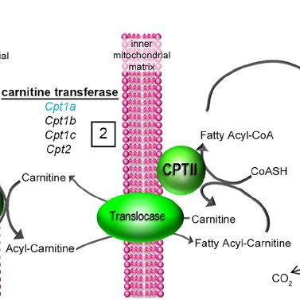
Carnitine acyltransferase I, which catalyzes the transfer of acyl groups from coenzyme A to carnitine, is inhibited by malonyl-CoA, an intermediate in fatty acid synthesis. Therefore, when fatty acids are being synthesized in the cytosol, malonyl-CoA inhibits their transport into mitochondria and, thus, prevents a futile cycle (synthesis followed by immediate degradation). Inside the mitochondrion, the fatty acyl-CoA undergoes beta-oxidation.
C. β-Oxidation of even-chain fatty acids
β-Oxidation (in which all reactions involve the β-carbon of a fatty acyl-CoA) is a spiral consisting of four sequential steps, the first three of which are similar to those in the TCA cycle between succinate and oxaloacetate. These steps are repeated until all the carbons of an even-chain fatty acyl-CoA are converted to acetyl-CoA.
FAD accepts hydrogens from a fatty acyl-CoA in the first step. A double bond is produced between the α- and β-carbons, and an enoyl-CoA is formed. The FADH2 that is produced interacts with the electron transport chain, generating ATP.
- Enzyme: Acyl-CoA dehydrogenase (Multiple variants of this enzyme)
- H2O adds across the double bond, and a β-hydroxyacyl-CoA is formed.
- Enzyme: Enoyl-CoA hydratase
- β -Hydroxyacyl-CoA is oxidized by NAD+ to a β-ketoacyl-CoA. The NADH that is produced interacts with the electron transport chain, generating ATP.
- Enzyme: L-3-hydroxyacyl-CoA dehydrogenase (which is specific for the L-isomer of the β-hydroxyacyl-CoA).
- The bond between the alpha and beta carbons of the β-ketoacyl-CoA is cleaved by a thiolase that requires coenzyme A. Acetyl-CoA is produced from the two carbons at the carboxyl end of the original fatty acyl-CoA, and the remaining carbons form a fatty acyl-CoA that is two carbons shorter than the original.
- Enzyme: β -ketothiolase
The shortened fatty acyl-CoA repeats these four steps. Repetitions continue until all the carbons of the original fatty acyl-CoA are converted to acetyl-CoA.

Oxidation of odd-chain and unsaturated fatty acids
Odd-chain fatty acids produce acetyl-CoA and propionyl-CoA.
These fatty acids repeat the four steps of the β-oxidation spiral, producing acetyl-CoA until the last cleavage when the three remaining carbons are released as propionyl-CoA. Propionyl-CoA, but not acetyl-CoA, can be converted to glucose.
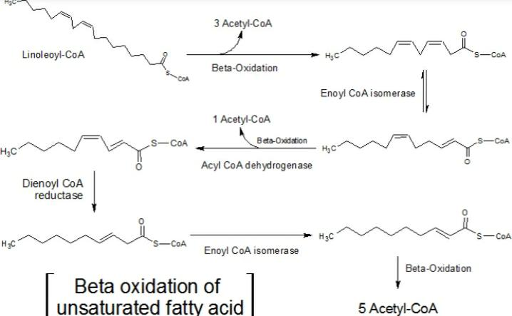
Unsaturated fatty acids, which comprise about half the fatty acid residues in human lipids, require enzymes in addition to the four that catalyze the repetitive steps of the β-oxidation spiral.
The reaction pathway differs depending on whether the double bond is at an even- or odd-numbered carbon position.
β -Oxidation occurs until a double bond of the unsaturated fatty acid is near the carboxyl end of the fatty acyl chain.
(1) If the double bond originated at an odd carbon number (such as 3, 5, 7, etc.), an isomerase will convert the eventual cis-Δ 3 to a trans-Δ 2 fatty acid.
(2) If the double bond originated at an even carbon number (such as 4, 6, 8, etc.), the eventual trans-Δ 2, cis-Δ 4 fatty acid will be reduced by a 2,4-dienoyl-CoA reductase, which requires NADPH and generates a trans-Δ 3-acyl-CoA and NADP1. The isomerase will convert the trans-Δ 3 fatty acyl-CoA to a trans-Δ 2 fatty acyl-CoA to allow β-oxidation to continue.
The overall reaction for one cycle of beta oxidation is:
Cn-acyl CoA + FAD + NAD+ + H2O + CoA → Cn-2-acyl CoA + FADH2 + NADH + H+ + acetyl CoA

