A
Term Paper
On
COMPONENTS OF THE AERIAL ENVIRONMENT
By
OLAOYE, OLUFUNBI JOSEPHINE
17/SCI05/009
Department of Microbiology
To
DR. ISITUA

MCB 308: Microbial Ecology
Afe Babalola University Ado-Ekiti
Ekiti State.

APRIL 2020

Contents
ABSTRACT 3
ATMOSPHERIC GASES 4
WATER VAPOR/WATER DROPLETS 4
DUST PARTICLES 5
POLLEN GRAINS 6
FUNGAL SPORES 7
Figure 2:Fungal spores 8
BACTERIAL SPORES 8
FUNGAL HYPHAL FRAGMENTS 9
ACTINOMYCETES AND THEIR SPORES 10
AEROPLANKTONS 11
SPORES OF BRYOPHYTES AND PTERIDOPHYTES 11
REFERENCES 13

ABSTRACT
Aeromicrobiology is the study of micro-organisms in the air. Micro-organisms are present in the air and have a major role in the transmission of some air-borne infectious diseases and the dispersal of microorganisms. The components of the aerial environment are varied and mostly include gases, pollen grains, fungal spores, aero planktons, bacterial spores, hyphal fragments, actinomycetes, spores of bryophytes and pteridophytes , suspended dust particles, water vapour etc.
These aerial components occur very numerously in the air and, on account of their dimensions (several micrometers), are classed as bioaerosols. They are always observed in natural air and their concentration changes depending on environmental conditions. Aeromicrobiolology investigates their occurrence in the air of the indoor-outdoor environment.

INTRODUCTION
The components of the aerial environment are varied and mostly include gases, pollen grains, fungal spores, aeroplanktons, bacterial spores, hyphal fragments, actinomycetes, spores of bryophytes and pteridophytes , suspended dust particles, water vapour etc. Because of the action of wind, the percent composition of air varies only slightly with altitude and location.

Components of aerial environment

ATMOSPHERIC GASES
Air is the commercial source for many of the gases it contains. The air around us is a mixture of gases, mainly nitrogen and oxygen, but containing much smaller amounts of water vapor, argon, and carbon dioxide, and very small amounts of other gases.
Gases %volume
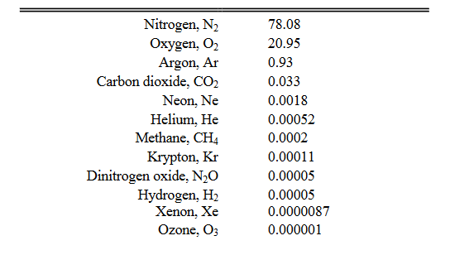

WATER VAPOR/WATER DROPLETS
Water vapor is the gaseous phase of water. It is one state of water within the hydrosphere. The water vapor concentration in the atmosphere varies from about 0.01% to 4.24% depending upon the temperature. When we respire we also release some amount of water vapor. In many chemical reactions, water vapor is evolved as a by-product. Apart from carbon dioxide and methane, water vapor also contributes to the greenhouse effect as it absorbs and emits radiations. Water vapor is used as steam which helps in cooking and also in producing energy. Water vapor is also used as a "lifting gas" as its density is lower than that of air. Water vapor can be produced from the evaporation or boiling of liquid water or from the sublimation of ice. Water vapor is transparent, like most constituents of the atmosphere. Under typical atmospheric conditions, water vapor is continuously generated by evaporation and removed by condensation. It is less dense than most of the other constituents of air and triggers convection currents that can lead to clouds.
Water vapor is a highly variable part of the atmosphere and is a major component of the hydrologic cycle. Atmospheric water vapor is characterized by various parameters, including vapor pressure, relative humidity, dew point temperature, water vapor density, and specific humidity. Relative humidity is probably the most familiar. It is defined as the ratio of the actual vapor pressure to the saturation vapor pressure of the air, which is solely a function of air temperature.

DUST PARTICLES
Fine solid particles are known as dust particles. Atmospheric dust is also known as Aeolian. These particles comprise of particles which originate from volcanic eruptions, pollution or soil. These dust particles also contain pollens, hair of humans and animals, soot particles, in small amounts. Dust settled on the roads also become airborne due to the constant movement of vehicles. Coal dust is responsible for respiratory diseases. The dust particles also have allergic effects on some people. If a large number of dust particles are present in the atmosphere, then it can also reduce visibility and is a safety hazard.
Dust particles, also called silt, are between 0.002 and 0.05 millimeters in diameter. Although very small particles in suspension create their own problems, dust particles are what make most storms so hazardous. Dust can be lifted more than 700 meters (2,296 feet) into the air. Dust particles, often referred to as particulate matter (PM); in the atmosphere arise from a wide variety of sources. Both the size and chemical composition vary widely in relation to the nature of the source and the history of the particles. Coarse particulates can be regarded as those with a diameter greater than 2.5 μm (e.g. PM₁₀ – 10 μm), and fine particles less than 2.5 μm (PM_{2.5}). Under humid conditions many particles attract water vapour and grow to form small droplets. The term 'aerosol' is often used for both solid particles and droplets suspended in air.
Particulate matter may be generated mechanically, for example by the wind, may be emitted directly to the atmosphere or may be formed by reactions in the atmosphere from precursor gases (e.g. Pruppacher & Klett, 2018).
Given the wide variety of pollutants and chemical compositions involved, dust particles play a role in many air pollution issues. These include:
- human health effects of particles; respiratory and heart problems caused by inhalation of small particles has been related to the mass concentration of particles below 10 µm diameter (PM10, e.g. Prescott et al., 2014)
- localised effects of dusts covering vegetation (Farmer, 2016)
- deposition of regional pollutants causing acidification and eutrophication
- deposition of heavy metals with toxic effects on plants, animals and humans
- transboundary transport of air pollutants as fine particles
- Light scattering leading to the potential to offset global warming.
- Climate change will affect PM concentrations in polluted environments by ±0.1-1μg m⁻³ over the coming decades. Wildfires fuelled by climate change could become an increasingly important PM source (RoTAP, 2012)
- light scattering leading to reductions in visibility

POLLEN GRAINS
Pollen grains have been present in the air since the beginning of flowering plants (~130 million years ago). They are the fertilizing agent in plant reproduction. So they are classed separately from airborne pollutants. A pollen grain is a microscopic body that contains the male reproductive cell of a plant. It is crucial in a plant's fertilization process. Pollen grains are microscopic structures that vary in size and shape. Some are tiny orbs, while others are egg-shaped. Although too small to see individually, they can be seen by the naked eye in large quantities. Pollen grains (from the Greek palynos for dust or pollen) contain the male gametophyte (micro gametophyte) phase of the plant. Pollen grains are produced by meiosis of microspore mother cells that are located along the inner edge of the anther sacs (microsporangia). The outer part of the pollen is the exine, which is composed of a complex polysaccharide, sporopollenin. Inside the pollen are two (or, at most, three) cells that comprise the male gametophyte. The tube cell (also referred to as the tube nucleus) develops into the pollen tube. The germ cell divides by mitosis to produce two sperm cells. Division of the germ cell can occur before or after pollination. Plant pollen is considered as the main aeroallergen causing allergic reactions.
Pollen is in the air seasonally, with the amount varying from one area to another, depending on the types of wind pollinating plants in the region and the weather conditions. During and after the rain some grains of pollen bursts releasing its allergen and starch granules and are dispersed in the air.
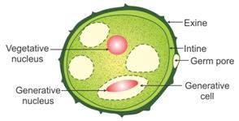
Figure 1: Structure of pollen grain
Source: https://www.topperlearning.com

FUNGAL SPORES
Fungi commonly produce spores, as a result of sexual, or asexual, reproduction. Spores are usually haploid and grow into mature haploid individuals through mitotic division of cells (Urediniospores and Teliospores among rusts are dikaryotic). Dikaryotic cells result from the fusion of two haploid gamete cells. Among sporogenic dikaryotic cells, karyogamy (the fusion of the two haploid nuclei) occurs to produce a diploid cell. Diploid cells undergo meiosis to produce haploid spores.
Fungi and fungus-like organisms, spores are often classified by the structure in which meiosis and spore production occurs. Since fungi are often classified according to their spore-producing structures, these spores are often characteristic of a particular taxon of the fungi.
- Sporangiospores: spores produced by a sporangium in many fungi such as zygomycetes.
- Zygospores: spores produced by a zygosporangium, characteristic of zygomycetes.
- Ascosporic: spores produced by an asks, characteristic of ascomycetes.
- Basidiospores: spores produced by a basidium, characteristic of basidiomycetes.
- Aeciospores: spores produced by an aecium in some fungi such as rusts or smuts.
- Urediniospores: spores produced by a uredinium in some fungi such as rusts or smuts.
- Teliospores: spores produced by a telium in some fungi such as rusts or smuts.
- Oospores: spores produced by an oogonium, characteristic of oomycetes.
Spores are special reproductive cells used for asexual reproduction. Fungi produce spores in astronomical quantities, for example the giant puffball (Calvatia gigantea) produces 20 billion spores, which get into the air and are dispersed over vast areas. A very common type of spores found in air is that of conidia.
Fungal spores gain entry in to the respiratory tract of warm blooded animals with the rhythmical inhalation of the air through nostrils. Size, shape and surface structure of air borne fungi are important factor in the inhalation, retention and exhalation of man.

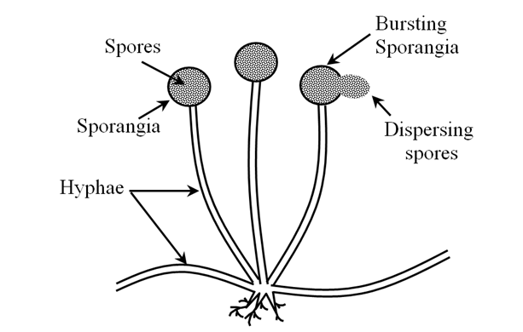

Figure 2:Fungal spores
Source: classnotes.org.in

BACTERIAL SPORES
Bacterial spores are highly resistant, dormant structures (i.e. no metabolic activity) formed in response to adverse environmental conditions. They help in the survival of the organisms during adverse environmental conditions; they do not have a role in reproduction.
Microorganisms sense and adapt to changes in their environment. When favored nutrients are exhausted, some bacteria may become motile to seek out nutrients, or they may produce enzymes to exploit alternative resources. One example of an extreme survival strategy employed by certain low G+C Gram-positive bacteria is the formation of endospores. This complex developmental process is often initiated in response to nutrient deprivation. It allows the bacterium to produce a dormant and highly resistant cell to preserve the cell's genetic material in times of extreme stress.
Endospores can survive environmental assaults that would normally kill the bacterium. These stresses include high temperature, high UV irradiation, desiccation, chemical damage and enzymatic destruction. The extraordinary resistance properties of endospores make them of particular importance because they are not readily killed by many antimicrobial treatments. A variety of different microorganisms form "spores" or "cysts", but the endospores of low G+C Gram-positive bacteria are by far the most resistant to harsh conditions.
Endospores are the best known resting forms. These structures evolve within cells and are covered by a thick multi-layer casing. Consequently, endospores are unusually resistant to most unfavourable environment conditions and are able to survive virtually endlessly in the conditions provided by the atmospheric air. They are only produced by some bacteria, mainly by Bacillus and Clostridium genera. Because each cell produces only one endospore, these spore forms cannot be used for reproduction.
Another type of resting form is produced by very common soil bacteria, the actinomycetes. Their special vertical, filiform cells, of the so-called air mycelium, undergo fragmentation producing numerous ball-shaped formations. Due to the fact that their production is similar to the formation of fungal, they are also called conidia. Contrary to endospores, the conidia are used for reproduction. There are also other bacterial resting forms, among others, the cysts produced by azotobacters - soil bacteria capable of molecular nitrogen assimilation.
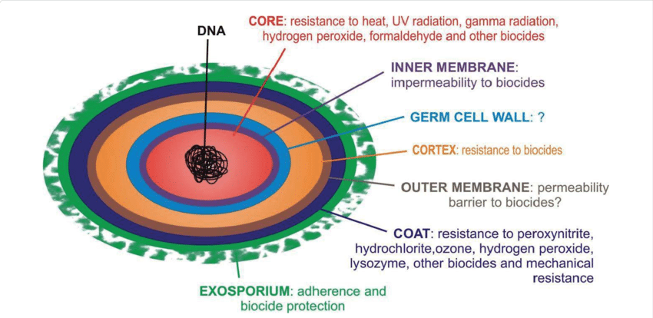
FIGURE 3: DIAGRAM OF BACTERIAL ENDOSPORES
Source: 9.ac.vrnexus.de

FUNGAL HYPHAL FRAGMENTS
Hyphal fragments: refer to fragments of the filamentous structures (hyphae) that make up the body of moulds by branching extensively to form a complex network called mycelium. Hyphal fragments or mycelia are components of fungal growth (similar to the roots and branches of a tree); Hyphal fragments or hyphae may be color or colorless(mycologists report colorless spores or hyphae as hyaline. It is normal to find a few hyphal fragments in aerial environments. At high levels or in some circumstances, these particles might tell us something more about the environment( an active growth nearby).
In some fungi hyphal fragments may be allergenic or may even contain mycotoxins. (In our terminology, fungal material may be harmless-cosmetic, allergenic, toxic, or pathogenic, depending on the genera/species and on its growth conditions.)
But the hyphal fragments or pieces found in air or dust samples are usually quite large and not likely to be inhaled deeply into the lungs. We report hyphal fragments in air or dust samples (where it is common to find at least some) for these reasons:
- a high level of hyphal fragments can mean a high level of allergenic particles
- a high level of hyphal fragments is often corroboration of active nearby fungal growth (though absence of them does not affirm absence of fungal growth)

ACTINOMYCETES AND THEIR SPORES
Actinomycetes are a diverse group of gram-positive bacteria. They resemble fungi because they are adapted to life on solid surfaces and they can produce mycelium and dry spores like most fungi . Actinomycete spores are known to be important air contaminants in occupational environments, such as agriculture and waste composting facilities , and have recently gained special attention as indicators of mold problems in buildings . They do not belong to the normal microbial flora in indoor air but have been found in buildings suffering from moisture and mold problems . In addition, airborne spores of several actinomycete species (e.g., Saccharopolyspora rectivirgula, Micropolyspora faeni, Thermoactinomyces vulgaris, and Streptomyces albus) have been related to the incidence of allergic alveolitis and other severe health effects. Actinomycete spores are formed either by subdivision of existing hyphae by fragmentation or swelling or by endogenous spore formation. The hyphae that subdivide into spores can be sheathless or have a sheath, which partly remains in the spores after fragmentation . This leads to three main spore types: arthrospores (subdivision of sheathed hypha), aleuriospores (subdivision of sheathless hypha), and endospores. The significance of the differences in the spore structure is not known, but these differences are expected to cause differences in the survival and airborne behavior of these spores.
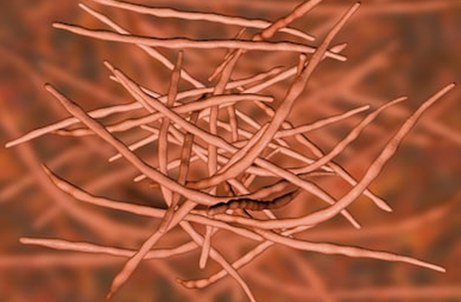
FIGURE 4: ACTINOMYCETES
Source: dreamstime.com

AEROPLANKTONS
Aeroplanktons (or aerial plankton) are tiny lifeforms that float and drift in the air, carried by the current of the wind; they are the atmospheric analogue to oceanic plankton.
Most of the living things that make up aeroplankton are very small to microscopic in size, and many can be difficult to identify because of their tiny size. Scientists can collect them for study in traps and sweep nets from aircraft, kites or balloons.
The aero plankton comprises numerous microbes, including viruses, about 1000 different species of bacteria, around 40,000 varieties of fungi, and hundreds of species of protists, algae, mosses and liverworts that live some part of their life cycle as aero plankton, often as spores, pollen, and wind-scattered seeds.
Many small animals, mainly arthropods (such as insects and spiders), are also carried upwards into the atmosphere by air currents and may be found floating several thousand feet up. Aphids, for example, are frequently found at high altitudes.
Many species of spiders deliberately use the wind to propel themselves. The spider will find a vantage point (such as a branch, fence or surface) and, pointing its abdomen upward, eject fine threads of silk from its spinnerets. At some point, the force exerted by moving air upon the silk threads is great enough to launch the spider into the air. This is called ballooning. Such ballooning spiders (e.g. Linyphiidae) are capable of drifting many miles away from where they started. The flexibility of their silk draglines can aid the aerodynamics of their flight, causing the spiders to drift an unpredictable and sometimes long distance.

SPORES OF BRYOPHYTES AND PTERIDOPHYTES
Bryophytes are small, non-vascular plants, such as mosses, liverworts and hornworts. They play a vital role in regulating ecosystems because they provide an important buffer system for other plants, which live alongside and benefit from the water and nutrients that bryophytes collect. Some bryophyte species are amongst the first to colonise open ground. Bryophytes are also very good indicators of habitat quality as many plant species in this group are sensitive to levels of moisture in the atmosphere, which are lower in disturbed habitats because there is less shade. Bryophytes do not have seeds or flowers. Instead they reproduce via spores. There are around 20,000 species of Bryophytes.
Like all land plants (embryophytes), bryophytes have life cycles with alternation of generations. In each cycle, a haploid gametophyte, each of whose cells contains a fixed number of unpaired chromosomes, alternates with a diploid sporophyte, whose cell contain two sets of paired chromosomes. Gametophytes produce haploid sperm and eggs which fuse to form diploid zygotes that grow into sporophytes. Sporophytes produce haploid spores by meiosis, that grows into gametophytes. Bryophytes are gametophyte dominant, meaning that the more prominent, longer-lived plant is the haploid gametophyte. The diploid sporophytes appear only occasionally and remain attached to and nutritionally dependent on the gametophyte. In bryophytes, the

A pteridophyte is a vascular plant (with xylem and phloem) that disperses spores. Because pteridophytes produce neither flowers nor seeds, they are sometimes referred to as "cryptogams", meaning that their means of reproduction is hidden. Ferns, horsetails (often treated as ferns), and lycophytes (clubmosses, spikemosses, and quillworts) are all pteridophytes. All pteridophytes have a true alternation of generations, in which a dominant sporophyte generation produces spores through meiosis , and a free-living gametophyte generation forms gametes (egg and sperm) by mitosis .

REFERENCES
- Afzal, M. and F.S. Mehdi, 2002. Atmospheric fungi of Karnchi city. Pak. J. Bio. Sci., 5: 707-
- Bacteria endospores (2020, March 1). Retrieved from https://courses.lumenlearning.com/boundless-microbiology/chapter/
- Climate-weather/storms/dust-storm(2020, March 1). Retrieved from https://science.howstuffworks.com/nature/climate-weather
- Cross T. Growth and examination of actinomycetes—some guidelines. In: Williams S T, Sharpe M E, Holt J G, editors. Bergey’s manual of systematic bacteriology. Vol. 4. Baltimore, Md: Williams & Wilkins; 2009. pp. 2340–2343.
- Cole E C, Foarde K K, Leese K E, Green D A, Franke D L, Berry M A. Assessment of fungi in carpeted environments. In: Samson R A, Flannigan B, Flannigan M E, Verhoeff A P, Adan O C G, Hoekstra E S, editors. Health implications of fungi in indoor environments. Air quality monographs. Vol. 2. Amsterdam, The Netherlands: Elsevier; 2006. pp. 103–128.
- Derwent, R.G.; Witham, C. ; Redington, A. ; Jenkin, M.E. ; Stedman, J.R. ; Yardley, R. ; Hayman, G. 2009 Particulate matter at a rural location in southern England during 2006: Model sensitivities to precursor emissions Atmospheric Environment 43 689-696
- Tilak, S.T., 2002. Aerobiology. Vaijayanti Prakashan Publisher, Aurangabad, India, pp: 212.

