NAME: FADIPE NAOMI INEMESIT
MATRIC NO: 17/MHS01/131
COURSE NAME: NEUROHISTOLOGY OF SPECIAL SENSES
COURSE CODE: ANA 305
LECTURER: DR ADESHINA

QUESTION 1: Write an essay on the histological importance of eye in relation to their cellular functions
ANSWER
The eye is a special organ for vision/sight. It is a photosensitive organ. The sense of vision is innervated by the cranial nerve ii(optic nerve). The eye has various structures which work together to bring about sight. There are structures such as cornea, pupil, iris, ciliary body, vitreous body, lens, retina, ora serrata and so on. The eyes receive light through cornea. The wall of the eye has three layers which are FIBROUS TUNIC which is the outermost and has sclera and cornea present. We have the UVEA OR UVEAL TRACT OR VASCULAR TUNIC which is the middle layer and it contains iris, ciliary body and choroid. We have the innermost layer which contains the retina. The importance according to their cellular functions will be the functions of each structure of the eye in relation to vision or sight.
Cornea is transparent and avascular and it directs light to the lens. Its refractive power is twice that of the lens. It is continuous with sclera at limbus.
Choroid is highly pigmented and highly vascular. It serves as vascular supply.
Ciliary body is the thickened portion of uveal tract at the level of lens. The contraction and relaxation of ciliary muscle regulates the shape of lens. It also assists in visual accommodation. There is also production of aqueous humor which maintains intra ocular pressure.
Iris regulates the pupil diameter. Eye color is determined by the quantity, distribution of pigment cells, primarily in the stroma of the iris. The stroma of iris is a highly vascular fibroblastic connective tissue that contains many melanocytes. Increasing amount of pigment imparts darker color to eye. Blue eyes show few melanocytes and little pigment in stroma. Grey to green eyes show moderate amount of melanocyte pigment. Brown eyes show heavily pigmented melanocytes in stroma. Pink eyes show albinism or absence of pigment.
Lens of the eye is the one which allows the light to enter.
Vitreous humor is a clear gelatinous mass which occupies posterior segment. It protects posterior segment of eye.
Retina has two parts which are the retinal pigment epithelium and the neural retina. The retinal pigment epithelium produces fluid to nurture rods and cones. It synthesizes melanin i.e. absorbs light, limits reflections and scatter. It phagocytosis photoreceptors discs shed by rods. It pools and esterifies vitamin A used in regeneration of rhodopsin by rods.
Neural retina has rods and cones. The rods are for night vision (scotopic) while the cones are for daylight (photopic).
Fovea centralis is the area of highest visual acuity at the center of visual axis.
Optic disc has the blind spot i.e. no photoreceptors are located there
QUESTION 2: Corona Virus can penetrate the body through the eye and implicate the immune system, briefly discuss the layers if the retina for information penetration.
ANSWER
The Retina is the innermost tunic of the eyeball. It is in the inner nervous coat surrounding the eye. It is a thin, transparent membrane. It is concerned with the visual function (photoreception). The microscopic layers of the retina are 10 in number. The layers of retina contain three types of cells which are:
- An outer layer of rod and cone cells
- A middle layer of bipolar cells
- An inner layer of ganglion cells
The layers include;
- Retinal pigment epithelium: This is the innermost layer of the retina. It has endings of photoreceptors embedded here. The apical membrane of epithelium cell contacts outer segments of rods and cones. They also esterify vitamin A which is used in the formation of visual pigment of rods and cones.
- Photoreceptor cell layer: This is the layer of rods and cones. These are neurons. Their dendrites synapse with cells of the pigmented epithelium and their bases or axons form synapse with cells of the bipolar layer. Rods are sensitive to light of low intensity. They may synapse with bipolar cells, giving rise to summation. Photoreception by rod is initiated by interaction of light with rhodopsin. Cones are sensitive to light of high intensity. They produce greater visual acuity ad are less numerous. Each cone synapses with single bipolar neuron where each rod may synapse with several bipolar neurons.
- External limiting membrane: This is not a true but an area where zonulae adherens are located between photoreceptor cells and retinal glial cells (muller cells). This membrane also has microvilli that project from muller cells.
- Outer nuclear layer: It contains nuclei of rods and cones bipolar cells.
- Outer plexiform layer: This consists of axodendritic synapses between axons of photoreceptor cells and dendrites of bipolar and horizontal cells. There are mainly the horizontal cells. They are laterally interconnecting neurons and they are responsible for allowing the eyes to adjust to see well under bright-light and dim-light conditions. The horizontal cells also increase visual acuity.
- Inner nuclear layer: They contain cell bodies of bipolar neurons, horizontal cells, diffuse amacrine, amacrine cells and the nuclei of muller cells. Amacrine cells synapse ganglion cells to bipolar cells. There are fibers of muller cells in this layer.
- Inner plexiform layer: They contain axodendritic synapses between the axons of bipolar cells and dendrites of ganglion cells. They also have centrifugal fibers present which are where the amacrine cells arise.
- Ganglion cell layer: They project their axons to a specific region of retina called optic disk. These cells are activated by hyperpolarization of rods and cones and generate an action potential which is transmitted to horizontal and amacrine cells and carried to the visual relay system of the brain. These cells have dendrites that synapse with bipolar cells.
- Optic nerve fiber layer: They possess unmyelinated axons of ganglion cells which forms the fibers of optic nerve. As each fiber pierces the sclera, it obtains myelin sheath. These nerve fibers pick up visual information and synapse with ganglion cells to commence the information transmission.
- Inner limiting membrane: They consist of the termination of muller cell processes and their basement membranes. Incident light from lens lie on this layer and the optic nerve fibers pick it up and start the transfer. In order to reach the photoreceptors, incoming light must first pass through the remaining layers of retina.
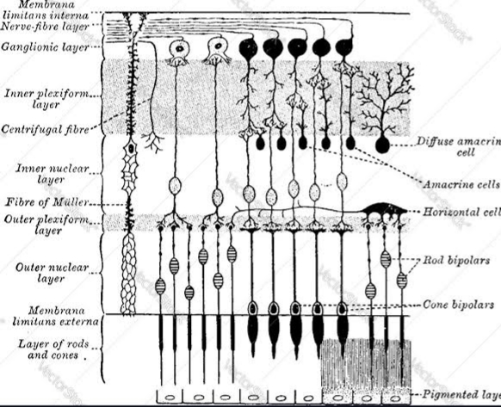
This shows the layers of retina for information penetration.

