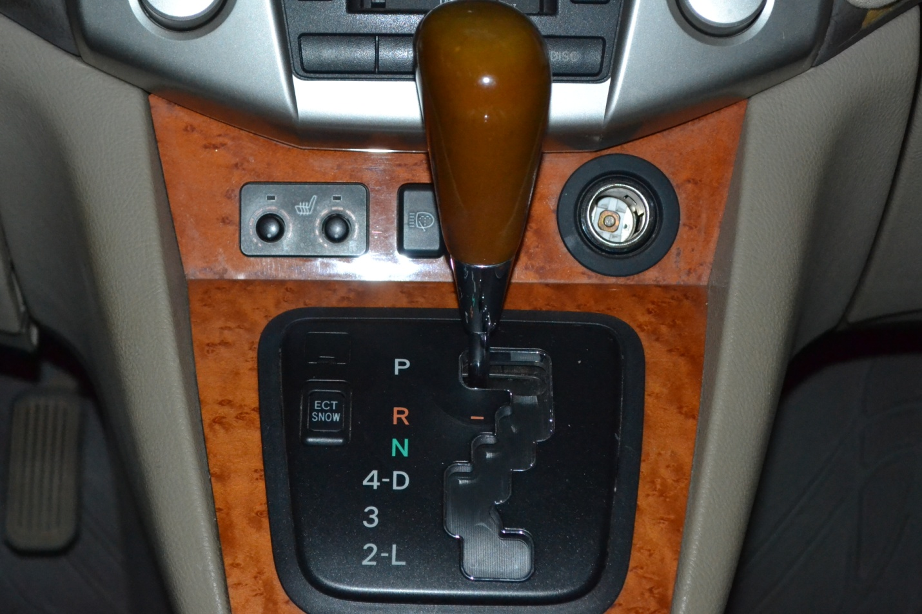[1]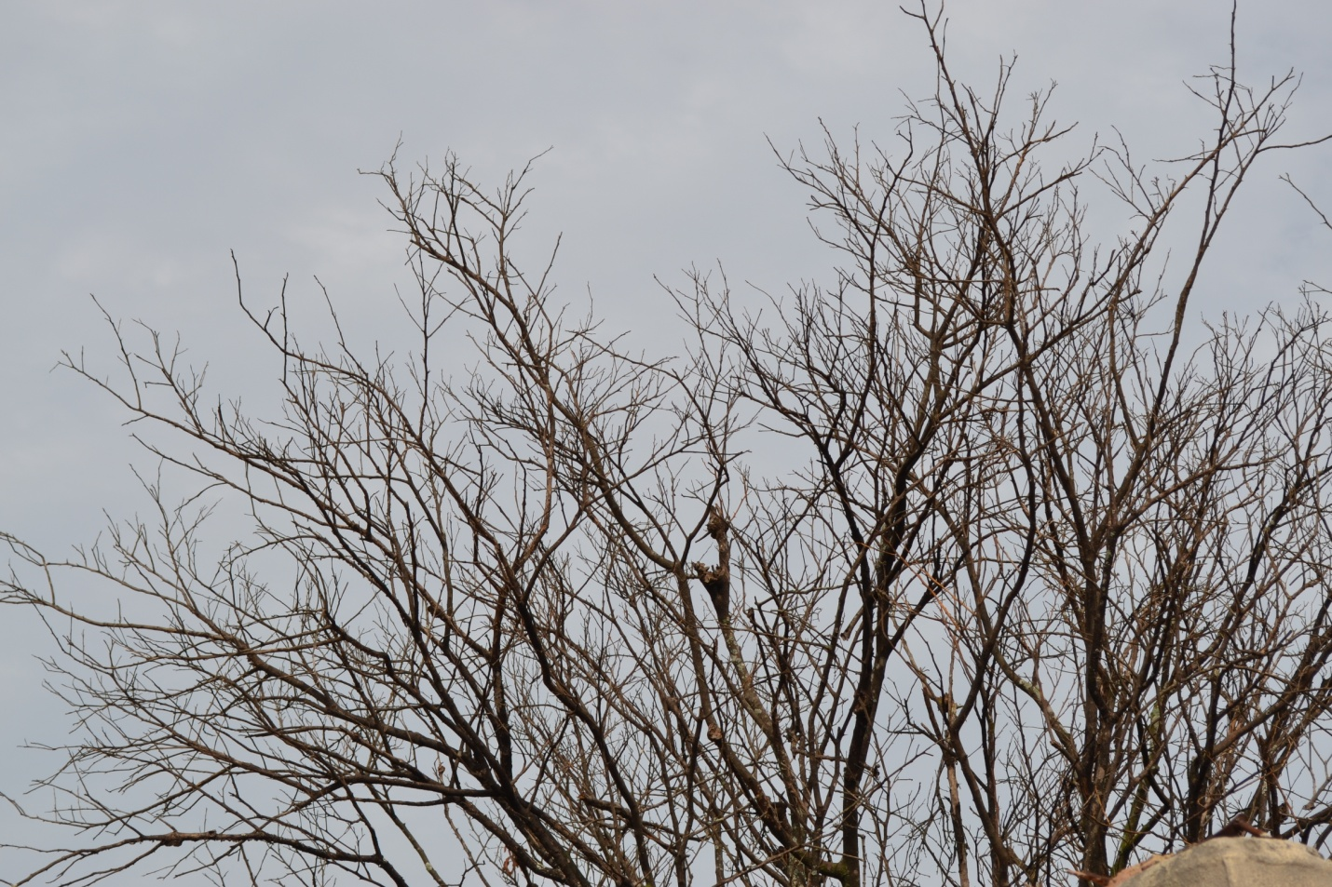[2]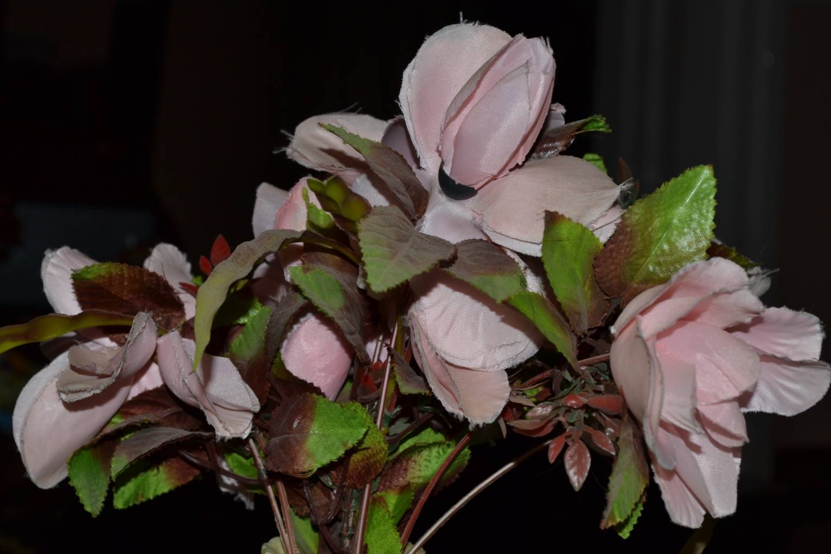***[3]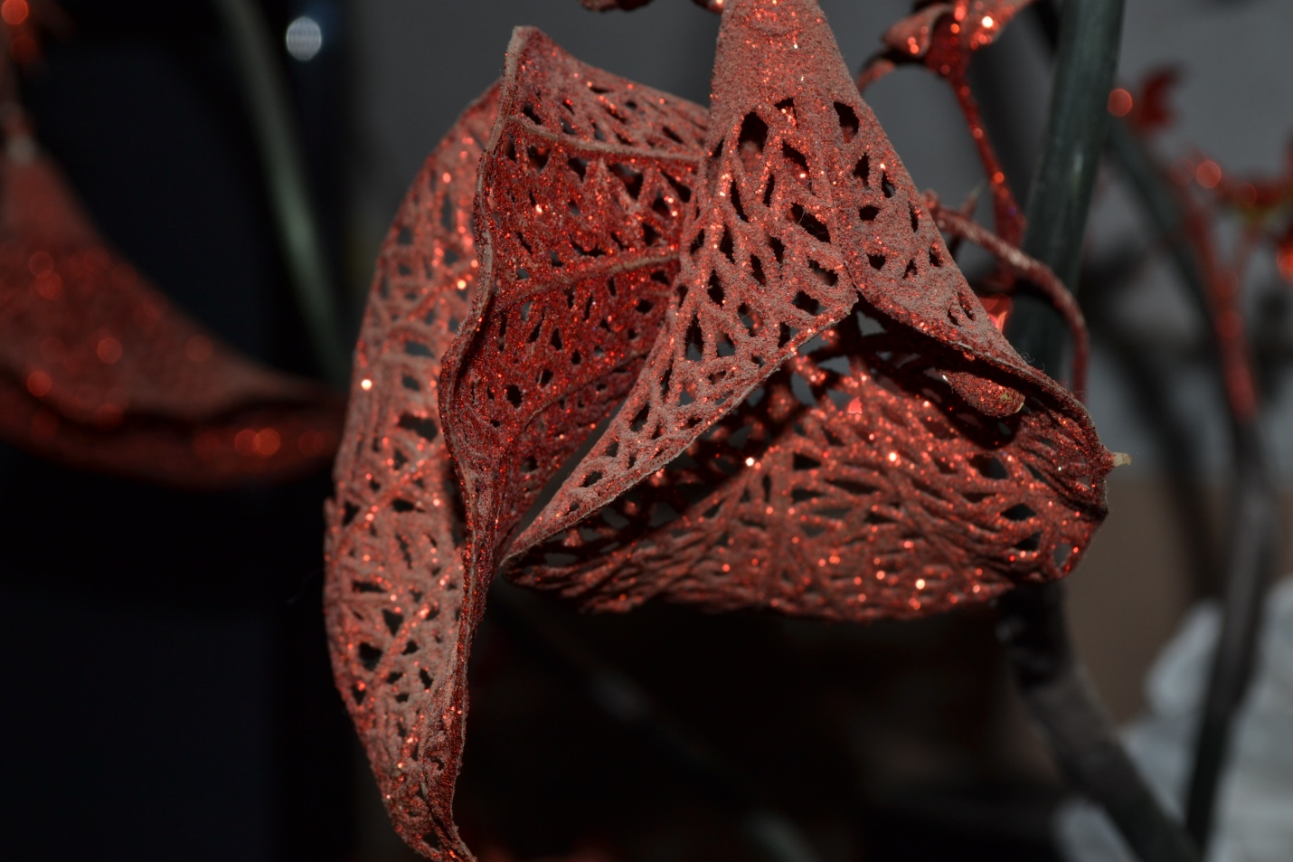***[4]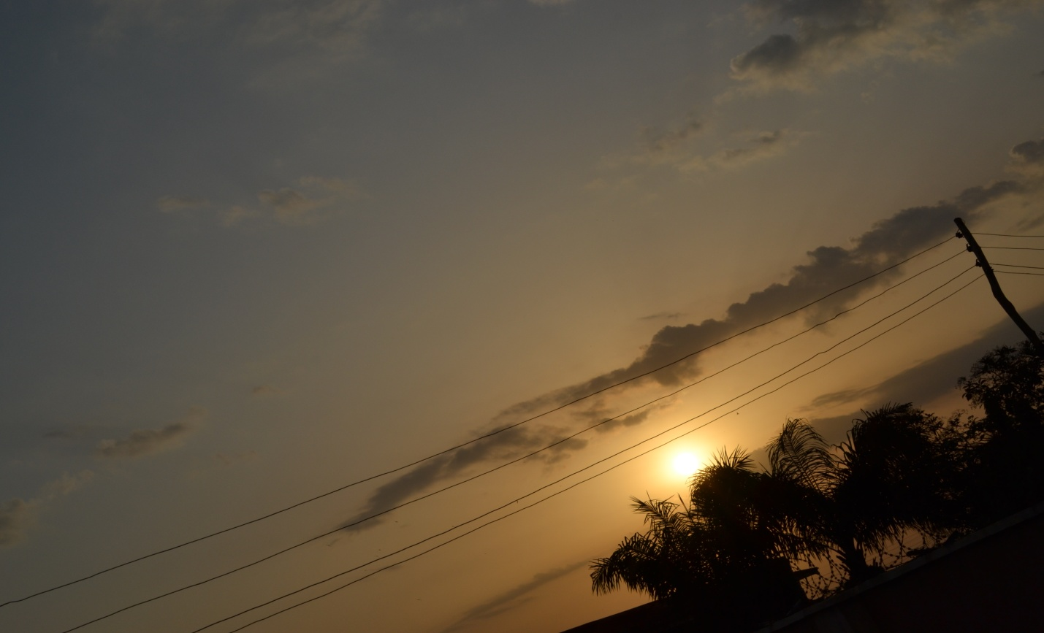

NATURE PHOTOGRAPHY OF THE SKY AT DAWN.

1. TECHNOLOGY PHOTOGRAHY OF A INNER LEXUS EDITION.
2. LANDSCAPE PHOTOGRAPHY OF A DRIED TREE.
3. STILL LIFE PHOTOGRAPHY OF A DECORATION.
4. POTRAIT PHOTOGRAPHY OF A FLOWERY DECORATION.