Name: Ibrahim Isma’il Abimbola

Matric no: 15/ENG03/015

Assignment Title: Forecasting Future Traffic Flows  
Course Title: Highway Engineering  
Course Code: CVE 506

**Principle of Demand Analysis**

If transport planners wish to modify a highway network either by constructing a new roadway or by instituting a programme of traffic management improvements, any justification for their proposal will require them to be able to formulate some forecast of future traffic volumes along the critical links. The prediction of highway demand requires a unit of measurement for travel behaviour to be defined. This unit is termed a trip and involves movement from a single origin to a single destination. The parameters utilised to detail the nature and extent of a given trip are as follows:

* Purpose
* Time of departure and arrival
* Mode employed
* Distance of origin from destination
* Route travelled.

Within highway demand analysis, the justification for a trip is founded in economics and is based on what is termed the utility derived from a trip. An individual will only make a trip if it makes economic sense to do so, i.e. the economic benefit or utility of making a trip is greater than the benefit accrued by not travelling, otherwise it makes sense to stay at home as travelling results in no economic benefit to the individual concerned.

**Demand Modelling**

Demand modelling requires that all parameters determining the level of activity within a highway network must first be identified and then quantified in order that the results output from the model has an acceptable level of accuracy. One of the complicating factors in the modelling process is that, for a given trip emanating from a particular location, once a purpose has been established for making it, there are an enormous number of decisions relating to that trip, all of which must be considered and acted on simultaneously within the model.

These can be classified as:

* Temporal decisions – once the decision has been made to make the journey, it still remains to be decided when to travel
* Decisions on chosen journey destination – a specific destination must be selected for the trip, e.g. a place of work, a shopping district or a school
* Modal decisions – relate to what mode of transport the traveller intends to use, be it car, bus, train or slower modes such as cycling/walking
* Spatial decisions – focus on the actual physical route taken from origin to final destination. The choice between different potential routes is made on the basis of which has the shorter travel time.

The ability of the model to predict future travel demand is based on the assumption that future travel patterns will resemble those of the past. Thus the model is initially constructed in order to predict, to some reasonable degree of accuracy, present travel behaviour within the study area under scrutiny. Information on present travel behaviour within the area is analysed to determine meaningful regression coefficients for the independent variables that will predict the dependent variable under examination.

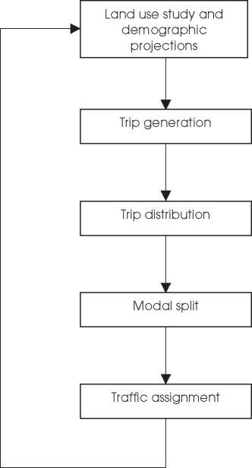

**Figure 1.1** Sequence of transport demand model.

**Land Use Model**

The demand for movement or trip making is directly connected to the activities undertaken by people. These activities are reflected in both the distribution and type of land uses within a given area. By utilising relationships between present day land uses and consequent movements in a given area, estimates of future movements given on land-use projections can be derived. The derivation of relationships between land uses and people movements are thus fundamental to an effective transport planning process. A land use model will thus estimate the future development for each of the zones within the study area, with estimates relating not only to predictions regarding the different land uses but also to those socio-economic variables that form the basic data for trip generation.

**Trip Generation**

Trip generation models provide a measure of the rate at which trips both in and out of the zone in question are made. They predict the total number of trips produced by and attracted to its zone. Centres of residential development, where people live, generally produce trips. The more dense the development and the greater the average household income is within a given zone, the more trips will be produced by it. Centres of economic activity, where people work, are the end point of these trips. The more office, factory and shopping space existing within the zone, the more journeys will terminate within it. These trips are 2-way excursions, with the return journey made at some later stage during the day.

**Trip Distribution**

The trip distribution model determines the individual zones where each of these will end. For the trips ending within the zone under examination, the individual zone within which each trip originated is determined. The model thus predicts zone-to-zone trip interchanges. The process connects two known sets of trip ends but does not specify the precise route of the trip or the mode of travel used.

**Modal Split**

Trips can be completed using different modes of travel. The proportion of trips undertaken by each of the different modes is termed modal split. The simplest form of modal split is between public transport and the private car. While modal split can be carried out at any stage in the transportation planning process, it is assumed here to occur between the trip distribution and assignment phases. The trip distribution phase permits the estimation of journey times/costs for both the public and private transport options. The modal split is then decided on the basis of these relative times/costs. In order to simplify the computation of modal split, journey time is taken as the quantitative measure of the cost criterion.

**Traffic Assignment**

Traffic assignment constitutes the final step in the sequential approach to traffic forecasting. The output from this step in the process will be the assignment of precise quantities of traffic flow to specific routes within each of the zones. Assignment requires the construction of a mathematical relationship linking travel time to traffic flow along the route in question. The simplest approach involves the assumption of a linear relationship between travel time and speed on the assumption that free-flow conditions exist, i.e. the conditions a trip maker would experience if no other vehicles were present to hinder travel speed. In this situation, travel time can be assumed to be independent of the volume of traffic using the route. (The ‘free-flow’ speed used assumes that vehicles travel along the route at the designated speed limit). A more complex parabolic speed/flow relationship involves travel time increasing more quickly as traffic flow reaches capacity. In this situation, travel time is volume dependent.

**Consideration and effects when forcasting traffic flows**

The process of traffic forecasting lies at the very basis of highway engineering. Modelling transport demand is normally undertaken using a four-stage sequential process starting with trip generation and distribution, followed by modalsplit and concluding with traffic assignment. Predicting flows along the links within a highway network provides vital information for the economic and environmental assessments required as part of the project appraisal process and allows the scale of each individual project within the network to be determined. Once the demand analysis and appraisal process have been completed, the detailed junction and link design can then be undertaken.

It should be remembered, however, that the modelling process is a simplification of reality. Predictions arising from it are broad estimates rather than precise forecasts. The error range within which the model results are likely to fall should accompany any data supplied to the transport planners.

REFERENCE

Rogers, M., 2003. Highway Engineering. Department of Civil and Structural Engineering.