AUGOYE OMESIRI
ANATOMY
ANA 212
18/MHS01/094

The External Female Genital
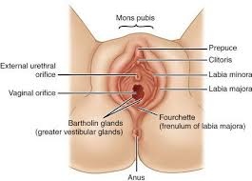
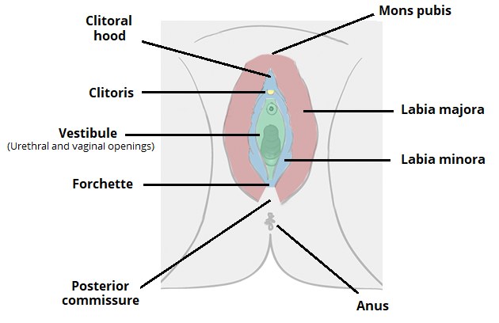
The external genital organs include the mons pubis, labia majora, labia minora, Bartholin glands, and clitoris. The area containing these organs is called the vulva.
The external genital organs have three main functions:
- Enabling sperm to enter the body
- Protecting the internal genital organs from infectious organisms
- Providing sexual pleasure
The mons pubis is a rounded mound of fatty tissue that covers the pubic bone. During puberty, it becomes covered with hair. The mons pubis contains oil-secreting (sebaceous) glands that release substances that are involved in sexual attraction (pheromones).
The labia majora (literally, large lips) are relatively large, fleshy folds of tissue that enclose and protect the other external genital organs. They are comparable to the scrotum in males. The labia majora contain sweat and sebaceous glands, which produce lubricating secretions. During puberty, hair appears on the labia majora.
The labia minora (literally, small lips) can be very small or up to 2 inches wide. The labia minora lie just inside the labia majora and surround the openings to the vagina and urethra. A rich supply of blood vessels gives the labia minora a pink color. During sexual stimulation, these blood vessels become engorged with blood, causing the labia minora to swell and become more sensitive to stimulation.
The area between the opening of the vagina and the anus, below the labia majora, is called the perineum. It varies in length from almost 1 to more than 2 inches (2 to 5 centimeters).
The labia majora and the perineum are covered with skin similar to that on the rest of the body. In contrast, the labia minora are lined with a mucous membrane, whose surface is kept moist by fluid secreted by specialized cells.
The opening to the vagina is called the introitus. The vaginal opening is the entryway for the penis during sexual intercourse and the exit for blood during menstruation and for the baby during birth.
When stimulated, Bartholin glands (located beside the vaginal opening) secrete a thick fluid that supplies lubrication for intercourse.
The opening to the urethra, which carries urine from the bladder to the outside, is located above and in front of the vaginal opening.

The clitoris, located between the labia minora at their upper end, is a small protrusion that corresponds to the penis in the male. The clitoris, like the penis, is very sensitive to sexual stimulation and can become erect. Stimulating the clitoris can result in an orgasm. Vestibule
The labia minora enclose an area called the vestibule, which contains the urinary and vaginal orifices along with the openings of the greater and lesser vestibular glands. The prepuce is found at the anterior margin of the vestibule.

Hymen
Most females (but not all) are born with a hymen, which is generally in the form of an elliptical/oval-shaped membranous ring around the vaginal orifice (It is generally perforated to some degree, most often in the centre, kind of like a 'donut' shape). The remnants of this membranous ring in adult females in known as hymenal caruncles, which appear as small thin elevations of mucous membrane around the vaginal opening. When the hymen completely covers the vaginal orifice, it is known as an imperforate hymen. An imperforate hymen may rupture naturally during various types of physical activity (aside from intercourse).Some females may undergo a hymenotomy, which involves the surgical removal, or opening of the hymen, most often to facilitate menstruation, or relieve discomfort during intercourse. This procedure may also be undertaken in the instance when the hymen is abnormally thick, and/or when the opening is small, limiting access to the vaginal orifice.

Blood supply
Vasculature of the external female genitalia is primarily supplied by the internal pudendal arteries, which are branches of the anterior division of the internal iliac artery.

Lymphatic drainage
Lymphatic drainage of the external female genitalia is via the superficial and deep inguinal lymph nodes. Lymph from the clitoris, vestibular bulb and anterior labia minora can alternatively drain into the internal iliac lymph nodes.

Innervation
The vulva is innervated from a variety of sources. The mons pubis and anterior labia is innervated via the anterior labial nerves, which derive from the lumbar plexus. The posterior aspect of the vulva is innervated via the pudendal nerve and its branches (posterior labial nerves), together with branches from the posterior cutaneous nerve of the thigh. Sensitive innervation to the clitoris is provided by the dorsal nerve of the clitoris.
CLINCAL ANATOMY

Vulvitis & Pruritus Vulvae
Vulvitis is simply the inflammation of the vulva where 'vulv-' refers to the 'vulva' and '-itis' means 'inflammation.' There are a ton of things that can cause vulvitis. An infection from pubic lice is one possibility. The prolonged wearing of a wet bathing suit is another. Horseback or bicycle riding can cause vulvitis as well. Even seemingly innocent things, like colored toilet paper, as well as some kinds of shampoos, can cause vulvitis.
Because vulvitis is an inflammatory process, redness and swelling are a part of the problem. Inflammation, and thus vulvitis as well, also involves itching. The medical term for itching is pruritus. Although the endings of '-itis' and '-itus' sound very similar, please do not get them confused, as I have seen many students and even medical professionals misspell pruritus as pruritis.

