NAME: OKAM EDNA ACHI CHINMA
MATRIC NUMBER: 19/MHS03/015
DEPARTMENT: HUMAN ANATOMY

STAGE 1: OXIDATION BY FAD LINKED DEHYDROGENASE
Four enzyme-catalysed reactions are involved in the first stage of fatty acid oxidation. First, dehydrogenation produces a double bond between the α and β carbon atoms (C-2 and C-3), yielding a trans-Δ²-enoyl-CoA. The symbol Δ² designates the position of the double bond. (It may be helpful to review fatty acid nomenclature. The new double bond has the trans configuration; recall that naturally occurring unsaturated fatty acids normally have their double bonds in the cis configuration. We shall consider the significance of this difference later.
The enzyme responsible for this first step, acyl-CoA dehydrogenase, includes FAD as a prosthetic group. The electrons removed from the fatty acyl-CoA are transferred to the FAD, and the reduced form of the dehydrogenase then immediately donates its electrons to an electron carrier, the electron-transferring flavoprotein (ETFP). ETFP, an integral protein of the inner mitochondrial membrane, is one of the electron carriers of the mitochondrial respiratory chain. The transfer of a pair of electrons from the FADH2 of acyl-CoA dehydrogenase to O₂ via the respiratory chain provides the energy for the synthesis of two ATP molecules.
The oxidation catalysed by acyl-CoA dehydrogenase is analogous to succinate dehydrogenation in the citric acid cycle; in both reactions the enzyme is bound to the inner membrane, a double bond is introduced into a carboxylic acid between the α and β carbons, FAD is the electron acceptor, and electrons from the reaction ultimately enter the respiratory chain and are carried to O₂ with the concomitant synthesis of two ATP molecules per electron pair.
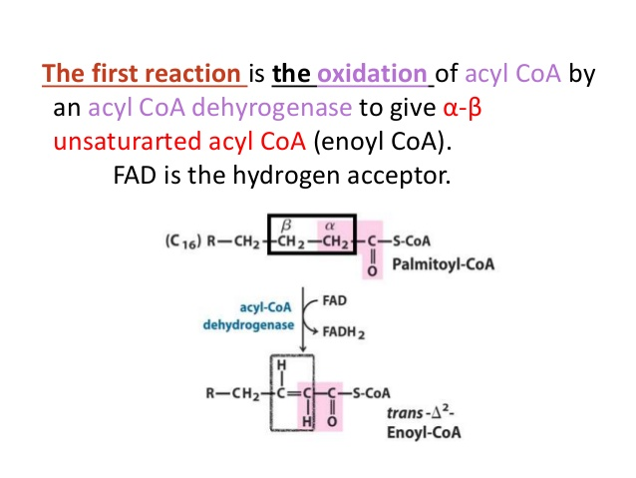

STAGE 2: HYDRATION BY HYDRATASE
In the second step of the fatty acid oxidation cycle, water is added to the double bond of the trans-Δ²-enoyl-CoA to form the L stereoisomer of β-hydroxyacyl-CoA (also designated β-hydroxyacyl-CoA). This reaction, catalysed by enoyl-CoA hydratase, is formally analogous to the fumarase reaction in the citric acid cycle, in which H₂O adds across an α-β double bond.
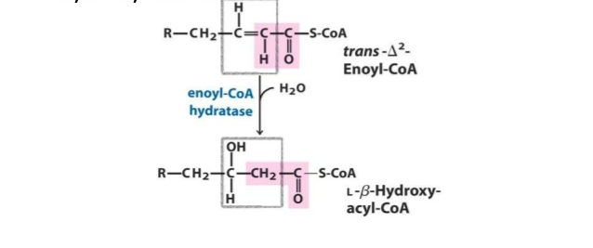
STAGE 3: OXIDATION BY NAD LINKED DEHYDROGENASE
in the third step, the L-β-hydroxyacyl-CoA is dehydrogenated to form β-ketoacyl-CoA by the action of β-hydroxyacyl-CoA dehydrogenase; NAD⁺ is the electron acceptor. This enzyme is specific for the r. stereoisomer. The NADH formed in this reaction donates its electrons to NADH dehydrogenase (Complex I), an electron carrier of the respiratory chain. Three ATP molecules are generated from ADP per pair of electrons passing from NADH to O₂ via the respiratory chain. The reaction catalysed by β-hydroxyacyl-CoA dehydrogenase is closely analogous to the malate dehydrogenase reaction of the citric acid cycle.
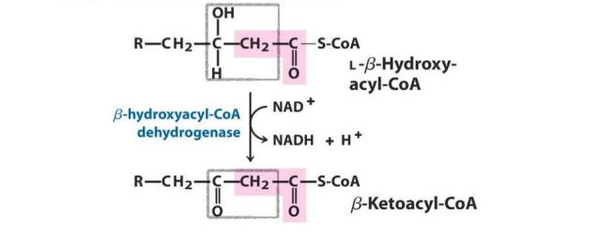

STAGE 4: THIOLYTIC CLEVAGE BY THIOLASE
The fourth and last step of the fatty acid oxidation cycle is catalysed by acyl-CoA acetyltransferase (more commonly called thiolase), which promotes reaction of β-ketoacyl-CoA with a molecule of free coenzyme A to split off the carboxyl-terminal two-carbon fragment of the original fatty acid as acetyl-CoA. The other product is the coenzyme A thioester of the original fatty acid, now shortened by two carbon atoms. This reaction is called thiolysis, by analogy with the process of hydrolysis, because the β-ketoacyl-CoA is cleaved by reaction with the thiol group of coenzyme A

The carbon-carbon single bond that connects methylene (-CH₂-) groups in fatty acids is relatively stable. The β-oxidation sequence represents an elegant solution to the problem of breaking these bonds. The first three reactions of β oxidation have the effect of creating a much less stable C-C bond, in which one of the carbon atoms (a carbon, C-2) is bonded to two carbonyl carbons. The ketone function on the β carbon (C-3) makes it a good point for nucleophilic attack by -SH of coenzyme A, catalysed by thiolase. The acidity of a carbon makes the terminal -CH₂-CO-S-CoA a good leaving group, facilitating breakage of the α-β bond.

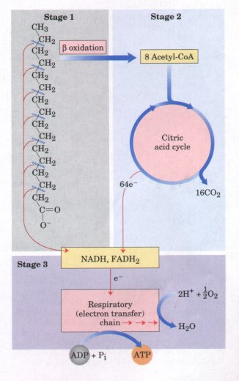

Stages of fatty acid oxidation.
Stage 1: A long-chain fatty acid is oxidized to yield acetyl residues in the form of acetyl-CoA.
Stage 2: The acetyl residues are oxidized to CO₂ via the citric acid cycle.
Stage 3: Electrons derived from the oxidations of stages 1 and 2 are passed to O₂ via the mitochondrial respiratory chain, providing the energy for ATP synthesis by oxidative phosphorylation.
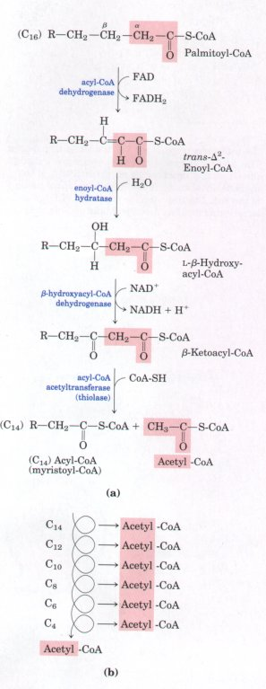
The fatty acid oxidation (β-oxidation) pathway.
(a) In each pass through this sequence, one acetyl residue (shaded in red) is removed in the form of acetyl-CoA from the carboxyl end of palmitate (C₁₆), which enters as palmitoyl-CoA.
(b) Six more passes through the pathway yield seven more molecules of acetyl-CoA, the seventh arising from the last two carbon atoms of the 16-carbon chain. Eight molecules of acetyl-CoA are formed in all.

