THERMAL ENHANCED OIL RECOVERY METHODS ASSIGNMENT
NAME: EDWARD INIOBONG IMAKAN
MATRIC NUMBER: 15/ENG07/014
COURSE CODE: PTE 512
COURSE TITLE: FUNDAMENTALS OF ENHANCED OIL RECOVERY

QUESTIONS
Briefly discuss the following Thermal Enhanced Oil Recovery methods (Diagrams inclusive);
- Steam Assisted Gravity Drainage (SAGD)
- Cyclic Steam Stimulation (CSS)
- Hot water flood
ANSWERS
1. STEAM ASSISTED GRAVITY DRAINAGE (SAGD)
Steam assisted gravity drainage or SAGD is a method that is widely used to extract bitumen from underground oil sands deposits. This method involves forcing steam into sub-surface oil sands deposits to heat the bitumen locked in the sand, allowing it to flow well enough to be extracted. This technology is particularly relevant in Canada because it is the primary method of in situ extraction used in the oil sands. In Alberta alone, 80% (or 135 billion barrels) of the oil sands are located in these underground deposits and would be difficult to access without techniques like SAGD.
In recent history, SAGD operations have become more common as technology continues to advance. In 2000, there were 5 SAGD projects underway in Alberta, but by 2013 those numbers had jumped to 16. In 2012, the total in situ production of bitumen was 990 000 barrels a day, which is about 52% of the total crude bitumen production. By 2022 predictions put the in situ production at 2.2 million barrels a day. In total, there is an estimated 1 trillion barrels of oil that are potentially recoverable.
To extract bitumen from below ground, a pair of horizontal wells are drilled into the formation. In these horizontal wells, there are two parallel horizontal pipes with one situated about 4-6 meters above the other. The upper section of this configuration is known as a steam injection well whereas the bottom section is known as the production well. At a nearby plant, water is turned into steam and travels to the location where the drilling is taking place. The steam is then passed through the upper well and into the reservoir that contains the oil sand. Steam then exits the upper well, expanding out into the formation in all directions. The heat from the steam is transferred to the bitumen. The warming of this bitumen results in a reduction of its viscosity, allowing it to flow more easily. Since the viscosity was decreased so dramatically, it is able to flow downward under the force of gravity into the production well.^{[2]} This draining of the bitumen is known as gravity drainage. From the production well, the now more fluid bitumen is pumped to the surface. The steps of steam injection and bitumen production happen simultaneously and continuously. The resulting bitumen and condensed steam emulsion is piped to the plant where it is separated and treated. The water from this process is recycled for generating more steam.
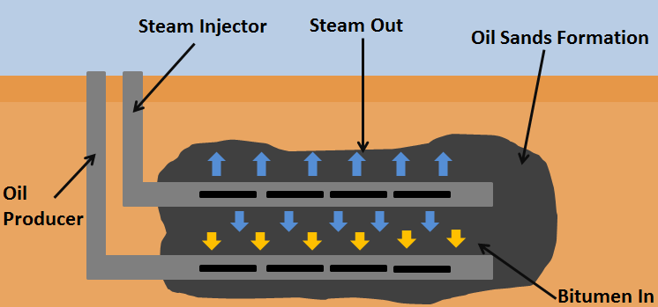
Figure 1-A SAGD setup to extract bitumen from an oil sand deposit.
2. CYCLIC STEAM STIMULATION (CSS)
This method, also known as the Huff and Puff method, consists of 3 stages: injection, soaking, and production. Steam is first injected into a well for a certain amount of time to heat the oil in the surrounding reservoir to a recover approximately 20% of the Original Oil in Place (OOIP), compared to steam assisted gravity drainage, which has been reported to recover over 50% of OOIP. It is quite common for wells to be produced in the cyclic steam manner for a few cycles before being put on a steam flooding regime with other wells.
The mechanism proceeds through cycles of steam injection, soak, and oil production. First, steam is injected into a well at a temperature of 300 to 340° Celsius for a period of weeks to months. Next, the well is allowed to sit for days to weeks to allow heat to soak into the formation. Finally, the hot oil is pumped out of the well for a period of weeks or months. Once the production rate falls off, the well is put through another cycle of injection, soak and production. This process is repeated until the cost of injecting steam becomes higher than the money made from producing oil. The CSS method has the advantage that recovery factors are around 20 to 25% and the disadvantage that the cost to inject steam is high.
Canadian Natural Resources use "employs cyclic steam or "huff and puff" technology to develop bitumen resources. This technology requires one well bore and the production consists of the injection and production phases. First steam is "injected for several weeks, mobilizing cold bitumen". Then the flow "on the injection well is reversed producing oil through the same injection well bore. The injection and production phases together comprise one cycle. "Steam is re-injected to begin a new cycle when oil production rates fall below a critical threshold due to the cooling of the reservoir. Artificial lift method of production may be used at this stage. After a few cycles, it may not be economical to produce by the huff and puff method. Steam flooding is then considered for further oil recovery if other conditions are favorable. It has been observed that recovery from huff and puff can be achieved up to 30% and from steam flooding recovery can be up to 50%.
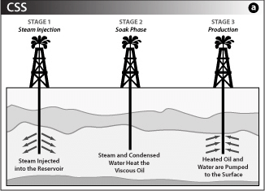
Figure 2-Cyclic Steam Stimulation Process

3. HOT WATER FLOOD
Hot water-flooding is the most common thermal method of enhanced oil recovery used in the CIS. One reason for this is that the existing equipment for straight water-flooding can be used. Also, in practice, because the generators used for steam injection are not powerful enough, it is often only hot water that arrives at the well bottom: experiments on steam-flooding have demonstrated that the oil has actually been displaced by hot water.
The choice of the water-flood parameters: the temperature of injected water, slug volume, injection rate, and starting time, is dictated by the specific geological and physical characteristics of the particular oilfield, after which a hydrodynamic estimate of the efficiency of hot water-flooding in comparison with other methods of enhanced oil recovery must be made.
Hot water-flooding is particularly effective in the development of fields of high viscosity oils which contain large quantities of paraffins and resinous asphaltene substances, and which exhibit anomalous (non-Newtonian) properties as they flow through porous media.
It is less effective than steam injection process, due to the fact that hot water has a lower heat content as compared to steam.
Over time the pressure in an oil reservoir slowly and steadily decreases and as a result the production rate decreases. This is one of the techniques used by E&P organizations to enhance the production of heavy to medium category crude oil from a reservoir. To use this technique, an injection well is drilled parallel to the primary producing well through which hot water is injected forcefully into the reservoir in the direction of the producing well.
The benefits of injecting water into the reservoir are:
- It supports the reservoir pressure, also known as voidage replacement.
- As oil is lighter than water hence it floats on top of the water. Also, the heat content of the water reduces the viscosity of heavy crude oil, making it not to stick on the edges of the reservoir and move quickly toward the producing well. Thus, water helps in displacing oil from its location in the reservoir and pushes it toward the producing well.
With this technique, oil recovery factor can be increased and well production rate can be maintained for a longer period.
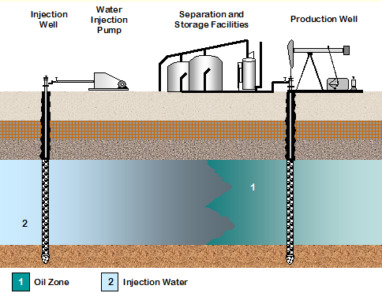

Figure 3- Hot water flooding
REFERENCES
- Athabasca Oil Corporation. (June 2, 2015). SAGD [Online]. Available: http://www.atha.com/operations/technology/sagd.html
- ↑ Jump up to:2.00 2.01 2.02 2.03 2.04 2.05 2.06 2.07 2.08 2.09 2.10 Alberta Government. (June 9, 2015). Talk about SAGD [Online]. Available: http://www.energy.alberta.ca/OilSands/pdfs/FS_SAGD.pdf
- ↑ Jump up to:3.0 3.1 3.2 3.3 3.4 Government of Alberta. (June 9, 2015). Facts about Alberta's oil sands and its industry [Online]. Available: http://history.alberta.ca/oilsands/resources/docs/facts_sheets09.pdf
- ↑ Created internally by a member of the Energy Education team.
- Butler, Roger (1991). Thermal Recovery of Oil and Bitumen. Englewood Cliffs: Prentice-Hall. p. 104.
- ^ "Cyclic Steam Stimulation". Thermal in situ oil sands. CNRL. 2013. Archived from the original on 2015-10-16.
- https://www.google.com/url?sa=i&url=https%3A%2F%2Fwww.researchgate.net%2Ffigure%2Fn-Situ-Oil-Sands-Recovery-Schemes-a-Cyclic-Steam-Stimulation-and-b-Steam-Assisted_fig17_322939126&psig=AOvVaw2Cs4VKjRNW2N2eHee9hbsn&ust=1587821618990000&source=images&cd=vfe&ved=0CAIQjRxqFwoTCLjej4ykgekCFQAAAAAdAAAAABAD

