MATRIC NUMBER : 18/MHS01/160
NAME: FASIPE BLESSING OLUWAFUNKE
COURSE CODE: BCH 204
ASSIGNMENT: Describe the three(3) stages of beta oxidation. Show pathways where necessary.
WHAT IS BETA OXIDATION?
Beta-oxidation is the catabolic process by which fatty acid molecules are broken down[1] in the cytosol in prokaryotes and in the mitochondria in eukaryotes to generate acetyl-CoA, which enters the citric acid cycle, and NADH and FADH2, which are co-enzymes used in the electron transport chain. It is named as such because the beta carbon of the fatty acid undergoes oxidation to a carbonyl group. Beta-oxidation is primarily facilitated by the mitochondrial trifunctional protein, an enzyme complex associated with the inner mitochondrial membrane, although very long chain fatty acids are oxidized in peroxisomes.
More specifically, beta oxidation consists in breaking down long fatty acids that have been converted to acyl-CoA chains into progressively smaller fatty acyl-CoA chains. This reaction releases acetyl-CoA, FADH2 and NADH, the three of which then enter another metabolic process called citric acid cycle or Krebs cycle, in which ATP is produced to be used as energy. Beta oxidation goes on until two acetyl-CoA molecules are produced and the acyl-CoA chain has been completely broken down.
The overall reaction for one cycle of beta oxidation is:
Cn-acyl-CoA + FAD + NAD+
+ H
2O + CoA → Cn-2-acyl-CoA + FADH
2 + NADH + H+
+ acetyl-CoA.

THE THREE STAGES OF BETA OXIDATION ARE:
- Activation of fatty acids occurring in the cytosol: Fatty acids are activated for degradation by conjugation with coenzyme A (CoA) in the cytosol. It takes place on the outer mitochondrial membrane. Fatty acids are activated to acyl CoA by thiokinases or acyl CoA synthetases. The reaction occurs in two steps and requires ATP, coenzyme A and Mg2+Fatty acid reacts with ATP to form acyladenylate which then combines with coenzyme A to produce acyl CoA. Two high energy phosphates are utilized, since ATP is converted to pyrophosphate (PPi).The enzyme inorganic pyrophosphate hydrolyses PPi to phosphate. The immediate elimination of PPi makes this reaction totally irreversible

Fatty acid + ATP <acyl-adenylate + PPi +PPi > 2Pi

Acyladenylate + HS-CoA > acyl-CoA + AMP

Fatty acid + ATP + HS-CoA > acyl-CoA + AMP + 2Pi
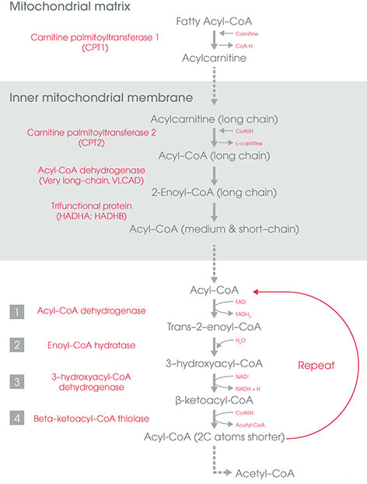
- Transport of activated fatty acids from cytosol into mitochondria (carnitine shuttle): Long chain acyl CoA transverses the inner mitochondria membrane with a special transport mechanism called carnitine shuttle.
Acyl groups from acyl CoA is transferred to carnitine to form acyl carnitine catalyzed by carnitine acyltransferase I, in the outer mitochondrial membrane. Acyl carnitine is then shuttled across the inner mitochondrial membrane by a translocase enzyme. The acyl group is transferred back to CoA in matrix by carnitine acyl transferase II. Then, carnitine is returned back to the cytosolic side by translocase in exchange for an incoming acyl carnitine.
This is considered the rare-limiting step.
- Beta-Oxidation proper in the mitochondrial matrix: Each cycle of β -oxidation, liberating a two carbon unit-acetyl CoA, occurs in a sequence of four reactions
  - Dehydrogenation
  - Hydration
  - Dehydrogenation
  - Cleavage
- DEHYDROGENATION: Oxidation of Acyl CoA undergoes dehydrogenation by an FAD-dependent flavoenzyme, acyl CoA dehydrogenase. A double bond is formed between α and β carbons (i.e., 2 and 3 carbons). FAD is the hydrogen acceptor.
It creates a double bond between the alpha and beta carbons on the fatty acid. The hydrogens are added to FAD creating a molecule of FADH₂.

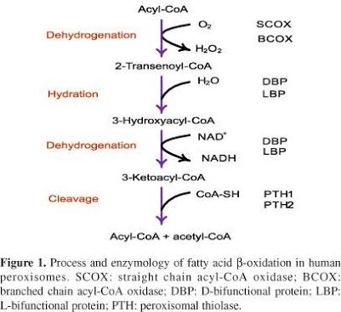

- HYDRATION: The trans alkene is then hydrated with the help of Enoyl-CoA hydratase. Enoyl CoA hydratase brings about the hydration of the double bond to form β -hydroxyacyl CoA. water is added to the double bond of the trans-Δ²-enoyl-CoA to form the L stereoisomer of β-hydroxyacyl-CoA (also designated β-hydroxyacyl-CoA). This reaction, catalyzed by enoyl-CoA hydratase, is formally analogous to the fumarase reaction in the citric acid cycle, in which H₂O adds across an α-β double bond .
- DEHYDROGENATION: the L-β-hydroxyacyl-CoA is dehydrogenated to form β-ketoacyl-CoA by the action of β-hydroxyacyl-CoA dehydrogenase. NAD⁺ is the electron acceptor. This enzyme is absolutely specific for the r. stereoisomer. The NADH formed in this reaction donates its electrons to NADH dehydrogenase (Complex I), an electron carrier of the respiratory chain (Fig. 16-9). Three ATP molecules are generated from ADP per pair of electrons passing from NADH to O₂ via the respiratory chain. The reaction catalyzed by β-hydroxyacyl-CoA dehydrogenase is closely analogous to the malate dehydrogenase reaction of the citric acid cycle .
- CLEAVAGE: catalyzed by acyl-CoA acetyltransferase (more commonly called thiolase), which promotes reaction of β-ketoacyl-CoA with a molecule of free coenzyme A to split off the carboxyl-terminal two-carbon fragment of the original fatty acid as acetyl-CoA. The other product is the coenzyme A thioester of the original fatty acid, now shortened by two carbon atoms. This reaction is called thiolysis, by analogy with the process of hydrolysis, because the β-ketoacyl-CoA is cleaved by reaction with the thiol group of coenzyme A.
The carbon-carbon single bond that connects methylene (-CH₂-) groups in fatty acids is relatively stable. The β-oxidation sequence represents an elegant solution to the problem of breaking these bonds. The first three reactions of β oxidation have the effect of creating a much less stable C-C bond, in which one of the carbon atoms (the a carbon, C-2) is bonded to two carbonyl carbons. The ketone function on the β carbon (C-3) makes it a good point for nucleophilic attack by -SH of coenzyme A, catalyzed by thiolase. The acidity of the a carbon makes the terminal -CH₂-CO-S-CoA a good leaving group, facilitating breakage of the α-β bond.
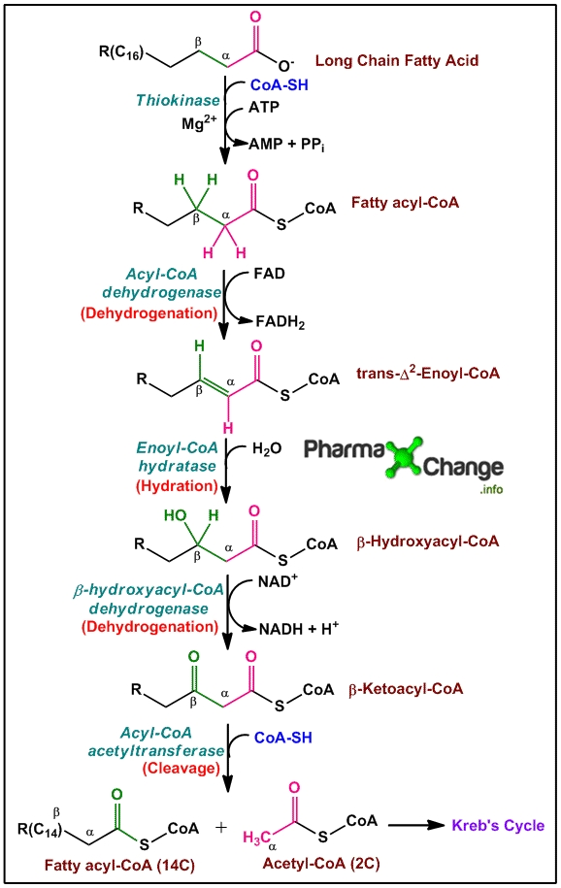

This four steps are repeated to yield Acetyl-CoA and ATP
In one pass through the fatty acid oxidation sequence, one molecule of acetyl-CoA, two pairs of electrons, and four H⁺ ions are removed from the long-chain fatty acyl-CoA, to shorten it by two carbon atoms. The equation for one pass, beginning with the coenzyme A ester of our example, palmitate, is
Palmitoyl-CoA + CoA + FAD + NAD⁺ + H₂O > myristoyl-CoA + acetyl-CoA + FADH₂ + NADH + H⁺
Following removal of one acetyl-CoA unit from palmitoyl-CoA, the coenzyme A thioester of the shortened fatty acid remains, in this case the 14-carbon myristate. The myristoyl-CoA can now enter the β-oxidation sequence and go through another set of four reactions, exactly analogous to the first, to yield a second molecule of acetyl-CoA and lauroylCoA, the coenzyme A thioester of the 12-carbon laurate. Altogether, seven passes through the β-oxidation sequence are required to oxidize one molecule of palmitoyl-CoA to eight molecules of acetyl-CoA.
The overall equation is
Palmitoyl-CoA + 7CoA + 7FAD + 7NAD⁺ + 7H₂O > 8 acetyl-CoA + 7FADH₂ + 7NADH + 7H⁺

