ENYONG, RUTH KINGSLEY
17/MHS01/119
MEDICINE AND SURGERY
HISTOLOGY OF SPECIAL SENSES AND NEUROHISTOLOGY (ANA 305)

- WRITE AN ESSAY ON THE HISTOLOGICAL IMPORTANCE OF EYE IN RELATION TO THEIR CELLULAR FUNCTIONS.

ANSWER
The human eye is a specialized sense organ capable of receiving visual images, which are then carried to the brain. It is an organ that reacts with light and allows light perception, color vision and depth perception. These actions are made possible by the kind of cell it contains which are called the Photoreceptor Cells.
The photoreceptor cell is the main cell of the eye. It is a specialized type of neuro-epithelial cell found in the retina that is capable of visual photo-transduction. The main function of the photoreceptor cell is to convert the light energy (visible electromagnetic radiation) of a photon into a form of energy or signal understood by the nervous system and readily usable to the organism: This conversion is called signal transduction. There are 3 known types of photoreceptor cells in human eye: the two classic photoreceptor cells which include the Rod Cells and the Cone Cells, and the Intrinsically Photosensitive Retinal Ganglion Cells. They all contribute information used by the visual system for the function of sight. There is a membranous photoreceptor protein called Opsin which contains a pigment molecule called Retinal. Opsins are a group of proteins, made light-sensitive, via the chromophore retinal (or a variant) found in photoreceptor cells of the retina. Five classical groups of opsins are involved in vision, mediating the conversion of a photon of light into an electrochemical signal, the first step in the visual transduction cascade. They can be further subdivided into rod opsins and four types of cone opsin. Another opsin found in the mammalian retina, Melanopsin, is involved in circadian rhythms and pupillary reflex but not in vision. The photoreceptor cells are further explained as follows:

- Rod Cells:
The human eye contains about 130 million rod cells. They are found on the outermost layer of the retina. They produces low-light, low-resolution vision, and are very sensitive to motion (as in drawing one’s attention to something moving in the peripheral vision). Rod vision is largely nonfunctional at the intensities of daylight and even most indoor artificial light i.e. it is mainly for night vision. Rod vision also is monochromatic. In rod cells, opsins pigments are together are called Rhodopsin. It is a G-protein-coupled receptor (GPCR). Rod opsins (rhodopsins) usually denoted Rh, are thermally stable. It is extremely sensitive to light, and thus enables vision in low-light conditions. When rhodopsin is exposed to light, it immediately photobleaches.
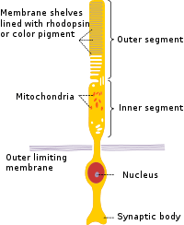
ROD CELLS

- Cone Cells:
The human eye contains about 7 million cone cells. They are found on the outermost layer of the retina. They produce high-resolution, trichromatic vision but require higher light intensity. . Cones are more concentrated in the macula (the central part of the retina). However, they are not limited to daylight. The threshold for activation of cone vision is about midway between the intensity of starlight and moonlight reflected from a sheet of white paper. In cone cells, the cone opsins are called Photopsins. Cone opsins are employed in color vision and are less-stable opsin. They are further subdivided according to their absorption maxima (λ_{max}), the wavelength at which the highest light absorption is observed. Evolutionary relationships, deduced using the amino acid sequence of the opsins, are also frequently used to categorize cone opsins into their respective group. The different photopsins in the cones react to different ranges of light frequency. Vertebrates typically have four cone opsins: long-wave sensitive (LWS), short-wave sensitive 1 (SWS1), short-wave sensitive 2 (SWS2) and rhodopsin-like 2 (Rh2). But the last opsin is now extinct making them 3 in number.
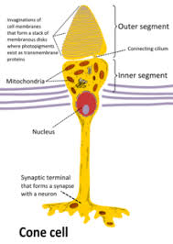
- Retinal Ganglion Cells:
There are over a million retinal ganglion cells in the human retina, and they allow you to see as they send the image to your brain. They process visual information that begins as light entering the eye and transmit it to the brain via their axons. It is located near the inner surface (the ganglion cell layer) of the retina of the eye. Retinal ganglion cells vary significantly in terms of their size, connections, and responses to visual stimulation but they all share the defining property of having a long axon that extends into the brain. These axons form the optic nerve, optic chiasm, and optic tract. A small percentage of retinal ganglion cells contribute little or nothing to vision, but are themselves photosensitive; their axons form the retino-hypothalamic tract and contribute to circadian rhythms and pupillary light reflex, the resizing of the pupil. It is here that the opsin called melanopsin is expressed.
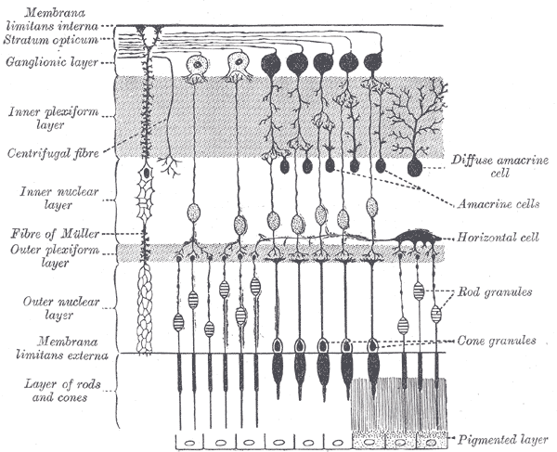
RETINAL GANGLION CELLS
Note that the rod cells and cone cells have the same basic structure but there are basic differences. Rod cells are narrower than cone cells. They are cylindrical and comparatively longer than cone cells.
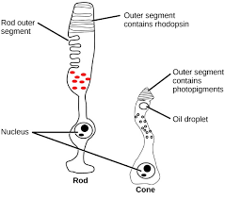
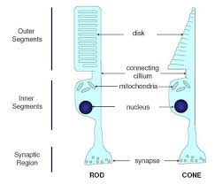
- CORONA VIRUS CAN PENETRATE THE BODY THROUGH THE EYE AND AFFECT THE IMMUNE SYSTEM. BRIEFLY DISCUSS THE LAYERS OF THE RETINA FOR INFORMATION PENETRATION.

ANSWER
The layers of the retina include:

- Outer Limiting Membrane
Radial glial cells of the retina, also known as Muller cells, are in the outer limiting membrane (OLM) of the retina and form adherens junctions between Muller cells and rods and cones in the inner segments which serves to separate the photosensitive regions of the retina from the areas that transmit the electrical signals.

- Inner Limiting Membrane
The ILM is the retina's inner surface bordering the vitreous humor and thereby forming a diffusion barrier between the neural retina and vitreous humor. The ILM contains laterally contacting Muller cell synaptic boutons and other basement membrane parts. It is a thin layer of Muller glial cells and basement membrane which demarcates the vitreous anteriorly from the retina posteriorly.

- Nerve Fiber Layer (NFL)
The nerve fiber layer is the second innermost layer of the retina from the vitreous. This layer contains axons of retinal ganglion cells and the astroglia which support them. Collectively, these axons constitute the optic nerve.

- Ganglion Cell Layer
This layer contains the retinal ganglion cells (RGCs) and displaced amacrine cells. As a rule of thumb, smaller RGCs dendrites arborize in the inner plexiform layer while larger RGCs dendrites arborize in other layers.

- Inner Plexiform Layer
The inner plexiform layer is an area comprised of a dense reticulum of fibrils formed by interlaced dendrites of RGCs and cells of the inner nuclear layer. This layer relays information from cells of the inner nuclear layer.

- Inner Nuclear Layer
This layer of the retina contains the cell bodies of glial, bipolar cells, horizontal cells, and amacrine cells.

- Outer Plexiform Layer
This layer of the retina contains a neuronal synapse of between rods and cones with the footplate of horizontal cells. Capillaries are also found to be primarily running through the outer plexiform layer.

- Outer Nuclear Layer
This layer contains the rod and cone granules that sense photon, extensions from the rod, and cone cell bodies.

- External Limiting Membrane
This layer contains the bases of the rod and cone photoreceptors cell bodies. The ELM forms a barrier between the subretinal space, into which the inner and outer segments of rods and cones project to be in close association with the pigment epithelial layer behind the retina, and the neural retina proper.

- Retinal Pigment Epithelium
The retina is supported by the retinal pigment epithelium (RPE), which has many functions including vitamin A metabolism, maintenance of the blood-retina barrier, phagocytosis of photoreceptor outer segments, production of mucopolysaccharide matrix surrounding the outer segments of the retina, and active transport of materials into and out of RPE.

