NAME: OMOLADE BRIGHT AYOMIDE
DEPARTMENT: COMPUTER SCIENCE
MATRIC NO. : 19/SCI01/078

Number 1

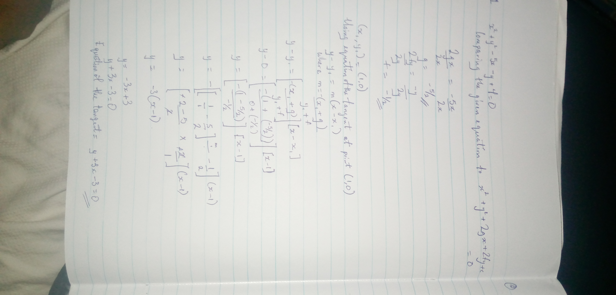

Number 2

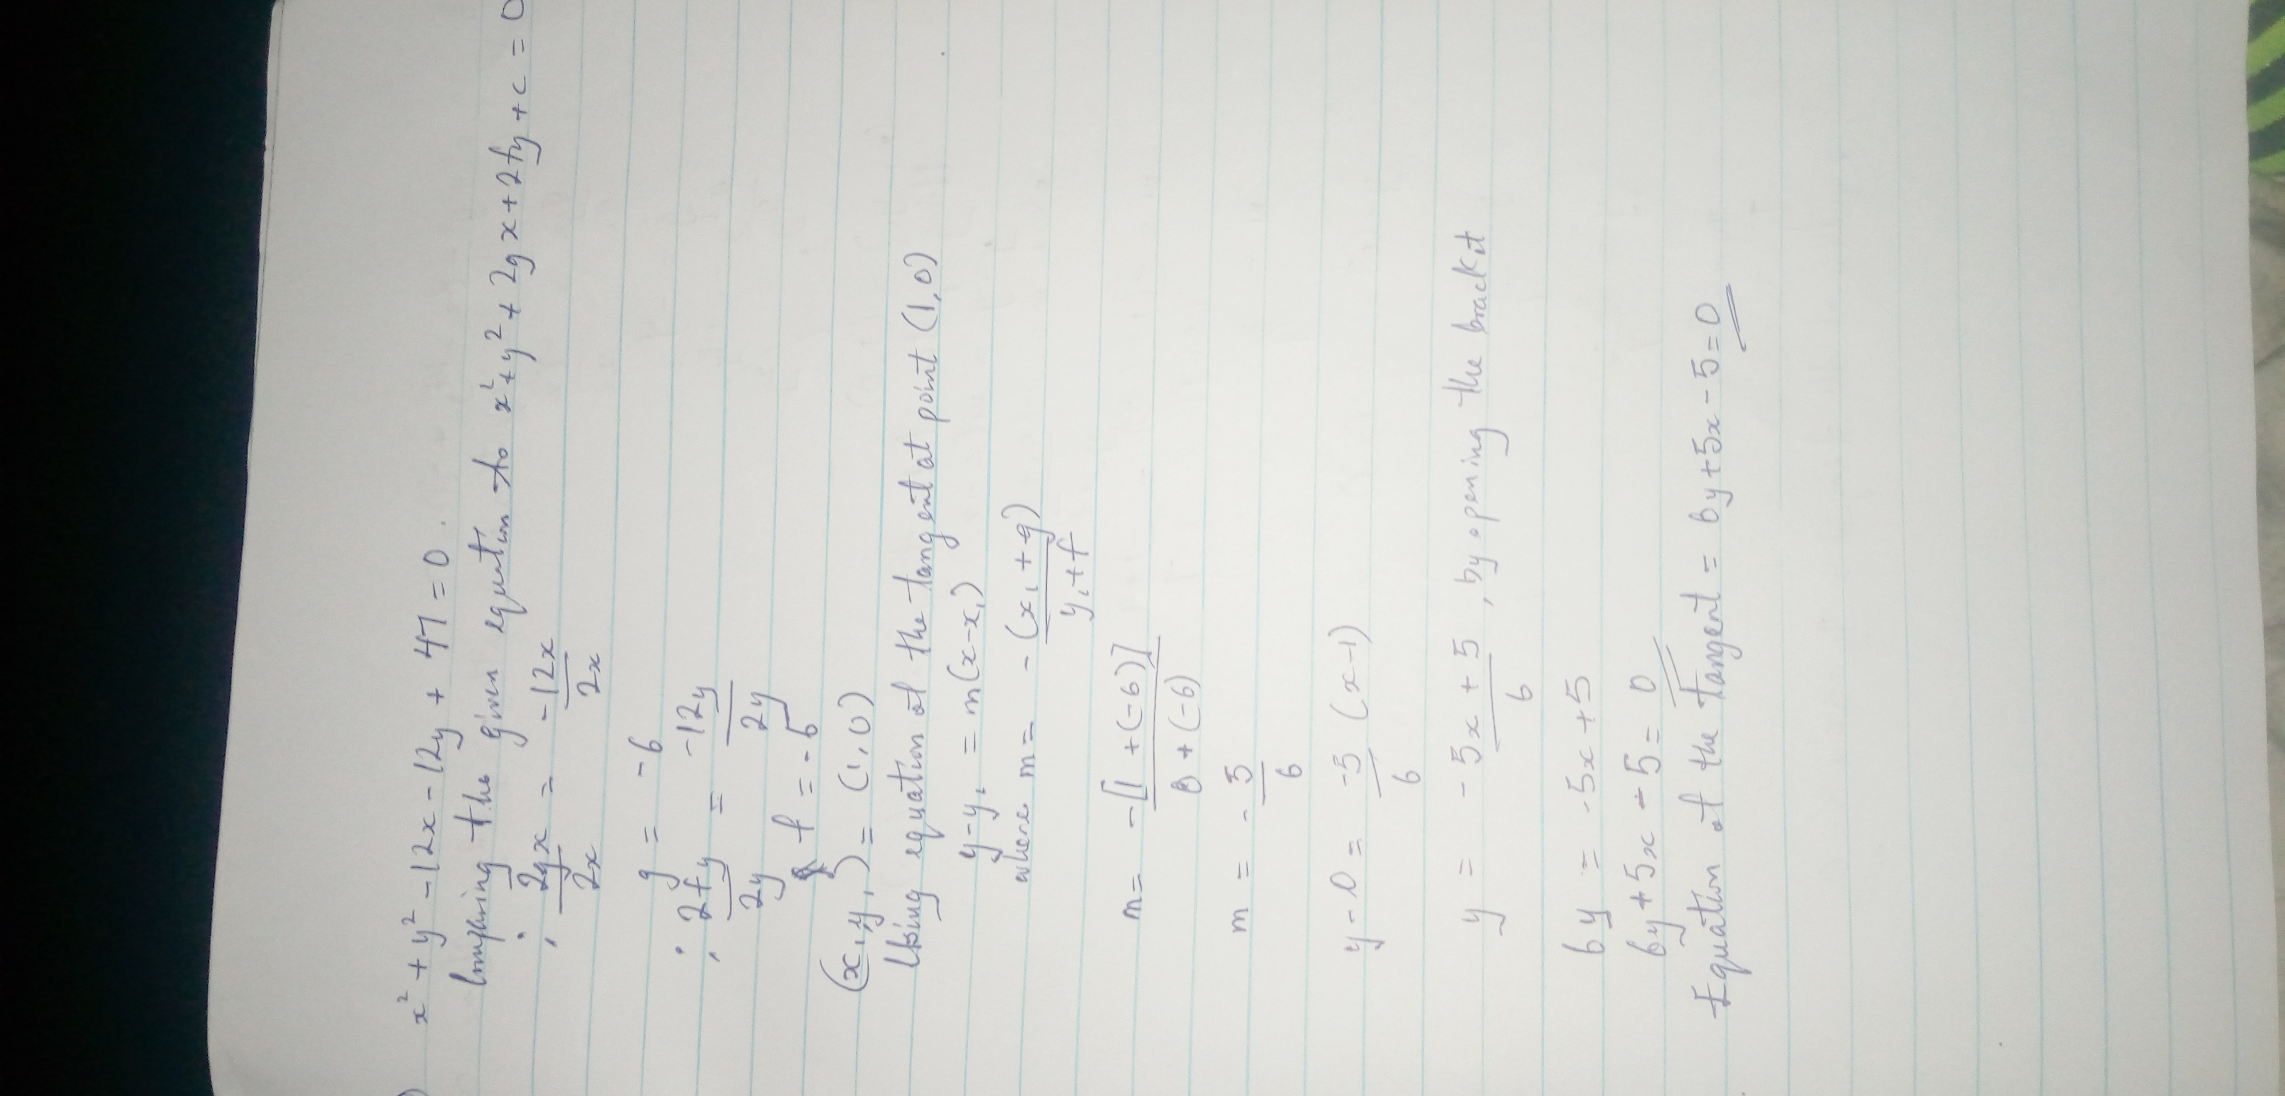

Number 3


