NAME: SUOWARI OYINEBI PASCHELIA
MATRIC NUMBER: 17/MHS01/299
DEPARTMENT: MEDICINE AND SURGERY
HISTOLOGY OF SPECIAL SENSES ASSIGNMENT
- Write an essay on the histological importance of eye in relation to their cellular functions.
- Corona virus can penetrate the body through eye and implicate the immune system, briefly discuss the layers of retina for information penetration.
ANSWERS
- HISTOLOGICAL IMPORTANCE OF THE EYE
The eye is an organ specialized for the detection and analysis of light. The eye is a fluid chamber enclosed by three layers of tissue. The outermost of the three coasts of the eye consists of cornea, limbus and sclera. The transparent cornea makes up about 18% outer coat of the eye; the white opaque sclera accounts for most of the rest. Both tissues consist mainly of collagen fibers. The cornea is the principal refractive element of the eye. The sclera is rigid and resistant to penetration; it is able to protect the more delicate inner layers. The limbus is the region of transition from cornea to sclera.
The middle layer, the uveal tract, includes the iris, ciliary body and choroid. The iris is a layer disposed in the anterior pole of the eye, behind the cornea, that limits the quantity of light entering into the eye through the pupil. The ciliary body is adjacent to the iris and it consists in a ring of muscle cells encircling the anterior portion of the eye. The aqueous humor is formed at this site. The ciliary body musculature is part of the system for altering the refractive power of the lens, accommodation. The choroid is composed of blood vessels and pigmented epithelium.
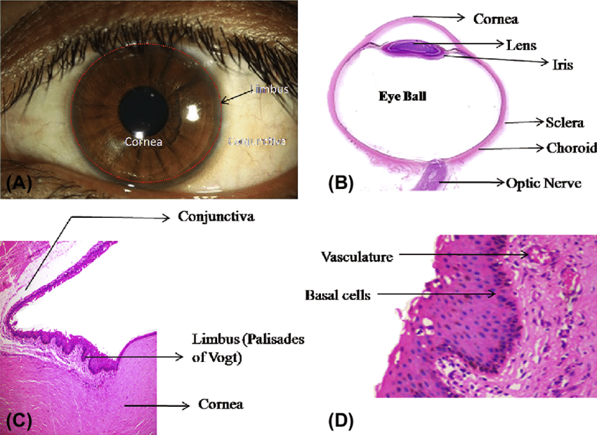
The collagen of the sclera is continuous with the cornea. From outer to innermost, the four layers of the sclera are:
- episclera
- stroma
- lamina fusca
- endothelium
The sclera is opaque due to the irregularity of the Type I collagen fibers, as opposed to the near-uniform thickness and parallel arrangement of the corneal collagen. Moreover, the cornea bears more mucopolysaccharide (a carbohydrate that has among its repeating units a nitrogenous sugar, hexosamine) to embed the fibrils.
The cornea, unlike the sclera, has five layers. The middle, thickest layer is also called the stroma. The sclera, like the cornea, contains a basal endothelium, above which there is the lamina fusca, containing a high count of pigment cells.
The Human eyes are somewhat distinctive in the animal kingdom in that the sclera is very plainly visible whenever the eye is open. This is not just due to the white colour of the human sclera, which many other species share, but also to the fact that the human iris is relatively small and comprises a significantly smaller portion of the exposed eye surface compared to other animals. It is theorized that this adaptation evolved because of our social nature as the eye became a useful communication tool in addition to a sensory organ. It is believed that the conspicuous sclera of the human eye makes it easier for one individual to identify where another individual is looking, increasing the efficacy of this particular form of nonverbal communication.
- LAYERS OF RETINA FOR INFORMATION PENETRATION
The retina processes the light information that it receives from the surrounding world. This portion of the nervous system processes the light information and transmits it to the brain via the optic nerve which exits the eyeball from its posterior pole. Retina works detecting light in the retinal image and sending it to the brain, but not as a simple point-by-point representation of the image. In the retina, complex processes are carried out before sending the information to superior centres.
The retina is the innermost layer in the eye that is responsible for the visual processing that turns light energy from photons into three-dimensional images. Located in the posterior portion of the eyeball, the retina is the only extension of the brain that can be viewed from the outside world and gives ophthalmologists a rare window into real-time pathology affecting the retina. Development of the retina is a long and complex process that begins during the fourth week of embryogenesis and continues into the first year of life. This long and complex embryonic development makes the retina vulnerable to genetic and environmental insults that can negatively affect retinal development. Retinal tissue develops to become the most metabolically expensive tissue in the human body, consuming oxygen more rapidly than any other tissue. The retina is fed oxygen from a unique dual blood supply that divides the retina into outer and inner layers for more efficient oxygenation. The retina itself consists of six different cell lines divided into ten different layers, each playing a specific role in creating and transmitting vision. The different cell types perform a particular role and form functional circuits that specialize in detecting specific variations and movements of light.
Vertebrate retina is organized in superimposed layers, formed by the different cells. The retina contains five mayor types of cells: photoreceptors (rods and cones), bipolar cells, horizontal cells, amacrine cells and ganglion cells (RGC). In general, cell somas are grouped in three distinct nuclear layers, separated by two connecting layers plexiform layers, where synapses between cells are formed.
The retina is a layered structure with ten distinct layers of neurons interconnected by synapses. The cells subdivide into three basic cell types: photoreceptor cells, neuronal cells, and glial cells. The layers from the closest to the front anterior of the head towards the posterior of the head are as follows:
- Inner limiting membrane
The ILM is the retina's inner surface bordering the vitreous humor and thereby forming a diffusion barrier between the neural retina and vitreous humor. The ILM contains laterally contacting Muller cell synaptic boutons and other basement membrane parts.
- Nerve fiber layer (NFL)
The nerve fiber layer is the second innermost layer of the retina from the vitreous. Patients with retinitis pigmentosa may have a measurable degree of RNFL thinning as determined by OCT.
- Ganglion cell layer
This layer contains the retinal ganglion cells (RGCs) and displaced amacrine cells. As a rule of thumb, smaller RGCs dendrites arborize in the inner plexiform layer while larger RGCs dendrites arborize in other layers.
- Inner plexiform layer
The inner plexiform layer is an area comprised of a dense reticulum of fibrils formed by interlaced dendrites of RGCs and cells of the inner nuclear layer.
- Inner nuclear layer
This layer of the retina contains the cell bodies of bipolar cells, horizontal cells, and amacrine cells
- Middle limiting membrane
- Outer plexiform layer
- Outer nuclear layer
This layer contains the rod and cone granules that sense photon, extensions from the rod, and cone cell bodies
- External limiting membrane
This layer contains the bases of the rod and cone photoreceptors cell bodies. The ELM forms a barrier between the sub retinal space, into which the inner and outer segments of rods and cones project to be in close association with the pigment epithelial layer behind the retina, and the neural retina proper.
- The layer of rods and cones
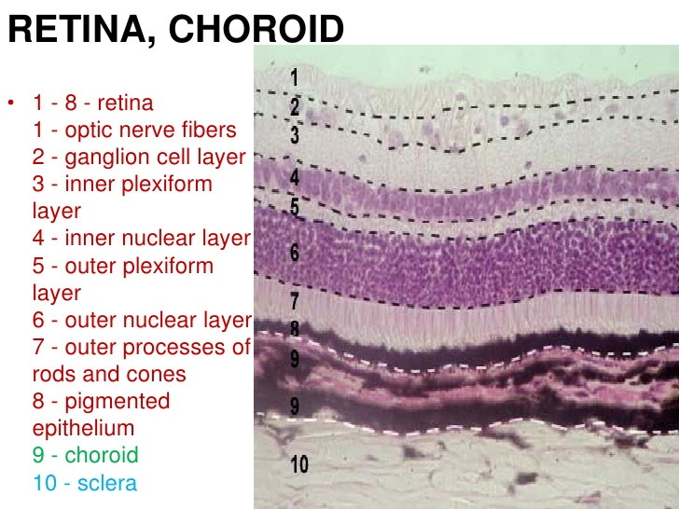
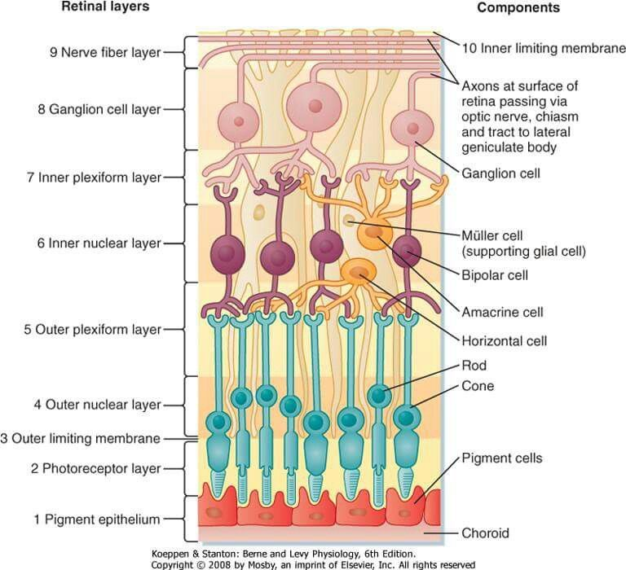
The basic system of retinal information processing consists on a direct pathway of visual information that flows from photoreceptors to bipolar cells to ganglion cells. The ganglion cells fire action potentials in response to light, and these impulses propagate down the optic nerve to the projection nuclei in the brain. This direct pathway is influenced by two transverse fluxes of modulatory signals coming from horizontal in outer plexiform layer and amacrine cells in inner plexiform layer. Horizontal cells receive input from the photoreceptors and project their processes laterally to influence surrounding bipolar cells. Amacrine cells receive input from bipolar cells and project their processes laterally to influence surrounding bipolar and ganglion cells. Both, horizontal and amacrine cells usually make electrical and chemical synapses with neighbour cells of the same type.

