Aliu Kudirat Oshione
17/MHS01/054
Neurohistology
Question 1: Write an essay on the histological importance of the eye in relation to their cellular function.
Answer:
Eyes are highly developed photosensitive organs for analyzing the form, intensity, and color of light reflected from objects and providing the sense of sight. Protected within the orbits of the skull which also contain adipose cushions, each eyeball consists externally of a tough, fibrous globe that maintains its overall shape. Internally the eye contains transparent tissues that refract light to focus the image, a layer of photosensitive cells, and a system of neurons that collect, process, and transmit visual information to the brain. Photoreceptors are the main cells of the eye.
A photoreceptor cell is a specialized type of neuroepithelial cell found in the retina that is capable of visual phototransduction. The great biological importance of photoreceptors is that they convert light (visible electromagnetic radiation) into signals that can stimulate biological processes. To be more specific, photoreceptor proteins in the cell absorb photons, triggering a change in the cell's membrane potential.
There are currently three known types of photoreceptor cells in mammalian eyes: rods, cones, and intrinsically photosensitive retinal ganglion cells. The two classic photoreceptor cells are rods and cones, each contributing information used by the visual system to form a representation of the visual world, i.e sight.
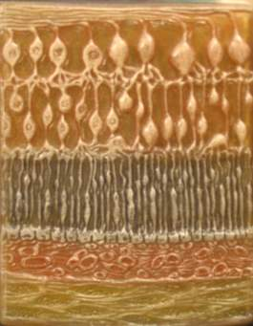
Fig: Histological layers of the eye
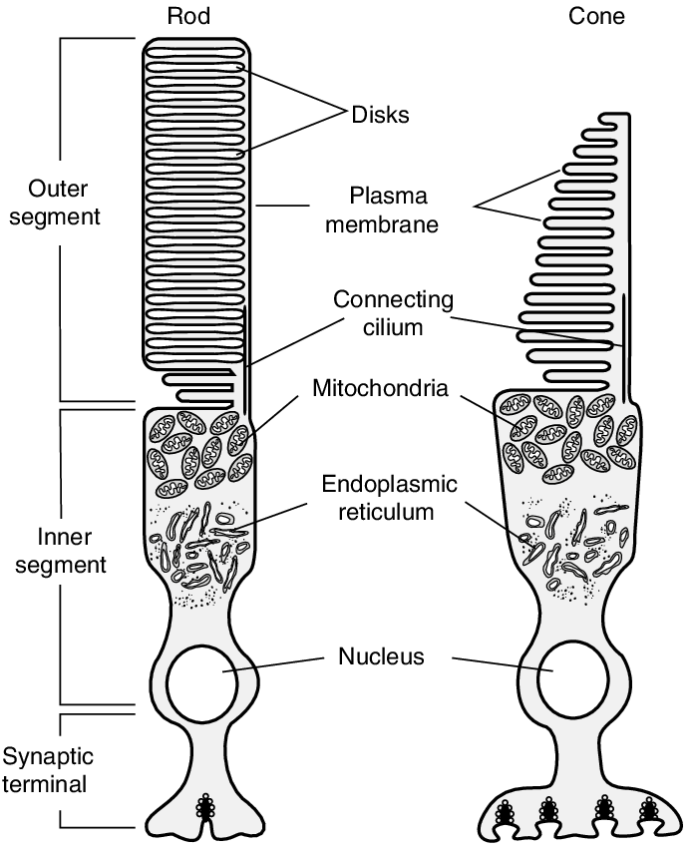
FIG: ROD AND CONE CELL

STRUCTURE OF THE EYE
The eye is made up of both internal and external structures:
• External Structures of the Eye:
1. Conjunctiva: The conjunctiva lines the inner part of the eyelids. The tarsal plate lies beneath the conjunctiva and contains meibomian glands, which secrete an oily substance to decrease the evaporation of the tear film.
2. Tear film: The tear film consists of aqueous, mucus, and oily secretions.
3. Accessory glands: Apocrine glands of Moll, meibomian glands, lacrimal glands.
4. Muscles: Orbicularis oculi, levator palpebrae superioris, superior tarsal muscle.
5. Eyelid: The eyelid, likewise known as the cover of the eye, a mobile layer made up of non keratinized squamous epithelium and also muscular tissue and also covers the eyeball.
• Internal Structures of the Eye: The innermost structures of the eye are organized into three layers:
(A) Outermost Layer: Sclera and Cornea:
1) The sclera (white of the eye): The sclera is a dense connective tissue made of mainly type 1 collagen fibers, oriented in different directions. The lack of parallel orientation of collagen fibers gives the sclera its white appearance, as opposed to the transparent nature of the cornea. However, the collagen of the sclera and cornea are continuous.
The four layers of the sclera from external to internal are episclera, stroma, lamina fusca, endothelium. The episclera is the external surface of the sclera. It is connected to the Tenon capsule by thin collagen fibers. At the corneoscleral junction, also known as the limbus, the Tenon capsule contacts stroma of the conjunctiva.
2. Cornea (transparent front layer of the eye): Made of type I collagen fibers oriented in a uniform parallel direction to maintain transparency. Consists of five layers: non-keratinized, stratified squamous epithelium, Bowman layer, stroma or substantia propria, Descemet’s membrane, corneal endothelium.
I) Corneal epithelium: This is a fast growing, regenerating multicellular layer which interacts directly with the tear film.
II) Bowman layer: This is a layer of subepithelial basement membrane protecting the underlying stroma. It is composed of type 1 collagen, lamina, and several other heparan sulfate proteoglycans.
III) Stroma: The largest layer of the cornea, the stroma has collagen fibers arranged in a regular pattern. Keratocytes maintain the integrity of this layer. The function of this layer is to maintain transparency, which occurs by the regular arrangement, and lattice structure of the fibrils, whereby scatter from individual fibrils gets canceled by destructive interference, and the spacing of less than 200 nm allows for transparency.
IV) Descemet’s membrane: It is an acellular layer made of type IV collagen that serves as a modified basement membrane of the corneal endothelium.
V) Corneal endothelium: This is a one cell thick layer made of either simple squamous or cuboidal cells. Cells in this region do not regenerate and have pumps that maintain fluid balance and prevent swelling of the stroma. When corneal endothelial cells are lost, neighboring cells stretch to attempt to compensate these losses.
(B) Middle Layer: Uvea (Iris, Ciliary Body, Choroid):
1. Iris: Consists of (1) a stromal layer with pigmented, fibrovascular tissue and (2) a pigmented epithelial cells beneath the stroma. The sphincter pupillae and dilator pupillae muscles connect to the stroma. The pigmented layer of cells blocks rays of light and ensures that light must move through the pupil to reach the retina. The angle formed by the iris and cornea contains connective tissue with endothelial channels called the trabecular meshwork, which drains aqueous humor in the anterior chamber into the venous canal of Schlemm. From here, fluid drains into episcleral veins.
2. Ciliary Body: The tissue that divides the posterior chamber and vitreous body. It consists of the ciliary muscle and the ciliary epithelium. The ciliary muscle, via the lens zonules, controls the structure of the lens, which is vital for accommodation. Zonules are connective tissue fibers that connect the ciliary muscle and lens. The ciliary epithelium produces aqueous humor which fills the anterior compartment of the eye.
3. Choroid: Consists of a dense network of blood vessels supplying nourishment to structures of the eye, housed in loose connective tissue. The choriocapillary layer is located in the innermost part of the choroid and supplies the retina. The Bruch membrane is an extracellular matrix layer situated between the retina and choroid and has significance in age-related macular degeneration, where an accumulation of lipid deposits prevent diffusion of nutrients to the retina.
(C) Innermost layer: Lens, Vitreous, Retina:
1. Lens: separates the aqueous and vitreous chambers. Consists of an outer capsule, a middle layer called cortex, and an inner layer called the nucleus. The capsule is the basement membrane of the lens epithelium which lies below. New lens cells differentiate from the lens epithelium and are incorporated peripherally, pushing older lens cells towards the middle.
2. Vitreous: a jelly-like space made of type II collagen separating the retina and the lens
3. Retina: The nervous tissue of the eye where photons of light convert to neurochemical energy via action potentials. It is divided into the following layers: retinal pigment epithelium, rod and cone cells layer, outer limiting membrane,outer nuclear layer, outer plexiform layer, inner nuclear layer, inner plexiform layer, ganglion cell layer nerve fiber layer and internal limiting membrane.

Functions of the Parts of the Eye
The layers of the eye perform distinct functions which coalesce to create a unified, perceptual experience. The essential role of the external eye structures is to protect the delicate tissue of the internal eye. The eyelid prevents foreign bodies from entering the inner eye and helps refresh and distribute the tear film by blinking. Eyelashes are finely sensitive to touch and warn the eye of possible debris and particles that may cause injury.
Internal parts of the eye have primarily structural and visual functions. The cornea serves a protective role and is responsible for two-thirds of the refractive properties of the eye. The remaining one-third of refraction is performed by the lens, which is functionally adjustable through the action of the zonular fibers and ciliary muscles. At the end of the visual process, as rays of light bend through the cornea and lens, photon energy is converted to neurochemical action potentials by cells of the retina, which then send these impulses to the brain, via the optic nerve.
The uvea of the eye is a crucial mediator of nutrition and gas exchange, as blood vessels course through the ciliary body and iris, while the choriocapillaris in the posterior eye help support the retina. This abundant blood supply is implicated in uveitis, as inflammatory mediators enter the eye through this vascular network.

Question 2: Corona virus can penetrate the body through eye and implicate the immune system, briefly discuss the layers of retina for information penetration.
Answer:
The retina is the most inner most tunic of the eye and it develops with two sublayers from the inner and outer layers of embryonic optic cup.
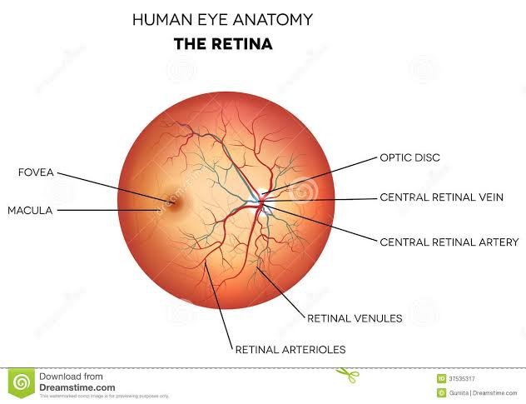
The microscopic layers of the retina contain 3 types of cells and their synapse are arranged in the following 10 layers:
- Inner limiting membrane (ILM): This consists of terminal expansions of Müller cell processes that cover the collagenous membrane of the vitreous body and form the inner surface of the retina. The ILM is the retina's inner surface bordering the vitreous humor and thereby forming a diffusion barrier between the neural retina and vitreous humor. It contains laterally contacting Müller cell synaptic boutons and other basement membrane parts.
- Nerve fiber layer (NFL): This is the second innermost layer of the retina from the vitreous. This layer contains axons of retinal ganglion cells and the astroglia which support them. Collectively, these axons constitute the optic nerve
- Ganglionic layer (GL): This layer is located near the vitreous and has neurons (ganglion cells) with much longer axon. The GL is thickest near the central, macular region of the retina but it thins peripherally to only one layer of cells.
- Inner plexiform layer (IPL): It consists of axons and dendrites connecting neurons of the INL with the ganglion cells. The area consists of dense reticulum of fibrils formed by interlaced dendrites of RGCs and cells of the inner nuclear layer. This layer relays information from cells of the inner nuclear layer.
- Inner nuclear layer (INL): This layer contains the nuclei of various neurons, notably the bipolar cells, amacrine cells, and horizontal cells, all of which make specific connections with other neurons and integrate signals from rods and cones over a wide area of the retina.
- Outer plexiform layer (OPL): It includes axons of the photoreceptors and dendrites of association neurons in the INL. It contains a neuronal synapse of between rods and cones with the footplate of horizontal cells. Capillaries are also found to be primarily running through the outer plexiform layer.
- Outer nuclear layer (ONL): This is located close to the pigmented epithelium. It contains cell bodies of photoreceptors (the rod and cone cells). These cells, receive O2 and nutrients by diffusion from the choroidocapillary lamina of the choroid.
- Outer limiting layer (OLL): This is a series of adherent junctions (zonula adherentes) between the photoreceptors and Müller cells (radial glial cells of the retina). The Müller cells are in the outer limiting membrane (OLM) of the retina and form adherens junctions between Muller cells and rods and cones in the inner segments which serves to separate the photosensitive regions of the retina from the areas that transmit the electrical signalS.
- Rod and cone cells layer: This layer is named for the shape of their outer segments. They are polarized neurons with their photosensitive portions aligned in the retina’s rod and cone layer and their axons in the OPL.
- Retinal pigment epithelium: The pigmented epithelial layer of the retina consists of low columnar cells or cubiodal cells with basal nuclei and surrounds the neural layer of the retina. The cells consist of well-developed gap junctions, junctional complexes, and numerous invaginations. The apical ends of the cells extend processes and sheath-like projections that surround the tips of the photoreceptors. Melanin granules are numerous in these extensions and in the apical cytoplasm. This cellular region also contains numerous phagocytic vacuoles and secondary lysosomes, peroxisomes, and abundant smooth ER (SER) specialized for retinal (vitamin A) isomerization.

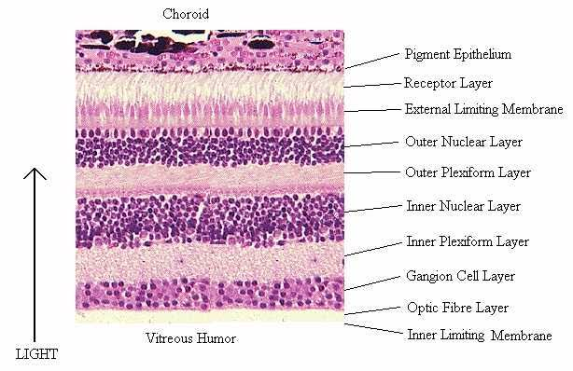FIG: LAYERS OF THE RETINA.

