Name: ADENIYI ADERONKE TEMILOLA
Matric number: 17/MHS02/019
Level: 300
Course: Histology

- Essay on histological importance of the eye in relation to their cellular functions.
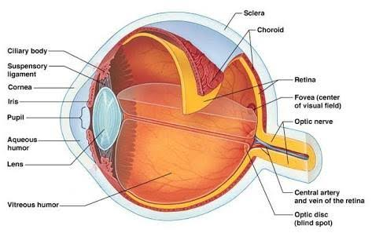
LAYERS OF THE EYE

The eyes are complex and highly developed photosensitive organ that analyses the form, intensity, and colour of light reflected from objects which are then carried to the brain. They provide the sense of sight. The eye is composed of three concentric tunics/ layer: the tough external fibrous layer, the middle vascular layer, the inner sensory layer (the retina).
The fibrous layer consists of the posterior sclera and the anterior cornea joined at the limbus. The sclera is the white opaque posterior five-sixths of the external layer. It averages 0.5 mm in thickness, is relatively avascular, and consists of tough, dense connective tissue containing flat type I collagen bundles. Its histological importance in relation to the cellular function is that it supports the eye shape, protects the more delicate internal structures and provides sites for extrinsic eye muscle attachment.
The cornea is the anterior one-sixth of the eye. It is colourless, transparent, and completely avascular. It consists of five distinct layers: an external stratified squamous epithelium aids in cell renewal and repair, also having one of the richest sensory nerve supplies. An anterior limiting membrane (Bowman's membrane, the basement membrane of the stratified epithelium) aids to protect against infection of the underlying stroma. The thick stroma aids in transparency of the avascular tissue. A posterior limiting membrane (Descemet's membrane). Lastly, an inner simple squamous endothelium, aids maximal transparency and optimal light refraction.
The vascular layer consists of three parts, from posterior to anterior: the choroid, the ciliary body, and the iris. The choroid is located in the posterior two-thirds of the eye, with loose, well-vascularized connective tissue rich in collagen and elastic fibers, fibroblasts, melanocytes, macrophages, lymphocytes, mast cells, and plasma cells. The abundant melanocytes give the layer its characteristic black colour and block light from entering the eye except through the pupil the ciliary body is an anterior expansion of the vascular layer that encircles the lens and lies posterior to the limbus. Its components are ciliary smooth muscle and ciliary processes covered with a secretory epithelium. Its histological importance in relation to its cellular function: it holds suspensory ligaments that attach to the lens and change lens shape for far and near vision.
The iris is the most anterior extension of the vascular layer that partially covers the lens, leaving a round opening in the center called the pupil. Apart from the pupil it has two layers of smooth muscle (sphincter pupillae and dilator pupillae) and connective tissue. Its histological importance in relation to its cellular function: it controls the pupil diameter and the amount of light entering the eye.
The retina is the inner layer of the eye derived from the embryonic optic cup. The retina consists of two major layers: The neural retina (inner) contains the bipolar neurons, ganglion cells, supporting Müller cells and photoreceptors. This layer's visual region extends anterior only as far as the ora serrata. Its histological importance in relation to its cellular function: it detects incoming light rays which are converted to nerve signals and transmitted to the brain. The pigmented layer (outer) is an epithelium resting on Bruch's membrane just inside the choroid. Its histological importance in relation to its cellular function: it serves as an important part of the blood-retina barrier. It absorbs light passing through the retina to prevent its reflection. Phagocytosis of shed components from the adjacent photoreceptors and degradation of this material occurs in these epithelial cells. It removes free radicals. It provides vitamin A for photoreceptor cells. Lastly, it isomerizes and regenerates the retinoids used as chromophores by the rods and cones.
In conclusion, the eyes are not just tissues, they are one of the finest creations of God; they have helped not just to realise dreams but to achieve them hence the importance of the eyes could not be overstated.

Clinical Significance
Several of the most common diseases of the eye are manifestations of pathology within specific histological layers. Below are examples of common eye conditions, and the layers of the eye implicated:
- "Chalazion": A sterile lump often in the upper eyelid caused by obstruction of the meibomian oil glands.
- "Conjunctivitis": Inflammation of the transparent conjunctiva that may be caused by bacterial or viral infections, allergies, or exposure to certain chemicals.
- "Cataracts": A sclerotic nuclear cataract is the most common and is due to opacification in the central nucleus of the lens. Cortical cataracts are due to opacifications in the cortex and have a distinct wedge-shaped appearance. Posterior subcapsular cataracts arise from behind the sac-like structure of the lens.
- "Glaucoma": Refers to optic nerve damage related to increased intraocular pressure. Drainage of aqueous humor through the trabecular meshwork is often implicated.

- Coronavirus can penetrate the body through the eye implicate the immune system; briefly discuss of the retina for information penetration.
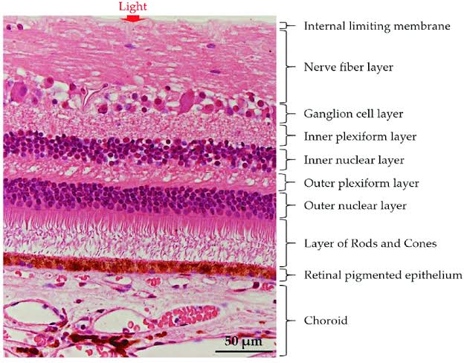
LAYERS OF THE RETINA
Coronaviruses are group of viruses which typically tend to affect human and other mammal’s respiratory tract and their guts. It is an infectious disease. It spreads from one person to another through small droplets from nose and mouth of an infected (coughing or sneezing) which lands on objects and surface around the person. Other people then catch by touching the surface then touching their eye, nose and mouth. People can also become infected if they breathe in droplets from a person with coronavirus disease.
The retina is the innermost, light-sensitive layer of tissue of the eye of most vertebrates and some molluscs. The vertebrate retina has ten distinct layers. From closest to farthest from the vitreous body:
    - Inner limiting membrane – basement membrane elaborated by Müller cells.
    - Nerve fibre layer – axons of the ganglion cell bodies (note that a thin layer of Müller cell footplates exists between this layer and the inner limiting membrane).
    - Ganglion cell layer – contains nuclei of ganglion cells, the axons of which become the optic nerve fibres, and some displaced amacrine cells.
    - Inner plexiform layer – contains the synapse between the bipolar cell axons and the dendrites of the ganglion and amacrine cells.
    - Inner nuclear layer – contains the nuclei and surrounding cell bodies (perikarya) of the amacrine cells, bipolar cells, and horizontal cells.
    - Outer plexiform layer – projections of rods and cones ending in the rod spherule and cone pedicle respectively. These make synapses with dendrites of bipolar cells and horizontal cells. In the macular region, this is known as the Fiber layer of Henle.
    - Outer nuclear layer – cell bodies of rods and cones.
    - External limiting membrane – layer that separates the inner segment portions of the photoreceptors from their cell nuclei.
    - Inner segment / outer segment layer– inner segments and outer segments of rods and cones. The outer segments contain a highly specialized light-sensing apparatus.
    - Retinal pigment epithelium – single layer of cuboidal epithelial cells (with extrusions not shown in diagram).This layer is closest to the choroid and provides nourishment and supportive functions to the neural retina. The black pigment melanin in the pigment layer prevents light reflection throughout the globe of the eyeball; this is extremely important for clear vision.
These layers can be grouped into 4 main processing stages: photoreception; transmission to bipolar cells; transmission to ganglion cells, which also contain photoreceptors, the photosensitive ganglion cells; and transmission along the optic nerve. At each synaptic stage there are also laterally connecting horizontal and amacrine cells. Structures that also aid in information penetration include:

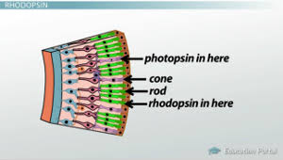

Photoreceptors: are called rods and cones located in the retina which are highly specialised neurons that convert information provided by light into electrical signals that are conducted in the brain. They are essentially little nerves with specialized endings called receptors, which catch light particles called photons and convert the information these photons provide into electrical signals that our brain can interpret and process into a visual image we can understand.
Photopsin: they are tiny little things which are light-sensitive protein responsible for colour vision located in the cone cells of the eye's retina. Aid in the ability to see colour.
Rhodopsin: they are rod cells located in the retina which have a light sensitive protein responsible for vision in low light conditions.

Clinical significance
There are many inherited and acquired diseases or disorders that may affect the retina. Some of them include:
- Retinitis pigmentosa is a group of genetic diseases that affect the retina and cause the loss of night vision and peripheral vision.
- Macular degeneration describes a group of diseases characterized by loss of central vision because of death or impairment of the cells in the macula.
- Cone-rod dystrophy (CORD) describes a number of diseases where vision loss is caused by deterioration of the cones and/or rods in the retina.

