NAME: ADEJUGBE SAMUEL ADEMIDUN
DEPARTMENT: COMPUTER SCIENCE
MATRIC NO. : 19/SCI01/004

Number 1

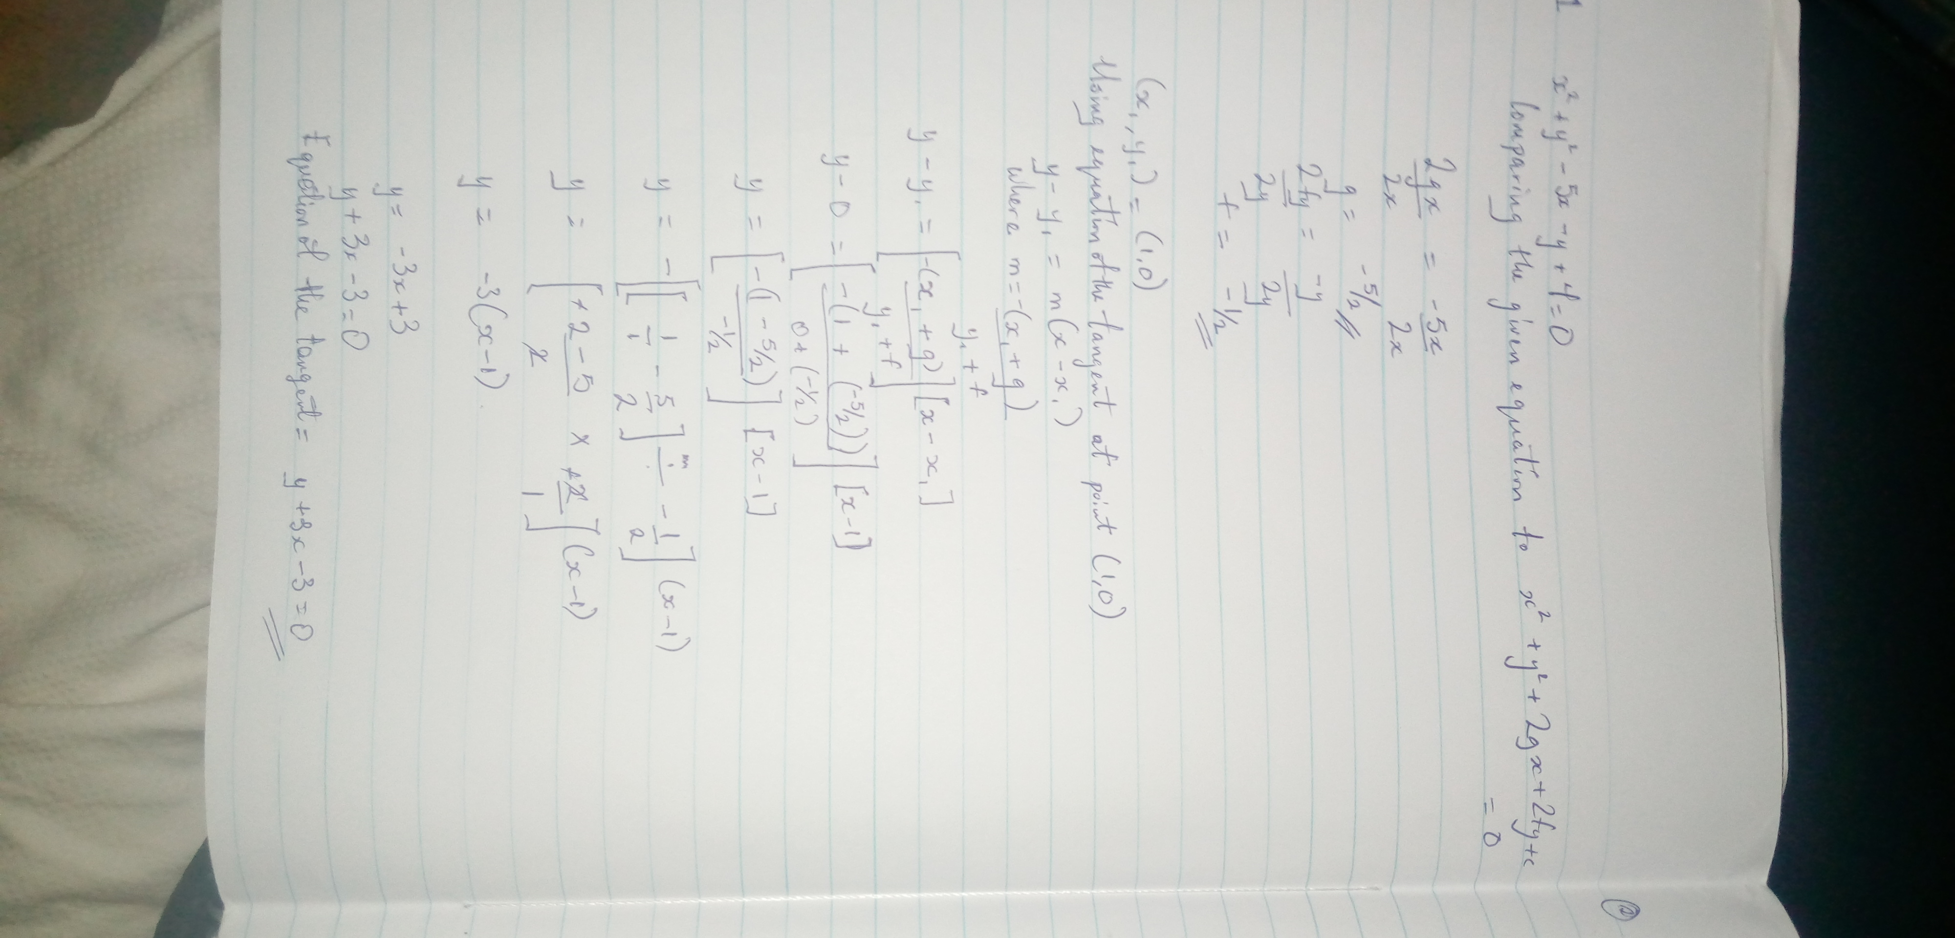

Number 2

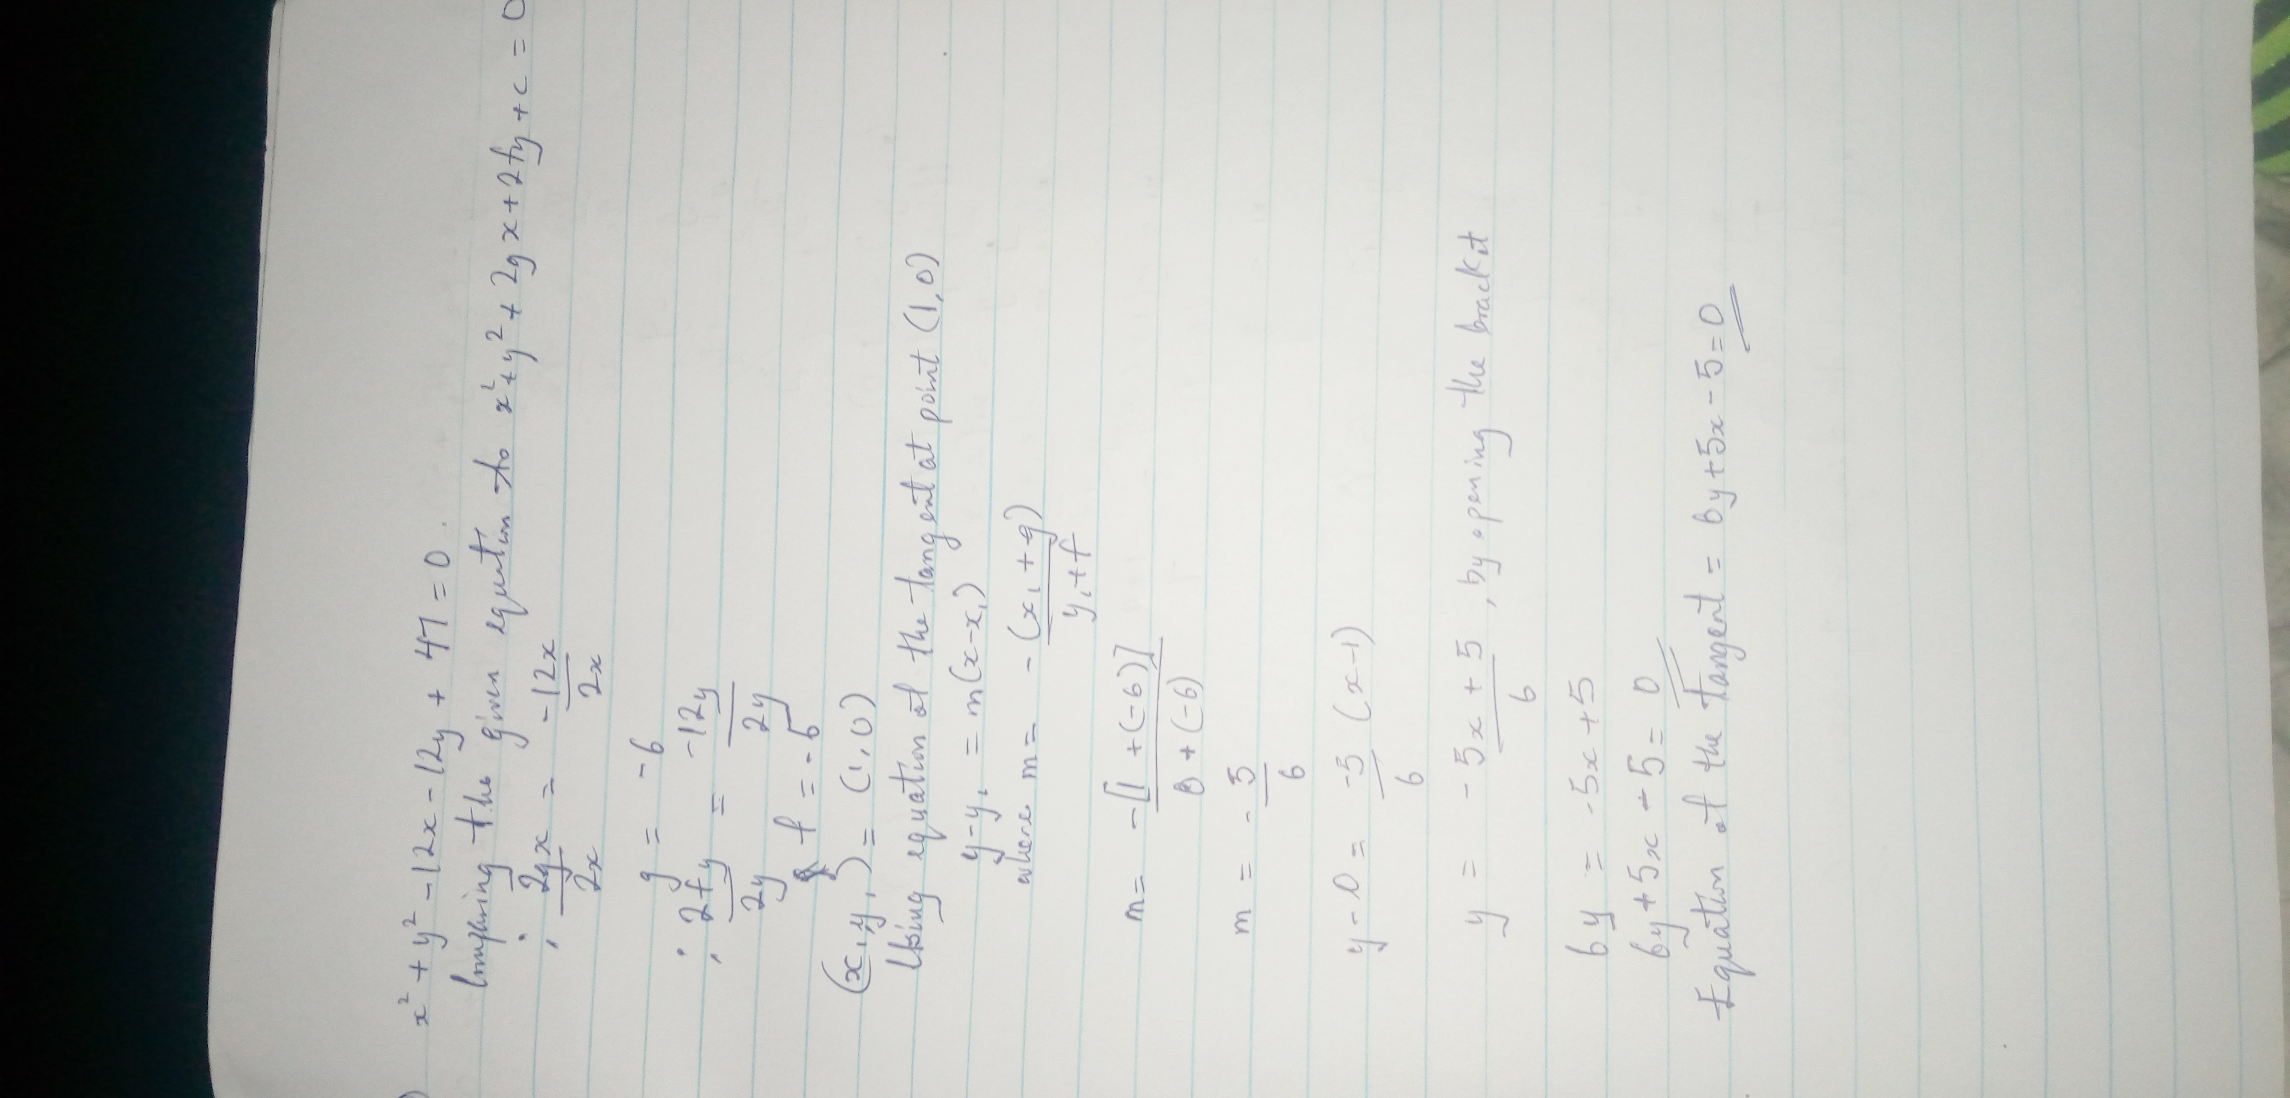

Number 3


