NAME: UBABIRI BENEDICT MESHACK
MATRIC NUMBER: 15/ENG07/046
QUESTIONS:
Briefly discuss the following thermal
enhanced oil recovery methods; (diagram inclusive)
1. steam assisted gravity drainage (SAGD)
2. Cyclic steam stimulation (CSS)
3. Hot water flood

Answers.
Thermal enhanced oil recovery involves burning natural gas to produce steam which is injected into the reservoir to heat heavy oil to reduce its viscosity. On the other hand, solar generated steam in EOR involves the use of concentrating solar power technology to produce this steam. Mirrors are used to reflect and concentrate sunlight onto receivers that collect solar energy and convert it to heat. This heat is then used to produce steam from water. One of the principal benefits of using solar energy for thermal EOR is the reduced energy costs and carbon footprint of the crude oil produced. the main aim of thermal is to use energy from steam to heat up the oil in the subsurface. This allows the oil to flow more easily due to the impact of various recovery mechanisms. Some of the mechanisms that have been shown to provide major contributions during thermal enhanced oil recovery which include crude, oil viscosity reduction, thermal expansion and crude-oil vaporization.

1. Steam assisted gravity drainage(SADG):
The Steam-Assisted Gravity Drainage (SAGD) process is an enhanced oil recovery (EOR) method for certain heavy oil non-fractured sandstones, In this case of (SAGD), the steam at high pressure is injected continually in a horizontal bwell to provide thermal energy in the well that reduces the oil viscosity. The heated well is then drained into a lower well where it is pumped,This method is best suited for heavy oil extraction in carbonate reservoirs.These are mostly naturally fractured reservoirs. The effect of this fracture properties like fracture orientation, fracture spacing, and fracture permeability on the SAGD performance in naturally fractured reservoirs were studied through experimentation and modeling using of thermal stimulators.
Experimentally, the combination of the SAGD and multiple thermal fluids assisted gravity drainage process was also tested and reported that fracture orientation affects the steam expansion and oil production from the horizontal well of pairs which is also reported that horizontal fractures have a negative effect on oil production, while vertical fractures have a higher production rate compared to its horizontal counterpart.
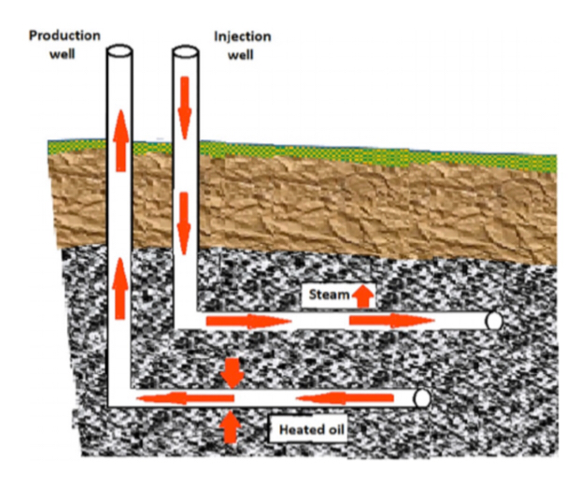
Figure 1.1. Schematic illustration of steam-assisted gravity drainage
2. Cyclic steam stimulation(CSS):
Cyclic steam stimulation (CSS) also known as huff-n-puff is another thermal EOR method which only requires one well,and it consists of three levels which are; injection,soaking and production.
Firstly,high pressure steam is injected through the target zone for several weeks to reduce the oil viscosity; then, in the next step, a soaking period is given to the steam to diffuse through the reservoir. Finally, oil is then produced from the same well. In multilayer reservoirs, the treatment starts from the bottom layer and moves up to the top layer.
cyclic steam stimulation, steam is injected into a production well for a period. Then the well is shut in and allowed to soak by steam for some period before it returns to production. The initial oil rate is high because of high initial oil saturation, high increased reservoir pressure, and lowered oil viscosity. As the oil saturation becomes lower, the reservoir pressure becomes lower and the oil viscosity becomes higher due to heat losses to the surrounding rock and fluids, oil rate declines. At some point, another cycle of steam injection is initiated. Such cycle may be repeated several times or many times or until the response to stimulation diminishes to non-economic level.
This process is quite effective specially in the first few cycles. Stimulation of the well by the ”huff and puff” process significantly improves oil rate by three times;
1. Removing accumulated asphaltic or paraffinic deposits around the wellbore, resulting in an improvement of the permeability around the wellbore (i.e., favorable skin factor).
2. Radically decreasing the oil viscosity, which in turn improves oil mobility and well productivity.
3. Increasing the thermal expansion of the oil, which impacts the oil saturation and its relative permeability.
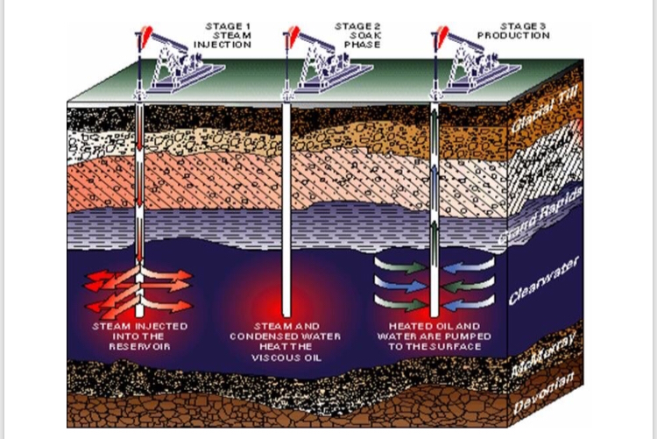
1.2. Cyclic steam stimulation showing the three different stages
3. Hot water flood:
It is a method of thermal recovery in which hot water is injected into a reservoir through specially distributed injections wells. Hot water flooding reduces the viscosity of the crude oil,allowing it to move more easily towards production wells. Hot water flooding, is also known as hot water injection, is typically less effective than a steam injection process because water has lower heat content than
steam .Nevertheless it is preferable under certain conditions such as formation sensitivity to fresh water. Hot water injection or hot water flood is a thermal recovery technique in which water is injected into hydrocarbon strata. The hot water injection reduces the viscosity of the heavy oil and provides a driving mechanism to sweep the heavy oil toward production wells.
They are water flood parameters which are ;the temperature of injected water, slug volume, injection rate, and starting time,which is dictated by the specific geological and physical characteristics of the particular oilfield, after which a hydrodynamic estimate of the efficiency of hot water-flooding or is in comparison with other methods of enhanced oil recovery which must be made.
Hot water-flooding is particularly effective in the development of fields of high- viscosity oils which contain large quantities of paraffins and resinous asphaltene substances, and which exhibit anomalous (non-Newtonian) properties as they flow through porous media’s .
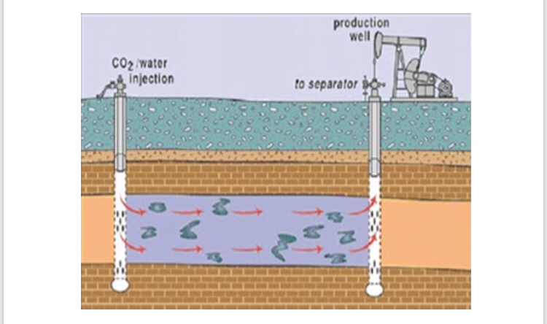
1.3. Hot water flood illustration diagram 1

The water used for water injection or flood is usually some sort of brime but it can also be made up of other sources that are treated. For example, some reservoirs water is produced with the hydrocarbons, removed from the production and re-injected into the formations. It is important that the water being injected works within the formation, filtration and processing of the water that will be injected are sometimes necessary to ensure that no materials clog the well pores and that bacteria is not permitted to grow. In an effort to reduce any corrosion within the reservoir, oxygen is often removed from the water, as well.
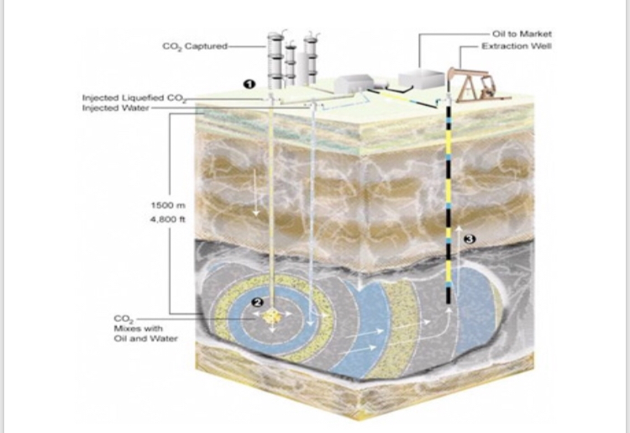
1.4. Hot water flood illustration diagram 2

A waterflood can recover anywhere from 5% to 50% of the oil that is remaining in the reservoir, greatly enhancing the productivity and economics of the development. This form of EOR is typically more productive when there are relatively small amounts of primary production, and the process becomes uneconomical when the water cut reaches the 90 to 99% level. Some waterfloods may take up to two years of injection before production is increased; and some reservoirs do not have the right characteristics, and water injection is not a viable option for increasing production from waning wells. (For example, water injection is never used on natural gas wells.)
Another form of hot water flood or injection involves introducing heated water into the reservoir. This helps to make the oil more fluid, especially in reservoirs that contain heavy oil. Also, the water can be treated with polymers to increase the viscosity of the water and help to encourage oil movement within the reservoir.

