Name: Obeta Ebubehukwuebuka
MATRIC NO:17/eng06/100
COURSE CODE:MEE586
LEVEL:500lvl
ASSIGNMENT
- What is an integrated CAD/ CAM?
An integrated CAD/CAM system usually provides one model supporting both design and manufacturing functions instead of having various file formats, numerous data translations/conversions, and different CAD and CAM models. To the CAM system, the CAD model becomes the sole geometry in play.
The major difference between CAD and CAM lies in the end user. While CAM software is mostly used by an engineer, CAM is used by a trained machinist. These machinists are highly skilled and are equivalent to a computer engineer. CAD refers to Computer Aided Design, while CAM stands for Computer Aided Manufacture.

- Draw a product cycle to describe the scope of CAD/CAM in the operation of manufacturing firm
Product Cycle Model

There are several Product cycle models in industry to be considered, one of the possible product
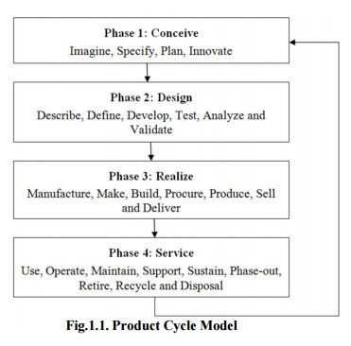

Step 1: Conceive

Imagine, Specify, Plan, Innovate

The first step is the definition of the product requirements based on company, market and customer. From this requirement, the product's technical data can be defined. In parallel, the early concept design work is performed defining the product with its main functional features. Various media are utilized for these processes, from paper and pencil to clay mock-up to 3D Computer Aided Industrial Design.

Step 2: Design

Describe, Define, Develop, Test, Analyze and Validate

This is where the completed design and development of the product begins, succeeding to prototype testing, through pilot release to final product. It can also involve redesign and ramp for improvement to existing products as well as planned obsolescence. The main tool used for design and development is CAD. This can be simple 2D drawing / drafting or 3D parametric feature based solid/surface modeling.

This step covers many engineering disciplines including: electronic, electrical, mechanical, and civil. Besides the actual making of geometry there is the analysis of the components and assemblies.

Optimization, Validation and Simulation activities are carried out using Computer Aided Engineering (CAE) software. These are used to perform various tasks such as: Computational Fluid Dynamics (CFD); Finite Element Analysis (FEA); and Mechanical Event Simulation (MES). Computer Aided Quality (CAQ) is used for activities such as Dimensional tolerance analysis. One more task carried out at this step is the sourcing of bought out components with the aid of procurement process.

Step 3: Realize

Manufacture, Make, Build, Procure, Produce, Sell and Deliver

Once the design of the components is complete the method of manufacturing is finalized. This includes CAD operations such as generation of CNC Machining instructions for the product’s component as well as tools to manufacture those components, using integrated Computer Aided Manufacturing (CAM) software.

It includes Production Planning tools for carrying out plant and factory layout and production simulation. Once details components are manufactured their geometrical form and dimensions can be verified against the original data with the use of Computer Aided Inspection Equipment (CAIE). Parallel to the engineering tasks, sales and marketing work take place. This could consist of transferring engineering data to a web based sales configuration.

Step 4: Service
Use, Operate, Maintain, Support, Sustain, Phase-out, Retire, Recycle and Disposal.
The final step of the lifecycle includes managing of information related to service for repair and maintenance, as well as recycling and waste management information. This involves using tools like Maintenance, Repair and Operations Management software.

- Explain seven (7) characteristics of a good CAD software
Efficient
Timely
Cost-effective
Non repetitive data manipulations.
Data translations are avoided
Data accuracy is secured
Concurrent design is promoted
Quality

- Explain three (3) divisions of software components
Application software
Application software is a program or group of programs designed for end users. Examples of an application include a word processor, a spreadsheet, an accounting application, a web browser, an email client, a media player, a file viewer, an aeronautical flight simulator, a console game or a photo editor.

System software,
System software is a type of computer program that is designed to run a computer's hardware and application programs. If we think of the computer system as a layered model, the system software is the interface between the hardware and user applications.

Web applications
In computing, a web application or web app is a client–server computer program that the client (including the user interface and client-side logic) runs in a web browser. Common web applications include webmail, online retail sales, online banking, and online auctions.

