NAME: IGO OYEINBONOGHA
MATRIC NO_;16/MHS07/012
DEPARTMENT: PHARMACOLOGY
COURSE: PHA304

PHAMRMACOLOGY OF THE PITUITARY GLAND
Pituitary gland
In vertebrate anatomy, the pituitary gland, or hypophysis, is an endocrine gland, about the size of a pea and weighing 0.5 grams in humans. It is a protrusion off the bottom of the hypothalamus at the base of the brain. The hypophysis rests upon the hypophysial fossa of the sphenoid bone in the center of the middle cranial fossa and is surrounded by a small bony cavity covered by a dural fold. The anterior pituitary is a lobe of the gland that regulates several physiological processes. The intermediate lobe synthesizes and secretes melanocyte-stimulating hormone. The posterior pituitary is a lobe of the gland that is functionally connected to the hypothalamus by the median eminence via a small tube called the pituitary stalk.

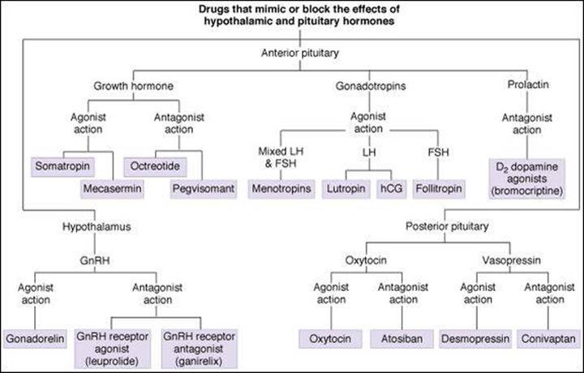

- The pituitary gland is called the "Master Gland" because it directs a multitude of endocrine functions in the body. It regulates hormone activity in other endocrine glands and organs.
- Pituitary activity is regulated by hormones of the hypothalamus, a brain region connected to the pituitary by the pituitary stalk.
- The pituitary is composed of an anterior and posterior lobe with an intermediate region between the two.
- Hormones of the anterior pituitary include adrenocorticotropin hormones (ACTH), growth hormone (GH), luteinizing hormone (LH), follicle-stimulating hormone (FSH), prolactin (PRL), and thyroid-stimulating hormone (TSH).
- Hormones stored by the posterior pituitary include antidiuretic hormone (ADH) and oxytocin.
- Melanocyte-stimulating hormone (MSH) is an intermediate pituitary hormone.

Hypothalamus-Pituitary Complex
The pituitary gland and hypothalamus are closely connected both structurally and functionally. The hypothalamus is an important brain structure that has both nervous system and endocrine system function. It serves as a link between the two systems translating nervous system messages into endocrine hormones.
The posterior pituitary is composed of axons that extend from the neurons of the hypothalamus. The posterior pituitary also stores hypothalmic hormones. Blood vessel connections between the hypothalamus and anterior pituitary allow hypothalamic hormones to control anterior pituitary hormone production and secretion. The hypothalamus-pituitary complex serves to maintain homeostasis by monitoring and adjusting physiological processes through hormone secretion.

Pituitary Function
The pituitary gland is involved in several functions of the body including:
- Growth hormone production
- Production of hormones that act on other endocrine glands
- Production of hormones that act on the muscles and the kidneys
- Endocrine function regulation
- Storage of hormones produced by the hypothalamus

Location
Directionally, the pituitary gland is located in the middle of the base of the brain, inferior to the hypothalamus. It is nestled within a depression in the sphenoid bone of the skull called the sella turcica. The pituitary gland extends from and is connected to the hypothalamus by a stalk-like structure called the infundibulum, or pituitary stalk.

Pituitary Hormones
The posterior pituitary lobe does not produce hormones but stores hormones produced by the hypothalamus. Posterior pituitary hormones include antidiuretic hormone and oxytocin. The anterior pituitary lobe produces six hormones that are either stimulated or inhibited by hypothalamic hormone secretion. The intermediate pituitary zone produces and secretes melanocyte-stimulating hormone.
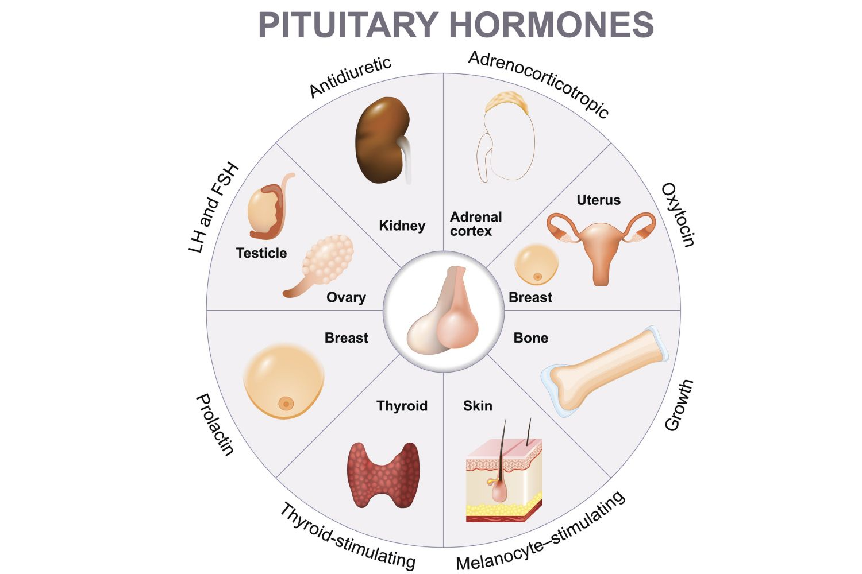
This image shows hormones of the pituitary and their affected organs. ttsz /iStock / Getty Images Plus

Anterior Pituitary Hormones
- Adrenocorticotropin (ACTH): stimulates the adrenal glands to produce the stress hormone cortisol.
- Growth Hormone: stimulates growth of tissues and bone, as well as the breakdown of fat.
- Luteinizing Hormone (LH): stimulates male and female gonads to release sex hormones, testosterone in men and estrogens and progesterone in women.
- Follicle-stimulating Hormone (FSH): promotes the production of male and female gametes (sperm and ova).
- Prolactin (PRL): stimulates breast development and milk production in women.
- Thyroid-stimulating Hormone (TSH): stimulates the thyroid to produce thyroid hormones.

Posterior Pituitary Hormones
- Antidiuretic Hormone (ADH): helps maintain water balance by decreasing water loss in urine.
- Oxytocin - promotes lactation, maternal behavior, social bonding, and sexual arousal.

Intermediate Pituitary Hormones
- Melanocyte-stimulating Hormone (MSH): promotes melanin production in skin cells called melanocytes. This induces skin darkening.

Pituitary Disorders
Pituitary disorders result in the disruption of normal pituitary function and the proper functioning of target organs of pituitary hormones. These disorders are most commonly the result of tumors, which cause the pituitary to produce either not enough or too much of a hormone. In hypopituitarism, the pituitary produces low levels of hormones. The insufficiency of pituitary hormone production causes a deficiency in the production of hormones in other glands. For example, a deficiency in thyroid-stimulating hormone (TSH) production can result in an under-active thyroid gland. Lack of thyroid hormone production slows down normal body functions. Symptoms that may arise include weight gain, weakness, constipation, and depression. Insufficient levels of adrenocorticotropic hormone (ACTH) production by the pituitary results in under-active adrenal glands. Adrenal gland hormones are important for maintaining vital body functions such as blood pressure control and water balance. This condition is also known as Addisons disease and can be fatal if not treated.
In hyperpituitarism, the pituitary is overactive producing hormones in excess. An overproduction of growth hormone may result in acromegaly in adults. This condition results in excessive growth of bones and tissues in the hands, feet, and face. In children, overproduction of growth hormone may result in gigantism. Overproduction of ACTH causes the adrenal glands to produce too much cortisol, which results in problems related to metabolism regulation. Overproduction of the pituitary hormone TSH may result in hyperthyroidism, or the overproduction of thyroid hormones. An overactive thyroid produces symptoms such as nervousness, weight loss, irregular heartbeat, and fatigue.
Master Gland--produces six major hormones, Stores two hormones: Anatomy
- Midsagittal section through human pituitary
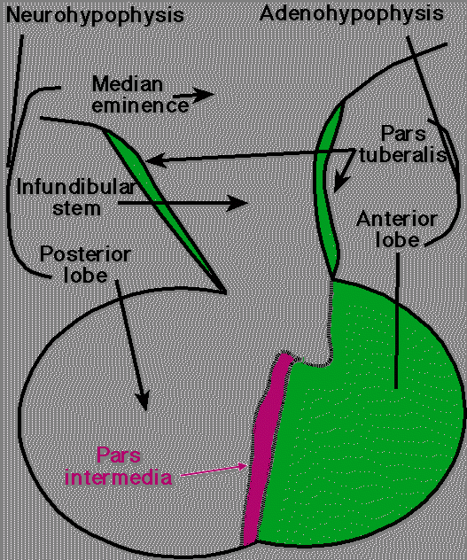
Midsagittal section of a human pituitary gland; courtesy of Robert H. Parsons, used with permission

- Sagittal section of a human pituitary, showing the relationship of its blood supply to the hypothalamic neurosecretory cells in the adenohypophysis
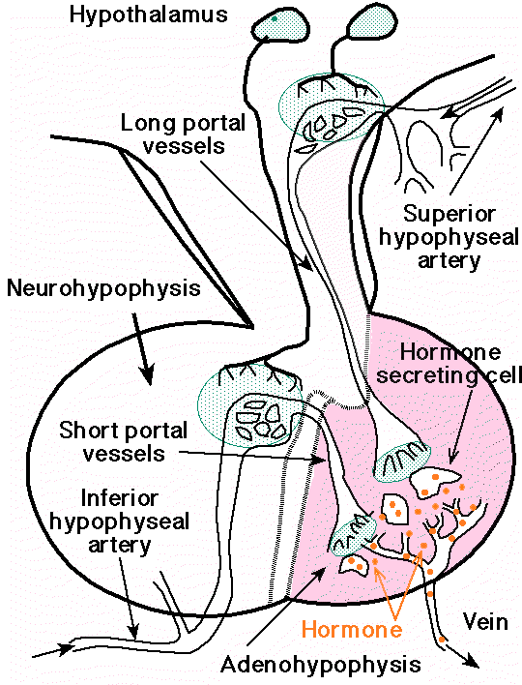
- Sagittal section of a human pituitary, showing the relationship of its blood supply to the hypothalamic neurosecretory cells in the adenohypophysis. Neurosecretory neurons are shown secreting releasing factors into the capillary networks giving rise the long and short hypophyseal portal vessels, respectively. The releasing hormones reach the hormone-secreting cells of the anterior lobe via the portal vessels.
- courtesy of Robert H. Parsons, Ph.D., Rensselaer Polytechnic Institute, used with permission

- Sagittal section of a human pituitary, showing the relationship of its blood supply to the neurosecretory cells of the supraoptic and paraventricular nuclei of the hypothalamus
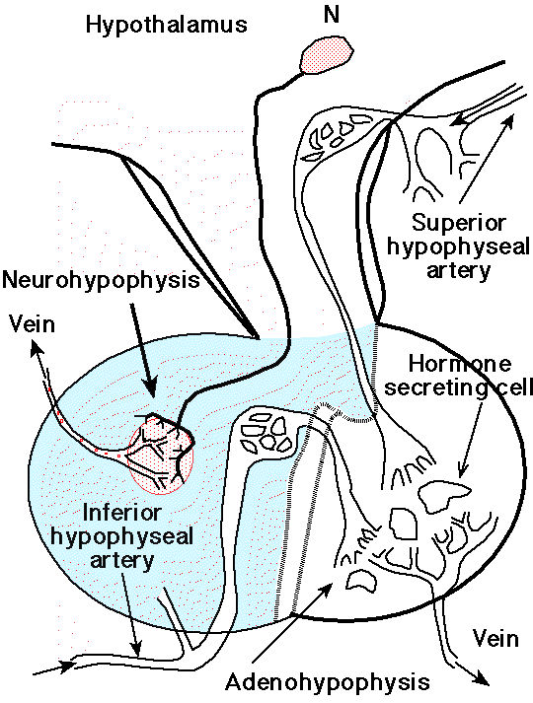
- "Sagittal section of a human pituitary, showing the relationship of its blood supply to the neurosecretory cells of the supraoptic and paraventricular nuclei of the hypothalamus. The neuron labeled N represent a neurosecretory cell releasing ADH (antidiuretic hormone) or oxytocin at its axon terminals into the capillaries giving rise to the venous drainage of the posterior lobe. "
- courtesy of Robert H. Parsons, used with permission
- Growth hormone (GHRH)-- anterior pituitary synthesis
  - growth regulation
  - intermediary metabolism effects
- Prolactin (PRL)-- anterior pituitary synthesis
  - required for lactation
- Luteinizing hormone (LH) & Follicle-stimulating hormone (FSH)--anterior pituitary synthesis
  - male and female gonadal control
- Thyroid-stimulating hormone (TSH, thyrotropin)--anterior pituitary synthesis
  - thyroid function regulation
- Adrenocorticotropin (ACTH)--anterior pituitary synthesis
  - regulation: adrenocortical glucocorticoid functions
- Vasopressin (AVP; antidiuretic hormone, ADH) --synthesis site: hypothalamic neurons; storage site: posterior pituitary.
  - AVP: regulation of renal water conservation
- Oxytocin: --synthesis site: hypothalamic neurons; storage site: posterior pituitary.
  - Oxytocin: required for milk let-down; may assist in parturition
- Feedback Relationships:
  - Feedback between anterior pituitary and its three target glands:
    - gonads
      - if gonads fail or removed then LH & FSH increased (primary hypogonadism)
    - adrenal cortex
      - with adrenal cortex destruction/removal, primary adrenal-insufficiency occurs (Addison's disease) with increased serum ACTH concentration
    - thyroid
      - thyroid failure leads to primary hypothyroidism resulting in increased TSH
  - With removal/destruction of the pituitary gland, trophic hormone is lost:
    - Secondary hypogonadism
    - Adrenal-insufficiency
    - Hypothyroidism
  - With removal/destruction of the pituitary gland: no effect on vasopressin (AVP) and oxytocin provided intact hypothalamus

- Pituitary Control:Hypothalamus- chemical mediation (hormones)
  - Hypothalamic hormonal synthesis through portal vascular system to the pituitary stalk to the pituitary anterior lobe
  - Pituitary stalk interruption causes:
    - decreased release from the anterior pituitary of: GH, LH, FSH, TSH, & ACTH
    - increased prolactin (hypothalamic influence is normally inhibitory for prolactin secretion)
  - Hypothalamic ablation:
    - decreased levels of GH, LH, FSH, TSH, ACTH, AVP & oxytocin
    - increased prolactin
- Secretion Control: hypothalamic factors (peptides)
  - growth hormone-releasing hormone (GHRH) dominant GH release influence (+)
  - Somatostatin: inhibitory hormone for GH release (-)
  - Luteinizing hormone-releasing hormone (LHRH) -- also called gonadotropin-releasing hormone (GnRH): controls LH & FSH
  - Thyrotropin-releasing hormone (TRH) controls TSH release; influences prolactin release
  - Corticotropin-releasing hormone (CRH) & other factors control ACTH release
  - Dopamine: major prolactin inhibitory influence (PIF)
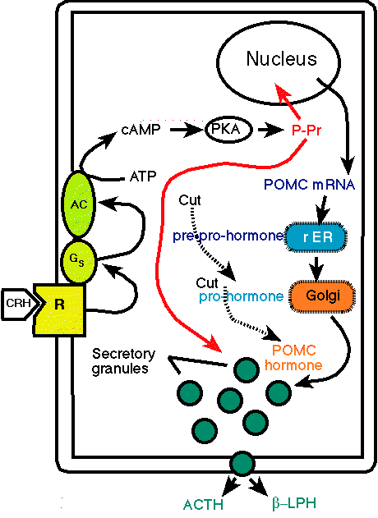
- "Action of corticotrophin-releasing hormone (CRH) on cells of the adrenal cortex. CRH binds to membrane receptors (R), which are coupled to adenylate cyclase (AC) by stimulatory G proteins (Gs). Adenylate cyclase is stimulated and cAMP rises in the cell. cAMP activates protein kinase A (PKA), which then phosphorylates proteins (P-Proteins) involved in stimulating ACTH secretion and the expression of the POMC (proopiomelanocortin) gene. The proteolytic processing of POMC occurs in the secretory granulas where it is split into several hormones, ACTH (adrenocorticotrophic hormone) and Beta-LPH (Beta-lipotropin). "
- courtesy of Robert H. Parsons, Ph.D., Rensselaer Polytechnic Institute, used with permission

Pituitary and Hypothalamic Hormones
Pituitary Hormone | Hypophysiotropic Hormone
Thyrotropin (TSH) | Thyrotropin-releasing hormone (TRH) -- tripeptide
Adrenocorticotropin (ACTH) | - Corticotropin-releasing hormone (CRH) -- 41 amino acids  - Vasopressin (AVP); and other peptides
Luteinizing hormone (LH) | Leutinizing hormone-releasing hormone (LHRH) -- decapeptide
Follicle-stimulating hormone (FSH) | LHRH -- decapeptide
Growth hormone (GH) | - Growth hormone-releasing hormone (GHRH) -- 44 amino acids  - Growth hormone release-inhibiting hormone (somatostatin, GIH) -- 14 amino acids; somatostatin: also inhibits TRH-stimulated TSH release
Prolactin | - Prolactin release-inhibiting factor (PIF) -- dopamine  - Prolactin-releasing factor (PRL) -- peptide; TRH stimulates prolactin release
{adapted from Table 328-1: Biller, Beverly, M. K. and Daniels, Gilbert, H. Neuroendocrine Regulation and Diseases of the Anterior Pituitary and Hypothalamus, In Harrison's Principles of Internal Medicine 14th edition, (Isselbacher, K.J., Braunwald, E., Wilson, J.D., Martin, J.B., Fauci, A.S. and Kasper, D.L., eds) McGraw-Hill, Inc (Health Professions Division), 1998, p. 197
- Physiological Consequences of Pituitary Tumors:
  - hormonal over production/under production
  - Pituitary tumors: most common syndromes due to:
    - growth hormone excess
      - gigantism, acromegaly
    - prolactin excess
      - galactorrhea and/or hypogonadism
  - ACTH-secreting tumors: Cushing's disease
  - TSH-secreting tumors: hyperthyroidism (rare)
  - Gonadotropin-secreting tumors: hypogonadism (paradoxical)
  - Large pituitary tumors:
    - hypopituitarism (due to gland compression; or pituitary stalk compression) ® visual field disturbances {optic chiasm compression}
- Hypothalamic disease:
  - Hypopituitarism
  - Prolactin secretion increased
  - Significant Diagnostic Indication:
    - Diabetes insipidus (due to vasopressin {AVP} deficiency)
Anatomy : Pituitary
- Pituitary gland (hypophysis) resides within sella turcica of the sphenoid bone at the skull base (weight = between 0.4 and 0.8 grams)
- Midsagittal section through human pituitary (above)
- Sagittal section of a human pituitary, showing the relationship of its blood supply to the hypothalamic neurosecretory cells in the adenohypophysis (above)
- Sagittal section of a human pituitary, showing the relationship of its blood supply to the neurosecretory cells of the supraoptic and paraventricular nuclei of the hypothalamus (above)
- Pituitary gland components:
  - anterior lobe (adenohypophysis)
  - posterior lobe (neurohypophysis)
- Separated from brain by diaphragma sella (dura mater extension) and by thin bone layers from the sphenoid sinus anteriorly and inferiorly
- Sella lateral walls abut on the cavernous sinuses (containing internal carotid arteries & cranial nerves III, IV, V, and VI. Recurrent
- Optic chiasm located slightly anterior to pituitary stalk -- just above diaphragma sella.
Reason why pituitary tumors result in visual field effects, cranial nerves palsies, sphenoid sinus invasion

