NAME: OBUNADIKE CHINENYE BLESSING
MATRIC NUMBER:17/MHS01/225

ASSIGNMENT
1)WRITE AN ESSAY ON THE HISTOLOGICAL IMPORTANCE OF EYE IN RELATION TO THE CELLULAR FUNCTION.
2)CORONA VIRUS CAN PENETRATE THE BODY THROUGH EYE AND IMPLICATE THE IMMUNE SYSTEM, BRIEFLY DISCUSS THE LAYERS OF THE RETINA FOR INFORMATION PENETRATION.

HISTOLOGICAL IMPORTANCE OF THE EYE IN RELATION TO THE CELLULAR FUNCTION.
INTRODUCTION: The eye is a highly developed photosensitive organ that permits an accurate analysis of the form, light intensity and color reflected from objects. The eyes are located in protective areas of the skull, the orbit, which also contain cushions of adipose tissue. Each eyeball includes a tough, fibrous globe to maintain its shape, a system of transparent tissues that refract light to focus the image, a layer of photosensitive cells, and a system of neurons whose function it is to collect, process, and transmit visual information to the brain
LAYERS OF THE EYE: It is important to note that the eye consist of some external structures (eyelashes,lids,muscles,accessory glands and conjunctiva). The internal structure however consist of three layers of tissue, they include;
-external layer – sclera and cornea
-middle layer(vascular uvea layer)- iris, ciliary body and choroid
-innermost layer - retina and nervous tissues

EXTERNAL LAYER:
SCLERA(WHITE OF THE EYE)
The sclera is dense connective tissue made up of mainly collagen fibers type 1, oriented in different directions. The lack of parallel orientation of the collagen fibers gives the sclera its white appearance, as opposed to the transparent nature of the cornea. However, the collagen of the sclera and cornea are continuous. The four layers of the sclera from external to internal are episclera, stroma, lamina fusca, endothelium. It is avascular with moderate amount of ground substance and scattered fibroblast.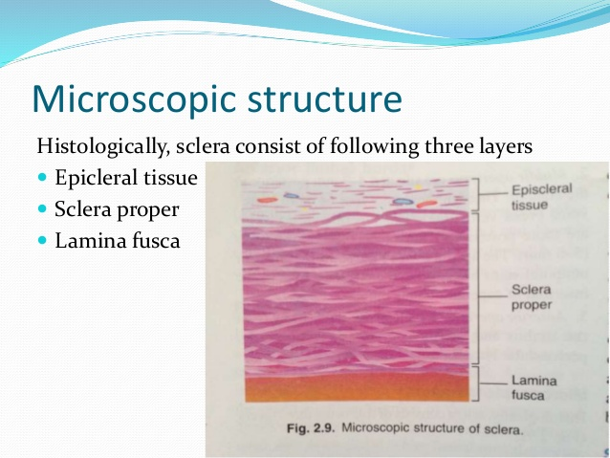

CORNEA( TRANSPARENT FRONT LAYER OF THE EYE)
It consist of type 1 collagen fibers oriented in a uniform parallel direction to maintain transparency. It consist of five layers which include epithelium(non keratinized stratified squamous epithelium), bowmans layer,stroma(substantia propria), descemet’s membrane, corneal endothelium. The epithelium is a fast, growing and regenerating muilticelluar layer. The bowman layers is a layer of subepithelial basement membrane protecting the underlying stroma. The stroma is the largest layer of the cornea and has collagen fibers arranged in a regular pattern. Keratocytes maintain the integrity of the layer. The function of this layer is to maintain transparency,which occur by the regular arrangement. The descemet membrane is an acellular layer that serves as a modified basement membrane of the corneal endothelium. The corneal endothelium is made either of squamous or cuboidal cells. Cells in this region do not regenerate and have pumps that maintain fluid balance and prevent swelling of the stroma.
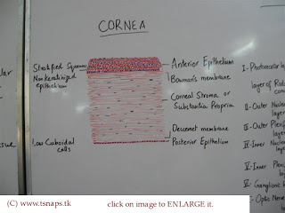
MIDDLE LAYER:
IRIS : this consist of stromal layer with pigmented, fibrovascular tissue and pigmented epithelial beneath the stroma. The pigmented layer of the cells blocks rays of light and ensures that the light moves through the pupil to reach the retina. The angle formed by the iris and the cornea contains connective tissues with endothelial channels the trabecular meshwork,ehich drains aqueoushumor in the anteriorchamber into the venous canal of schlemn.
CILIARY BODY(the tissue that divides the posterior chamber and vitreous body): this consist of ciliary muscle and ciliary epithelium. The ciliary muscles via lens zonules,controls the structure of the lens, which is vital for accommodation. Zonules are connective tissue fibers that connect the ciliary muscle and lens. The ciliary epithelium produces aqueous humor which fills the anterior compartment of the eye.
CHOROID : This consist of dense network of blood vessels supplying nourishment to structures of the eye, housed in loose connective tissue. The bruch membrane is an extracellular matrix layer situated between the retina and choroid and has significance in age related macular degeneration,where an accumulation of lipid deposit prevent diffusion of nutrients to the retina.

INNERMOST LAYER
LENS: this separates the aqueous and vitreous chambers. It consist of an outer capsule, a middle layer called cortex and an inner layer called the nucleus. The capsule is the basement membrane of the lens epithelium which lies below. New lens cells differentiate from the lens epithelium snd are incorporated peripherally, pushing older lens cells towards the middle.
VITREOUS: a jelly like space made of type II collagen separating the retina from lens.
RETINA: it is the nervous tissues of the eye where photons of light convert to neurochemical energy via action potential. It is divided into 10 layers which include retinal epithelium, rod and cone cells,outer limiting membrane, outer nuclear layer, outer plexiform layer, inner nuclear layer, iner plexiform layer, ganglion cell layer, nerve fiber layer and the internal limiting membrane.
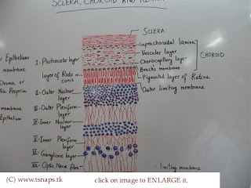
Diagram showing most of the layers of the eyes

GENERAL FUNCTIONS OF THE INTERNAL LAYER OF THE EYE.
Cornea serves as a protective role and is responsible for two-third of the refractive properties of the eye. The remaining one-third of refraction is performed by the lens. The uvea of the eye is a crucial mediator of nutrition and gas exchange, as blood vessels course through the ciliary body and iris.
CLINICAL CORRELATES
1) CATARACTS: sclerotic nuclear cataracts is due to opacification in the central nucleus of the lens.
2)FUCHS DYSTROPHY: a disease of the corneal epithelium, that causes the accumulation of excess edema in the corneal stroma

Question two
LAYERS OF THE RETINA FOR INFORMATION PENETATION.
According to an updated journal published for ophthalmologist, several reports suggests that SARS-CoV-2(covid 19) can cause a mild follicular conjunctivitis and is possibly transmitted by aerosol contact with conjunctiva. Therefore, patients who go to the ophthalmologist for conjunctivitis and respiratory symptoms, in addition to having traveled to areas with known outbreaks could be suspects of having the virus. droplets from nose or mouth can enter the eye and spread throughout the body through blood vessels within the conjunctiva. It is however seen in recent studies by the journal ophthalmology researchers in Singapore that no traces of corona virus in patients tears.
The layers of retina include:
1) RETINAL PIGMENT EPITHELIUM: this is made of cuboidal cells containing melanin which absorbs light. These cells also establish a blood retina barrier through tight junctions.
2) ROD AND CONE CELLS: this is the layer of cells with photoreceptors and glial cells. Rods are located peripherally and are more sensitive to light and motion than cones. Cones have higher visual acuity and specificity for color vision.
3)OUTER LIMITING MEMBRANCE: a layer of muller cells and rod/cone junctions which serves to separate the photosensitive region of the retina from the areas that transmit the electrical signals.
4) OUTER NUCLEAR LAYER: this layer consist of nuclei of rod and cone cells.
5) OUTER PLEXIFORM LAYER: this layer contains synaptic processes of rod and cone cells.
6)INNER NUCLEAR LAYER: this layer contains the cell body of glial,amacrine,bipolar, and horizontal cells.
7)INNER PLEXIFORM LAYER: this layer relays information from cells of the inner nuclear layer. Thus, this layer has axons of amacrine , bipolar and glial cells and dendrites of retinal ganglion cells.
8)GANGLION CELL LAYER: this layer contains nuclei of retinal ganglion cells.
9)NERVE FIBER LAYER: this layer contains axons of retinal ganglion cells and the astrooglia which support them. Collectively ,these axons constitute the optic nerve.
10) INTERNAL LIMITING MEMBRANE: a thin layer of muller glial cells and basement membrane which dermarcates the vitreous anteriorly from the retina posteriorly.

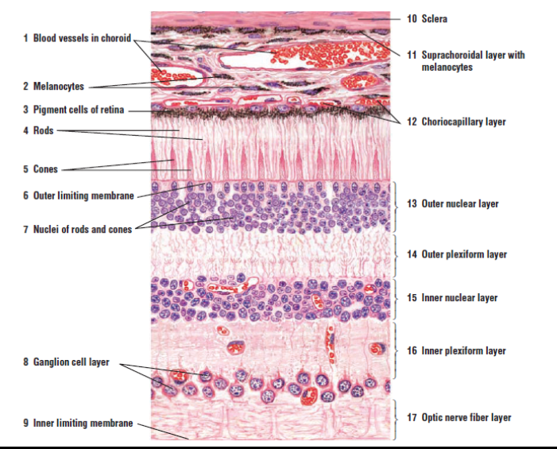

Information(light) is transduction by rods and cones . both rod and cones contain photo pigment, which are pigments that undergo a chemical changes when they absorb light. In vertebrates, the main photo pigement, rhodopsin, has two main parts an opsin which is a membrane protein and retinal, a molecule that absorbs light. When light hits photo receptor, it causes a shape change in the retinal, altering its structure from a bent(cis) form of the molecule to its linear (trans) isomer.the isomerization of retinal activates the rhodopsin, starting a casade of events that ends with closing Na+ channel in the membrane of the photoreceptor. Thus, unlike most other sensory neurons (which become depolarized by exposure to a stimulus), visual receptors become hyperpolarized and are driven away from the threshold.

CLINICAL CORRELATES
1)AGE RELATED MACULAR DEGENERATION : a progressive eye disease causing damage to the maculaor central portion of the retina. Accumulation of drunsen, or lipid-laden deposits in bruch’s membrane of the retina, is associated with disease severity.
2)RETINAL DETACHMENT: it occurs when the outer pigment epithelial layer consisting of rod and cones;this is a vision-threatening condition as the neurosensory layer is unable to receive nutrient from underlying choiocapillaris and retinal epithelium.

