OKWUENU CHUKWUEBUKE.C
15/eng07/035
PTE 512
- Steam-assisted gravity drainage (SAGD; "Sag-D") is an enhanced oil recovery technology for producing heavy crude oil and bitumen. It is an advanced form of steam stimulation in which a pair of horizontal wells is drilled into the oil reservoir, one a few metres above the other. High pressure steam is continuously injected into the upper wellbore to heat the oil and reduce its viscosity, causing the heated oil to drain into the lower wellbore, where it is pumped out.
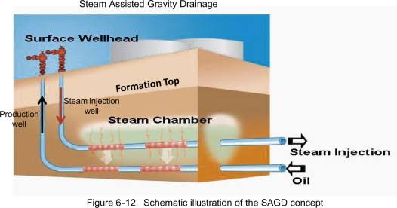

- Cyclic steam stimulation is often the preferred method for production in heavy oil reservoirs that can contain high-pressure steam without fracturing the overburden. In cyclic steam stimulation (CSS), steam is injected into a production well for a period. Then the well is shut in and allowed to soak by steam for some period before it returns to production. The initial oil rate is high because of high initial oil saturation, high increased reservoir pressure, and lowered oil viscosity. As the oil saturation becomes lower, the reservoir pressure becomes lower and the oil viscosity becomes higher due to heat losses to the surrounding rock and fluids, oil rate declines. At some point, another cycle of steam injection is initiated. Such cycle may be repeated several times or many times.
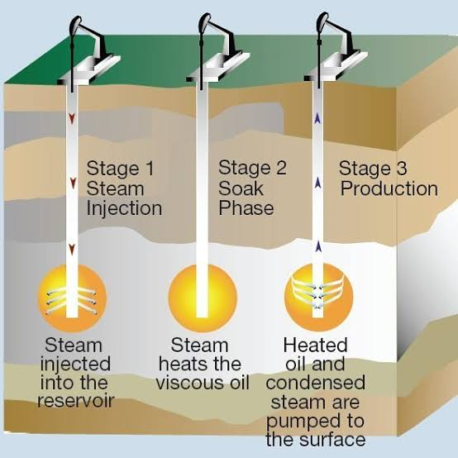

Hot Water Flooding, also known as hot water injection is a technique of increasing crude oil production from a producing well by injecting hot water into the reservoir. The hot water is injected through an injection well which is drilled parallel to the primary producing well. The heat from the hot water acts as a way of reducing the viscosity of crude oil, making it to flow toward the producing well with ease. Hot water flooding is generally used to extract crude oil which has an API degree of less than 20. Hot water flooding is considered as one of the techniques of increasing crude oil production under Enhanced Oil Recovery Technique (EOR) and thermal recovery. It is less effective than steam injection process, due to the fact that hot water has a lower heat content as compared to steam.
Over time the pressure in an oil reservoir slowly and steadily decreases and as a result the production rate decreases. This is one of the techniques used by E&P organizations to enhance the production of heavy to medium category crude oil from a reservoir. To use this technique, an injection well is drilled parallel to the primary producing well through which hot water is injected forcefully into the reservoir in the direction of the producing well.
