OKOYE IFECHUKWU CHINELO
MATRIC NO. 18/MHS01/271
MEDICAL LABORATORY SCIENCE

BETA OXIDATION OF FATTY ACIDS
Mitochondrial oxidation of fatty acids takes place in three stages. In the first stage- beta oxidation- fatty acids undergo oxidative removal of successive two carbon units in the form of acetyl-CoA, starting from the carboxyl end of the fatty acyl cahain. For example, the 16-carbon palmitic acid undergoes seven passes through the oxidative sequence, in each pass losing two carbons as acetyl-CoA. At the end of the seven cycles the last two carbons of the palmitate remain as acetyl-CoA. The overall result is the conversion of the 16-carbon chain of palmitate to eight two- carbon acetyl groups of acetyl-CoA molecules. Formation of each acetyl-CoA requires removal of four hydrogen atom from the fatty acyl moiety by dehydrogenases.
The beta oxidation of fatty acids has four basic steps
Four enzyme reactions make up the first stage of fatty acid oxidation. First, dehydrogenation of fatty acyl-CoA produces a double bond between the alpha and beta carbon atoms.
DEHYDROGENATION
This first step is catalyzed by three isozymes of acyl-CoA dehydrogenase, each specific for a range of fatty-acyl chain lengths: very-long-chain acyl-CoA dehydrogenase, acting on fatty acids of 12 to 18 carbons; medium chain(MCAD), acting on fatty acids of 4 to 14 carbons and short chain(SCAD), actind on fatty acids of 4-8 carbons. VLACAD is in the inner mitochondrial membrane; MCAD and SCAD are in the matrix. All three isozymes are flavoproteins with thightly bound FAD as a prosthetic group. The electrons removed from the fatty acyl-CoA are transferred to FAD, and the reduced form of the dehydrogenase immediately donates its electrons to an electron carrier of the mitochondrial respiratory chain, the , the electron transferring flavoprotein. The oxidation catalyzed by an acyl-CoA dehydrogenase is analogous to succinate dehydrogenation in the citric acid cycle; in both reactions the enzyme is bound to the inner membrane, a double bond is introduced into the carboxylic acid between the alpha and beta carbons, FAD is the electron acceptor, and electrons from the reaction ultimately enter the respiratory chain and pass to oxygen, with the concomitant synthesis of about 1.5 ATP molecules per electron pair. 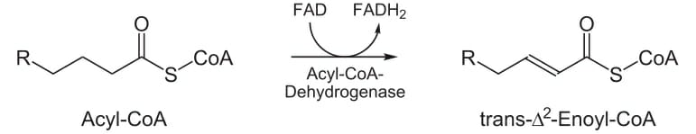
HYDRATION
In the second step of the beta oxidation cycle, water is added to the double bond of the trans-enoyl-CoA to form the L stereoisomer of beta-hydroxyl-acyl-CoA(3-hydroxyacyl-CoA). This reaction catalyzed by enoyl-CoA hydratase, is formally analogous to the fumerase reaction in the citric acid cycle, in which water adds across an alpha-beta double bond.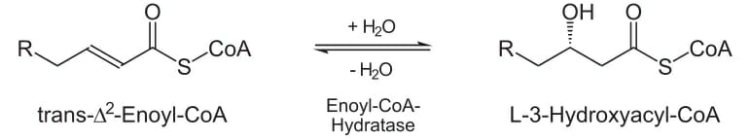
OXIDATION
In the third step, L-beta-hydroxyacyl-CoA is dehydrogenated in the form of beta-ketoacyl-CoA, by the action of beta-hydroxyacyl-CoA dehydrogenase; NAD⁺ is an electron acceptor. This enzyme is absolutely specific for the L stereoisomer of hydroxyacyl-CoA. The NADH formed in the reaction donates its electron to NADH dehydrogenase, an electron carrier of the respiratory chain, an ATP is formed from ADP as the electrons pass to oxygen. The reaction catalyzed by beta-hydroxyacyl-CoA dehydrogenase is closely analogous to the malate dehydrogenase reaction of the citric acid cycles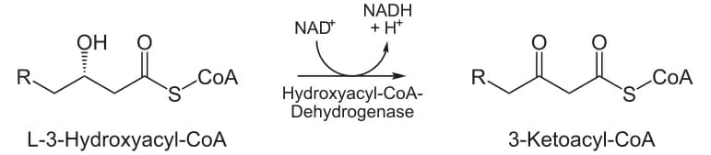
THIOLYSIS
The fourth and last step of the beta-oxidation cycle is catalyzed by acyl-CoA acetyltransferase, more commonly called thiolase, which promotes reaction of beta-ketoacyl-CoA which a molecule of free coenzyme A to split off the carboxyl-terminal two-fragment of the original fatty acid as acetyl-CoA. The other product is the coenzyme A thioester of the fatty acid, now shortened by two carbon atoms. This reaction is called thiolysis, by analogy with the process of hydrolysis, because the beta-ketoacyl-CoA is cleaved by reaction with the thiol group of coenzyme A. The thiolase reaction is a reverse Claisen condensation.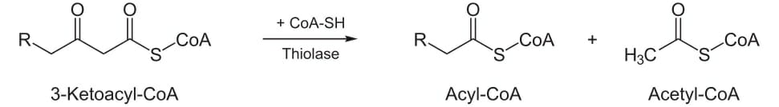
In the second stage of fatty acid oxidation, the acetyl groups of the acetyl-CoA are oxidized to carbondioxide in the citric acid cycle, which also takes place in the mitochondrial matrix. Acetyl-CoA derived from fatty acids thus enters a final common pathway of oxidation with the acetyl-CoA derived from the glucose via glycolysis and pyruvate oxidation. The first two stages of fatty acid oxidation produce the reduced electron carriers NADH and FADH_{2,} which in the third stage denote electrons to the mitochondrial respiratory chain, through which the electrons pass to oxygen with the concomitant phosphorylation of ADP to ATP. The energy released by fatty acid oxidation is thus conserved as ATP.

