SEMEN
Semen, also known as seminal fluid, is an organic fluid that contains spermatozoa. It is secreted by the gonads (sexual glands) and other sexual organs of male or hermaphroditic animals and can fertilize the female ovum. In humans, seminal fluid contains several components besides spermatozoa: proteolytic and other enzymes as well as fructose are elements of seminal fluid which promote the survival of spermatozoa, and provide a medium through which they can move or “swim”.
Semen is produced and originates from the seminal vesicle, which is located in the pelvis. The process that results in the discharge of semen is called ejaculation. Semen is also a form of genetic material.
During the process of ejaculation, sperm passes through the ejaculatory ducts and mixes with the fluids from the seminal vesicles, the prostate, and the bulbourethral glands to form the semen.
✓The seminal vesicles produce a yellowish viscous fluid rich in fructose and other substances that makes up about 70% of human semen.
✓The prostatic secretion influenced by dihydrotestosterone, is a whitish (sometimes clear), thin fluid containing protedytic enzymes, citric acid, acid phosphatase and lipids.
✓The bulbourethral glands secrete a clear secretion into the lumen of the urethra to lubricate it. Semen is typically translucent with white, grey or even yellowish tint.
After ejaculation, the latter part of the ejaculated semen coagulates immediately, forming globules, while the earlier part of the ejaculate typically does not. After a period typically ranging from 15-30 minutes, prostate-specific antigen present in the semen causes the de-coagulation of the seminal coagulum. It is postulated that the initial clotting helps keep the semen in the vagina, while liquefaction frees the sperm to make their journey to the ova.
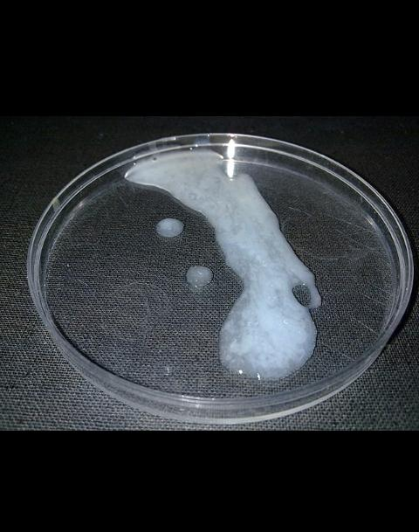
Human Semen in a Petri-dish

MALE INFERTILITY
Infertility is the inability to produce an offspring. Infertility occurs due to various factors such as immature reproductive system, defective reproductive system, endocrine disorders, etc.
Male infertility is any health issue in a man that lowers the chances of his female partner getting pregnant. Male infertility refers to a male’s inability to cause pregnancy in a fertile female. It is commonly due to deficiencies in the semen, and semen quality is used as a surrogate measure of male fecundity.

CAUSES OF MALE INFERTILITY
- Decreased sperm count – oligospermia
Normal sperm count in a male is about 100 to 150millions/ml of semen. Infertility occurs when the sperm count decreases because of disruption of seminiferous tubules or acute infection in testis. In some males, there is possibility of sterility (permanent inability to produce offspring) because of absence of spermatogenesis as in the case of cryptorchidism or underdeveloped testis.
- Abnormal sperms
Sometimes, the sperm count may be normal, but the structure of the sperm may be abnormal. The sperms may be without tail and non-motile or with two heads or with abnormal head. When a large number of abnormal sperms are produced, infertility occurs.
Aspermia – complete lack of semen
Hypospermia – reduced seminal volume
Azoospermia – absence of sperm cells in semen
Teratospermia – increase in sperm with abnormal morphology
Asthenozoospermia – reduced sperm motility
Necrozoospermia – all sperm in the ejaculate are dead
Leucospermia – a high level of white blood cell in semen
Normozoospermia or normospermia – it is a radar of semen analysis that shows not only values of all ejaculate paralletion by WHO but still there are chances of being infertile. This is also called as unexplained infertility.
- Obstruction of Reproductive Ducts
Obstruction of reproductive ducts like vas deferens leads to infertility
- Other Disorders
- Cryptorchidism
- Trauma
- Mumps
- Long-term use of drugs
- Alcoholism
- Generic disorders
- Hypothalamic disorders
- Disorders of pituitary, thyroid and pancreas.

