AUGOYE OMESIRI

ANATOMY

18/MHS01/094

ANA206

The development of the human lungs arises from the laryngotracheal groove and develop to maturity over several weeks in the foetus and for several years following birth.
The larynx, trachea, bronchi and lungs that make up the respiratory tract, begin to form during the fourth week of embryogenesis from the lung bud which appears ventrally to the caudal portion of the foregut.
lungs during development, showing the early branching of the primitive bronchial buds
The respiratory tract has a branching structure, and is also known as the respiratory tree. In the embryo this structure is developed in the process of branching morphogenesis, and is generated by the repeated splitting of the tip of the branch. In the development of the lungs (as in some other organs) the epithelium forms branching tubes.The lung has a left-right symmetry and each bud known as a bronchial bud grows out as a tubular epithelium that becomes a bronchus. Each bronchus branches into bronchioles. The branching is a result of the tip of each tube bifurcating. The branching process forms the bronchi, bronchioles, and ultimately the alveoli. At the end of the fourth week the lung bud divides into two, the right and left primary bronchial buds on each side of the trachea. During the fifth week the right bud branches into three secondary bronchial buds and the left branches into two secondary bronchial buds. These give rise to the lobes of the lungs, three on the right and two on the left. Over the following week, the secondary buds branch into tertiary buds, about ten on each side. From the sixth week to the sixteenth week, the major elements of the lungs appear except the alveoli. From week 16 to week 26, the bronchi enlarge and lung tissue becomes highly vascularised. Bronchioles and alveolar ducts also develop. By week 26 the terminal bronchioles have formed which branch into two respiratory bronchioles. During the period covering the 26th week until birth the important blood–air barrier is established. Specialized type I alveolar cells where gas exchange will take place, together with the type II alveolar cells that secrete pulmonary surfactant, appear. The surfactant reduces the surface tension at the air-alveolar surface which allows expansion of the alveolar sacs. The alveolar sacs contain the primitive alveoli that form at the end of the alveolar ducts, and their appearance around the seventh month marks the point at which limited respiration would be possible, and the premature baby could survive.
At birth, the baby's lungs are filled with fluid secreted by the lungs and are not inflated. After birth the infant's central nervous system reacts to the sudden change in temperature and environment. This triggers the first breath, within about 10 seconds after delivery. Before birth, the lungs are filled with fetal lung fluid. After the first breath, the fluid is quickly absorbed into the body or exhaled. The resistance in the lung's blood vessels decreases giving an increased surface area for gas exchange, and the lungs begin to breathe spontaneously. This accompanies other changes which result in an increased amount of blood entering the lung tissues.
At birth the lungs are very undeveloped with only around one sixth of the alveoli of the adult lung present. The alveoli continue to form into early adulthood, and their ability to form when necessary is seen in the regeneration of the lung. Alveolar septa have a double capillary network instead of the single network of the developed lung. Only after the maturation of the capillary network can the lung enter a normal phase of growth. Following the early growth in numbers of alveoli there is another stage of the alveoli being enlarged.
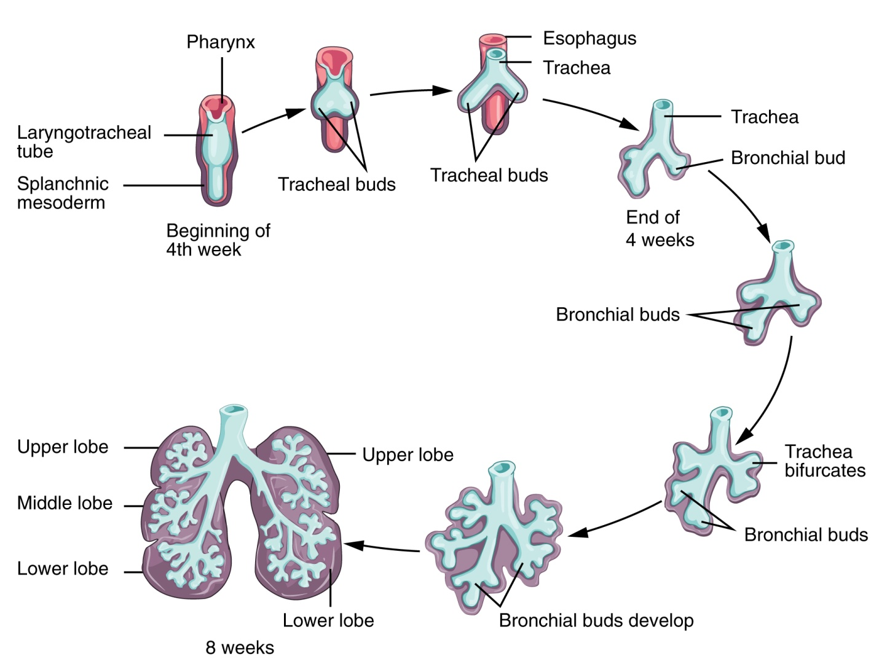

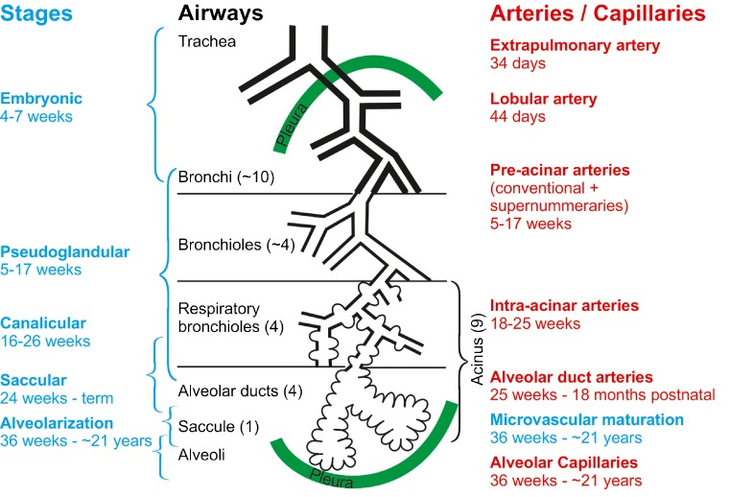
Blood supply
The lungs have a dual blood supply provided by a bronchial and a pulmonary circulation. The bronchial circulation supplies oxygenated blood to the airways of the lungs, through the bronchial arteries that leave the aorta. There are usually three arteries, two to the left lung and one to the right, and they branch alongside the bronchi and bronchioles. The pulmonary circulation carries deoxygenated blood from the heart to the lungs and returns the oxygenated blood to the heart to supply the rest of the body.
The blood volume of the lungs is about 450 milliliters on average, about 9% of the total blood volume of the entire circulatory system. This quantity can easily fluctuate from between one-half and twice the normal volume. Also, in the event of blood loss through hemorrhage, blood from the lungs can partially compensate by automatically transferring to the systemic circulation.

Nerve supply
The lungs are supplied by nerves of the autonomic nervous system. Input from the parasympathetic nervous system occurs via the vague nerve. When stimulated by acetylcholine, this causes constriction of the smooth muscle lining the bronchus and bronchioles, and increases the secretions from glands. The lungs also have a sympathetic tone from norepinephrine acting on the beta 2 adrenoceptors in the respiratory tract, which causes bronchodilation
The action of breathing takes place because of nerve signals sent by the respiratory center in the brainstem, along the phrenic nerve from the cervical plexus to the diaphragm.

Variation
The lobes of the lung are subject to anatomical variations A horizontal interlobar fissure was found to be incomplete in 25% of right lungs, or even absent in 11% of all cases. An accessory fissure was also found in 14% and 22% of left and right lungs, respectively. An oblique fissure was found to be incomplete in 21% to 47% of left lungs In some cases a fissure is absent, or extra, resulting in a right lung with only two lobes, or a left lung with three lobes.
A variation in the airway branching structure has been found specifically in the central airway branching. This variation is associated with the development of COPD in adulthood.

ROTATION OF THE STOMACH AND DEVELOPMENT OF THE OMENTAL BURSA

Stomach
The primordium of the primitive stomach is visible about the end of the fourth week. It is initially oriented in the median plane and suspended from the dorsal wall of the abdominal cavity by the dorsal mesentery or mesogastrium. During development the stomach rotates 90 degree in a clockwise direction along its longitudinal axis, placing the left vagus nerve along its anterior side and the right vagus nerve along its posterior side. Rotation of the stomach creates the omental bursa or lesser peritoneal sac.
The omental bursa or lesser sac is a hollow space that is formed by the greater and lesser omentum and its adjacent organs. It communicates with the greater sac via the epiploic foramen of winslow, which is known as the general cavity of the abdomen that sits within the peritoneum, but outside the lesser sac.
This space has well-defined borders which are represented by certain organs or their parts, so they are quite easy to spot and form a mental image of the omental bursa. In addition, like anything in anatomy, the omental bursa doesn't just exist as a standalone and isolated entity, but rather it communicates with several other spaces and recesses found throughout the body.

The development of the omental bursa and its forming organs has been studied in 53 embryos, 2.8--30 mm parietococcygeal length. As the data obtained demonstrate, isolation of the omental bursa anlage from the right pleuroperitoneal canal of the coelomic cavity results from the appearance of an additional right pulmonary mesentery and a fold of the inferior vena cava. The pulmonary-esophageal part of the anlage is the first to form, and then the gastrohepatic one. The latter gives origin to the omental bursa proper and the antrum. Both parts of the anlage participate in the formation of the superior omental recess. During the human embryogenesis the anterior intestinal derivates undergo spiralization which is realized by two phases--the first, at the level of the inferior third of the stomach and the forming superior horizontal part of the duodenum, and the second--at the level of the superior third of the developing stomach and the esophageal peritoneal part. The spiralization is ensured by a predominant growth of the presumptive greater curvature of the stomach and by the presence of fixative zones in the area of the transversal septa and the future superior horizontal part of the duodenum. Early stages in the stomach development, dynamics of specific interrelations between the organ's margins of the ventral and dorsal mesenterii in embryos at different ages, reflect the phases of spiralization and witness against mechanical furn over of the stomach around the vertical and sagittal axes.

DEVELOPMENT OF THE OESOPHAGUS

The esophagus becomes recognizable at the 2.5- mm stage (approximately the 3rd week of gestation) as a constriction separating pharynx and stomach. When it reaches 5 mm (32 days) it is a short tube, which rapidly elongates during the 6th and 7th weeks, mostly by cephalad migration of the laryngopharyngeal area. 1, 2 Lateral ridges of proliferating epithelium rapidly develop in the uppermost segment, dividing the lumen into an anterior and a posterior portion. Necrosis of epithelium in the septa thus formed and immigration of mesenchyme cause separation of the trachea and esophagus by the 36th day.

The original epithelium is composed of simple pseudostratified columnar cells .These layers thicken, and at the 13-mm stage (6 weeks) extracellular vacuoles appear between the epithelial cells.

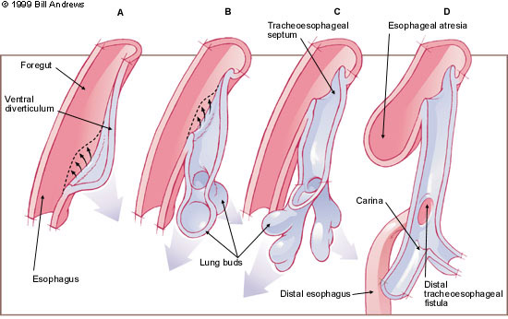

This process is said to be most marked at the 25-mm stage (71/2 weeks), at which point some of the spaces formed may exceed the diameter of the esophageal lumen. Thin epithelial septa separate vacuoles from each other and from the lumen. By the 72-mm stage (11-12 weeks), vacuoles are said to coalesce and disappear. Abnormalities of this process are one explanation for certain developmental cysts. It should be noted that this vacuolization process has been disputed. Schridde, quoted by Rosenthal4 states that the so-called vacuoles represent epithelial bridges caused by irregular circumscribed epithelial proliferation. We have noted a vacuolization stage in our specimens but find its appearance and disappearance variable. Ciliated cells appear among the columnar cells at about the 28-mm stage (8 weeks) and rapidly become more. During this time, further stratification occurs and degeneration and sloughing of individual cells is recognizable. Squamous cells begin to appear in the midesophagus during the 5th to 6th months (130- 160 mm); the process spreads gradually both proximally and distally, replacing the ciliated mucin secretory cells .Columnar cells may persist to birth in the upper esophagus;5,6 however, small islands ofmucin-secretingcells, i.e., superficial glands, may also persist .These are called cardiac glands and are superficial to the muscularis mucosa. In contrast, deep submucosal glands develop late, at about the 7th month. Parietal and chief cells are not normally present although they may occur. Keratinization does not normally occur in man, nor in carnivores, although it is a normal finding in rodents and ruminants. Cilia occur in a wide array of species during ontogenesis and persist in many lower forms, such as frogs, and in the distal esqphagus of the opossum. 7 At 6 weeks the circular muscle coat of the muscularis propria can be recognized. When first formed, the entire esophagus is composed of smooth muscle, although striated muscle is already apparent at that time in the somatic musculature. At about 38 mm, scattered striated fibers appear in a deep circular and adjacent longitudinal coat of the upper segment of the muscularis propria. By the 5th month, all of the longitudinal and most of the circular muscle in the upper third of the esophagus is striated; in the middle third variable numbers of striated muscle fibers are found, tending to decrease distally.8 Contrary to some reports, striated muscle is not formed by a process of invasion from the pharynx. Although the upper third of the esophageal muscularis is usually striated, some smooth muscle may persist.9 N euroblasts reach the esophagus before the 10-mm stage, appearing about the periphery of the forming circular muscle layer ,and eventually form a complete ring. Both myenteric and submucosal esophageal plexi and associated ganglion cells form between the 35- and 140-mm stages. They are well organized by the 5th month.

Nerve supply
The esophagus is innervated by the vagus nerve and the cervical and thoracic sympathetic trunk. The vagus nerve has a parasympathetic function, supplying the muscles of the esophagus and stimulating glandular contraction. Two sets of nerve fibers travel in the vagus nerve to supply the muscles. The upper striated muscle, and upper esophageal sphincter, are supplied by neurons with bodies in the nucleus ambiguus, whereas fibers that supply the smooth muscle and lower esophageal sphincter have bodies situated in the dorsal motor nucleus. The vagus nerve plays the primary role in initiating peristalsis. The sympathetic trunk has a sympathetic function. It may enhance the function of the vagus nerve, increasing peristalsis and glandular activity, and causing sphincter contraction. In addition, sympathetic activation may relax the muscle wall and cause blood vessel constriction. Sensation along the esophagus is supplied by both nerves, with gross sensation being passed in the vagus nerve and pain passed up the sympathetic trunk.
Clinical anatomy

Barrett's esophagus
Prolonged esophagitis, particularly from gastric reflux, is one factor thought to play a role in the development of Barrett's esophagus. In this condition, there is metaplasia of the lining of the lower esophagus, which changes from stratified squamous epithelia to simple columnar epithelia. Barrett's esophagus is thought to be one of the main contributors to the development of esophageal cancer.

Cancer
Esophageal cancer
There are two main types of cancer of the esophagus. Squamous cell carcinoma is a carcinoma that can occur in the squamous cells lining the esophagus. This type is much more common in China and Iran. The other main type is an adenocarcinoma that occurs in the glands or columnar tissue of the esophagus. This is most common in developed countries in those with Barrett's esophagus, and occurs in the cuboidal cells.
In its early stages, esophageal cancer may not have any symptoms at all. When severe, esophageal cancer may eventually cause obstruction of the esophagus, making swallowing of any solid foods very difficult and causing weight loss. The progress of the cancer is staged using a system that measures how far into the esophageal wall the cancer has invaded, how many lymph nodes are affected, and whether there are any metastases in different parts of the body. Esophageal cancer is often managed with radiotherapy, chemotherapy, and may also be managed by partial surgical removal of the esophagus. Inserting a stent into the esophagus, or inserting a nasogastric tube, may also be used to ensure that a person is able to digest enough food and water.

