Odukoya Treasure
18/MHS05/010
Physiology
BCH 204
Question
Describe the three (3) stages of beta oxidation. (Show pathways where necessary)

Beta-oxidation is the catabolic process by which fatty acid molecules are broken down in the cytosol in prokaryotes and in the mitochondria in eukaryotes to generate acetyl-CoA (energy), which enters the citric acid cycle, and NADH and FADH2, which are co-enzymes used in the electron transport chain. For beta-oxidation to take place, fatty acids must enter the cell through the cell membrane , then bind to coenzyme A (CoA), forming fatty acyl CoA and, in the case of eukaryotic cells, enter the mitochondria, where beta-oxidation occurs.
It is named beta-oxidation because the beta carbon of the fatty acid undergoes oxidation to a carbonyl group. Beta-oxidation is primarily facilitated by the mitochondrial tri-functional protein, an enzyme complex associated with the inner mitochondrial membrane, although very long chain fatty acids are oxidized in peroxisomes.
The overall reaction for one cycle of beta oxidation is:
C_{n}-acyl -CoA+FAD+NAD⁺+H₂O+CoA → C_{n-2}-acyl-CoA +FADH₂+ NADH + H⁺+ acetyl-CoA
Beta-oxidation steps / stages
Once the fatty acid is inside the mitochondrial matrix, beta-oxidation occurs by cleaving two carbons every cycle to form acetyl-CoA. The process consists of 4 steps.
A long-chain fatty acid is dehydrogenated to create a trans double bond between C2 and C3. This is catalyzed by acyl CoA dehydrogenase to produce trans-delta 2-enoyl CoA. It uses FAD as an electron acceptor and it is reduced to FADH2.
Trans-delta2-enoyl CoA is hydrated at the double bond to produce L-3-hydroxyacyl CoA by enoyl-CoA hydratase.
Oxidation L-3-hydroxyacyl CoA is dehydrogenated again to create 3-ketoacyl CoA by 3-hydroxyacyl CoA dehydrogenase. This enzyme uses NAD as an electron acceptor.
Thiolysis occurs between C2 and C3 (alpha and beta carbons) of 3-ketoacyl CoA. Thiolase enzyme catalyzes the reaction when a new molecule of coenzyme A breaks the bond by nucleophilic attack on C3. This releases the first two carbon units, as acetyl CoA, and a fatty acyl CoA minus two carbons. The process continues until all of the carbons in the fatty acid are turned into acetyl CoA.
Once inside the mitochondria, each cycle of β-oxidation, liberating a two carbon unit (acetyl-CoA), occurs in a sequence of four reactions:
Description | Diagram | Enzyme | End product
Dehydrogenation by FAD: The first step is the oxidation of the fatty acid by Acyl-CoA-Dehydrogenase. The enzyme catalyzes the formation of a double bond between the C-2 and C-3. | 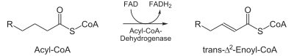 | acyl CoA dehydrogenase | trans-Δ²-enoyl-CoA
Hydration: The next step is the hydration of the bond between C-2 and C-3. The reaction is stereospecific, forming only the L isomer. | 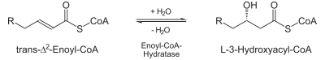 | enoyl CoA hydratase | L-β-hydroxyacyl CoA
Oxidation by NAD⁺: The third step is the oxidation of L-β-hydroxyacyl CoA by NAD⁺. This converts the hydroxyl group into a keto group. | 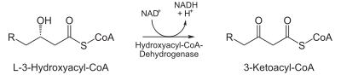 | 3-hydroxyacyl-CoA dehydrogenase | β-ketoacyl CoA
Thiolysis: The final step is the cleavage of β-ketoacyl CoA by the thiol group of another molecule of Coenzyme A. The thiol is inserted between C-2 and C-3. | 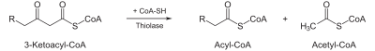 | β-ketothiolase | An acetyl-CoA molecule, and an acyl-CoA molecule that is two carbons shorter
This process continues until the entire chain is cleaved into acetyl CoA units. The final cycle produces two separate acetyl CoAs, instead of one acyl CoA and one acetyl CoA. For every cycle, the Acyl CoA unit is shortened by two carbon atoms. Concomitantly, one molecule of FADH₂, NADH and acetyl CoA are formed.

