NAME: YAKUBU ZAINAB IZEE COURSE: BIO 102 ASSIGNMENT
DEPARTMENT: PHARMACY MATRIC NO: 19/MHS11/149
- Eichler classified the plant kingdom into two sub-kingdoms they are i) Cryptogamae
ii) Phanerogamae.
- CRYPTOGAMAE: The cryptogams are flowerless and seedless plants. They are simple plants like algae, mosses and ferns which do not produce flowers, fruits and seeds. Cryptogams are classified as lower plants. It can be further divided into;
- Algae: it is a collective term for all those chlorophyll bearing organism which are thalloid, examples are; pond scums, stonewort and seaweeds.
- Bryophytes: they are the simplest land plants with undifferentiated plant body that lack vascular tissues. They are adapted to grow in water and on land. The bryophytes are divided into three classes named;
- Hepatica- liverworts e.g.: Riccia, Marchantia etc.
- Anthocerotae- horn worts e.g. Anthoceros.
- Musci: Mosses e.g. Funaria.
- Pteridophyta: pteridophytes are also called vascular cryptogams. The plant is differentiated into roots, stem and leaves. Vascular tissues are present in the plant body. Pteridophyta is divided into four;
- Psilopsida e.g. Psilotum
- Lycopsida- e.g. Lycopodium, Selaginella etc.
- Sphenosida – e.g. Equisetum
- Pteridopsida- e.g. Nephrolepis, Pteris, Dryopteris etc.
- PHANEROGAMAE: Phanerogams are seed bearing plants so they are also referred to as spermatophytes. They are higher plants and the body is differentiated into roots, stem and leaves with a developed vascular system. It is divided into Gymnosperms and Angiosperm.
- Gymnosperm: they are naked- seeded plants which seeds are not enclosed in fruits. E.g. cycads, conifers etc.
- Angiosperms: they are flowering and seed bearing plants which seeds are enclosed in fruits e.g. mango, pea plant/
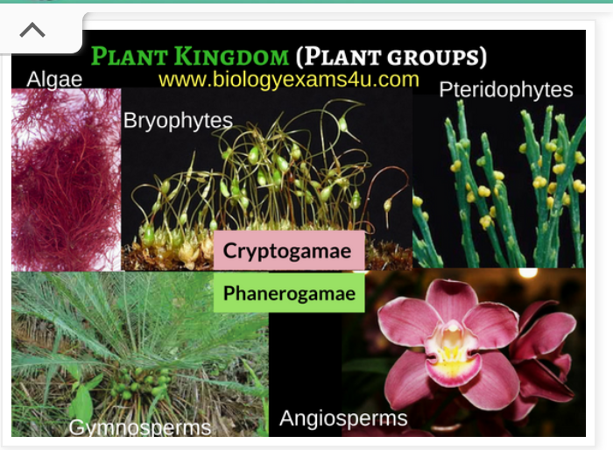
- Importance of Algae to man:
- Algae serve as food for man
- The serve as a source of agar used in preparation of ice cream, jellies, desserts etc.
- They serve as medicines and minerals.
- They are used in the manufacture of iodine
- Alginic acid, align and mannitol; used in sizing material for water proof materials, dyes, combs etc.
- In the manufacture of soaps and alums.
- Manufacture of potash.
- Manufacture of paper
- Ornamental uses.
- Utilization of chlorella; chlorella is rich in proteins, fats and vitamins.

- Unicellular form of algae
Chlamydomonas represent the unicellular form of green algae found in stagnant water usually along with other forms. The cell is bounded by a cellulose cell wall; contains organelles e.g. nucleus, mitochondria, stigma (eye spot), cup-shaped chloroplast, pyrenoid. Flagella are the structures for mobility.
- The nucleus carries the genetic programme of the cell
- The stigma is for photoreception.
- The mitochondria mediate the elaboration of energy molecules
- Manufactured sugar is processed into starch on the pyrenoid.

- Unicellular Algae reproduce in two ways; Sexual and Asexual
Asexual reproduction is the production of progeny without the union of cells or nuclear material. Many small algae reproduce asexually by ordinary cell division or by fragmentation, whereas larger algae reproduces by spores.

Sexual reproduction is characterized by the process of meiosis, in which progeny cells receive half of their genetic information from each parent cell. Certain environmental conditions e.g. lack of nutrient or moisture may trigger the haploid daughter cell to undergo sexual reproduction. Instead of forming into spores, the haploid daughter cells form gametes that have two different mating strains which are structurally similar and are positive and negative strains. Opposite mating strains fuse in a process called ISOGAMY to form a diploid zygote, which contains two sets of chromosomes. After a period of dormancy, the zygote undergoes meiosis, a type of cell division that reduces the genetic content of a cell by half. The cell division produces four genetically unique haploid cells that eventually grow into mature cells.

- DIFFERNCES BETWEEN VOLVOX AND SYNURA
VOLVOX | SYNURA
- Reproduction is both sexual and Asexual | Reproduction is sexual
- Spherical colonies of up to 50,00 cells | Few cells in colonies.
- A volvox have 500 or more biflagellate algal cells | They have varied number of ovoid golden brown cells.

- Filamentous algae; FUCUS
Fucus is a genus of brown algae whose species are often found on rocks in the intertidal zones of the sea shores. The plant body is flattened, dichotomously-branched thallus with a mid-rib, a vegetative apex, a reproductive apex (at maturity) and a multicellular disk (hold fast) with which plant is attached to rock surface. The plant bodies also have air bladders which is believed to aid the plant to float on the water. Various species of focus exist; varying in size from a few centimetres to about two metres in length.

