NAME: ADAJI ADAKOLE EMMANUEL
DEPARTMENT: PHARMACOLOGY
MATRIC NUMBER: 18/MHS05/001
COURSE CODE: BCH 204

Beta oxidation takes place in four steps: dehydrogenation, hydration, oxidation and thyolisis. Each step is catalyzed by a distinct enzyme.

Dehydrogenation; In the first step, acyl-CoA is oxidized by the enzyme acyl CoA dehydrogenase. A double bond is formed between the second and third carbons (C2 and C3) of the acyl-CoA chain entering the beta oxidation cycle; the end product of this reaction is trans-Δ²-enoyl-CoA (trans-delta 2-enoyl CoA). This step uses FAD and produces FADH2, which will enter the citric acid cycle and form ATP to be used as energy.
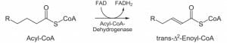

Hydration ;In the second step, the double bond between C2 and C3 of trans-Δ²-enoyl-CoA is hydrated, forming the end product L-β-hydroxyacyl CoA, which has a hydroxyl group (OH) in C2, in place of the double bond. This reaction is catalyzed by another enzyme: enoyl CoA hydratase. This step requires water.
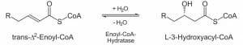

Oxidation; In the third step, the hydroxyl group in C2 of L-β-hydroxyacyl CoA is oxidized by NAD+ in a reaction that is catalyzed by 3-hydroxyacyl-CoA dehydrogenase. The end products are β-ketoacyl CoA and NADH + H. NADH will enter the citric acid cycle and produce ATP that will be used as energy.
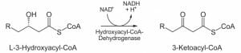

Thiolysis ;Finally, in the fourth step, β-ketoacyl CoA is cleaved by a thiol group (SH) of another CoA molecule (CoA-SH). The enzyme that catalyzes this reaction is β-ketothiolase. The cleavage takes place between C2 and C3; therefore, the end products are an acetyl-CoA molecule with the original two first carbons (C1 and C2), and an acyl-CoA chain two carbons shorter than the original acyl-CoA chain that entered the beta oxidation cycle.
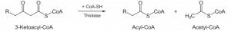
In the case of even-numbered acyl-CoA chains, beta oxidation ends after a four-carbon acyl-CoA chain is broken down into two acetyl-CoA units, each one containing two carbon atoms. Acetyl-CoA molecules enter the citric acid cycle to yield ATP. While in the case of odd-numbered acyl-CoA chains, beta oxidation ensues in the same way except for the last step: instead of a four-carbon acyl-CoA chain being broken down into two acetyl-CoA units, a five-carbon acyl-CoA chain is broken down into a three-carbon propionyl-CoA and a two-carbon acetyl-CoA

