TITLE: DISCUSS IN DETAIL THE DIFFERENT METHODS STORING OF NATURAL GAS

ETUK GABRIEL EDIMA

17/ENGO7/011

PTE316

SUBMITTED TO THE

DEPARTMENT OF CHEMICAL AND PETROLEUM ENGINEERING
COLLEGE OF ENIGINEERING
AFE BABALOLA UNIVERSITY ADO-EKITI (ABUAD)

DATE PERFORMED: 13TH APRIL2020
DATE OF SUBMISSION: 20TH APRIL 2020

DISCUSS IN DETAIL THE DIFFERENT METHODS STORING OF NATURAL GAS
Compressor stations are an integral part of the natural gas pipeline network that moves natural gas from individual producing well sites to end users.
Compressor stations are an integral part of the natural gas pipeline network that moves natural gas from individual producing well sites to end users. As natural gas moves through a pipeline, distance, friction, and elevation differences slow the movement of the gas, and reduce pressure. Compressor stations are placed strategically within the gathering and transportation pipeline network to help maintain the pressure and flow of gas to market.
Components of a Compressor Station
Natural gas enters a compressor station through station yard piping and is passed through scrubbers and filters to extract any liquids and remove solids or other particulate matter that may be in the gas stream (Figure 1).
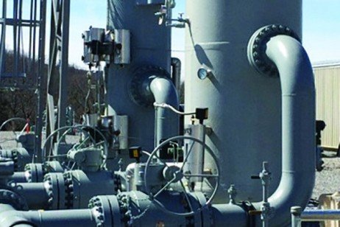
Figure 1. A separator filters out liquids, solids, and other particulate matter that may be in the gas stream. Photo courtesy of the National Fuel Gas Midstream Corporation
Once the natural gas stream has been cleaned, it is directed through additional yard piping to individual compressors. Computers regulate the flow and number of units that are needed to handle the scheduled system flow requirements. Most compressor units operate in parallel, with the individual compressor units providing the needed additional pressure before directing the gas back into the pipeline with full operational pressure restored. When the required boost in pressure is very high, several compressor units may be operated in stages (serially) to achieve the desired pressure in stages.
As natural gas is compressed, heat is generated and must be dissipated to cool the gas stream before leaving the compressor facility. For every 100 psi increase in pressure, the temperature of the gas stream increases by 7-8 degrees. Most compressor stations have an aerial cooler system to dissipate excess heat (an "after" cooler). The heat generated by the operation of the individual compressor units is dissipated via a sealed coolant system similar to an automotive radiator.
In wet gas areas, or areas that produce natural gas liquids (NGLs), changes in pressure and temperature cause some of the liquids to drop out. The liquids that drop out are captured in tanks and trucked off site. The liquids captured are referred to as natural gasoline or drip gas, which is often used as a blend in motor gasoline.
Most compressor stations are fueled by a portion of the natural gas flowing through the station, although in some areas of the country, all or some of the units may be electrically powered primarily for environmental or security reasons. Gas-powered compressors may be driven by either conventional piston engines or natural gas turbine units. There are site design and operational differences, as well as unique air and sound emissions, between these competing compressor engine technologies.
There may be one or more individual compressor units at a station, which can be out in the open, or more often, housed in a building to facilitate maintenance and sound management. Newer units are often housed one per building, but there may be multiple units in one large building. Compressor buildings generally incorporate insulated walls, shielded exhaust systems, and advanced fan technology to dampen sound. Newly constructed compressor buildings may incorporate these features where local, state, or federal regulations require noise mitigation (Figure 2).
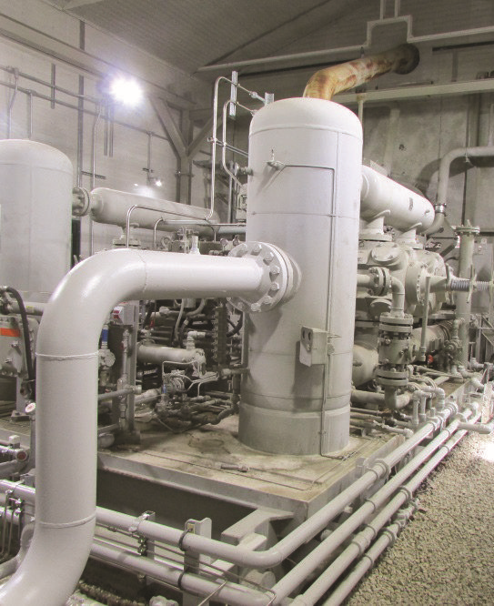
Figure 2. Inside compressor building. Courtesy of the Marcellus Education Team
Compressor station yards for gathering lines are often larger than transmission line compressors due to multiple pipelines coming into the complex, and in some cases, additional equipment needed to filter and remove liquids from the gas stream (Figure 3). Other components of a compressor complex include backup generators, gas metering equipment, gas filtration systems, and system monitoring and safety controls. There may also be odorization equipment to add mercaptan, which provides the distinctive sulfurous odor to natural gas.
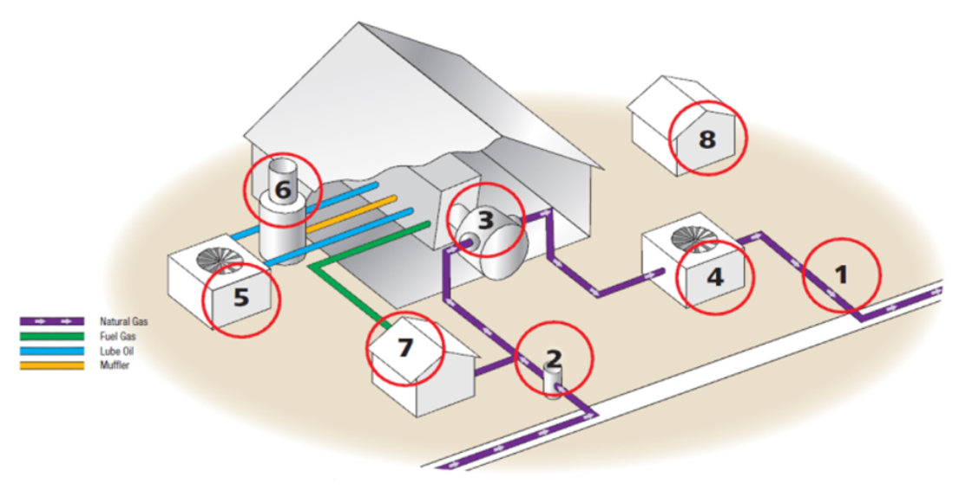

Figure 3. Compression station yard. Courtesy of Spectra Energy
- Station Yard Piping 2. Filter Separators/Scrubbers 3. Compressor Units 4. Gas Cooling System 5. Lube Oil System 6. Mufflers (Exhaust Silencers) 7. Fuel Gas System 8. Backup Generator
Permitting and Regulatory Framework
Compressor stations are either permitted and regulated at the federal or state level depending on the type of the pipeline the compressor services. For this publication, two basic types of pipeline/compressor systems will be discussed: gathering systems and interstate transmission systems. It should be noted that it is the purpose, not the size of the pipe, that defines whether a pipeline is a gathering or interstate line.
Compressor Stations within the Gathering System
Gathering lines are commonly smaller diameter pipelines (generally in the range of 6 to 20 inches) that move natural gas from the wellhead to a natural gas processing facility or an interconnection with a larger mainline pipeline. Gathering lines are regulated at the state level and compressor stations that are part of a gathering system are also regulated by the state. In Pennsylvania, the Department of Environmental Protection (PA DEP) is responsible for environmental permitting and regulation during gathering system compressor planning and construction. The Gas Safety Division of the Pennsylvania Public Utility Commission (PA PUC) is responsible for safety oversight during construction and operation of certain Class 2, Class 3, and Class 4 locations. PA PUC regulation includes material and design specifications, on-site inspections, and review of company maintenance and safety procedures.
Natural gas within a gathering system can arrive at a compressor station at a variety of pressures depending on the pressure of the wells feeding the system and the distance gas travels from the wellhead to the compressor. Regardless of the incoming pressure, the gas must be regulated or compressed to transmission pressures (generally 800 to 1,200 psi) before it can enter an interstate transmission system. Because compression requirements can be significant within the gathering system, these compressor systems are generally large facilities consisting of 6 to 12 compressors in several buildings. Many of these gathering system compressor stations are scaled up in size as more wells are drilled in an area, increasing the demand for compression. The permanent land requirements of a gathering system compressor are generally 5 to 15 acres, but they can exceed this, considering slope of land and other factors.
Compressor Stations within the Interstate Transmission System
Transmission pipelines are generally wide-diameter (20-48 inches), long-distance pipelines that transport natural gas from producing areas to market areas. These interstate pipelines carry natural gas across state boundaries--in some cases, clear across the country. The Federal Energy Regulatory Commission (FERC) has authority over the location, construction, and operation of interstate pipelines and compressors. The FERC review process includes an environmental review, evaluation of site alternatives, and interfacing with landowners and the public.
Once federally regulated interstate compressor stations become operational, station safety is regulated, monitored, and enforced by the U.S. Department of Transportation (DOT). Within DOT, the Pipeline and Hazardous Materials Safety Administration (PHMSA) is responsible for enforcing proper design, construction, operation, maintenance, testing, and inspection standards.
Interstate transmission lines are regulated at the federal level and compressor stations that are part of an interstate transmission system are also federally regulated. Interstate compressor facilities must generally comply with local and state regulations; however, if there is a conflict, the more stringent regulations will prevail.
Natural gas within an interstate pipeline is generally already pressurized at 800 to 1,200 psi. To ensure that gas continues to flow optimally, it must be periodically compressed and pushed through the pipeline. Friction and elevation differences slow the gas and reduce the pressure, so compressor stations are placed typically 40 to 70 miles apart along the pipeline to provide a boost in pressure. Because they are only providing a boost in pressure, interstate transmission system compressors are generally smaller facilities compared to gathering system compressors. A typical facility may consist of two compressor units (one that is operational and one that serves as a backup unit) within a single building. The typical permanent land requirement of an interstate compressor is 4 to 5 acres.

WHY ARE COMPRESSOR STATIONS NESSECARY IN OIL AND GAS INDUSTRY
Compressor stations enable the natural gas itself to travel through the pipelines which is crucial to the natural gas transport system. They also allow the gas to be rerouted into storage areas during periods of low demand. In addition, compressor stations are often accompanied by PIG launchers and PIG receivers which are vital for the maintenance and efficiency of the pipeline. They even include many safety features allowing the pipeline and station to function safely.
STI Group offers full turnkey construction and fabrication services for compressor stations. These services include the various components such as scrubbers, reciprocating and centrifugal compressors, compressor skid modularization, associated piping and housing. In addition we handle pumping stations, gas treatment facilities, launcher and receiver fabrication and installation, and even the assembly, dismantling, and reassembly of the stations themselves.
Components of a Compressor Station
Compressor stations are a vital part of any gas transmission system, keeping gas at a particular pressure so it can continue to flow to its destination. According to numbers from the U.S. Department of Transportation Pipeline and Hazardous Materials Safety Administration, the U.S. had 1,768 compressor stations in operation along its pipelines in 2013. Most appear along the interstate pipeline system at intervals of 40 to 100 miles. Of installed compressor types at those stations, 91.6 percent were reciprocating compressors, with centrifugal compressors making up the other 8.4 percent. The type of compressor used is determined by a number of factors, including efficiency, flow rate, and load control.
Reciprocating compressors — which have been around since the first half of the twentieth century — work off the concept of positive displacement, using pistons in reciprocating motion to compress and displace gas. Most are powered by natural gas and are useful for low-volume flow conditions. They excel in situations where capacity, gas composition, and pressure vary.
Centrifugal compressors- which are a more recent addition, relying on the use of a continuous flow of gas through an impeller. The speedy flow is then decelerated in a diffuser and volute, which subsequently causes the flow’s pressure to rise. Most are powered by electricity and are useful for high-volume flow rates. They excel in situations where capacity, gas composition, and pressure are relatively constant.
While the compressors themselves are the key components, a compressor station has other important facets as well. Incoming feed gas must be filtered to remove solids and liquids that may have accumulated or condensed out during transport from the previous compressor station or source. Outgoing gas, having run through the compressors, must also be cooled before returning to the pipeline since the process of compression raises the temperature, which can damage the inner protective coating. Emergency shutdown systems are also vital, shutting down engines and isolating and venting gasses during abnormal conditions. Noise is also a concern, with special regulations that state that noise levels can’t exceed 55 decibels to the closest residence or within 300 feet when on state forest land. This means mufflers are put in place on exhaust and intake systems. It also means in many cases sound-reducing infrastructure and insulation is built to enclose stations and reduce sound levels.

REFERENCES
https://extension.psu.edu/understanding-natural-gas-compressor-stations
https://setxind.com/midstream/compressor-stations-what-how-why/
https://auduboncompanies.com/components-of-a-compressor-station/

