Ifeanyichukwu tonia ..pharmacy(19/mhs11/068)
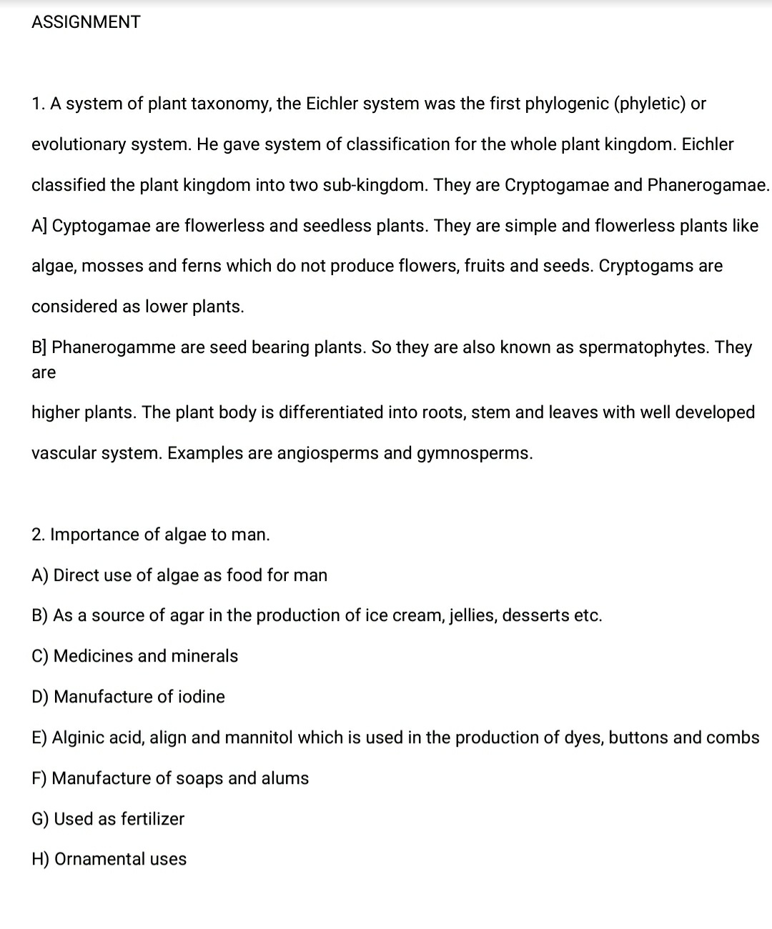
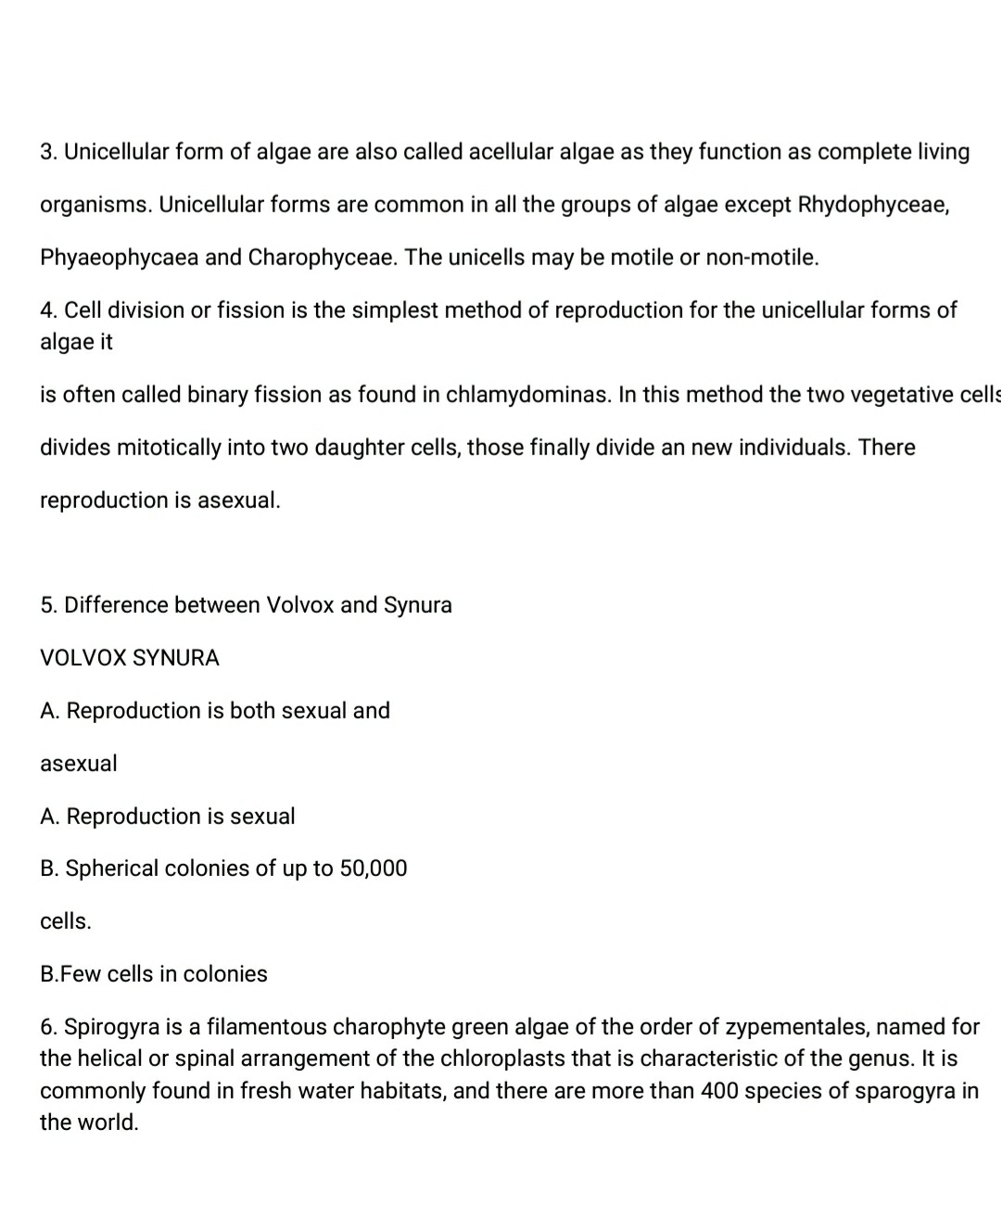
24 Apr 2020

