NAME: PHILIP-UGBODAGA .O. VANESSA
MATRIC NUMBER: 19/MHS01/384
DEPARTMENT: MBBS
COLLEGE:MHS
COURSE CODE: BIO 102

1]. Classification of plants according to Eichler’s group 0f 1883
According to this system of classification of plant kingdom is divided into two sub-kingdoms;
. sub-kingdom cryptogamae
. sub-kingdom phanerogamae

A] SUB-KINGDOM CRYPTOGAMAE
.they are flowerless and seedless plants
. they reproductive organs are conspicuous
. the embryo is naked and called spores
. they include three divisions;

I] Division Thallophyta
. they are non-vascular plants
. they are predominately aquactic. Fresh water or marine
. Examples are ulothrix, cledophora and chara

ii] Divison Bryophytha
. they are simple non-vascular plants having multicellular embryo
. they are called amphibians of the plant kingdom because they grow in moist plants
. Roots are not present but small root-like structure called rhizoids are present
. Examples are mosses and marchantia( liverwort)

Iii] Division Pteridophyta
. They are first vascular land plants with multicellular embryo
. pteridophyte are called vascular cryptogamae
. seeds are absent. They produce named embryo called spores
. they bear sporangia which produces spores

B] SUB-KINGDOM PHANEROGAMAE
. They bear flowers and seeds. They are called the spermatophytes
. The plant body is well differentiated into stems, leaves and roots
. seeds are as a result of sexual reproduction process
. they are further classified into GYMNOSPERM(NAKED SEEDS) AND ANGIOSPERM(ENCLOSED SEED)

I] SUB-DIVISION GYMNOSPERMAE
. these are naked seed plants in which the seeds are not enclosed in the ovary
. Fruit formation is absent
.it includes medium-sized trees and shrubs
. Examples are cycas, pica(Christmas tree), Thuja

ii] SUB-DIVISION ANGIOSPERMAE
. they are flowering plants
. their seeds develop inside an organ which is modified to become a fruit
.these are the highly evolved group of plants
. they have plant embryo in seed structure called cotyledons
. their reproductive organs are aggregated into flowers
. they are divided into two groups; MONOCOTS(plants that have one cotyledon) and DICOT (plants that have two cotyledon)

2]. How are algae of importance to man?
1. Food for sea animals and fishes:
The algae are used as a direct source of food by several sea animals and fishes.
The marine algae are rich in iodine and several other important minerals. This makes the fundamental source of food for all marine animals and in this respect sea is the richest food producing area. Marine planktonic diatoms together with Dinoflagellata are of fundamental biological importance since all life of sea is dependent upon them.

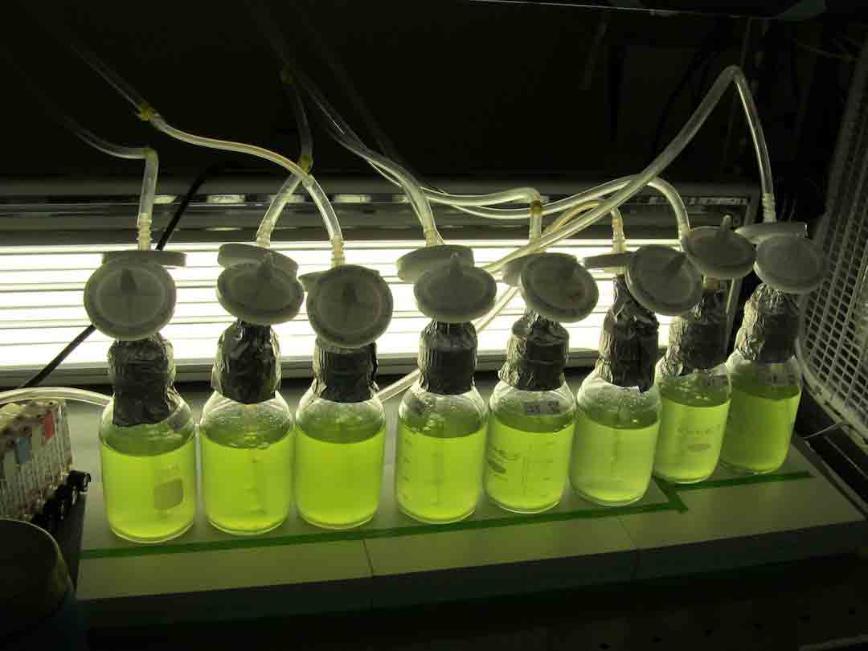
2. As a source of vitamins:
The marine algae are the richest source of vitamins. The vitamins A, B and E are found abundantly in sea weeds. The vitamin B essentially required for the development of human body is found in great abundance in almost all Phaeophyceae. The cod liver oil is the rich source of vitamin A, which is acquired from sea weeds. Vitamin E is equally important for human beings which are found in many marine algae.
According to Lundin and Ericson (1956), in the sea weeds of Sweden maximum amount of vitamin B12 and folic acid are found in spring and summer and niacin and folic acid in winter. Vitamin B12 content and also that of B1 are higher in green and red algae than in brown algae and that the niacin and vitamin C content appear to be about the same in the above three groups of marine algae. Several vitamins except ascorbic acid have been reported from Chlorella. The vitamins found in Chlorella are – thiamin, riboflavin, niacin, pyridoxine, pantothenic acid, chlorine, biotin, vitamin B12 and lipoic acid.

3.Antibiotics and Medicines: Some algae yield antibiotics, e.g., Chlorellin is obtained from green alga Chlorella; that inhabits the growth of certain bacteria. Similarly some species of Polysiphonia produce antibacterial substances which are effective against gram-negative and gram-positive bacteria. An antibiotic is obtained from a diatom Nitzschia palea which is effective against Escherichia coli. Because of high iodine contents, brown algae are used in manufacture of various goiter medicines

4. Nitrogen Fixation: The conversion of atmosphere nitrogen compounds is one of the major roles being played by the algal plants especially by the members of Cyanophyta (blue-green algae). A high rice yield has obtained when the rice fields were inoculated by certain nitrogen-fixating blue-green algae.

5.Fertilizers: Due to presence of phosphorous, potassium, calcium and some traces elements, the sea weeds (brown algae) are used as fertilizers in most of the coastal countries of the world. For example Chara is used to overcome calcium deficiency in the fields, and Fucus is used as common manure.

6.Industrial Use: Many algae yield certain chemical products which are used in various industries for various purposes. Some of these products and their uses are:
a. Agar-Agar: It is dried; jelly-like, non-nitrogenous extract obtained from some genera of Rhodophyta like Gelidum, Gracilaria, Ahnfeltia,etc. It is used as base for different culture media in laboratory for culturing microorganisms because of its food value and ability to afford good range of temperature for culturing.

b. Alginates: These are alginic acid and their derivatives, the most common being algin. They are usually extracted from the middle lamella and primary walls of the brown and red algae. The alginates are used in rubber-tyre industry, paints, and ice-creams and in preparation of flame proof fabrics and plastic articles.
c. Carrageenin: It is carbohydrate mucilage extracted from red algae used as clearing agent in beer preparation, in preparation of tooth pastes, cosmetics, and paints and in pharmaceutical industries.

3.DESCRIBE A UNICELLULAR FORM OF ALGAE:
Unicellular algae are plant like autotrophs and contain chlorophyll. They include groups that have both multicellular and unicellular species: Euglenophyta, flagellated , mostly unicellular algae that occur often in fresh water. Unicellular forms of algae are also called acellular algae as they function as complete living organisms. Unicellular forms are common in all groups of algae except RHODOPHYCEAE , PHAEOPHYCEA and CHAROPHYCEAE. The unicells may be motile or non-motile.

4. How does this unicellular algae described in question 3 carry out its reproduction?
REPRODUCTION: Reproduction in algae can be vegetative, asexual, or sexual. Vegetative reproduction occurs through fragmentation, asexual occurs through formation of spores and binary fission, whereas sexual reproduction takes place by fusion of two haploid gametes. Some algal species can reproduce by more than one means depending upon the environmental conditions. Here’s more about the reproductive process in algae.
Procreation in Algae
The reproduction of algae can be discussed under two types, namely asexual reproduction and sexual reproduction. The former type refers to reproduction in which a new organism is generated from a single parent. In case of the sexual type, two haploid sex cells are fused to form a diploid zygote that develops into an organism. Let’s discuss in brief about the vegetative, asexual, and sexual reproduction in algae along with examples.
Vegetative Reproduction
Vegetative breeding in algae is quite diverse. Some unicellular forms of algae like Euglena reproduce by binary fission, in which the parent cell divides (longitudinal or transverse) into two similar parts. These two cells develop as organisms and are similar to the parent cell. Fragmentation is a process that is classified under vegetative reproduction in algae. It occurs in Sargassum and other colonial algae, whereby the parent cell divides into two or more fragments that grow into new organisms.

Asexual Reproduction
Asexual reproduction occurs by the formation of spores; the algal species Chlamydomonas and Chlorella reproduce by this method. Depending upon the algal species, the spores can be produced in normal or specialized cells. They are either motile or non-motile. Different types of spores are zoospores, synzoospores, aplanospores, hypnospores, autospores, and tetraspores.

Sexual Reproduction
As mentioned earlier, sexual reproduction takes place by the union of male and female gametes. The gametes may be identical in shape, size, and structure (isogamy) or different (heterogamy). Some of the simplest forms of algae like Spirogyra reproduce by the conjugation method of sexual reproduction. In the process of conjugation, two filamentous strands (or two organisms) of the same algae species exchange genetic material through the conjugation tube. Among two strands, one acts as a donor and another behaves as a receiver. After exchanging the genetic material, two strands separate from each other. The receiver then gives rise to a diploid organism.
In the higher forms of algae, for example Ulva and Laminaria, an alternation of generation is usually observed. Both asexual and sexual reproduction occur in such organisms. Thus, the mature forms of haploid organisms called gametophyte and diploid organisms called sporophyte are present in the life cycle. If gametophyte and sporophyte organisms are similar in appearance, then they are referred to as isomorphic, whereas algae with different gametophyte and sporophyte forms are called heteromorphic. The gametophyte produces haploid gametes by mitosis cell division, which unite to form diploid zygote that develops into a sporophyte. The sporophyte then undergoes meiotic cell division to give rise to haploid spores, which grow into gametophytes. This way, the gametophyte and sporophyte generations alter with each other.

5. DIFFERENTIATE BETWEEN THE TWO TYPES OF COLONIAL ALGAE
VOLVOX: i] it is a multicellular motile thallus
Ii] sexual reproduction is oogamus
Iii] it is a complex form of pandorina

PANDORINA: i] it has a unicellular motile thallus
Ii] it’s sexual reproduction is angiogamous
Iii] it is a genus of green algae

6.DESCRIBE A NAMED COMPLEX FORM OF ALGAE
FUCUS: focus are perennial algae, some of which have a life span of up to four years. They feature bladder like floats(pneumatocysts), disk-shaped holdfasts for clinging to rocks, and mucilage covered blades that resist dessication and temperature change. fucus is a genus of brown algae found in the interdial zones of rocky seashores.

