17/MHS06/049
Obikpo Chisom E.L
MBBS, 300 level
ANA 305: Histology of special senses and neurohistology

Special senses assignment

- Write an essay on the histological importance of the eye in relation to their cellular functions.

The eye is the organ of vision which has the ability to receive and process visual detail, as well as enabling several photo response functions that are independent of vision. They function to detect light and convert it to electro-chemical impulses in neurons.
The eye as an organ is composed of 3 layers of tissue arranged concentrically namely:
- An external layer (fibrous tunic) which format a capsule enclosing and protecting other components of the eye. It is subdivided into the sclera and the cornea.
- A middle layer (vascular tunic) which forms the lens, the choroid and the cilliary body.
- An internal layer (neural tunic) which consists of the retina
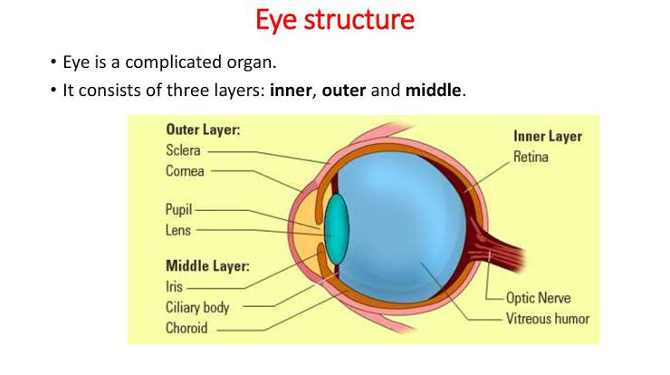

THE EXTERNAL LAYER
- The sclera: this is a tough, dense layer of connective tissue consisting of collagen fibres and networks of elastic fibres. Type 2 collagen fibres are dominant and arranged in irregular directions. This lack of orientation of the fibres accounts for the “white opaque” nature of the sclera unlike the cornea which is transparent. Melanocytes are present in deep parts of the sclera in addition to the usual complement of connective tissue cells. The collagen of the sclera is continuous with the cornea thus forming a slight protrusion into one eyeball before it merges with the cornea. The sclera is composed of 4 layers. From external to internal they include a. the episclera, the stroma, the lamina and the endothelium
Histological importance of the sclera
The sclera being an opaque, fibrous, tough, protective outer layer of the eye upon distension by intraocular pressure maintains the shape of the eye. It is also a site of attachment for the ocular muscles. The sclera mainly participated in the structural functions concerned with the eye

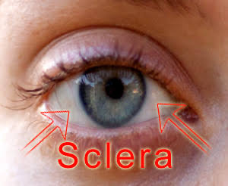
- the cornea: the cornea forms the anterior surface of the eye. It is formed by 3 cellular layers which are separated by 2 acellular layers. It is a vascular and the cells are not pigmented it consists mainly of type I collagen fibres but types III, V, VI may be present. These fibres are oriented in a uniform parallel direction to maintain transparency, presence of flattened fibrocytes (keratocytes) which are located between the layers of collagen fibres. The layers include:
- Corneal epithelium: the anterior surface of the cornea is line by a non-keratinized stratified squamous epithelium which is a regenerating multicellular layer which interacts with the tear film
- Bowman layer: this is the layer on which the basement membrane of the corneal epithelium rests on. This is the first acellular layer which separates the corneal epithelium from the corneal stroma. It consists of densely packed collagen fibrils embedded in ground substance with the absence of cells thus the name, the first acellular layer. The bowman’s membrane contributes greatly to the stability of the cornea.
- Corneal stroma: this is the largest layer consisting of 200-250 layers of regularly organized collagen fibrils. Presence of keratocytes which maintains the integrity of this layer. The primary function of this layer is to maintain transparency which is aided by how small the diameter (20-60nm) and the regular arrangement of the collagen fibres.
- Descemet’s membrane: also known as the posterior limiting lamina because it separates the corneal stroma from the corneal endothelium. It serves as a modified basement membrane of the corneal endothelium. It is an acellular homogenous layer made up of type B fibres.
- Corneal endothelium: this is the posterior endothelium made up of simple cuboidal or simple squamous cells it has the inability to regenerate but has the presence of pumps to maintain fluid balance and to prevent swelling of the stroma

Histological importance of the cornea
The main function of the cornea is to retract or bend light. It is responsible for focusing most of the light that enters the eye. It is able to protect the eye from infections and also tends to repair itself from minor abrasions. However, deep abrasions to the cornea could form scars leading to loss of transparency and therefore impairing vision.

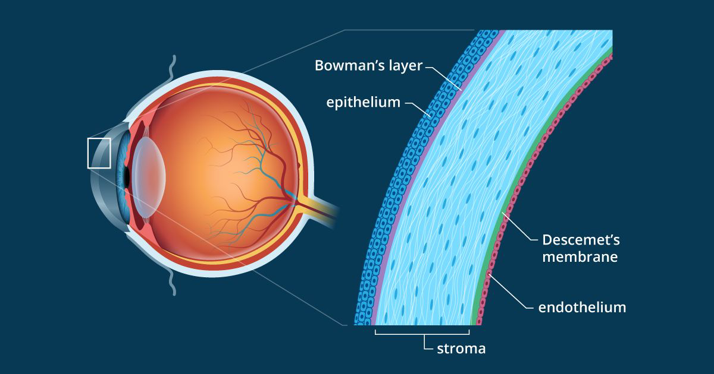

CORNEOSCLERAL JUNCTION or LIMBUS is an area of transition from the transparent collagen bundles of the cornea to the white opaque fibers of the sclera. It is highly vascularized, and it’s
Blood vessels assume an important role in corneal inflammatory processes.

MIDDLE LAYER
- The choroid: the choroid consists of loose connective tissue which houses a dense network of blood vessels, connective tissue cells and melanocytes. The melanocytes contribute to the dark color of the choroid. The choroid is solely for nutritive functions and provides nourishment to structures of the eye. There is a presence of a choriocapillary layer which is the innermost part of the choroid containing small blood vessels. Brunch’s membrane is located between the choroid and the retina.
- The cilliary body: this is an inward extension of the choroidea at the level of the lens. Presence of cilliary processes which are short extensions of the cilliary body toward the lens which contains a dense network of capillaries. The cilliary body is composed of cilliary epithelium and cilliary muscles. The cilliary epithelium lines the inner surface of the cilliary body which is composed of 2 layers; an outer cell layer which is pigmented and an inner cell layer which is not pigmented. It is this non pigmented layer that generates the aqueous humor of the eye. There is also a presence of zonule fibres which form the shape sort ligaments of the lens
- The iris:the iridal stroma consists of a vascularized connective tissue rich in melanocytes in addition to macrophages and fibrocytes which are all surrounded by a loose mesh work or fine collagen fibres. There is a presence of pigmented epithelial cells beneath the stroma. The sphincter pupillae and the dilator pupillae muscles connects to the stroma. The pigmented layer of cells block light rays and ensure that light must move through the pupil to rich the retina

Histological importance of the iris
The anterior surface of the iris contains loose, variably pigmented stroma. It is open to the circulating aqueous humor within the anterior chamber.
Two layers of heavily pigmented epithelium cover the posterior surface of the iris.
Note that the sphincter pupillae muscle can be easily seen near the pupil margin. It is smooth muscle controlled by parasympathetics. The dilator pupillae muscle is more difficult to identify, but it dilates the pupil upon sympathetic innervation.

Histological importance of the ciliary body
contains ciliary muscle that is composed of smooth muscle. Contraction and relaxation of the Ciliary muscles changes the tension of the zonular fibers, or suspension ligaments, of the lens. This allows the lens to change shape, a process known as accommodation.
The ciliary processes are folds of connective tissue that are covered by two layers of epithelium. There is also a complex vasculature they cannot be seen easily. Fluid from these vessels is processed and transported by the epithelial cells to the posterior chamber as aqueous humor. The epithelial cells constitute the blood- aqueous barrier.

Histological importance of the choroid
Choroid. The vascular (major blood vessel), central layer of the eye lying between the retina and sclera. Its function is to provide nourishment to the outer layers of the retina through blood vessels. It is part of the uveal tract.

INNERMOST LAYER

- The lens: the lens consists of a lens capsule, the subcapsular epithelium and lens fibres. It doesn’t contain any blood vessels or any nerves. The lens capsule is generated by the cells of the subscapular epithelium and corresponds to a thick, elastic basal lamina. The zonule fibres insert into the lens capsule. The cells of the subscapular epithelium are mitotically active and cover the anterior hemisphere of the lens in adults. It separates the aqueous and vitreous chambers.
- The vitreous: this is a jelly-like space made up of type II collagen separating the retina and the lens. The vitreous humor is transparent, colorless, gelatinous mass that fills the space in the eye between the lens and the retina. The vitreous humor is fluid-like near the center and gel-like near the edges.
- The retina: nervous tissue of the eye where photons of light convert to neurochemical energy via action potentials. The retina serves a function analogous to that of the film or image sensor in a camera. The neural retina consists of several layers of neurons interconnected by synapses, and is supported by an outer layer of pigmented epithelial cells.

Histological importance of the lens
The lens is a transparent and flexible biconvex structure in the eye that, along with the cornea, helps to refract light to be focused on the retina. The flexibility allows the lens to be easily manipulated by the ciliary muscles, by changing the curvature of the lens, one can focus the eye on objects at different distances from it.

Histological importance of the vitreous body
The vitreous body provides physical support holding the retina in place next to the choroid, the blood supply for the outer retina. (Neural retina and choroid are only connected to each other at the disc and the ora serrata.)

Question 2
Corona virus can penetrate the body through the eye and implicate the immune system, briefly discuss the layers of the retina for information of penetration.

The retina is a thin layer of tissue that lines the back of the eye on the inside. It is located near the optic nerve. The purpose of the retina is to receive light that the lens has focused, convert the light into neural signals, and send these signals on to the brain for visual recognition.
Similar to the retinal lining of the iris and cilliary body, the outer layer of the light sensitive retina forms a single layer of cuboidal cells (the pigment epithelium). The inner layer of the
Retjna contains the photoreceptors, the first neurons which process the sensory information and the neurons which convey pre-processed sensory information to the central nervous system. These are layers from the farthest to closest to the vitreous body:

- The layer of rods and cones contains the outer, rod- or cone-shaped light sensitive segements of the photoreceptive cells. The lights sensitive part and the perikayon of the rods and cones are connected by a narrowed bridge of cytoplasm. At the level of this connection the rods and cones are surrounded by the processes of a specialised type of glial cells, Müller cells, which form the outer limiting membrane.
- The outer limiting membrane: layer that separates the inner segment portions of the photoreceptors from their cell nuclei
- The outer nuclear layer: contains the nuclei and the perikarya of the rods and cones with their processes forming part of the outer plexiform layer.
- The outer plexiform layer: layer where they form synapses with the processes of neurons whose cell bodies are located in the inner nuclear layer. Synapses with dendrites of of bipolar & horizontal cells.
- The inner nuclear layer: the cells of this layer are concerned with initial processing sensory input. The 3 major neurone cell types are horizontal, bipolar and amacrine cells. It also houses the perikarya of müller cells.
- The inner plexiform layer: it contains the processes of the inner nuclear layer neurons which convey the sensory input to the ganglion cell layer
- The ganglion cell layer: Ganglion cells are not evenly distributed. There are few of them towards the periphery of the retina. Close to the fovea, ganglion cells form a densely packed layer. Both ganglion cells and the cell bodies located in the inner nuclear layer which contact the rods and cones of the fovea are displaced towards the margins of the fovea.
- Layer of optic nerves: the acorns of the ganglion cells travel in this layer towards the optic disc. Towards the optic disc, the thickness of this layer increases as axons are being added to it
- The inner limiting membrane: it contributes to the basal lamina formed by the müller cells.
- Retinal pigment epithelium: single layer of cuboidal epithelium cells. This is the layer closer to the choroid and provides nourishment and supportive functions to the neural retina.

These layers can be grouped into 4 main processing stages: photoreception; transmission to bipolar cells; transmission to ganglion cells, which also contain photoreceptors, the photosensitive ganglion cells; and transmission along the optic nerve.

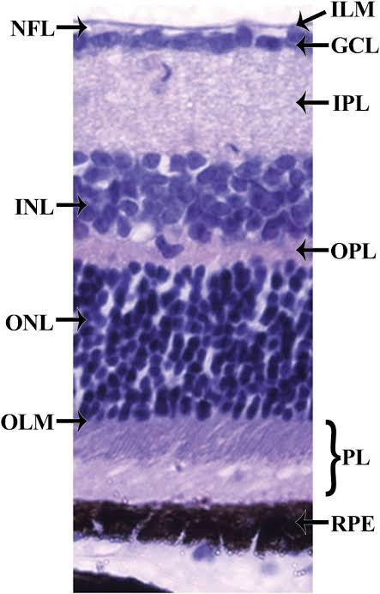
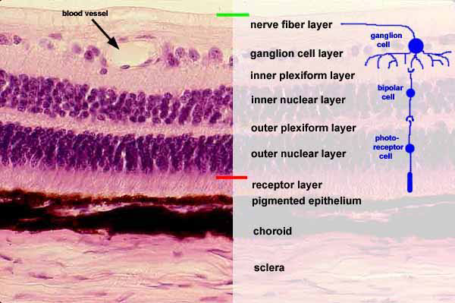
NFL- Nerve fibre layer
INL- inner nuclear layer
ONL- outer nuclear layer
OLM- outer limiting membrane
ILM- inner limiting membrane
GCL- ganglion cell layer
IPL- inner plexiform layer
OPL- outer plexiform layer
PL- pigment layer
RPE- retinal pigment epithelium

