ADEBARA FAITH INUMIDUN
17/SCI05/001
MEDICINE AND SURGERY
300 LEVEL
2019/2020

ASSIGNMENT:
- Write an essay on the histological importance of eye in relation to their cellular functions
- Corona virus can penetrate the body through eye and implicate the immune system, briefly discuss the layers of the retina for information penetration.

Question One
HISTOLOGICAL IMORTANCE OF THE EYE IN RELATION TO THEIR CELLULAR FNCTIONS
Information about the external world is conveyed to the central nervous system from sensory receptors. There are 5 special senses- the sense of taste, smell, touch, sight and equilibrium and hearing.
The eyes provide the sense of sight. They are highly developed photosensitive organs for analyzing the form, intensity, and colour of light reflected from objects and providing the sense of sight.
External structure of the eye includes:
- Conjunctiva, which lines the inner part of the eyelid. It is a thin, transparent mucosa that covers the exposed, anterior portion of the sclera and continues as the lining on the inner surface of the eyelids. It consists of a stratified columnar epithelium, with numerous small goblet cells, supported by a thin lamina propria of lose vascular connective tissue. Mucosa secretions from conjunctiva cells are added to the tear film that coats this epithelium and the cornea.
- Tear film, consisting of aqueous, mucous and oily secretions.
- Eyelid, a mobile layer made up of skin and muscular tissues which covers the eyeball and prevents foreign bodies from entering the inner eye. It also helps refresh and distribute tear film by blinking.
- Muscles, including the orbicularis oculi, levator palpebrae superiorlis, superior tarsal muscle.
- Accessory glands, such as the apocrine glands of Moll, meibonmian glands and lacrimal glands.
Internal structure of the eye consists of three layers of tissues arranged concentrically. They are:
- A tough external fibrous layer (sclera and cornea).
- A middle vascular layer (choroid, ciliary body and iris).
- An inner sensory layer, the retina.
A histological understanding of the layers of the eye is essential for appreciating disease pathophysiology and understanding certain therapeutic approaches.
The layers of the eye perform distinct functions which coalesce to create a unifies, perceptual experience.
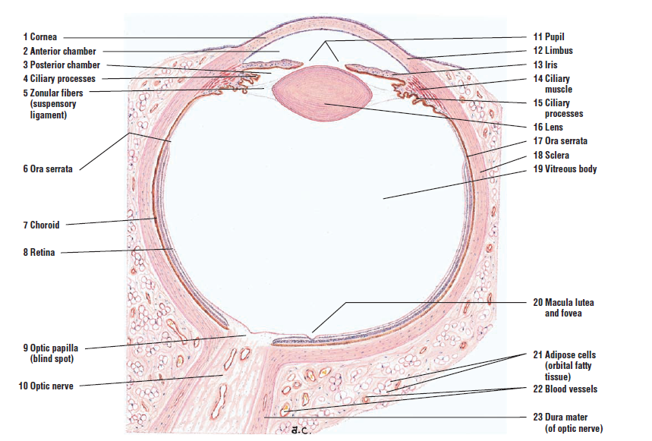

- FIBROUS TUNIC (External layer)
This layer protects the more delicate internal structures of the eye, resists intraocular pressure and maintains the shape of the eyeball. It also provides site for attachment of muscles that move the eyeball.
It consists of the posterior sclera and anterior cornea. At the corneoscleral or sclerocorneal junction, the sclera is continuous with the cornea. This junction is known as the limbus.

- SCLERA
Histology
It is the white posterior five-sixths of the fibrous layer. It is about 0.5mm in thickness. The sclera consists mainly of dense connective tissue, with flat bundles of type I collagen parallel to the organ surface but intersecting in various directions. The lack of parallel orientation of collagen fibres gives the sclera its white appearance as opposed to the transparent nature of the cornea. However, the collagen of the sclera and cornea are continuous. Some elastic fibers and connective tissues cells, mainly fibroblasts are also present.
The four (4) layers of the sclera from external to internal are:
- Episcleral- also called fascial sheath. It is the external surface of the sclera. It is connected to the Tenon Capsule by thin collagen fibres. At the limbus, the Tenon Capsule contacts stroma to the conjunctiva.
- Stroma
- Lamina fusca- also called suprachoroid lamina. It is the delicate connective tissue, containing collagen, elastic fibres and branching cells containing pigment, that is present in the perichoroidal space (the space that separates the deep surface of the sclera from the choroid). The lamina fusca is non-vascular.
- Endothelium
Functions of the sclera
- The sclera supports the eye shape.
- It protects delicate internal structures.
- It provides site of attachment for extrinsic eye muscle.

- CORNEA
Histology
The cornea is the anterior one-sixth of the eye. It is transparent and completely avascular but has a rich nerve supply. It receives nutrition from blood vessels round its periphery.
It consists of type I collagen fibres oriented in a uniform parallel direction to maintain transparency.
The cornea is made up of five distinct layers:
- Corneal epithelium
- Bowman’s membrane
- Corneal stroma
- Descemet’s membrane
- Corneal endothelium

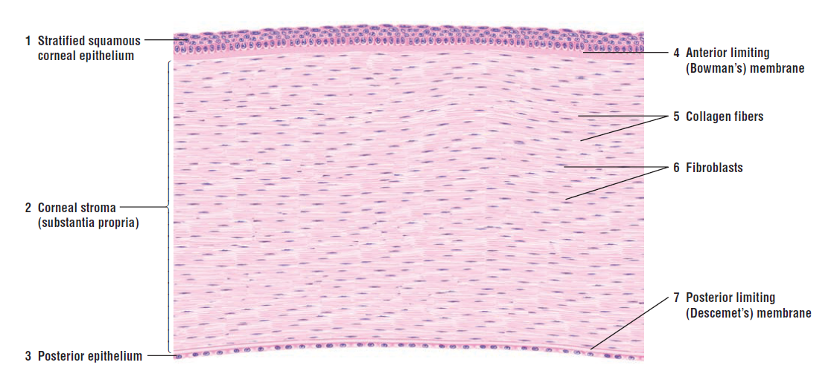

- Corneal epithelium: it is composed of non-keratinized stratified squamous (NKSS) epithelium. It is about 50microns and comprises about 10% of the corneal thickness. The NKKS epithelial cells are held together by tight junctions to form an effective barrier against fluid loss and pathogen penetration.
The epithelium is about 5-6 layers structure with 3 types of cells: -
- The cells in the superficial 2-3 layers are flattened. These cells have projections either in the form of microvilli or folds of plasma membrane, which increases the surface area and play an important role in retaining the film of fluid over the surface if the cornea.
- The middle 2-3 layers are polyhedral cells, commonly known as wing cells.
- The cells at the deepest layer are columnar, known as basal cells. The basal cells have high proliferative capacity important for renewal and repair of the corneal surface.

- Bowman’s membrane: it is the basement membrane of the corneal epithelium. It contributes to the stability and strength of the cornea, helping to protect against infection of the underlying stroma. It is not a true membrane. This layer is tough and keeps the cornea from pulling forward.
It is composed of type I and IV collagen, laminin, and several other heparin sulfate proteoglycans.
It has no regenerative ability, hence, when injured, this layer does not regenerate and may result in a scar that can affect vision.
- Corneal stroma: also called substantia propria. It is the largest layer of the cornea and makes up about 90% of the cornea’s thickness. The stroma has collagen fibres (mainly type II collagen) arranged in a regular pattern. Between the collagen lamellae are cytoplasmic extensions of flattened fibroblast-like cells called keratocytes or corneal corpuscles, which maintain the thickness of this layer. The ground substance around these cells contains proteoglycans such as lumican with keratan sulfate and chondroitin sulfate, which help to maintain the precise organisation and spacing of the collagen fibrils.
The function of this layer is to maintain transparency, which occurs by the regular arrangement and lattice structures of the fibrils, whereby scatter from the individual fibrils gets canceled by destructive interference and the spacing of less than 200nm allows for transparency.
Injuries at this level also produces scar.

- Descemet’s membrane: it is a true basement membrane and is thicker than the bowman’s membrane. It is an acellular layer made of type IV collage that serves as a modified basement membrane of the corneal endothelium.

- Corneal endothelium: it is a one cell thick layer made of either simple squamous or cuboidal cells and measures about 5 microns thick. Cells in this region do not regenerate. It includes the most metabolically active cells of the cornea. The endothelial cells have pups that maintain fluid balance and prevent swelling of the stroma. When corneal endothelial cells are lost, neighbouring cells stretch to attempt to compensate these losses.

Functions of the cornea
- The cornea protects the anterior surface of the eye.
- It refracts(bends) incoming light

- MIDDLE VASCULAR LAYER
The eye’s more vascular middle layer is known as the uvea. This layer is deep to the sclera. It consists of 3 parts: choroid, ciliary body and iris.
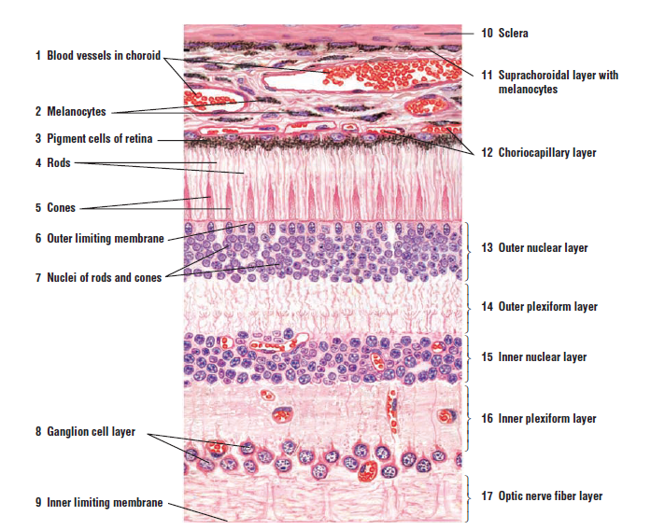

- CHOROID
It is located in the posterior two-third of the eye. It consists of a dense network of blood vessels supplying oxygen and nutrients to the structures of the eye, particularly the adjacent retina, housed in loose connective tissue. Numerous melanocytes are also present, which gives the characteristic black layer in the choroid and prevent light from entering the eye except through the pupil.
The choroid consists of 2 layers:
- Choroido-capillary lamina: it is located in the innermost part of the choroid and supplies nutrient to the retina. This layer is not pigmented.

- Bruch membrane: is a thin extracellular matrix layer situated between the retina and choroid. It is composed of collagen fibres and elastic fibres surrounding the adjacent microvasculature and basal lamina of the retina pigmented layer. Nutrients passing from the choroido-capillary lamina to the retina layer have to pass through this membrane.

Functions of the choroid
- The choroid supplies nourishment to the retina
- The pigment present in it absorbs extraneous light.

- CILIARY BODY
It is the tissue that divides the posterior chamber and vitreous body. The inner surface of the epithelium is lined by a double layered epithelium which represents a forward continuation of the retina.
The ciliary body is made up of:
- Vascular tissue
- Loose connective tissue containing melanocytes
- Smooth ciliary muscle: this muscle via the lens zonules controls the structure of the lens, which is vital for accommodation.
- Ciliary processes: these are radially arranged ridges extending from the inner highly vascular region of the ciliary body. They provide a large surface area. Each fold has a core of connective tissue and are covered by a double layer of low columnar epithelial cells, the ciliary epithelium. This ciliary epithelium of the ciliary processes secretes the aqueous humour.
- Ciliary zonules: are connective tissue fibres that connect the ciliary muscle and lens.

Functions of ciliary body
- The ciliary body holds suspensory ligaments that attach to the lens and change lens shape for far and near visions.
- The ciliary epithelium secretes aqueous humour.

- IRIS
It is the most anterior layer of the uvea. It forms a diaphragm placed immediately in front of the lens, leaving a round central aperture called the pupil.
The iris consists of:
- Stromal layer:
- The anterior surface of the iris, exposed to aqueous humour in the anterior chamber, consists of dense layer of fibroblasts and melanocytes with interdigitating processes. It lacks an epithelial covering.
- Deeper in the iris, the stroma consists of loose connective tissue containing melanocyte and has blood vessels embedded in it.

- Pigmented epithelial cells: it lies beneath the stroma. This highly pigmented posterior epithelium of the iris blocks all light from entering the eye except that passing through the pupil. This protects the eye’s interior from an excess of light.
Myoepithelial cells form a partially pigmented epithelial layer and extend contractile processes radially as the very thin dilator pupillae muscle. Some smooth muscles are arranged circularly around the pupil to form the sphincter pupillae muscle. The dilator and sphincter pupillae muscles have sympathetic and parasympathetic innervation respectively to enlarge and constrict the pupil.
The angle formed by the iris and cornea contains connective tissue with endothelial channels called the trabecular meshwork, which drains aqueous humour in the anterior chamber into the venous canal of Schlemm. Form here, fluid drains into the episcleral veins.

Functions of the iris
- The iris controls pupil diameter and thus the amount of light entering the eye.
- Melanocytes of the iris stroma provides the colour of one’s eyes.

- INNER SENSORY LAYER (RETINA)
The retina is the innermost tunic of the eye. It is the nervous tissue of the eye where photons of light convert to neurochemical energy via action potentials.

The retina has two distinct layers:
- The non-neural pigmented epithelium layer.
- The photosensitive neural layer.

- The non-neural pigmented epithelium layer: it is a single layer of cuboidal epithelial cells containing melanin which absorbs light.

Functions
- It absorbs scattered and excessive light that passes through the neural layer.
- These cells also establish a blood-retina barrier through tight junctions, thereby isolating retina photoreceptors from the highly vascular choroid and regulates ion transport between these compartments.
- The cells play key roles in the visual cycle of retinal regeneration.
- They phagocytise shed components from the adjacent photoreceptors.

- The photosensitive neural layer: it consists of 9 distinct layers:

- Rods and cones layer (RCL): this layer contains the outer segment of these cells where the photoreceptors are located. Glial cells are also present.
- Outer limiting layer (OLL): it is a layer of Muller cells and red/cone junctions which serves to separate the photosensitive regions of the retina from the areas that transmit the electrical signals.
- Outer nuclear layer (ONL): this layer consists of the cell bodies and nuclei of the photosensitive rod and cone cells.
- Outer plexiform layer (OPL): this layer contains synaptic processes of rod and one cells.
- Inner nuclear layer (INL): this layer contains the cell bodies of glial, amacrine, bipolar and horizontal cells.
- Inner plexiform layer (IPL): this layer has axons of amacrine, bipolar and glial cells and dendrites of retinal ganglion cells. This layer relays information from cells of the INL.
- Ganglionic layer (GL): this layer contains nuclei of retinal ganglion cells.
- Nerve fibre layer (NFL): this layer contains axons of retinal ganglion cells and the astroglia which support them. Collectively, these axons constitute the optic nerve.
- Internal limiting layer (ILL): it is a thin layer of Muller cells and basement membrane which demarcates the vitreous anteriorly from the retina posteriorly.

Within these layers of the retina, there are multiple different types of cells with specific jobs that help to transmit incoming photons into action potentials that the brain cortices process into 3-dimensional vision. The different cell types in the retina include the following:

- ROD CELLS
The human retina has an average of 95 million rod cells. In humans, approximately 95% of the photoreceptors in the retina are rods and they specialize in registering low light levels, thus helping to create a black ad white vison- known as scotopic vision. Rods are extremely sensitive to light, responding to a single photon of light, and allow to see vision with low light levels. They are thin elongated cells (5 microns * 3 microns).
Each rod cell consists of cell body containing the nucleus and processes.
The cell body lies in the outer nuclear layer.
The process can be divided into an outer and inner segment.
- The outer segment is the real photoreceptor element. It is a modified primary cilium, photosensitive and shaped like a short rod. It contains about 600-1000 flattened membranous discs stacked on one another like coins and surrounded by the plasma membrane. Proteins in the cytoplasmic surface of each disc include abundant rhodopsin (or visual purple). Rhodopsin are photosensitive pigments that are concerned with the conversion of light into nerve impulses. They are bleached by light and initiates visual stimulus.
- The inner segment contains glycogen, mitochondria and polyribosomes for the cell’s biosynthetic activity. The large number of mitochondria ae concentrated in the region that is called the ellipsoid. The inner segment of the rod process or cone process is wider than the outer segment.
- At the junction of the inner and outer segments of the rod or cone processes, there is a constriction called the connecting stalk. The connecting stalk contains fibrillar cilium which is believed to give rise to the flattened membranous discs of the outer segment.
More rods converge unto a single retinal ganglion cell. The configuration of rods into the retinal system allows them to use their unique sensitivity to photons and integrate the photon signal for longer by converging multiple rods onto a single retinal ganglionic cell and thus reducing background noise.
Rod cells use glutamate as their neurotransmitter and synapse onto second-order bipolar cells at the outer plexiform layer.

- CONE CELLS
They are less numerous and are less light sensitive than rods. The human retina has about 5-7 million cone cells. The cone cells produce colour vision in adequately bright light. They respond to bright light (photopic vision). They are responsible for sharp vision for the discrimination of colour. Just as rhodopsin is seen in rods, iodopsin (or photopsins) are seen in cones.
There are 3 morphologically similar cases of cones, each containing one type of visual pigment iodopsin. Each of the 3 iodopsin has maximal sensitivity to light of a different wavelength, in the red, blue or green regions of the visible spectrum respectively.by mixing neural input produced y these visual pigments, cones produce a colour image. Therefore, cones are believed to be of 3 types: red sensitive; blue sensitive and green sensitive. However, these 3 types cannot be distinguished by their ultrastructure.
Like rods, cone cells are elongated with outer and inner segments, connecting stalk and an accumulation of mitochondria and polyribosomes.
The outer segment of cones differs from those of rods in their shorter, more conical form and in the structure of their stacked membranous discs, which in cones remain as continuous invaginations of the plasma membrane along one side. Also, newly synthesized iodopsins and other membrane protein are distributed uniformly throughout the cone outer segment and, although iodopsins turns over, discs in cones are shed more less frequently than in rods.

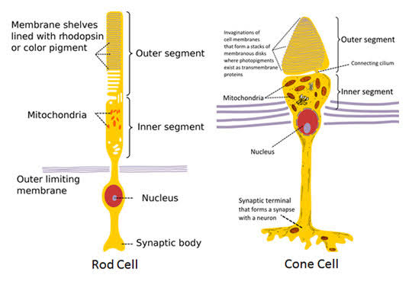

- RETINAL GANGLION CELLS(RGC)
RGC are the retina’s main output neuro, but also a third class of photoreceptors that are also photosensitive and help transmit both image-forming and non-image forming information that functions in the physiological processes of the circadian rhythm, modulation of melatonin release, and regulation of pupil size. There are approximately 20 different RGCs and 1 to 2% of all RGCs are intrinsically photosensitive.
RGCs receive both excitatory and inhibitory inputs from two types of intermediate neurons, amacrine cells and bipolar cells. RGCs and amacrine cells form a functional subunit of on-off centres that allow for the brain to interpret a small dot moving at a distance. RGCs send axonal projections that converge in the optic disc and pas through the lamina cribrosa unmyelinated, to not interfere with incoming light. RGC axons target the suprachiasmatic nucleus, olivary pretectal nucleus, intergeniculate leaflet, ventral division of the lateral geniculate nucleus, and preoptic are and thud assist with synchronization of circadian rhythm and the pupillary light reflex.

- THE HORIZONTAL NEURONS
Horizontal neurons establish numerous connections between photoreceptors. Some of them are excitatory, while others are inhibitory. In this way these neurons play a role in integrating the activity of photoreceptors located in adjacent parts of the retina. As they participate in synapses between photoreceptors and bipolar neurons horizontal neurons may regulate synaptic transmission between these cells.
Horizontal neurons are of two types, rod horizontals and cone horizontals, depending on whether they synapse predominantly with rods or cones.
Each horizontal cell gives off one long process, and a number of short processes (7 in case of rod horizontal cells, and 10 in case of cone horizontal cells). The short processes are specific for the type of cell: those of rod horizontals synapse with a number of rod spherules, and those of cone horizontals synapse with cone pedicles. The long processes synapse with both rods and cones (which are situated some distance away from the cell body of the horizontal neuron). The long and short processes of horizontal cells cannot be distinguished as dendrites or axons, and each process probably conducts in both directions.

- AMACRINE NEURONS
The term amacrine is applied to neurons that have no true axon. Like the processes of horizontal cells those of amacrine neurons also conduct impulses in both directions. Each cell gives off one or two thick processes that divide further into a number of branches.
Different types of amacrine neurons are recognised depending upon the pattern of branching. The processes of amacrine neurons enter the internal plexiform layer where they may synapse with axons of several bipolar cells, and with the dendrites of several ganglion cells. They also synapse with other amacrine cells. At many places an amacrine process synapsing with a ganglion cell is accompanied by a bipolar cell axon. The two are referred to as a dyad.
The amacrine cells are believed to play a very important role in the interaction between adjacent areas of the retina resulting in production of sharp images. They are also involved in the analysis of motion in the field of vision. Internal plexiform cells (present in the internal plexiform layer) represent a third variety of horizontally oriented neurons in the retina. Apart from integration of impulses from rods and cones horizontal, amacrine and internal plexiform cells act as ‘gates’ that can modulate passage of inputs from rods and cones to ganglion cells. In this connection it is to be noted that processes of amacrine neurons are interposed between processes of bipolar cells and ganglion cells, while processes of horizontal cells are interposed between photoreceptors and bipolar cells.

- BIPOLAR NEURONS
Bipolar cells are second-order long projection neurons, named after their axons 180-degree orientation, that receive visual inputs form photoreceptors and projects their axons onto retinal ganglion cells.
The Bipolar Neurons Bipolar cells of the retina are of various types. The primary division is into bipolars that synapse with rods (rod-bipolars), and those that synapse with cones (cone-bipolars). As there are three types of cones, responding to the colours red, green and blue we can distinguish three corresponding types of cone bipolars (red cone bipolar, green cone bipolar, blue cone bipolar).
When a photoreceptor (rod or cone) is exposed to light it releases neurotransmitter at its synapse with the bipolar cell. Some bipolars respond to neurotransmitter by depolarisation (and secretion of neurotransmitter at their synapses with ganglion cells). These are called ON-bipolars as they are ‘switched on’ by light. Other bipolars respond to release of neurotransmitter by hyperpolarisation. In other words, they are ‘switched off’ by light and are called OFF-bipolars.
On the basis of structural characteristics, and the synapses established by them, cone bipolars are divided into three types: midget, blue cone and diffuse. (a) A midget bipolar establishes synapses with a single cone (which may be red or green sensitive). Some midget bipolars synapse with indented areas on cone pedicles forming triads. These are ON-bipolars. Other midget bipolars establish ‘flat’ synapses with the cone pedicle (and are also referred to as flat-bipolars). These are OFF-bipolars. (b) A blue cone bipolar connects to one blue cone, and establishes triads. It may be of the ON or OFF variety. (c) Diffuse cone bipolars establish synapses with several cone pedicles. They are not colour specific.
Axons of rod bipolar neurons synapse with up to four ganglion cells, but those of one midget bipolar neuron synapse with only one (midget) ganglion cell, and with amacrine neurons.

- MULLER GLIAL CELLS (RETINAL GLIOCYTES)
All neurons of the retina are supported physically by glial cells called Muller cells. They are elongated glial cells. Muller cells are modified astrocytes of the retina. Their nuclei are seen in the inner nuclear layer. With their nuclei in the INL, Muller cells give off numerous protoplasmic processes and branching lamellae that extend through almost the whole thickness of the retina to serve as a scaffold for the neurons and their fibres.
Muller cells also organize two boundaries that appear as a very thin layers within the retina:
- Externally, they form a thin outer limiting layer
- Internally, they form an inner limiting layer
These layers separate the retina from the vitreous. The inner segments of the rods and cones are attached to Muller cells.

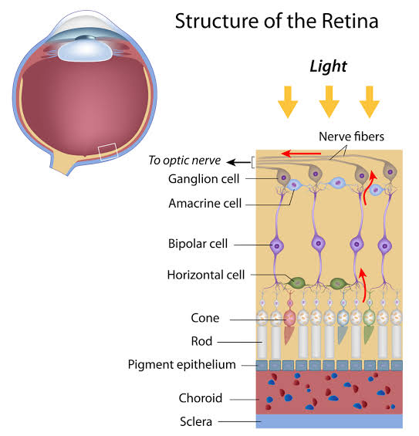
Functions of retina
- The pigmented layer absorbs extraneous light.
- They provide vitamin A for photoreceptors cells.
- The neural layer detects incoming light rays and the light rays are converted to nerve signals and transmitted to the brain.
Other structures not part of the 3 tunics of the eye include:
- LENS
The lens is a transparent biconvex structure suspended immediately behind the iris, which focuses light on the retina. The lens has 3 principal components
- Lens capsule: it is composed of proteoglycans and type IV collage surrounds the lens. It provides the place of attachment for the fibres of the ciliary zonule
- Lens epithelium: it is deep to the capsule. It consists of a single layer of cuboidal cells present only on the anterior surface of the lens.
- lens fibres: are highly elongated, terminally differentiated cells that appear as thin, flattened structures. The lens contains about 2000 of these fibres. The fibres are tightly packed together and form a perfectly transparent tissue highly specialized for light refraction.

- VITREOUS BODY
The vitreous body occupies the large vitreous chamber behind the lens. It consists of transparent, gel like connective tissue that is 99% water (vitreous humour), with collagen fibrils and hyaluronate, contained within an external lamina called the vitreous membrane.

CLINICAL SIGNIFICANCE
Several of the most common diseases of the eye are manifestations of pathology within specific histological layers. The following are examples of common eye conditions and the layers of the eye implicated:
- Chalazion: a sterile lump often in the upper eyelid caused by obstruction of the meibomian oil glands
- Conjunctivitis: inflammation of the transparent conjunctiva that may be caused by bacterial or viral infections, allergies, or exposure to certain chemicals
- Cataracts: when areas of the lens become opaque or cloudy and vision is impaired, the condition is termed a cataract. Causes of cataract include excessive exposure to ultraviolet light or other radiation, trauma, and as secondary effects in diseases such as diabetes mellitus and hypertension.
- Glaucoma: refers to optic nerve damage related to increased intraocular pressure. Drainage of aqueous humour through the trabecular meshwork is often implicated.
- Age-related macular degeneration: a progressive eye disease causing damage to the macula or central portion of the retina. Accumulation of drusen, or lipid-laden deposits in Bruch’s membrane of the retina is associated with disease severity. This accumulation of lipid deposits prevents diffusion of nutrients to the retina.
- Fuchs dystrophy: a disease of the corneal endothelium, that causes accumulation of excess edema in the corneal stroma. Progression of the disease, often causes blisters in the eye, also referred to as bullous keratopathy.
- Retinal detachment: it occurs when the outer pigment epithelial layer separates from the inner neurosensory layer consisting of rods and cones; this is a vision-threatening condition as the neurosensory condition is unable to receive nutrients from the underlying choriocapillaris and retinal pigment epithelium.
- Uveitis: inflammation of the uvea. The abundant supply of blood between ciliary body and iris is implicated in this condition, as inflammatory mediators enter the eye through this vascular network.

Question two
The novel Corona virus, which causes a respiratory disease called COVID-19 can penetrate the body through eye and implicate the immune system. The American Optometric Association (AOA) indicates the corona virus might enter the body through the conjunctiva and then spread throughout the body through blood vessels within the conjunctiva.

LAYERS OF THE RETINA FOR INFORMATION PENETRATION
The retina is a thin layer of tissue that lines the back of the eye on the inside. The retina receives light that the lens has focused, converts the light into neural signals and send these signals on the brain for visual recognition. The retina processes the information gathered by the photoreceptor cells ad sends this information to the brain via the optic nerve.
The retina is a layered structure with ten distinct layers of neurons interconnected by synapses. The 10 layers of the retina for information penetration are:
- Non-neural pigmented epithelium layer
- Rods and cones layer (RCL)
- Outer limiting layer (OLL)
- Outer nuclear layer (ONL)
- Outer plexiform layer (OPL)
- Inner nuclear layer (INL)
- Inner plexiform layer (IPL)
- Ganglionic layer (GL)
- Nerve fibre layer (NFL)
- Inner limiting layer (ILL)

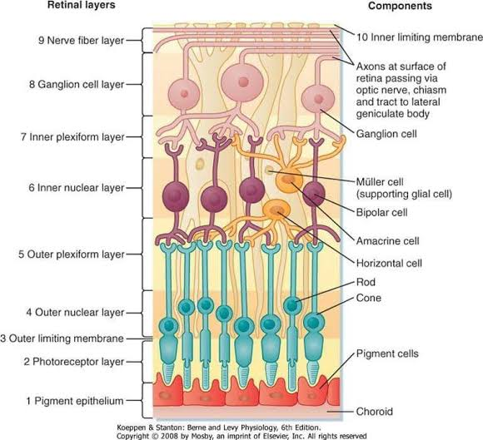
- Non-neural pigmented epithelium layer
It consists of a single layer of cuboidal or low columnar epithelial cells with basal nuclei. They contain melanin which absorbs light. This layer has several supportive functions for the function and maintenance of the neural retina. Each pigment cell is related to about a dozen rods and cones. The diverse functions of the retinal pigmented epithelium include:
- It absorbs scattered and excessive light that passes through the neural layer
- These cells also establish a blood-retina barrier through tight junctions, thereby isolating retina photoreceptors from the highly vascular choroid and regulates ion transport between these compartments.
- The cells play key roles in the visual cycle of retinal regeneration.
- They phagocytise shed components from the adjacent photoreceptors.

- Rods and cones layer (RCL):
This layer contains the outer segment of these cells where the photoreceptors are located. Glial cells are also present.

- Outer limiting layer (OLL):
It is a layer of Muller cells and red/cone junctions which serves to separate the photosensitive regions of the retina from the areas that transmit the electrical signals. It is a faint layer but well-defined.

- Outer nuclear layer (ONL):
This layer consists of the cell bodies and nuclei of the photosensitive rod and cone cells.
The rod and cone cells are photoreceptors that convert the stimulus of light into nervous impulses. Each rod cell or cone cell cam be regarded as a modified neuron. It consists of a cell body, a peripheral (or external) process, and a central (or internal) process.
- The peripheral process is rod shaped in the case of the rods ad cone shaped in the case of the cone cells. These processes lie in the RCL
- The central process of each rod or cone cell is an axon. It extends into the outer plexiform layer here it synapses with dendrites of bipolar neurons

- Outer plexiform layer (OPL):
This layer contains synaptic processes of rod and one cells, therefore also called outer synaptic zone.
The axons of the photoreceptors synapse here with dendrites of association neurons in the inner nuclear layer. The association neurons include bipolar neurons majorly and process of horizontal cells may also take part in the synapses.

- Inner nuclear layer (INL)
This layer contains the cell bodies of glial, amacrine, bipolar and horizontal cells.
- The bipolar neurons give off dendrites that enter the OPL to synapse with the axons of rods and cones; and axons that enter the internal plexiform layer where they synapse with dendrites of ganglion cells.
- The horizontal cells give off processes that un parallel to the retinal surface. These processes enter the OPL and synapse with rods, cones and dendrites of bipolar cells.
- The amacrine cells also lie horizontally in the retina. Their processes enter the internal plexiform layer where they synapse with axons of bipolar cells and the dendrite of ganglion cells.

- Inner plexiform layer (IPL):
This layer has axons of amacrine, bipolar and glial cells and dendrites of retinal ganglion cells. This layer relays information from cells of the INL.

- Ganglionic layer (GL):
This layer contains nuclei of retinal ganglion cells. It is thicker near the central, macular region of the retina than at its periphery. The dendrites of the ganglion cells enter the IPL to synapse with processes of bipolar cells and amacrine cells. Each ganglion cell gives off an axon that forms a fibre of the optic nerve.
Near the vitreous, the ganglionic layer has neurons (ganglion cells) with much longer axons. These axons make up the optic nerve which leaves the eye and passes to the brain.

- Nerve fibre layer (NFL):
This layer contains axons of retinal ganglion cells and the astroglia which support them. Collectively, these axons constitute the optic nerve.
- Internal limiting layer (ILL):
It is a thin layer of Muller cells and basement membrane which demarcates the vitreous anteriorly from the retina posteriorly.

PHOTOTRANSDUCTION

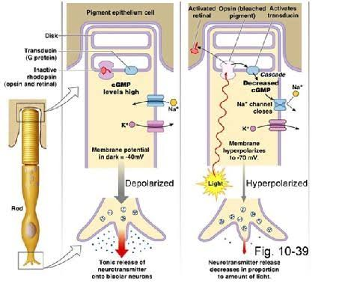

The stacked membranous discs of rod and cone outer segments are parallel with the retinal surface, which maximizes their exposure to light. The membranes are very densely packed with rhodopsin or one of the iodopsin proteins; one rod contains about a billion rhodopsin molecules. Each of these visual pigments contains a transmembrane protein, the opsin, with a small, light-sensitive chromophore molecule bound to it. The vitamin A derivative called retinal acts as the chromophore of rhodopsin in rods.
Phototransduction involves a cascade of changes in the cell triggered when light hits and activates the chromophore, a basically similar process in both rods and cones.
- When no light falls on the retina, the rhodopsin is not active and cation channels in the cell membrane are open. The cell is depolarized and continuously releases neurotransmitter (inhibitors) at the synapse with the bipolar neuron. This prevents the bipolar neuron from firing. Release of inhibitor is controlled by voltage gated calcium channels.
- Exposure to light causes hyperpolarisation. Hyperpolarisation of photoreceptor leads to closure of Ca++ gates and release of inhibitor is stopped. This causes the bipolar neuron to fire. As explained earlier, this description applies to ON-bipolars.
- Rhodopsin, present in photoreceptors, is a complex of a protein opsin and cis-retinal that is sensitive to light. When retinal on rhodopsin absorbs a photon of light, it isomerizes within one picosecond from 11-cis-retinal to all-trans-retinal. This causes a configuration change in the opsin, which in turn activates the adjacent membrane-associated protein transducin. Transducin is a heterotrimeric G protein to which opsin is coupled. Transducin activity then indirectly leads to decrease in concentration of cyclic GMP that in turn leads to closure of sodium channels. Closure of sodium channels results in hyperpolarisation (of photo-receptor) which reduces the synaptic release of neurotransmitter.
- This change in turn depolarizes sets of bipolar neurons, which send action potentials to the ganglion cells of the optic nerve.

The conformation change induced by light in retinal which initiates the cascade of events also causes the chromophore to dissociate from the opsin, a process called bleaching. The free all-trans-retinal is transported from the rod into the adjacent pigmented epithelial cells where it is converted back to 11-cis-retinal, then transported back into a photoreceptor for reuse. This cycle of retinal regeneration and rhodopsin recovery from bleaching may take a minute or more and is part of the slow adaptation of the eyes that occurs when moving from bright to dim light.

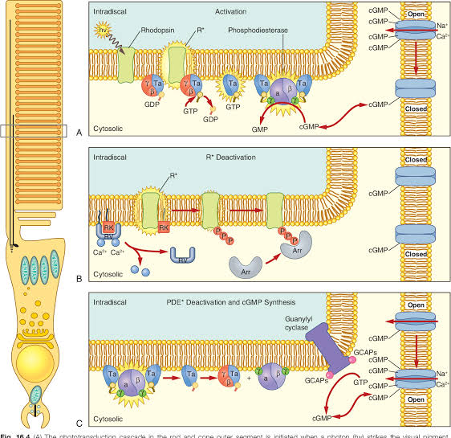

CLINICAL SIGNIFICANCE
- Age-related macular degeneration: a leading cause of blindness in elderly individuals of developed countries is age related macular degeneration, which causes blindness in the centre of the visual field. Degenerative changes in the retina around the macular include depigmentation of the posterior epithelium, focal thickening of the adjacent Bruch’s membrane, major changes and blood loss in the capillaries in the choroid and retina, and eventual loss of the photoreceptor cells producing blind spot. There appears to be a genetic predisposition to the disorder, along with environmental triggers such as excessive exposure to ultraviolent radiation. Progression of the disease can be slowed by laser surgery to destroy the abnormal and excessive retinal capillaries.
- Retinal detachment: it occurs when the outer pigment epithelial layer separates from the inner neurosensory layer consisting of rods and cones; this is a vision-threatening condition as the neurosensory condition is unable to receive nutrients from the underlying choriocapillaris and retinal pigment epithelium. There are several modern treatment methods for fixing a retinal detachment: pneumatic retinopexy, scleral buckle, cryotherapy, laser photocoagulation and pars plana vitrectomy.
- Retinitis pigmentosa: is a group of diseases that affect the retina and cause the loss of night vision and peripheral vision.
- Cone-rod dystrophy (CORD): describes a number of diseases where vision loss is caused by deterioration of the cones and/or rods in the retina.
- Retinoblastoma: is a cancer of the retina.

