LIKINYO OLUGBOLAHAN OLUTAYO
18/MHS01/205
ANA 212
QUESTION: With the aid of diagram, discuss the gross anatomy of the female genitalia
The human female reproductive system (or female genital system) contains two main parts:
- Uterus
  - Hosts the developing fetus
  - Produces vaginal and uterine secretions
  - Passes the anatomically male sperm through to the fallopian tubes
- Ovaries
  - Produce the anatomically female egg cells.
  - Produce and secrete estrogen and progesterone
These parts are internal; the vagina meets the external organs at the vulva, which includes the labia, clitoris, and urethra. The vagina is attached to the uterus through the cervix, while the uterus is attached to the ovaries via the fallopian tubes. At certain intervals, the ovaries release an ovum, which passes through the fallopian tube into the uterus.
If, in this transit, it meets with sperm, the sperm penetrates and merges with the egg, fertilizing it. The fertilization usually occurs in the oviducts, but can happen in the uterus itself. The zygote then implants itself in the wall of the uterus, where it begins the process of embryogenesis and morphogenesis. When developed enough to survive outside the womb, the cervix dilates and contractions of the uterus propel the fetus through the birth canal (vagina).
The ova are larger than sperm and have formed by the time an anatomically female infant is born. Approximately every month, a process of oogenesis matures one ovum to be sent down the fallopian tube attached to its ovary in anticipation of fertilization. If not fertilized, this egg is flushed out of the system through menstruation.
An anatomically female’s internal reproductive organs are the vagina, uterus, fallopian tubes, cervix, and ovary.
The external components include the mons pubis, pudendal cleft, labia majora, labia minora, Bartholin’s glands, and clitoris.
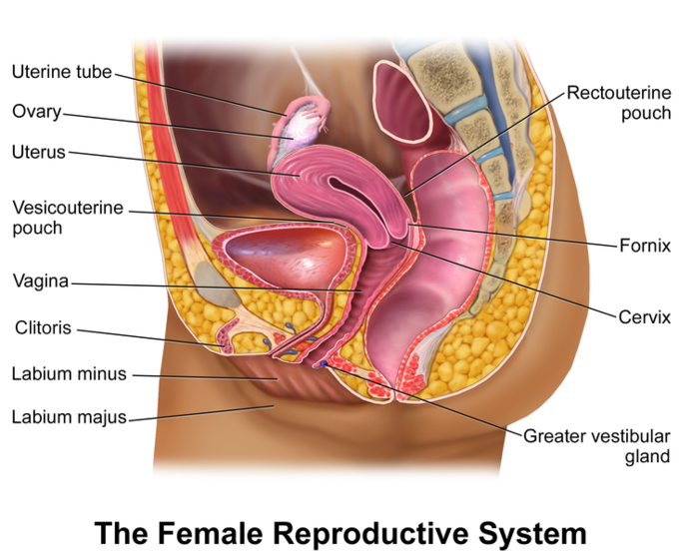

Ovaries
The ovaries are the ovum-producing organs of the internal female reproductive system
The ovary is an ovum-producing reproductive organ, typically found in pairs as part of the vertebrate female reproductive system. Ovaries in females are analogous to testes in males in that both are gonads and endocrine glands. Ovaries secrete both estrogen and progesterone. Estrogen is responsible for the appearance of secondary sex characteristics of females at puberty and for the maturation and maintenance of the reproductive organs in their mature functional state. Progesterone functions with estrogen by promoting menstrual cycle changes in the endometrium.

Anatomical Features
The ovaries are located in the lateral wall of each side of the pelvis in a region called the ovarian fossa. The fossa usually lies beneath the external iliac artery and in front of the ureter and internal iliac artery.
In humans, the paired ovaries lie within the pelvic cavity on either side of the uterus, to which they are attached via a fibrous cord called the ovarian ligament. The ovaries are tethered to the body wall via the suspensory ligament of the ovary. The part of the broad ligament of the uterus that covers the ovary is known as the mesovarium. The ovary is the only organ in the human body which is totally invaginated into the peritonium, making it the only intraperitoneal organ.
There are two extremities to the ovary, the tubal extremity and the uterine extremity. The tubal extremity is the end to which the Fallopian tube attaches via the infundibulopelvic ligament. The uterine extremity points downward and is attached to the uterus via the ovarian ligament.
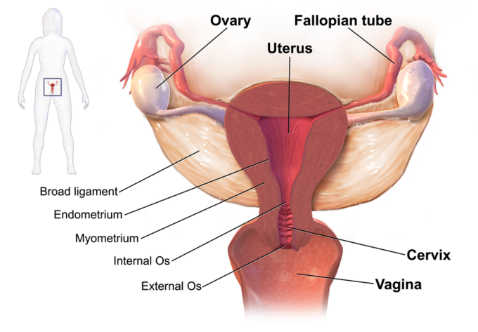

Physiology and Function
The ovaries are the site of egg cell production and also have specific endocrine function.

Oogenesis
The ovaries are the site of gamete (egg cell, oocyte) production. The developing egg cell (or oocyte) grows within the environment provided by ovarian follicles. Follicles are composed of different types and number of cells according to their maturation stage, which can be determined by their size. When oocyte maturation is completed, a luteinizing hormone ( LH ) surge secreted by the pituitary gland stimulates follicle rupture and oocyte release.
This oocyte development and release process is referred to as ovulation. The follicle remains functional and transforms into a corpus luteum, which secretes progesterone to prepare the uterus for possible embryo implantation. Usually each ovary takes turns releasing eggs each month. However, this alternating egg release is random. When one ovary is absent or dysfunctional, the other ovary will continue to release eggs each month.

Endocrine Function
Ovaries secrete estrogen, progesterone, and testosterone. Estrogen is responsible for the secondary sex characteristics of females at puberty. It is also crucial for the maturation and maintenance of the mature and functional reproductive organs. Progesterone prepares the uterus for pregnancy and the mammary glands for lactation. The co-actions of progesterone and estrogen promote menstrual cycle changes in the endometrium. In women, testosterone is important for the development of muscle mass, muscle and bone strength, and for optimal energy level. It also has a role in libido in women.

Uterus
The uterus is the largest and major organ of the female reproductive tract that is the site of fetal growth and is hormonally responsive.
The uterus or womb is a major female hormone -responsive reproductive sex organ of most mammals including humans. One end, the cervix, opens into the vagina, while the other is connected to one or both fallopian tubes, depending on the species. It is within the uterus that the fetus develops during gestation, usually developing completely in placental mammals such as humans.
Two Müllerian ducts usually form initially in a female fetus and, in humans, they completely fuse into a single uterus depending on the species. The uterus consists of a body and a cervix. The cervix protrudes into the vagina. The uterus is held in position within the pelvis by condensations of endopelvic fascia, which are called ligaments. These ligaments include the pubocervical, transverse, cervical, cardinal, and uterosacral ligaments. It is covered by a sheet-like fold of peritoneum, the broad ligament.
The uterus is essential in sexual response by directing blood flow to the pelvis and to the external genitalia, including the ovaries, vagina, labia, and clitoris. The reproductive function of the uterus is to accept a fertilized ovum which passes through the utero-tubal junction from the fallopian tube. It implants into the endometrium, and derives nourishment from blood vessels which develop exclusively for this purpose.
The fertilized ovum becomes an embryo, attaches to a wall of the uterus, creates a placenta, and develops into a fetus (gestates) until childbirth. Due to anatomical barriers such as the pelvis, the uterus is pushed partially into the abdomen due to its expansion during pregnancy. Even during pregnancy, the mass of a human uterus amounts to only about a kilogram (2.2 pounds).
The uterus is located inside the pelvis immediately dorsal (and usually somewhat rostral) to the urinary bladder and ventral to the rectum. The human uterus is pear-shaped and about three inches (7.6 cm) long. The uterus can be divided anatomically into four segments: The fundus, corpus, cervix and the internal os.
The uterus is in the middle of the pelvic cavity in frontal plane (due to ligamentum latum uteri). The fundus does not surpass the linea terminalis. The fundus of the uterus is the top, rounded portion, opposite from the cervix. The vaginal part of the cervix does not extend below interspinal line. The uterus is mobile and moves under the pressure of the full bladder or full rectum anteriorly, whereas if both are full it moves upwards. Increased intra-abdominal pressure pushes it downwards. The mobility is conferred to it by musculo-fibrous apparatus that consists of a suspensory and sustentacular part. Under normal circumstances the suspensory part keeps the uterus in anteflexion and anteversion (in 90% of women) and keeps it “floating” in the pelvis. In cases where the uterus is “tipped,” also known as retroverted uterus, women may have symptoms of pain during sexual intercourse, pelvic pain during menstruation, minor incontinence, urinary tract infections, difficulty conceiving, and difficulty using tampons. A pelvic examination by a doctor can determine if a uterus is tipped.
The lining of the uterine cavity is called the endometrium. It consists of the functional endometrium and the basal endometrium from which the former arises. Damage to the basal endometrium results in adhesion formation and/or fibrosis (Asherman’s syndrome). In all placental mammals, including humans, the endometrium builds a lining periodically which is shed or reabsorbed if no pregnancy occurs. Shedding of the functional endometrial lining is responsible for menstrual bleeding (known colloquially as a “period” in humans, with a cycle of approximately 28 days, +/- 7 days of flow and +/- 21 days of progression) throughout the fertile years of a female and for some time beyond.
Depending on the species and attributes of physical and psychological health, weight, environmental factors of circadian rhythm, photoperiodism (the physiological reaction of organisms to the length of day or night), the effect of menstrual cycles to the reproductive function of the uterus is subject to hormone production, cell regeneration, and other biological activities. The menstrual cycles may vary from a few days to six months, but can vary widely even in the same individual, often stopping for several cycles before resuming.
The uterus mostly consists of smooth muscle, known as myometrium. The innermost layer of myometrium is known as the junctional zone, which becomes thickened in adenomyosis. The parametrium is the loose connective tissue around the uterus. The perimetrium is the peritoneum covering of the fundus and ventral and dorsal aspects of the uterus. The uterus is primarily supported by the pelvic diaphragm, perineal body, and the urogenital diaphragm. Secondarily, it is supported by ligaments and the peritoneum (broad ligament of uterus).

Female Duct System
The Fallopian tubes, or oviducts, connect the ovaries to the uterus.
The Fallopian tubes, also known as oviducts, uterine tubes, and salpinges (singular salpinx), are two very fine tubes lined with ciliated epithelia, leading from the ovaries of female mammals into the uterus via the uterotubal junction. In non-mammalian vertebrates, the equivalent structures are the oviducts. These tubes allows passage of the egg from the ovary to the uterus.
The different segments of the fallopian tube are ( lateral to medial):
- The infundibulum with associated fimbriae near the ovary
- The ampullary region that represents the major portion of the lateral tube
- The isthmus, which is the narrower part of the tube that links to the uterus
- The interstitial (intramural) part that transverses the uterine musculature
The tubal ostium is the point at which the tubal canal meets the peritoneal cavity, while the uterine opening of the Fallopian tube is the entrance into the uterine cavity, the uterotubal junction.
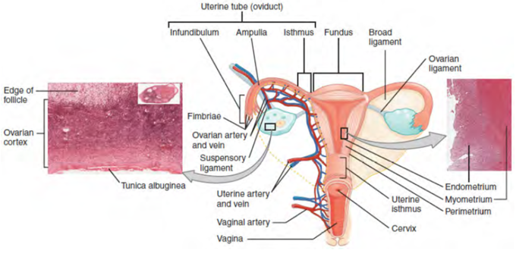
There are two types of cells within the simple columnar epithelium of the Fallopian tube. Ciliated cells predominate throughout the tube, but are most numerous in the infundibulum and ampulla. Estrogen increases the production of cilia on these cells.
Interspersed between the ciliated cells are peg cells, which contain apical granules and produce the tubular fluid. This fluid contains nutrients for spermatozoa, oocytes, and zygotes. The secretions also promote capacitation of the sperm by removing glycoproteins and other molecules from the plasma membrane of the sperm. Progesterone increases the number of peg cells, while estrogen increases their height and secretory activity. Tubal fluid flows against the action of the ciliae, toward the fimbrated end.
When an ovum is developing in an ovary, it is encapsulated in a sac known as an ovarian follicle. On maturation, the follicle and the ovary’s wall rupture, allowing the ovum to escape. The egg is caught by the fimbriated end and travels to the ampulla where typically the sperm are met and fertilization occurs. The fertilized ovum, now a zygote, travels towards the uterus aided by the tubal cilia and tubal muscle. After about five days, the new embryo enters the uterine cavity and implants about a day later. Occasionally, the embryo implants into the Fallopian tube instead of the uterus, creating an ectopic pregnancy.

Vagina
The vagina is the female reproductive tract and has two primary functions: sexual intercourse and childbirth
The vagina, a female sex organ, is a fibromuscular tubular tract that has two main functions: sexual intercourse and childbirth. In humans, this passage leads from the opening of the vulva to the uterus, but the vaginal tract ends at the cervix.

Anatomy of the Vagina
The vaginal opening is much larger than the urethral opening. During arousal, the vagina gets moist to facilitate the entrance of the penis. The inner texture of the vagina creates friction for the penis during intercourse.
The vaginal opening is at the caudal end of the vulva behind the opening of the urethra. The upper quarter of the vagina is separated from the rectum by the rectouterine pouch. The vagina and the inside of the vulva are a reddish-pink color, as are most healthy internal mucous membranes in mammals. A series of ridges produced by the folding of the wall of the outer third of the vagina is called the vaginal rugae. These transverse epithelial ridges and provide the vagina with increased surface area for extension and stretching.
Vaginal lubrication is provided by the Bartholin’s glands near the vaginal opening and the cervix. The membrane of the vaginal wall also produces moisture, although it does not contain any glands. Before and during ovulation, the cervix’s mucus glands secrete different variations of mucus, which provides an alkaline environment in the vaginal canal that is favorable to the survival of sperm.
The hymen is a membrane of tissue that surrounds or partially covers the external vaginal opening. The tissue may or may not be ruptured by vaginal penetration. It can also be ruptured by childbirth, a pelvic examination, injury, or sports. The absence of a hymen may not indicate prior sexual activity. Similarly, its presence may not indicate a lack of prior sexual activity.

Function of the Vagina
The vagina’s primary functions are sexual arousal and intercourse as well as childbirth.

Sexual Arousal and Intercourse
The concentration of the nerve endings close to the entrance of a woman’s vagina (the lower third) can provide pleasurable sensation during sexual activity when stimulated. Ninety percent of the vagina’s nerve endings are in this area. However, the vagina as a whole has insufficient nerve endings for sexual stimulation and orgasm; this lack of nerve endings makes childbirth significantly less painful.
Research indicates that clitoral tissue extends considerably into the vulva and vagina. During sexual arousal, and particularly clitoral stimulation, the vaginal walls lubricate to reduce friction caused by sexual activity. With arousal, the vagina lengthens rapidly to an average of about 4 in. (10 cm), and can continue to lengthen in response to pressure. As the woman becomes fully aroused, the vagina tents (expands in length and width), while the cervix retracts. The walls of the vagina are composed of soft elastic folds of mucous membrane which stretch or contract (with support from pelvic muscles) to the size of the inserted penis or other object, stimulating the penis and helping the male to experience orgasm and ejaculation, thus enabling fertilization.
An erogenous zone commonly referred to as the G-Spot (also known as the Gräfenberg Spot) is located at the anterior wall of the vagina, about five centimeters in from the entrance. Some women experience intense pleasure if the G-Spot is stimulated appropriately during sexual activity. A G-Spot orgasm may be responsible for female ejaculation, leading some doctors and researchers to believe that G-Spot pleasure comes from the Skene’s glands, a female homologue of the prostate, rather than any particular spot on the vaginal wall. Other researchers consider the connection between the Skene’s glands and the G-Spot to be weak. They contend that the Skene’s glands do not appear to have receptors for touch stimulation and that there is no direct evidence for their involvement. The G-Spot’s existence as a distinct structure, is still under dispute, as its location can vary from woman to woman and is sometimes nonexistent.

The Vagina and Childbirth
The vagina provides the channel to deliver the baby from the uterus to its independent life outside the mother’s body. During birth, the elasticity of the vagina allows it to stretch to many times its normal diameter. The vagina is often referred to as the birth canal in the context of pregnancy and childbirth.

Vulva
The vulva is the external genitalia of the female reproductive tract, situated immediately external to the genital orifice
The vulva consists of the external genital organs of the female mammal. Its development occurs during several phases, chiefly during the fetal and pubertal periods.
As the outer portal of the human uterus or womb, the vulva protects its opening with a “double door”: the labia majora (large lips) and the labia minora (small lips). The vulva also contains the opening of the female urethra, and thus serves the vital function of passing urine.
In human beings, major structures of the vulva are:
- The mons pubis
- The labia majora and the labia minora
- The external portion of the clitoris and the clitoral hood
- The vulval vestibule
- The pudendal cleft
- The frenulum labiorum pudendi or fourchette
- The opening (or urinary meatus) of the urethra
- The opening (or introitus) of the vagina
- The hymen
Other notable structures include:
- The perineum
- The sebaceous glands on labia majora
- The vaginal glands (Bartholin’s glands and paraurethral or Skene’s, glands)
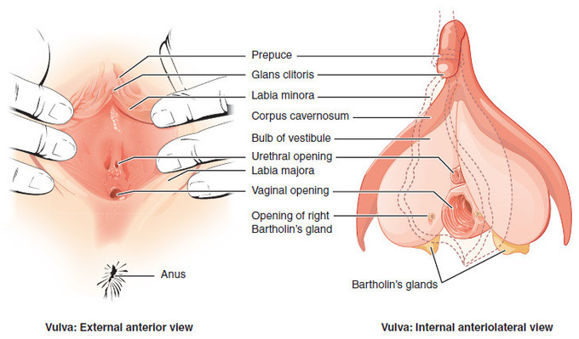
Vulva: Labeled image of a vulva, showing external and internal views.
The soft mound at the front of the vulva, the mons pubis, is formed by fatty tissue covering the pubic bone. The mons pubis separates into two folds of skin called the labia majora, literally “major (or large) lips.” The cleft between the labia majora is called the pudendal cleft, or cleft of Venus, and it contains and protects the other, more delicate structures of the vulva. The labia majora meet again at the perineum, a flat area between the pudendal cleft and the anus. The color of the outside skin of the labia majora is usually close to the individual’s overall skin color although there is considerable variation.
The inside skin and mucus membrane are often pink or brownish. After the onset of puberty, the mons pubis and the labia majora become covered by pubic hair. This hair sometimes extends to the inner thighs and perineum, but the density, texture, color, and extent of pubic hair coverage vary considerably due to both individual variation and cultural practices of hair modification or removal. The labia minora are two soft folds of skin within the labia majora.
The clitoris is located at the front of the vulva where the labia minora meet. The visible portion of the clitoris is the clitoral glans, roughly the size and shape of a pea. The clitoral glans is highly sensitive, containing as many nerve endings as the analogous organ in males, the glans penis. The point where the labia minora attach to the clitoris is called the frenulum clitoridis. A prepuce, the clitoral hood, normally covers and protects the clitoris; however, in women with particularly large clitorises or small prepuces, the clitoris may be partially or wholly exposed. The clitoral hood is the female equivalent of the male foreskin and may be partially hidden inside of the pudendal cleft.
The area between the labia minora is called the vulval vestibule, and it contains the vaginal and urethral openings. The urethral opening (meatus) is located below the clitoris and just in front of the vagina. This is where urine passes from the urinary bladder.
The opening of the vagina is located at the bottom of the vulval vestibule toward the perineum. The term introitus is more technically correct than “opening,” since the vagina is usually collapsed, with the opening closed unless something is inserted. The introitus is sometimes partly covered by a membrane called the hymen. The hymen will rupture during the first episode of vigorous sex, and the blood produced by this rupture has been traditionally seen as a sign of virginity. However, the hymen may also rupture spontaneously during exercise or be stretched by normal activities such as use of tampons. Slightly below and to the left and right of the vaginal opening are two Bartholin glands which produce a waxy, pheromone-containing substance, the purpose of which is not yet fully known

