Afolayan Mariam Omolola
17/MHS01/029
medicine and surgery
Neurohistology assignment

QUESTION 1
The eye is A complex and highly developed photosensitive organ that permits an accurate analysis of the form, light intensity, and color reflected from objects.
Each eye is composed of three concentric layers:
- an external layer that consists of the sclera and the cornea.
- a middle layer also called the vascular layer consisting of the choroid, ciliary body and the iris.
- an inner layer of nerve tissue, the retina, which consists of an outer pigment epithelium and an inner retina proper.
The photosensitive retina proper is part of the central nervous system and communicates with the cerebrum through the optic nerve and extends forward to the Ora serrata.
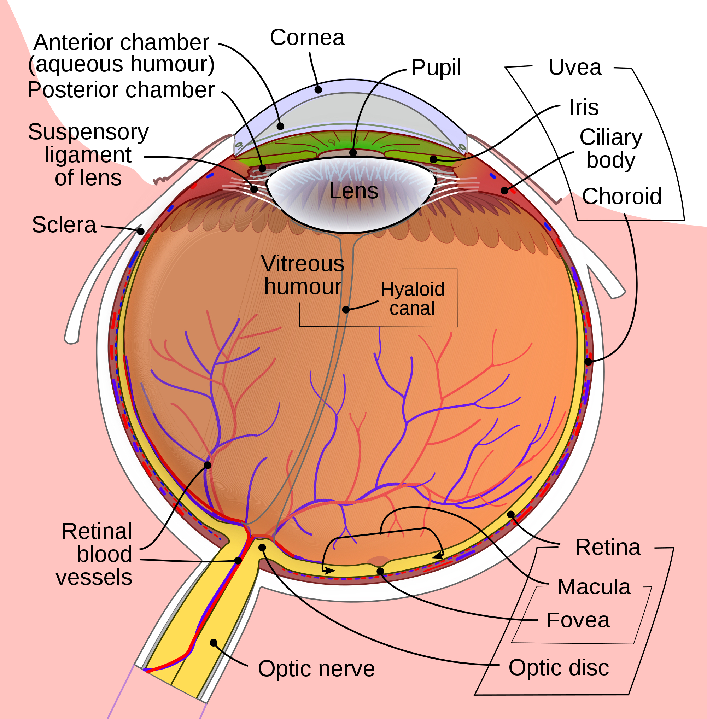
DIAGRAM OF THE EYE

External layer
THE SCLERA
The sclera is dense connective tissue made of mainly type 1 collagen fibers, oriented in different directions. The lack of parallel orientation of collagen fibers gives the sclera its white appearance, as opposed to the transparent nature of the cornea. However, the collagen of the sclera and cornea are continuous.
The four layers of the sclera from external to internal are episclera, stroma, lamina fusca, endothelium.
The episclera is the external surface of the sclera. It is connected to the Tenon capsule by thin collagen fibers. At the corneoscleral junction, also known as the limbus, the Tenon capsule contacts stroma of the conjunctiva.
The exposed front surface of the eye, including the cornea is lined by a thin, non-ketatinized stratified squamous epithelium.
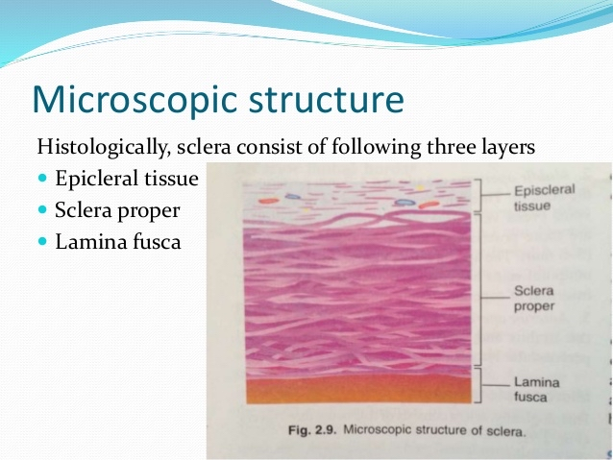
Histological importance of the sclera
The sclera is the opaque, fibrous, tough, protective outer layer of the eye that is directly continuous with the cornea in front and with the sheath covering the optic nerve behind . The sclera provides protection and form to the eye which is evident from its cellular features.

CORNEA
The cornea Consists of type I collagen fibers oriented in a uniform parallel direction to maintain transparency. Consists of five layers: epithelium (non-keratinized, stratified squamous epithelium), Bowman layer, stroma (also called substantia propria), Descemet’s membrane, corneal endothelium.
Corneal epithelium: fast growing, regenerating multicellular layer which interacts directly with the tear film.
Bowman layer: This is a layer of subepithelial basement membrane protecting the underlying stroma. It is composed of type 1 collagen, laminin, and several other heparan sulfate proteoglycans. There are no cells in this layer. Bowman’s membrane contributes greatly to the stability and strength of the cornea.
Stroma: The largest layer of the cornea, the stroma has collagen fibers arranged in a regular pattern. Keratocytes maintain the integrity of this layer. The function of this layer is to maintain transparency, which occurs by the regular arrangement, and lattice structure of the fibrils, whereby scatter from individual fibrils gets canceled by destructive interference, and the spacing of less than 200 nm allows for transparency.
Descemet’s membrane: an acellular homogenous layer made of fine type IV collagen that serves as a modified basement membrane of the corneal endothelium
Corneal endothelium: a one cell thick layer made of either simple squamous or cuboidal cells. Cells in this region do not regenerate and have pumps that maintain fluid balance and prevent swelling of the stroma. When corneal endothelial cells are lost, neighboring cells stretch to attempt to compensate these losses hence is responsible for maintaining the transparency of the cornea.
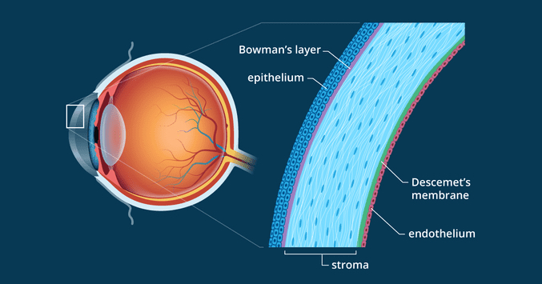
LAYERS OF THE CORNEA

Histological importance of the cornea
The cornea is a transparent avascular tissue that acts as a structural barrier and protects the eye against infections. Along with the tear film, it provides proper anterior refractive surface for the eye. Cornea contributes to two-third of the refractive power of the eye.
The cornea's main function is to refract, or bend, light. The cornea is responsible for focusing most of the light that enters the eye.

The cornea tends to repair itself quickly from minor abrasions. However, deeper abrasions may cause scars to form on the cornea, which causes the cornea to lose its transparency, leading to visual impairment.

CORNEOSCLERAL JUNCTION or LIMBUS is an area of transition from the transparent collagen bundles of the cornea to the white opaque fibers of the sclera. It is highly vascularized, and it’s
Blood vessels assume an important role in corneal inflammatory processes.

Middle or Vascular layer

The middle or vascular layer of the eye consists of three parts: the choroid, ciliary body, and iris. Known collectively as the uveal tract.

CILIARY BODY
Consists of the ciliary muscle and the ciliary epithelium. The ciliary muscle, via the lens zonules, controls the structure of the lens, which is vital for accommodation. Zonules are connective tissue fibers that connect the ciliary muscle and lens.
The ciliary epithelium produces aqueous humor which fills the anterior compartment of the eye.

Histological importance of the ciliary body
contains ciliary muscle that is composed of smooth muscle. Contraction and relaxation of the Ciliary muscles changes the tension of the zonular fibers, or suspension ligaments, of the lens. This allows the lens to change shape, a process known as accommodation.
The ciliary processes are folds of connective tissue that are covered by two layers of epithelium. There is also a complex vasculature they cannot be seen easily. Fluid from these vessels is processed and transported by the epithelial cells to the posterior chamber as aqueous humor. The epithelial cells constitute the blood- aqueous barrier.

IRIS
Consists of (1) stromal layer with pigmented, fibrovascular tissue and (2) pigmented epithelial cells beneath the stroma
The sphincter pupillae and dilator pupillae muscles connect to the stroma
The pigmented layer of cells blocks rays of light and ensures that light must move through the pupil to reach the retina
The angle formed by the iris and cornea contains connective tissue with
endothelial channels called the trabecular meshwork, which drains aqueous humor in the anterior chamber into the venous canal of Schlemm. From here, fluid drains into episcleral veins.

Histological importance of the iris
The anterior surface of the iris contains loose, variably pigmented stroma. It is open to the circulating aqueous humor within the anterior chamber.
Two layers of heavily pigmented epithelium cover the posterior surface of the iris.
Note that the sphincter pupillae muscle can be easily seen near the pupil margin. It is smooth muscle controlled by parasympathetics. The dilator pupillae muscle is more difficult to identify, but it dilates the pupil upon sympathetic innervation.

CHOROID
Consists of a dense network of blood vessels supplying nourishment to structures of the eye, housed in loose connective tissue.
The choriocapillary layer is located in the innermost part of the choroid and supplies the retina
The Bruch membrane is an extracellular matrix layer situated between the retina and choroid and has significance in age-related macular degeneration, where an accumulation of lipid deposits prevent diffusion of nutrients to the retina.

Histological importance of the choroid
Choroid. The vascular (major blood vessel), central layer of the eye lying between the retina and sclera. Its function is to provide nourishment to the outer layers of the retina through blood vessels. It is part of the uveal tract.
Innermost layer: Lens, Vitreous, Retina
1. Lens: separates the aqueous and vitreous chambers
Consists of an outer capsule, a middle layer called cortex, and an inner layer called the nucleus.
The capsule is the basement membrane of the lens epithelium which lies below
New lens cells differentiate from the lens epithelium and are incorporated peripherally, pushing older lens cells towards the middle.
Histological importance of the lens
The lens is a transparent and flexible biconvex structure in the eye that, along with the cornea, helps to refract light to be focused on the retina. The flexibility allows the lens to be easily manipulated by the ciliary muscles, bu changing the curvature of the lens, one can focus the eye on objects at different distances from it.
2. Vitreous: a jelly-like space made of type II collagen separating the retina and the lens. The vitreous humor is a transparent, colorless, gelatinous mass that fills the space in the eye between the lens and the retina. It is surrounded by a layer of collagen called the vitreous membrane (or hyaloid membrane or vitreous cortex) separating it from the rest of the eye. It makes up four-fifths of the volume of the eyeball.[1] The vitreous humour is fluid-like near the centre, and gel-like near the edges.
Histological importance of the vitreous body
The vitreous body provides physical support holding the retina in place next to the choroid, the blood supply for the outer retina. (Neural retina and choroid are only connected to each other at the disc and the ora serrata.)
3. Retina: nervous tissue of the eye where photons of light convert to neurochemical energy via action potentials
The retina serves a function analogous to that of the film or image sensor in a camera. The neural retina consists of several layers of neurons interconnected by synapses, and is supported by an outer layer of pigmented epithelial cells.

QUESTION 2
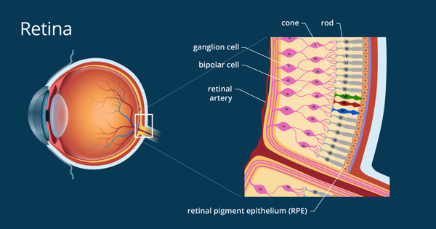

The retina is a thin layer of tissue that lines the back of the eye on the inside. It is located near the optic nerve. The purpose of the retina is to receive light that the lens has focused, convert the light into neural signals, and send these signals on to the brain for visual recognition.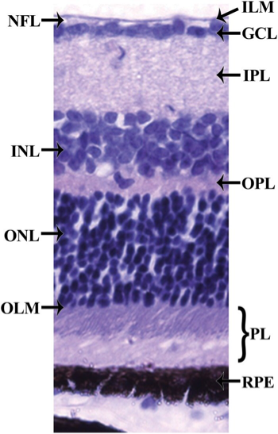

Histology of the retina. The retina can be divided into 10 layers including (1) the inner limiting membrane (ILM); (2) the nerve fiber layer (NFL); (3) the ganglion cell layer (GCL); (4) the inner plexiform layer (IPL); (5) the inner nuclear layer (INL); (6) the outer plexiform layer (OPL); (7) the outer nuclear layer (ONL); (8) the outer limiting membrane (OLM); (9) the photoreceptor layer (PL), and (10) the retinal pigmented epithelium (RPE) monolayer.

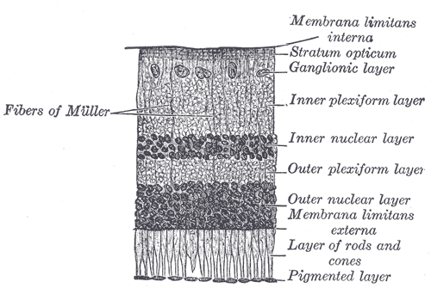
Retinal layers
The vertebrate retina has ten distinct layers. From closest to farthest from the vitreous body:
- Inner limiting membrane – basement membrane elaborated by Müller cells.
- Nerve fibre layer – axons of the ganglion cell bodies (note that a thin layer of Müller cell footplates exists between this layer and the inner limiting membrane).
- Ganglion cell layer – contains nuclei of ganglion cells, the axons of which become the optic nerve fibres, and some displaced amacrine cells.
- Inner plexiform layer – contains the synapse between the bipolar cellaxons and the dendrites of the ganglion and amacrine cells.
- Inner nuclear layer – contains the nuclei and surrounding cell bodies (perikarya) of the amacrine cells, bipolar cells, and horizontal cells.
- Outer plexiform layer – projections of rods and cones ending in the rod spherule and cone pedicle, respectively. These make synapses with dendrites of bipolar cells and horizontal cells. In the macular region, this is known as the Fiber layer of Henle.
- Outer nuclear layer – cell bodies of rods and cones.
- External limiting membrane – layer that separates the inner segment portions of the photoreceptors from their cell nuclei.
- Inner segment / outer segment layer – inner segments and outer segments of rods and cones. The outer segments contain a highly specialized light-sensing apparatus.
- Retinal pigment epithelium – single layer of cuboidal epithelial cells (with extrusions not shown in diagram). This layer is closest to the choroid, and provides nourishment and supportive functions to the neural retina, The black pigment melanin in the pigment layer prevents light reflection throughout the globe of the eyeball; this is extremely important for clear vision.
These layers can be grouped into 4 main processing stages: photoreception; transmission to bipolar cells; transmission to ganglion cells, which also contain photoreceptors, the photosensitive ganglion cells; and transmission along the optic nerve. At each synaptic stage there are also laterally connecting horizontal and amacrine cells.
The optic nerve is a central tract of many axons of ganglion cells connecting primarily to the lateral geniculate body, a visual relay station in the diencephalon (the rear of the forebrain). It also projects to the superior colliculus, the suprachiasmatic nucleus, and the nucleus of the optic tract. It passes through the other layers, creating the optic disc in primates.

