NAME: ADETOKUNBO PRECIOUS ADEMIDE
MATRIC NO: 19/MHS11/015
PHARMACY
BIO102

- Classify plants according to Eichler’s grouping in 1833
In 1833, A.W Eichler gave a system of classification for the whole plant kingdom. It is a traditional system as well as phylogenetic system of classification of plants.
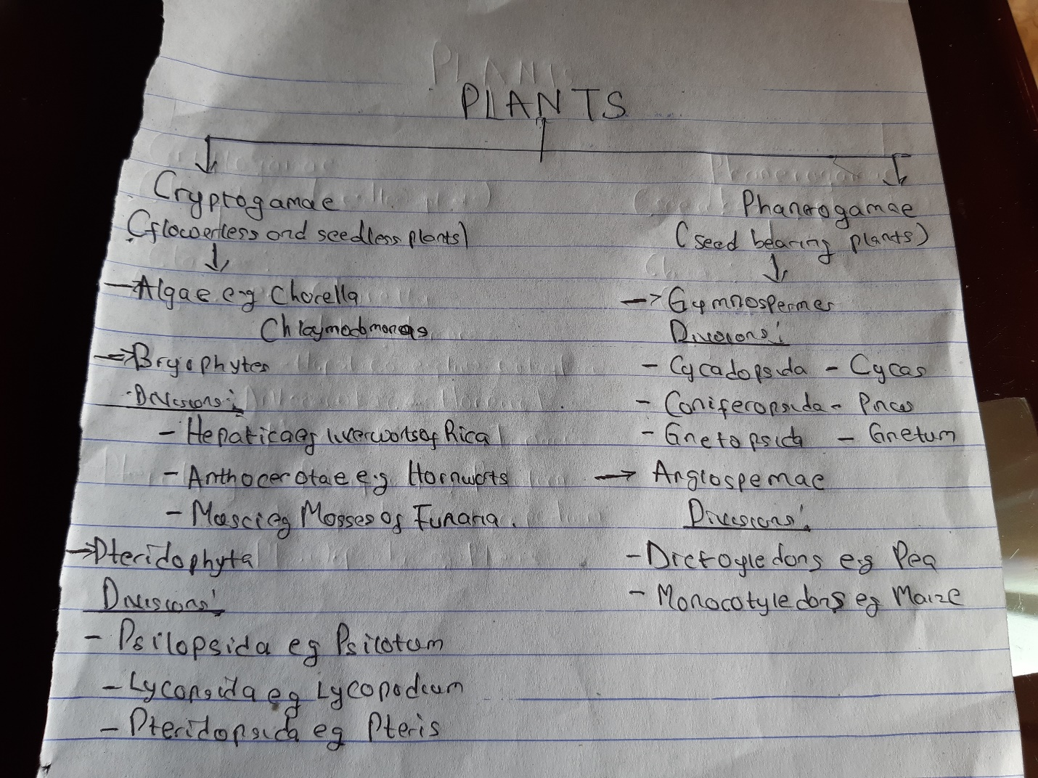

- How are algae of importance to man?
- Food for sea animals and fishes: The marine algae are rich in iodine and other important minerals. Thus makes the fundamental source of food for all marine animals and in this aspect sea is the richest food producing area.
- Mineral contents: Iodine which is in algae is an important food nutrient to human.
- As a source of agar: Agar is obtained from marine algae, and this agar is used in several ways e.g the preparation of ice cream, jellies, deserts e.t.c.
- Medicine and minerals: Iodine which is found in marine algae helps in eradicating vitamin deficiency. Iodine is the most important element to enable the thyroid gland to secrete thyroism.
- Manufacture of Iodine: The world’s supply of iodine is fuilfilled from sea algae.
- Manufacture of soaps and alums: By burning sea algae on the sea coast, the alkalies are prepared from sea algae ashes. These alkalies are employed in the manufacture of soaps and alums.
- Ornamental uses: Some algae like Botrydium and Spirogyra are grown in the ponds for their good looking habits.
- Nitrogen fixation by blue green algae: Many members of blue green algae have the ability to fix atmospheric nitrogen in the soil.
- Reclamation of alkaline ussar soils by blue green algae: It has been found that some blue green algae form a thick stratum on the surface of saline usar soils during the rainy season when other plants including crop fail to grow.
- Binding of soil particles: Algae act as an important binding agent on the surface of the soil.
- Describe a unicellular form of algae
Unicellular forms of algae are also called acellular algae as they function as complete living organism. Unicellular forms are common to all groups of algae except Rhodophyceae and Charophyceae. The unicells may be motile or non motile.
- The motile cells are either rhizopodial or flagellated. The rhizopodial form lacks rigid cell and have cytoplasmic projections that help them in ameboid movement e.g Chrysamoeba.
The flagellated unicells resemble the motile gametes and zoospores. The flagella functions as the organ of locomotion varying in number and in types in different groups. The flagellated unicells are found in many group of algae e.g Phacotus.
- The non motile cells may be spiral filament as found in Spiruliuna. The coccoid unicellular algae are the simplest forms of algae found in Cynaophyceae.
- How does this unicellular algae described in question3 carry out its production
Unicellular forms of algae carries out cell division or fission which is the simplest form of reproduction. In this method the vegetative cells divide into two daughter cells, those finally behave as new individuals.
- Differentiate between the two types of colonial form of algae

Unicellular Algae | Multicellular Algae
It has only one cell | It has more than one cell
An example is microalgae | An example is Chorella
They undergo asexual reproduction | They undergo sexual reproduction
They do not develop specialized tissues | The multicellular algae develop specialized tissues but they lack true stems.
- Describe a named complex form of algae
CHAROPHYTA
Charophyta is a taxoniomic group comprised of green algae that live predominantly in fresh water habitat. Their basic features are presence of chlorophyll, presence of carotenoids, they store their carbohydrate as starch, they use a phragmoplast that serve as a scaffold for cell plate assembly, they have enzymes. The charophyta belong to the class Streptophyta which is a clade of green plant and are characterized by having chlorophyll pigments. The cell wall of charophyta is made up of cellulose cell wall and they store their food reserve as starch. The Charophyta serve as important source of photosynthetic products, they serve as the producer in ecosystem and as food too many heterotrophs especially in the aquatic habitat.

