NAME: ADETOKUNBO PRECIOUS ADEMIDE
MATRIC NO: 19/MHS11/015
PHARMACY
CHM102
- Give the IUPAC name of the following compounds
- HCOOH – Methanoic acid
- HOOCCH₂CH₂CH₂COOH – Petan-1,5-diotic acid
- CH₃CH₂CH₂COOH – Butanoic acid
- HO₂C-CO₂H – Ethanedioic acid
- CH₃(CH₂)₄COOH – Hexanoic acid
- CH₃CH=CHCH₂CH₂COOH – Hex-4-eneoic acid
- Discuss briefly the physical properties of carboxylic acid under the following headings
- Physical appearance
- Boiling point
- Solubility
- Physical appearance: All simple aliphatic acids up to C₁₀ are liquids at room temperature. Most other carboxylic acids are solid at room temperature although anhydroyus carboxylic acid (acetic acid) also known as glacial ethanoic acid freezes to an ice-like solid below room temperature.
- Boiling point: Boiling points increase with increasing relative molecular mass. Aromatic carboxylic acids are crystalline solids and have higher boiling point than their aliphatic counterpart of comparable relative molecular mass.
- Solubility: Lower molecular mass carboxylic acids with up to four carbon atoms in their molecules are soluble in water; this is largely due to their ability to form hydrogen bond with water molecules. The water solubility of the acids decreases as the relative molecular mass increases because the structure becomes more relative hydrocarbon in nature and hence covalent. All carboxylic acids are soluble in organic solvents.
- Write two industrial preparations of carboxylic acid
- From carbon(II)oxide
Methanoic acid (formic acid) is manufactured by adding carbon(II)oxide under pressure to hot aqueous solution of sodium hydroxide. The free carboxylic acid is liberated by careful reaction with tetraoxosulphate(VI)acid (H₂SO₄).
NaOH H₂SO₄
CO ----------> HCOONA -----------> HCOOH + NAHSO₄
- From Petroleum: Liquid phase air oxidation of C₅-C₇ alkanes, obtained from petroleum at high temperature and pressure will give C₅-C₇ carboxylic acids with methanoic, propanoic and butanedioic acids as by products.
C₅-C₇ O₂/ High temperature and pressure C₅-C₇ carboxylic acids
-------------------------------------------------->
- Write equations and brief explanation discuss the synthetic preparation of carboxylic acid
- Oxidation of primary alcohols and aldehydes
Oxidation of primary alcohols and aldehyde can be used to prepare carboxylic acids with the usual oxidizing agents (i.e K₂Cr₂O₇ or KMnO₄) in acidic solution.
RCH₂OH [O] excess acid /KMnO₄ RCHO [O] RCOOH
----------------------------------> ----------->
- Carbonation of Grignard reagent:
Aliphatic carboxylic acids are obtained by bubbling carbon(IV)oxide into the gringard reagent and then hydrolyzed with dilute acid
RMgBr + CO₂(C₂H₃)₂O RCOOMgBr H₂O/dil.acid RCOOH + MgBrOH
-----> ----------------->
R may be 1⁰, 2⁰, 3⁰ aliphatic akyl or aryl radical.
- Hydrolysis of nitriles( cyanides) or esters
RCN + 2H₂O H⁺ RCOOH + NH₄⁺
(R= alkyl or arly radical)
RCOOR’ H₂O/H⁺ reflux RCOOH + R’OH
----------------------->
C₆H₅CH₂CN + 2H₂O H⁺ C₆H₅CH₂COOH + NH₄⁺
----------->
CH₃CH₂COOCH₃ H₂O/H⁺ reflux CH₃CH₂COOH + CH₃OH
------------------------->
- With chemical equation only, outline the reduction, decarboxylation and esterification of catrboxylic acid.
REDUCTION
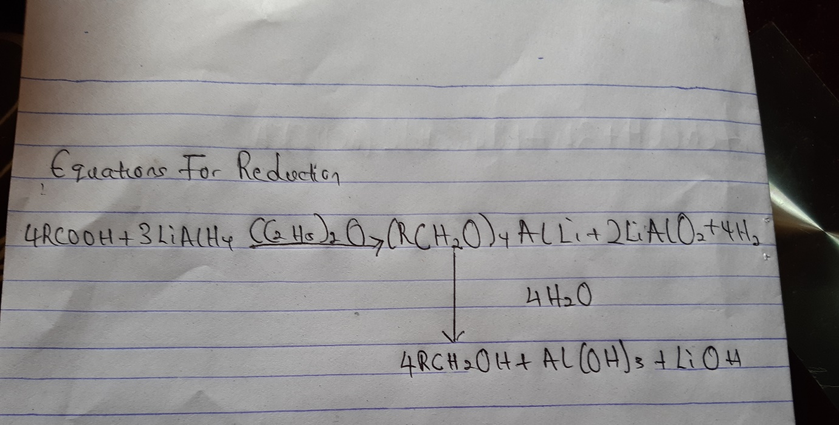

DECARBOXYLATION
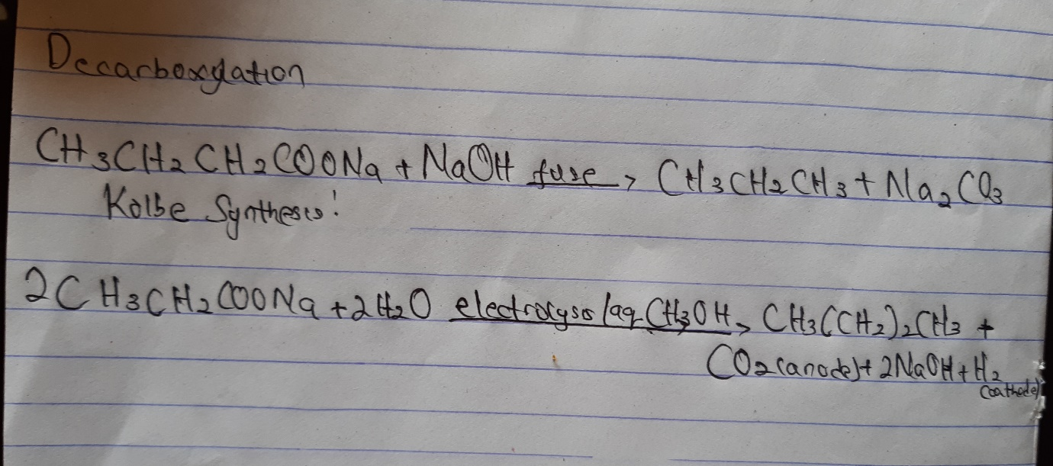
ESTERIFICATION