NAME: ONOTHOJA DOMERO EWOMA
MATRIC NO: 17/MHS01/263
COURSE: NEUROHISTOLOGY

- Write an essay on the histological importance of the eye in relation to its cellular function.
Answer.
The eye is a peripheral organ for vision. It is made up of different parts.
Sclera: this consists of white fibrous tissue (collagen) and some elastic fibres and connective tissue cells which are mainly fibroblast. These strengthen the eyes balls by resisting intraocular pressure and maintain its shape.
Rods and Cones: They are found in a layer of the retina. They are responsible for sharp vision and for the discrimination of colour. The outer segments of rods and cones contains photo-sensitive segments that are concerned with the conversion of light into nerve impulses.
Pigment cells also present in the retina play a major role in the regular spacing of rods and cones and provide mechanical support to them they also help in absorption of excessive light and avoidance of back reflection.
Cornea: it is made up of non-keratinized stratified squamous epithelium. The endothelial membrane with the cells on the superficial surface of the epithelium show projections in form of microvilli or folds of plasma membrane. They help in retaining a fil of fluid over the surface of the cornea.
Also, the collagen fibres which are type II are arranged with great uniformity and this s why the cornea has great transparency. The endothelial cells in the cornea are adapted for transport of ions and are united to neighbouring cells and desmosomes by occluding junctions. These cells pump out excessive fluid from the cornea and thus ensures its continuous transparency.
The Iris is composed of a stroma of connective tissue containing pigment cells.
In which are embedded blood vessels and smooth muscle. The smooth muscle fibres which are arranged around the pupil help in constricting it and dilating it. In bright light the pupil constricts but in dim light the pupil dilates so that optimum amount of light required for proper vision reaches the retina.
- The axons of the ganglion cells constitute the fibres of the optic nerve. It is of two types. The arrangement of the mono-synaptic ganglion cells allows high resolution of vision to be attained. The arrangement of the polysynaptic ganglion cells allows for summation of stimuli received through a very large number of photoreceptors facilitating vision in poor sight.
- Corona Virus can penetrate the body through the eye and implicate the immune system, briefly discuss the layers of the retina for information penetration.

Answer
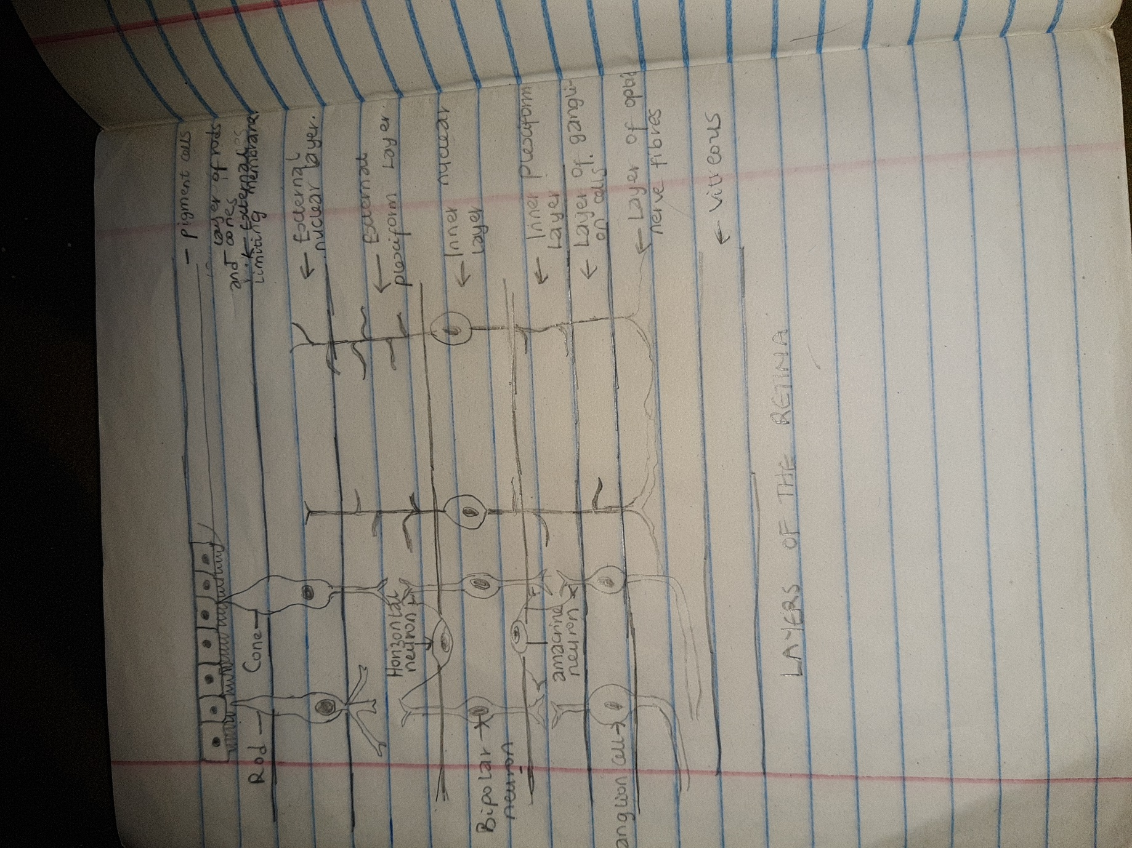
The retina has an external surface which is in contact with the choroid and an internal surface which is in contact with the Vitreous. Beginning from the external surface the layers are:
- Pigment Cell Layer: it consists of a single layer of cells containing pigment, Processes from these pigments extend into the next layer.
- Layer of Rods and Cones: The rods are processes of rod cells while the cones are processes of cone cells. The tips of the rod and cones are surrounded by processes of pigment cells.
- External Nuclear Layer: it contains the cell bodies and nuclei of the rod and cone cells. These cells re photoreceptors that convert the stimulus of light into nervous impulses. Each rod or cone cell can be regarded as a modified neuron consisting of a peripheral and central process. The central process of each rod cell or cone cell extends into the External Plexiform Layer where it synapses with dendrites of bipolar neurons.
- External Plexiform Layer: it is also called the outer synaptic zone. It consists only of nerve fibres that form a plexus. The axons of rods and cones synapse here with dendrites of bipolar neurons. Processes of horizontal cells also take part in this synapse.
- Internal Nuclear Layer: this layer contains the cell bodies and nuclei of three types of neurons:
- The bipolar neurons which give off dendrites that enter the external plexiform layer to synapse with the axons of rods and cones cells and axons that enter the internal plexiform layer to synapse with dendrites of ganglion cells.
- The Horizontal Neurons: it gives off processes that run parallel to the retinal surface. These processes enter the outer plexiform layer and synapse with rods, cones and dendrites of bipolar neurons.
- The Amacrine Cells which lie horizontally in the retina have processes that enter the inner plexiform layer where they synapse with axons of bipolar cells, and with dendrite of ganglion cells.
- Internal Plexiform Layer: it is also called inner synaptic zone. It consists of synapsing nerve fibres. The axons of bipolar cells synapse with dendrites of ganglion cells and both these processes synapse with processes of amacrine cells.
- Layer of Ganglion Cells: it contains the cell bodies of ganglion cells. Dendrite of these cells enter the internal plexiform layer to synapse with processes of bipolar cells and amacrine cells.
- Layer of Optic Nerve Fibres: it is made up of axons of ganglion cells. The fibre converge on the optic disc where they pass through foramina of the lamina cribrosa to enter the optic nerve.

