NAME: OKE SUCCESS OLUWASEYI
MATRIC NUMBER: 17/MHS01/243
DEPARTMENT: MEDICINE AND SURGERY
NEUROHISTOLOGY ASSIGNMENT
QUESTION 1
Human eyes are “camera-type eyes,” i.e they work like camera lenses focusing light onto film. The cornea and lens of the eye are similar to the camera lens, while the retina of the eye is like the film. Light enters the eye by passing through the transparent cornea and aqueous humor. The iris controls the size of the pupil, which is the opening that allows light to enter the lens. Light is focused by the lens and goes through the vitreous humor to the retina, rods and cones in the retina translate the light into an electrical signal that travels from the optic nerve to the brain. The eye can be viewed as a series of overlapping layers of tissue.
External structures of the eye include eyelashes, lids, muscles, accessory glands, and conjunctiva. The internal structures of the eye consist of three layers of tissue arranged concentrically:
- The Sclera and the Cornea make up the exterior layers
- The Uvea is the vascular layer in the middle, subdivided into the Iris, Ciliary body and choroid.
- The Retina constitutes the innermost layer and is made up of nervous tissue.
EXTERNAL STRUCTURES OF THE EYE
- CONJUCTIVA: The conjunctiva lines the inner part of the eyelids. The tarsal plate lies beneath the conjunctiva and contains meibomian glands, which secrete an oily substance to decrease the evaporation of the tear film.
- TEAR FILM: The tear film consists of aqueous, mucus and oily secretions.
- ACCESSORY GLANDS: Apocrine glands of Moll, meibomian glands, lacrimal glands.
- MUSCLES: Orbicularis oculi, Levator palpebrae superioris, superior tarsal muscle.
- EYELID: The eyelid, also known as the cover of the eye, a mobile layer made up of skin and also muscular tissue and also covers the eyeball.

INTERNAL STRUCTURES OF THE EYE
The innermost structures of the eye are organized in the three layers as follows:
OUTERMOST LAYER: SCLERA AND CORNEA
- THE SCLERA(WHITE OF THE EYE)
The sclera is a dense connective tissue made of mainly type I collagen fibers, oriented in different directions. The lack of parallel orientation of collagen fibers gives the sclera its white appearance, as opposed to the transparent nature of the cornea. However, the collagen of the sclera and cornea are continuous.
The four layers of the sclera from external to internal are episclera, stroma, lamina fusca, endothelium.
The episclera is the external surface of the sclera. It is connected to the Tenon capsule by thin collagen fibers. At the corneoscleral junction, also known as the limbus, the Tenon capsule contacts stroma of the conjunctiva.

- CORNEA(TRANSPARENT FRONT LAYER OF THE)
It consists of type I collagen fibers oriented in a uniform parallel direction to maintain transparency. It consists of five layers.
- Corneal epithelium: Fast growing, regenerating multicellular layer which interacts directly with the tear film.
- Bowman layer: This is a layer of subepithelial basement membrane protecting the underlying stroma. It is composed of type I collagen, laminin, and several other heparin sulfate proteoglycans.
- Stroma(a.k.a Substantia propria) : The largest layer of the cornea, the stroma has collagen fibers arranged in a regular pattern. Keratocytes maintain the integrity of this layer. The function of this layer is maintain transparency, which occurs by the regular arrangement, and lattice structure of the fibrils, whereby scatter from individual fibrils gets cancelled by destructive interference, and the spacing of less than 200nm allows for transparency.
- Descemet’s membrane: An acellular layer made of type IV collagen that serves as a modified basement membrane of the corneal endothelium.
- Corneal endothelium: A one cell thick layer made of either simple squamous or cuboidal cells. Cells in this region do not regenerate and have pumps that maintain fluid balance and prevent swelling of the stroma. When corneal endothelial cells are lost, neighboring cells stretch to attempt to compensate these losses.

MIDDLE LAYER: UVEA(IRIS, CILIARY BODY, CHOROID)
- IRIS: Consists of one stromal layer with pigmented, fibrovascular tissue and two pigmented epithelial cells beneath the stroma. The sphincter pupillae and dilator pupillae muscles connect to the stroma. The pigmented layer of cells block rays of light and ensures that light must move through the pupil to reach the retina.
The angle formed by the iris and cornea contains connective tissue with endothelial channels called the trabecular meshwork, which drains aqueous humor in the anterior chamber into the venous canal of Schlemm. From here, fluid drains into episcleral veins.
- CILIARY BODY: The tissue that divides the posterior chamber and vitreous body. Consists of the ciliary muscle and ciliary epithelium.
The ciliary muscle, through the lens zonules, controls the structure of the lens, which is vital for accommodation. Zonules are connective tissue fibers that connect the ciliary muscle and lens. The ciliary epithelium produces aqueous humor which fills the anterior compartment of the eye.
- CHOROID: Consists of a dense network of blood vessels supplying nourishment to the structures of the eye, housed in loose connective tissue. The choriocapillary layer is located in the innermost part of the choroid and supplies the retina. The Bruch membrane is an extracellular matrix layer situated between the retina and choroid and has significance in age- related macular degeneration, where an accumulation of lipid deposits prevent diffusion of nutrients to the retina.

INNERMOST LAYER: LENS, VITREOUS, RETINA.
- LENS: separates the aqueous and vitreous chambers. Consists of an outer capsule, a middle layer called cortex, and an inner layer called the nucleus. The capsule is the basement membrane of the lens epithelium which lies below. New lens cells differentiate from the lens epithelium and are incorporated peripherally, pushing older lens cells towards the middle.
- VITREOUS: This is a jelly-like space made of type II collagen fibers separating the retina and the lens.
- RETINA: This is the nervous tissue of the eye where photons of light convert neurochemical energy through action potentials. The retina has some layers some of which include:
Retinal pigment epithelium: This layer is made of cuboidal cells containing melanin which absorbs light. These cells also establish a blood-retina barrier through tight junctions.

Rod and cone cells: The layer of the cells with photoreceptors and glial cells. Rods are located peripherally and are more sensitive to light and motion than cones. Cones have higher visual acuity and specificity for color vision.

FUNCTIONS
- The layers of the eye perform distinct functions which work together to create a unified, perceptual experience.
- The essential role of the external eye structures is to protect the delicate tissue of the internal eye.
- The eyelid prevents foreign bodies from entering the inner eye and helps refresh and distribute the tear film by blinking.
- Eyelashes are finely sensitive to touch and warn the eye of possible debris and particles that may cause injury.
- Internal parts of the eye have primarily structural and visual functions.
- The cornea serves a protective role and is responsible for two-thirds of the refractive properties of the eye. The remaining one-third of refraction is performed by the lens, which is functionally adjustable though the action of the zonular fibersand ciliary muscles. At the end of the visual process, as rays of light bend through the cornea and lens, photon energy is converted to neurochemical action potentials by cells of the retina, which then send these impulses to the brain, via the optic nerve.
- The uvea of the eye is a crucial mediator of nutrition and gas exchange, as blood vessels course through the ciliary body and iris, while the choriocapillaris in the posterior eye help support the retina. This abundant blood supply is implicated in uveitis, as inflammatory mediators enter the eye through this vascular network.

CLINICAL SIGNIFICANCE
Some clinical correlates are listed below:
- GLAUCOMA: This refers to optic nerve damage related to increased intraocular pressure. Drainage of aqueous humor through the trabecular meshwork is often implicated.
- CHALAZION: A sterile lump often in the upper eyelid caused by the obstruction of the meibomian oil glands.
- CONJUNCTIVITIS: Inflammation of the transparent conjunctiva that may be caused by the bacterial or viral infections, allergies or exposure to certain chemicals.
- AGE-RELATED MACULAR DEGENERATION: A progressive eye disease causing damage to the macula or central portion of the retina.
- RETINAL DETACHMENT: It occurs when the outer pigment epithelial layer separates from the inner neurosensory layer is unable to receive nutrients from the underlying choriocapillaris and retinal pigment epithelium.
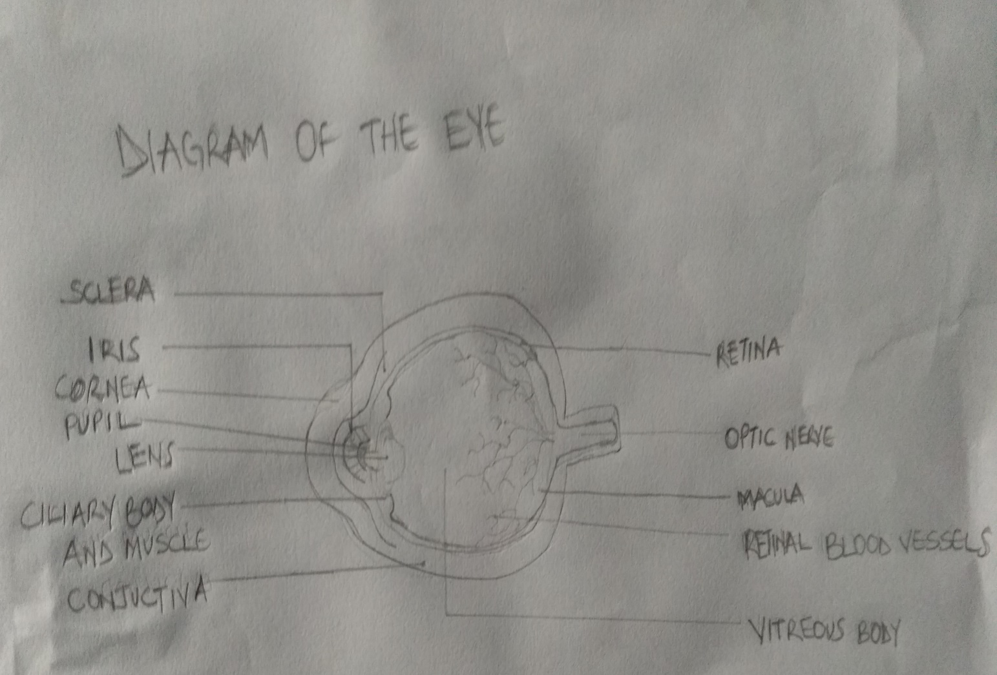

QUESTION 2:
The retina at the back of the eye is essential for all vision. Each layer of cells in this tissue serves a specific purpose. The layers are as follows:
THE INNER LIMITING MEMBRANE(ILM): This forms the innermost boundary of the retina. It is the boundary between the retina and the vitreous body, it is formed by astrocytes and the end feet of the Muller cells. It is separated from the vitreous humor by a basal lamina.
THE NERVE FIBER LAYER: A.K.A Stratum opticum, is formed by the expansion of the nerve fibers of the optic nerve; it is the thickest near the optic disc(the point of exit for ganglion cell axons leaving the eye), gradually diminishing toward the ora serrate(it is the serrated junction between the retina and the ciliary body).
THE GANGLION CELL LAYER(GCL): Ganglionic layer is a layer of the retina that consists of the retinal ganglion cells and displaced amacrine cells.
THE INNER PLEXIFORM LAYER(IPL): The inner plexiform layer is an area of the retina that is made up of a dense reticulum of fibrils formed by interlaced dendrites of retinal ganglion cells and cells of the inner nuclear layer.
THE INNER NUCLEAR LAYER(INL): Or layer of inner granules of the retina, is made up of a number of closely packed cells, of which there are three varieties, i.e bipolar cells, horizontal cells, and amacrine cells.
THE OUTER PLEXIFORM(OPL): A.k.a External plexiform layer is a layer of neuronal synapses in the retina of the eye. It consists of a dense network of synapses between dendrites of horizontal cells from the inner nuclear layer, and photoreceptor cell inner segments from the outer layer. It is much thinner than the inner plexiform layer, where amacrine cells synapse with retinal ganglion cells.
THE OUTER NUCLEAR LAYER(ONL): A.k.a layer of outer granules or external nuclear layer, it is one of the layers of the vertebrate retina, the light detecting portion of the eye. Like the inner nuclear layer, it contains several strata of oval nuclear bodies; they are of two kinds i.e rod and cone granules, so named on account of their being respectively connected with the rods and cones of the next layer.
THE OUTER LIMITING MEMBRANE(OLM): Or outer limiting membrane is one of the ten distinct layers of the retina of the eye. It has a network-like structure and it is situated at the basis of the rods and cones.
THE PHOTORECEPTOR LAYER(PL): A photoreceptor cell is specialized type of neuroepithelial cell found in the retina that is capable of visual phototransduction. The great biological importance of photoreceptors is that they convert light (visible electromagnetic radiation) into signals that can stimulate biological processes.
THE RETINAL PIGMENTED EPITHELIUM(RPE): This is the pigmented cell layer just outside the neurosensory retina that nourishes retinal visual cells, and it is firmly attached to the underlying choroid and overlying retinal visual cells.

