18/LAW01/130
ZEE’S POULTRY ENTERPRISE
BUSINESS PLAN
OWNER: JATTO ZUBAIDAT ENEZE
4/24/2020

NAME: JATTO ZUBAIDAT ENEZE MATRIC NUMBER: 18/LAW01/130 COURSE: FOOD SECURITY AND HEALTH AWARENESS COURSE CODE: AFE202

TOPIC | PAGE NO
COVER PAGE

TABLE OF CONTENT | 1
EXECUTIVE SUMMARY  - Product  - Customers  - Future of the company | 2
COMPANY DESCRIPTION  - Mission statement  - Principal members  - Legal structure | 3
MARKET RESEARCH  - Industry  - Detailed description of customers  - Accurate plan | 4
COMPANY ADVANTAGES  - Regulations | 5
SERVICE LINE  - product or service | 6
PRICING STRUCTURE  - product life cycle  - intellectual property rights | 7
MARKET AND SALES  - growth strategy  - communicating with customers | 8
HOW TO SELL | 9
BUSINESS PROJECTION  - GRAPHICAL REPRESENTATION | 10
COMMENT  - conclusion | 11
TABLE OF CONTENT
EXECUTIVE SUMMARY
PRODUCT
Zee’s poultry company produces eggs and meat for individuals and the public at large. All the eggs and meat are carefully transported from the poultry where breeds of hens are reared, and then taken to the city for the sale of meat and eggs. For the sole purpose of meat, broilers are used, in order for customers to get their fully grown meat, and for eggs, other dual purpose chicken can be used, for example, layers are used for eggs.

CUSTOMERS
The target audience for zee’s poultry is everyone in the society or community at large so long as they eat meat and eggs. People who don’t eat meat and eggs are called vegetarians and as such, not the target audience for Zee’s poultry. Everyone including parents, elderly people, children who need egg and meat to grow, become healthy and strong are the main people the company targets to purchase goods.

FUTURE OF THE COMPANY
The goal of zee’s poultry is to build a bigger house and raise thousand breeds of chicken to continue to provide for quality meat and eggs.

COMPANY DESCRIPTION
Mission statement
To provide quality meat and eggs for the good of the society
Principal members
JATTO ZUBAIDAT: owner, designer.
AJAYI BISOLA: the leading hand/certified tradesperson
OZOHU MARIAM: senior poultry hand/farm transporter
IZE AISHAT: poultry business manager
MUHAMMED HALIMAT: hatchery assistant/farm maintenance worker.
Legal structure
The company is registered in Nigeria with certificate number RC12332558 dated June 12, 2017. The company started with five experienced and technical staff to manage the various departments for effective service delivery.

MARKET RESEARCH
INDUSTRY
The industry is suffering from higher demand than supply as the industry is not yet equipped to provide meat and eggs for over five hundred people.
DETAILED DESCRIPTION OF CUSTOMERS
The people that the company plans to market good to are the parent and children who want to provide the best nutrients for their children to grow. Elderly people also need egg to be healthy as it provides protein.
ESTIMATED PROJECT COSTS AND REVENUE
Land/housing
activity | qty | naira | kobo
House for chickens | 1 | 500,000 | 00
Room for products | 1 | 300,000 | 00
Transport shed | 2 | 100,000 | 00
offices | 4 | 200,000 | 00
Total | 8 | 1,100,000 | 00

- equipment
name | qty | usd | naira | kobo
incubator | 1 | 110 | 40,000 | 00
feeder | 200 | 3,328 | 1,200,000 | 00
Water pot | 10 | 138 | 50, 000 | 00
heater | 2 | 55 | 20,000 | 00
Laying nests | 100 | 1,386 | 500, 000 | 00
Egg handling nests | 120 | 665 | 240,000 | 00
fencing | 1 | 416 | 150,000 | 00
Coops and cages | 200 | 2,496 | 900,000 | 00
miscellaneous | 20 | 277 | 100, 000 | 00
Total |  | 8,871 | 3,350,000 | 00

- vehicle
Type | model | qty | naira | kobo
Chicken van | Mazda 18 | 2 | 4,000,000 | 00
Total |  |  | 4,000,000 | 00

COMPANY ADVANTAGES
Zee’s poultry has the following advantages compared to competitors;
- safe, non-toxic meat and eggs
- quick, 48 hour delivery since demand is always high
- high quality products
- interactive website
- Face to face interaction with customers at craft shows over a three state area.

REGULATION
Zee’s poultry must meet all federal and state regulations concerning the production of food and not hindering the lives of the citizens any way at all.

SERVICE LINE
PRODUCT/SERVICE
- full crate layers egg
- half crate of layers egg
- double layer special
- a full broiler
- head, neck, thigh
- 20 quail eggs
- 10 quail eggs
- Chicken feet
- 10 chicken thigh
- Chicken wings
- Chicken breasts

PRICING STRUCTURE
Zee’s poultry will offer the products in the following prices:
- full crate of layers eggs: N1200
- half crate: N750
- double layer special: N5000
- a full broiler: 5500
- head, neck and thigh: 3300
- 20 quail eggs: 7000
- 10 quail eggs: 3500
- Chicken feet only: 1100
- 10 chicken thigh: 8000
Product lifestyle
All products have at least 1 week warranty and two weeks validity, because it is a perishable good.
Intellectual property rights
Zee’s poultry is a trademarked name well known in Nigeria.

Research and development
- Include a feedback mechanism on the website for ideas, suggestions, improvements
- Provide more vans
- Review products before departure

MARKETING AND SALES
GROWTH STRATEGY
To grow the company, zee’s poultry will be doing the following;
- Provide vans and rent more buildings
- Ensure that there is enough meat and eggs to go round from broilers and layers.
- Attend meetings with similar poultry to grow business
- Ensure that the price ranges is suitable for all classes of people.
Communicate with customers
Zee’s poultry will communicate with its customers by
- Providing an email newsletter with company news, product information, and schedule
- Using targeted google and Facebook advertisements
- Utilizing social media such as twitter, YouTube, Facebook, LinkedIn, interest, instagram and tumbler
- Providing contact information on the company website.
- Adding labels on packaged products.

HOW TO SELL
Currently, the only person in charge of sales for zee’s poultry is the owner, jatto zubaidat. As profits increases, jatto zubaidat will look to add an employee to assist with social media.

BUSINESS PROJECTION FOR ZEE’S POULTRY
 | Year 1 | Year 2 | Year 3
revenue | 500,000 | 800,000 | 1,200,000
Direct cost | 175,000 | 280,000 | 420,000
Indirect cost | 200,000 | 320,000 | 480,000
Total cost | 375,000 | 600,000 | 900,000
profit | 125,000 | 200,000 | 300,000
assets | 2,000,000 | 2,200,000 | 2,400,000
Share capital | 1,500,000 | 1,500,000 | 1,500,000
liability | 500,000 | 700,000 | 900,000

GRAPHICAL REPRESENTATION
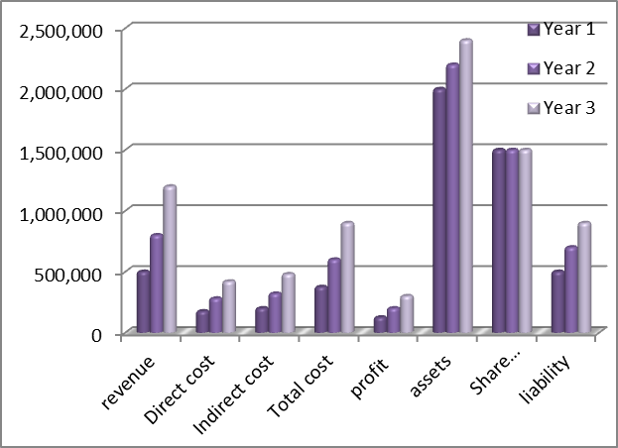

COMMENT
From the above projection, it could be seen that the business would be making good progress from year one to year three and the financial base is very strong based on the capital and asset projection.
CONCLUSION
Zee’s poultry is set to be the best poultry farm to ever be known.

