NAME EMMANUEL PETER PEIBULUEMI
DEPARTMENT PETROLEUM ENGINEERING
MATRIC NO. 15/ENG07/019
COURSE CODE PTE512
COURSE TITLE FUNDAMENTALS OF ENHANCED OIL RECOVERY
SOME EOR METHODS DISCUSSED
1. STEAM ASSISTED GRAVITY DRAINAGE
This process was developed by Butler McNob and Lo in 1979.
This is a thermal EOR process which is used for producing crude oil and bitumen. It is a tertiary oil recovery which is applied in the production of conventional heavy oil though it was originally conceived for the recovery of bitumen where the in-situ viscosity is so high that conventional production methods are not feasible.
This technique involves the drilling of pair of high-angle injection wells with a nearby production well along the parallel trajectory. The pair of stacked horizontal well are drilled into the reservoir about 400 meters beneath the surface. The wells are drilled with a vertical separation of about 5 meters. High pressured steam is continuosly injected into the upper wellbore to heat the oil; reduces its viscosity and it causes the oil to drain into the lower wellbore by gravity. Gravity forces the oil to drain into the lower well where it is being produced i.e, pumped to the surface and separated from water. The water is then treated and recycled as steam.
It is widely used in Canada for recovery of heavyoil and tar sand resources.
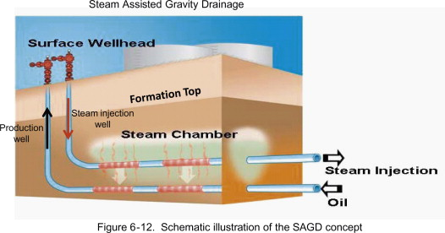

2. CYCLIC STEAM STIMULATION
The cyclic steam stimulation is another thermal EOR method recommended for production in heavy oil reservoirs that can contain high-pressure steam without fracture. This method is commonly known as the huff and puff method. Here the same well is used for injection and production of oil hence the name huff and puff.
It involves the injection of steam into a well at high temperature (about 572 to 644⁰F) for a long period of time (months).. In this process, after a particular viscosity is reached, injection is stopped to allow heat redistribute evenly in the formation. The well is soaked with the steam for some period in order to heat up the surrounding of the injection well through convection and reduce the viscosity of the oil, and then the heated heavy oil is pumped out of the well The well is then produced until temperature drops after which a new cycle is initiated.
In summary, the method consists of three stages; the injection, the soaking and the production stage.
Once production rate falls after the completion of the three stages, the well is subjected to another cycle of injection, soak and production again. The process is repeated until the cost of injecting steams becomes higher than the revenue generated from production. The cyclic steam stimulation has a recovery factor of about 20% to 25%. However the cost of production is high.
Artificial lift are being utilised in this method to aid the production.
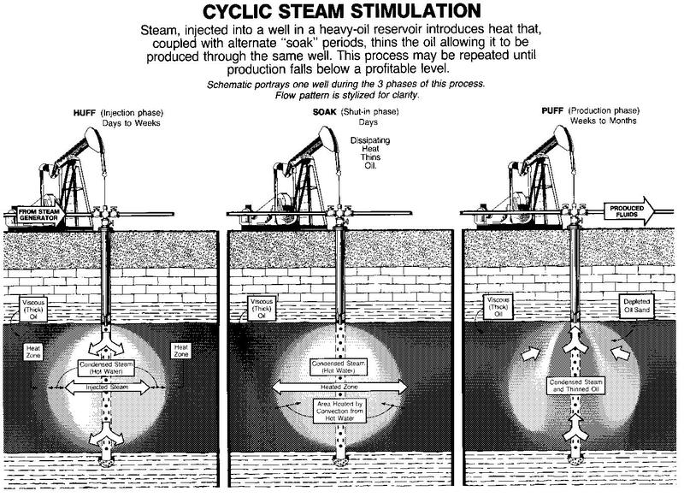

3. HOT WATER FLOODING
This is also known as hot water injection. It is a technique of increasing crude oil production from the producing well by injecting hot water into the formation. The hot water is introduced into the reservoir via an injection well drilled parallel to the primary producing well. The heat produce by the hot water causes reduction in the viscosity of the crude oil, making it to flow toward the producing well with ease. This technique is used to extract crude oil which has an API degree of less than 20.
This is also a thermal recovery method in which hot water is injected into a reservoir through specially distributed injection wells.
It is less effective than steam injection process, due to the fact that hot water has a lower heat content as compared to steam.
After producing primarily for sometime, the pressure in an oil reservoir slowly and steadily decreases and as a result the production rate decreases. Many companies make use of this method to produce heavy and medium crude oil from the reservoir.
Some of the benefits of the hot water flooding is that it supports the reservoir pressure (voidage replacement). The oil also floats on the water, thus making the water to effectively displace the oil from its location in the reservoir and pushes it to the producing well.
The hot water flooding increases the oil recovers factor and well production rate can be maintained for a long period of time.
