NAME: AJAYI AYODAMOLA MOSUNMOLA
DEPARTMENT: NURSING
MATRIC NO.: 19/MHS02/011
COURSE: BIO 102

- Classify plants according to Eichler’s grouping of 1883
Plant kingdom

Non-Floral (Concealed reproduction) Cryptogamae (Hidden reproduction) Phanerogamae (visible reproduction)

Angiosperm Gymnosperms

Monocotyledonae Dicotyledonae
The system was based on dividing the plant kingdom into those plants with concealed reproductive organs (non-floral), the (Cryptogamae, = hidden reproduction) and those with visible reproductive organs (floral), the (Phanerogamae, = visible reproduction). Moreover, Eichler was the first taxonomist to separate the Phanerogamae into Angiosperms and Gymnosperms and the former into Monocotyledonae and Dicotyledonae.

- How was algae of importance to man
- Food:
Algae have been in use as human food for centuries in various parts of the world, including Scotland, Ireland, Norway, Sweden, France, Germany, North and South America, China and Japan. Algae are taken in several ways according to the choice and taste and can be taken as salad, cooked with meat or eaten as vegetable, sprinkled with oatmeal or fried with meat.
- Fertilizers:
The large brown and red algae are used as organic fertilizers, especially on land close to the sea. The weed is used either directly or as a seaweed meal. However, the greatest utility of the algae, as a friend to the farmers, is seen in common forms belonging to Cyanophyceae for their capacity to fix atmospheric nitrogen and thus enriching the soil.
- Commercial products:
Many forms of marine algae, phaeophyceae and rhodophyceae are highly valuable for certain commercial products, chiefly agar-agar, algin or alginic acid and carrageenin.
- Medicinal use:
Alaria was once used for strengthening the stomach and restoring the appetite after sickness.
- Antibiotics:
The antibacterial product chlorellin, obtained from chlorella is well known. The antibacterial effects are more pronounced against coliforms and other related intestinal bacteria.

- Describe a unicellular form of algae.
Unicellular algae are plant like autotrophs and contain chlorophyll. They include groups that have multicellular and unicellular species. They possess the flagella which enables movement. The cell is bounded by a cellulose cell wall. The stigma is for photoreception. They are usually found in stagnant water

- How does this unicellular alga described in question 3 carry out its reproduction.
Reproduction can either be vegetative (asexual) or sexual.
- The vegetative results in daughter cells because the genetic materials contained in the mother cells are maintained in the daughter cells. The mitotic division maintains the quality and quantity of genetic material.
- The sexual reproduction involves the mating and this pairing is isogamous because the gametes are morphologically identical.

- Differentiate between the two types of colonial form of algae.
VOLVOX | SYNURA
Possess a hollow shape | Possess a Globular (Spherical) shape
100-600 µm | 30µm (Smaller in size)
Possesses Eye spots | Does not possess an eye spot
Undergoes Both Sexual and Asexual Reproduction | Only undergoes Asexual reproduction

- Describe a named complex form of algae
Spirogyras are common free-floating freshwater algae that inhabit ponds, pools, tanks, lakes, ditches, etc. The word ‘Spirogyra’ is derived from the two Greek words, ‘Speria’, meaning coil, and ‘gyras’ meaning twisted. Spirogyra has many common names, including blanket weed, water silk, mermaid`s tresses, etc. It grows up to several centimeters in length and 10-100μm in width. There are about 400 known species of Spirogyra worldwide. They are filamentous and slippery in natures due to the presence of external mucilaginous sheath; hence, they are called pond scum or pond silk. Some of the species of Spirogyra (Spirogyra adnata, S. jogensis) bear holdfast or haptera by which they remain attached to the substratum.

Systematic Position
Division: Chlorophyta
Class: Chlorophyceae
Order: Zygnematales
Family: Zygnemataceae
Genus: Spirogyra
Species: Spirogyra maxima, S. negnecta, S. elongate, S.

Reproduction of Spirogyra
They increase in length of the filament takes place by ordinary cell divisions and by subsequent growth of individual cells, each of which may divide further. Spirogyra reproduces vegetatively and sexually. In this case, asexual reproduction is absent.

Vegetative Reproduction of Spirogyra
Vegetative reproduction in Spirogyra takes place by means of fragmentation. This is performed by softening of the cross wall between the two adjacent cells, as a result of which each part or piece of the broken filament grows out into a filament by repeated cell divisions, or by the accidental breaking of the filament by external mechanical injury.
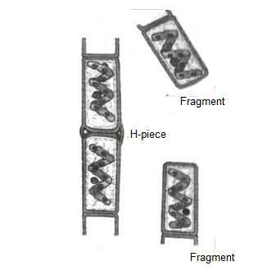
Sexual Reproduction of Spirogyra
Spirogyra may be monoecious or dioecious. Sexual reproduction takes place by conjugation of two morphologically identical gametes and each of which is called a gametangium. The sexual reproduction shows physiological anisogamy, as out of the two isogametes, one is motile, and the other one is non-motile. Sexual reproduction occurs at different times of the year according to species.

Parthenogenesis
Parthenogenesis may occur in Spirogyra by the development of perthenospore or a zygospore. These are formed at the condition when the gametes fail to fuse. The gametes secrete a thick wall around it to become a perthenospore, which after a period of rest, germinate to form a new filament.
Life Cycle of Spirogyra
In the life cycle of Spirogyra, alternation of haploid (n) generation and diploid (2n) generation is noted. The haploid (n) phase is long, but the diploid (2n) phase is very short-lived. The diploid phase is restricted within the zygospore only.
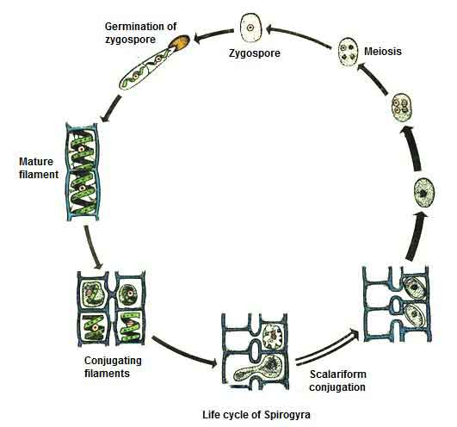
Conclusion
The Spirogyra produces food matters by means of photosynthesis, and many aquatic animals use them as food. Spirogyra is used as fish`s food. Dried Spirogyra used in the preparation of soups. Spirogyracontains lots of vitamins A and E. It is cultured in garden tanks for ornamental purposes. Spirogyra is also used in the aquarium. Besides these, Spirogyra spoils the water of drinking tanks. If it grows in abundance, Spirogyra, create disturbances in swimming and fishing.

