NAME: MBONG AKANINYENE A.
MATRIC NUMBER: 15/ENG07/028
DEPARTMENT: PETROLEUM EN GINEERING
COURSE: FUNDAMENTALS OF ENHANCED OIL RECOVERY (PTE512)

Steam assisted gravity drainage
Steam assisted gravity drainage or SAGD is a method that is widely used to extract bitumen from underground oil sands deposits. This method involves forcing steam into sub-surface oil sands deposits to heat the bitumen locked in the sand, allowing it to flow well enough to be extracted. This technology is particularly relevant in Canada because it is the primary method of in situ extraction used in the oil sands.[1] In Alberta alone, 80% (or 135 billion barrels) of the oil sands are located in these underground deposits and would be difficult to access without techniques like SAGD.[2]

In recent history, SAGD operations have become more common as technology continues to advance. In 2000, there were 5 SAGD projects underway in Alberta, but by 2013 those numbers had jumped to 16.[2] In 2012, the total in situ production of bitumen was 990 000 barrels a day, which is about 52% of the total crude bitumen production. By 2022 predictions put the in situ production at 2.2 million barrels a day.[2] In total, there is an estimated 1 trillion barrels of oil that are potentially recoverable.[3]

Technique

To extract bitumen from below ground, a pair of horizontal wells are drilled into the formation. In these horizontal wells, there are two parallel horizontal pipes with one situated about 4-6 meters above the other.[2] The upper section of this configuration is known as a steam injection well whereas the bottom section is known as the production well.[1] At a nearby plant, water is turned into steam and travels to the location where the drilling is taking place. The steam is then passed through the upper well and into the reservoir that contains the oil sand. Steam then exits the upper well, expanding out into the formation in all directions. The heat from the steam is transferred to the bitumen. The warming of this bitumen results in a reduction of its viscosity, allowing it to flow more easily. Since the viscosity was decreased so dramatically, it is able to flow downward under the force of gravity into the production well.[2] This draining of the bitumen is known as gravity drainage. From the production well, the now more fluid bitumen is pumped to the surface. The steps of steam injection and bitumen production happen simultaneously and continuously. The resulting bitumen and condensed steam emulsion is piped to the plant where it is separated and treated. The water from this process is recycled for generating more steam.[2]

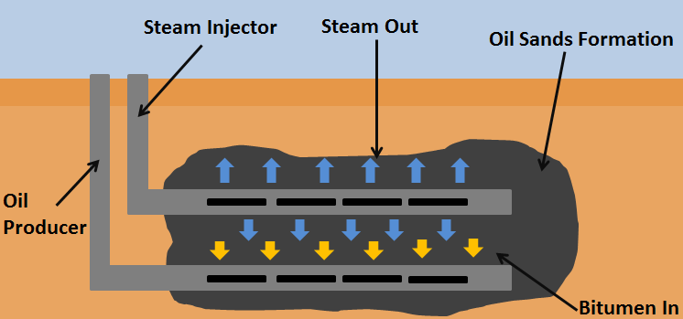

Figure 1. A SAGD setup to extract bitumen from an oil sand deposit.[4]
After the extraction, water is injected into the deposit to maintain stability. 25-75% of the bitumen in the deposit can be extracted through SAGD operations.[3]

Environmental Concerns

Developing any sort of infrastructure to obtain a resource requires a certain amount of land use and SAGD is no exception. Although land must still be used when extracting bitumen through a SAGD operation, the surface impact is similar to that of conventional oil and gas extraction processes. All of these methods recover product from underground by making a small hole and having the petrochemical flow out. Estimates say that the well pad disturbs less than 10% of the total resource area being accessed.[2] Although the land impact is small, surrounding ecosystems could be dramatically affected depending on the ecological significance of the land. The labelled, interactive map below can be used to explore the size difference in the land used by in situ (the SAGD) mining and traditional surface mining. Take a note of the scale on the bottom right-hand side of the map (this will change when zooming in and out, but gives an idea of the size of mines).
The extensive use of water in oil sands extraction is also an issue that is spoken of widely. Although up to 90% of the water used during extraction is recycled and used again,[2] 10% is still quite a bit of water that needs to be disposed. This water can be fresh or brackish,[5] and may contain a variety of pollutants. Depending on how this water is disposed of, it could contaminate clean groundwater deposits or harm plant and animal life around the deposit. Additionally, the volume of water creates concerns with how much is being taken for in situ use.

Emissions are also an issue when it comes to anything involving the production of fossil fuels. The emissions of carbon dioxide for bitumen development and pre-processing are about 110 kg per barrel, three times what it is for a barrel from crude oil.[6] The SAGD process is responsible for roughly half of that (60 kg per barrel).[2] SAGD is on par with other mining and upgrading operations for bitumen specifically (as opposed to crude oil).[2] Additionally, the consumption of natural gas to produce the steam used in these operations causes further issues since this combustion releases emissions such carbon monoxide and sulfur compounds depending on the purity of the gas. Although the exact numbers for the consumption of natural gas vary, some reports say that it takes at least a gigajoule of natural gas (around 26 cubic meters) to heat water into the steam needed to obtain the bitumen and produce one barrel of oil.[2]

Alternatives

Steam assisted gravity drainage is not the only way to extract bitumen from underground deposits, but it is the most widely used. Other options include Toe-to-Heel Air Injection, Vapour Extraction Process, and an Electro-Thermal Dynamic Stripping Process. The Toe-to-Heel Air Injection process utilizes pressurized air and a hot fluid injected into the formation instead of steam. This process has a higher recovery rate of bitumen, is less expensive, uses less natural gas and water, and produces fewer greenhouse gas emissions. Additionally, this process can work in deposits that are of lower quality, thinner, deeper, or contain more shale.[3].The Vapour Extraction Process uses a solvent instead of steam and thus reduces the thickness of the bitumen even more. Solvents such as ethane or propane are injected and this method has the benefits of having lower energy costs and the fact that the method can be used in thinner reservoirs. However, there are significant field challenges which make this hard to implement in practice. At the time of this writing field tests haven't yet been done.[3].
The final Electro-Thermal Dynamic Stripping Process is one of the most advanced, and is supposed to allow for the recovery of bitumen buried too deeply to dig for but too shallowly for traditional in situ recovery. Electricity passes through steel electrodes in the deposit, electrically heating the bitumen to make it flow better. This process can potentially produce next to no greenhouse gas emissions and use minimal water (but there would still be greenhouse gas emissions from producing the electricity). This process is still highly experimental and at the time of writing hasn't been attempted.[3]

CYCLIC STEAM STIMULATION
Cyclic steam stimulation (CSS) is a petroleum extraction technique. It uses hot steam injection into heavy-oil reservoirs or oil-sands deposits, through a common wellbore, used for injecting hot steam downward and extraction of oil through pumping upward, in cycles.

The production cycle of a CSS technique consists of the following stages:

Injection stage for heating and thinning the oil in the deposit.
Soaking stage, allowing the separation of oil from other ingredients, allowing reservoir pressure to build.
Extraction by natural flow and also by forced pumping.
Once the third stage is completed the production cycle is repeated a number of times till production becomes uneconomical.
This is also sometimes referred to as huff and puff technique.

The study of the CSS technique is important because:

It is widely used for petroleum extraction from oil sands and reservoirs with very heavy crudes, in California, Alberta (Canada) as well as other places.
There is flexibility of using the same wells for steam flooding technique, at a later stage.
This technique is by far the most popular3 thermal stimulation process and will be discussed in great detail in this thesis. Steam is injected into a formation at high rates for several weeks through a vertical well. The well is then shut-in for a certain period of time, which is called “soak” period. Steam condenses in the formation, thus heating the reservoir rock and fluids around the wellbore. During this period the oil viscosity is reduced by many times. The amount of oil produced in a cyclic steam injection process depends largely on the how much the viscosity of oil is reduced, which is controlled by the amount of heat that is transferred from the injected steam to the reservoir. The heated sand contains mobilized oil, steam and water. The oil and other fluids are expelled out as the sand face pressure is lowered when the well is put on production. Oil is produced until the well reaches an economic limit and the cycle is repeated again.

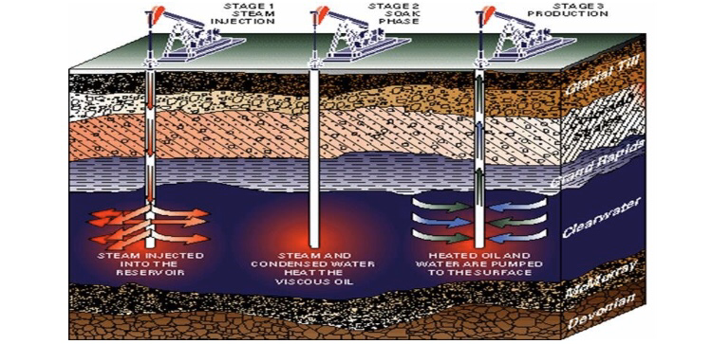

Figure 2.0: A typical cyclic steam injection process

There are several mechanics of oil production during this process. In high pressure reservoirs, oil is produced at higher rates due to the availability of the driving force, increase in oil mobility as a result of decreased viscosity. Gravity drainage is also a significant mechanism in thick formations, pressure depleted reservoirs. The low density phase i.e., steam, in this case, displaces the oil as it drains. Another mechanism is the compaction drive, which is seen in Bolivar Coast in Western Venezuela. As the pore pressure falls, there is a consolidation in the reservoir rock, which results in decrease in average porosity, and hence, oil is squeezed out from the porous rock. Another significant mechanism which is the key to success in Cold Lake is formation fracturing. Steam is injected at fracture pressure creating fractures in the formation and resulting in increase in the productivity of the reservoir. A part of the injected energy is stored in the form of potential energy by lifting the ground at the surface. When the well is put on production, the fluids are squeezed out of the formation5.

HOT WATER FLOODING
Hot water flooding also known as hot water injection is a technique of increasing crude oil production from a producing well by injecting hot water into the reservoir. The hot water is injected through an injection well which is drilled parallel to the primary producing well. The heat from the hot water acts as a way of reducing the viscosity of crude oil, making it to flow toward the producing well with ease. Hot water flooding is generally used to extract crude oil which has an API degree of less than 20. Hot water flooding is considered as one of the techniques of increasing crude oil production under Enhanced Oil Recovery Technique (EOR) and thermal recovery. It is less effective than steam injection process, due to the fact that hot water has a lower heat content as compared to steam. Over time the pressure in an oil reservoir slowly and steadily decreases and as a result the production rate decreases. This is one of the techniques used by E&P organizations to enhance the production of heavy to medium category crude oil from a reservoir. To use this technique, an injection well is drilled parallel to the primary producing well through which hot water is injected forcefully into the reservoir in the direction of the producing well.
The benefits of injecting water into the reservoir are:
• It supports the reservoir pressure, also known as voidage replacement.
• As oil is lighter than water hence it floats on top of the water. Also, the heat content of the water reduces the viscosity of heavy crude oil, making it not to stick on the edges of the reservoir and move quickly toward the producing well. Thus, water helps in displacing oil from its location in the reservoir and pushes it toward the producing well.
With this technique, oil recovery factor can be increased and well production rate can be maintained for a longer period.

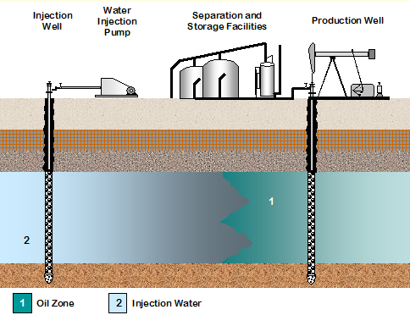

Figure 3.0: A typical Hot water flooding process

References

↑ Jump up to: 1.0 1.1 Athabasca Oil Corporation. (June 2, 2015). SAGD [Online]. Available: http://www.atha.com/operations/technology/sagd.html
↑ Jump up to: 2.00 2.01 2.02 2.03 2.04 2.05 2.06 2.07 2.08 2.09 2.10 Alberta Government. (June 9, 2015). Talk about SAGD [Online]. Available: http://www.energy.alberta.ca/OilSands/pdfs/FS_SAGD.pdf
↑ Jump up to: 3.0 3.1 3.2 3.3 3.4 Government of Alberta. (June 9, 2015). Facts about Alberta's oil sands and its industry [Online]. Available: http://history.alberta.ca/oilsands/resources/docs/facts_sheets09.pdf
↑ Created internally by a member of the Energy Education team.
↑ Alberta Energy Regulator. (June 9, 2015). In Situ Impacts [Online]. Available: https://www.aer.ca/about-aer/spotlight-on/oil-sands/in-situ-impacts
↑ US Department of Energy, National Energy Technology Laboratory "An Evaluation of the Extraction, Transport and Refining of Imported Crude Oils and the Impact on Life Cycle Greenhouse Gas Emissions", March 27th 2009. DOE/NETL-2009/1362 available online:

